社区服务中心
全年负荷计算书

工程名称 | 社区服务中心
设计编号
建设单位
设计单位 | 安徽工业大学
计 算 人
校 对 人
审 核 人
计算日期 | 2024年12月29日

采用软件 | 暖通负荷BECH2024
软件版本 | 20240430(SP1)
研发单位 | 北京绿建软件股份有限公司
正版授权码 | T13965423625
目 录

1 建筑概况 1
2 气象数据 1
2.1 气象地点 1
2.2 逐日干球温度表 1
2.3 逐月辐照量表 2
2.4 峰值工况 2
3 软件介绍 2
4 围护结构 2
4.1 屋顶构造 2
4.1.1 屋顶构造一 2
4.2 外墙构造 3
4.2.1 填充墙构造一 3
4.3 楼板构造 3
4.3.1 控温房间楼板构造一 3
4.4 周边地面构造 3
4.4.1 地面构造一 3
4.5 非周边地面构造 4
4.5.1 地面构造一 4
4.6 地下墙构造 4
4.6.1 地下墙构造一 4
4.7 门构造 4
4.8 窗构造 4
5 房间类型 5
5.1 房间参数表 5
5.2 作息时间表 5
6 系统设置 5
6.1 系统划分 5
6.2 运行时间表 6
7 计算结果 6
7.1 模拟周期 6
7.2 全年冷暖需求 6
7.3 负荷分项统计 6
7.4 逐月负荷表 7
8 附录 9

建筑概况
地理位置 | 安徽-马鞍山
气候分区 | 夏热冬冷A区
北纬 | 31.43
东经 | 118.28
建筑名称 | 社区服务中心
建筑类型 | 公共建筑
建筑面积 | 地上 13366.47 ㎡ | 地下 2920.06 ㎡
建筑高度 | 地上 17.10 m | 地下0.45
建筑层数 | 地上 4 | 地下 1
北向角度 | 90°

气象数据

气象地点
江苏-南京, 《建筑节能气象参数标准》JGJ346-2014

逐日干球温度表
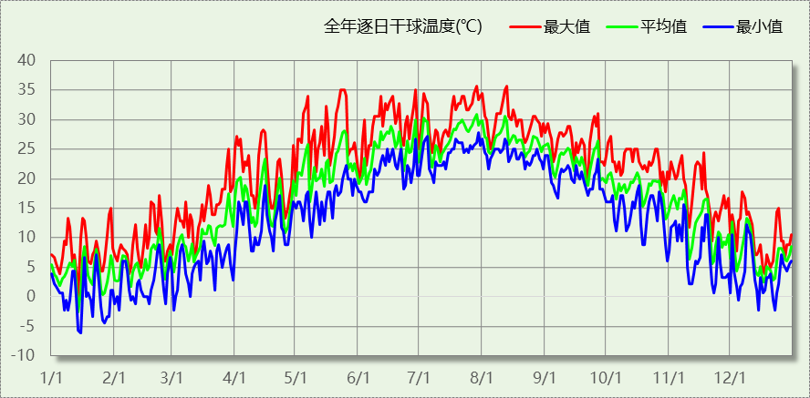

逐月辐照量表
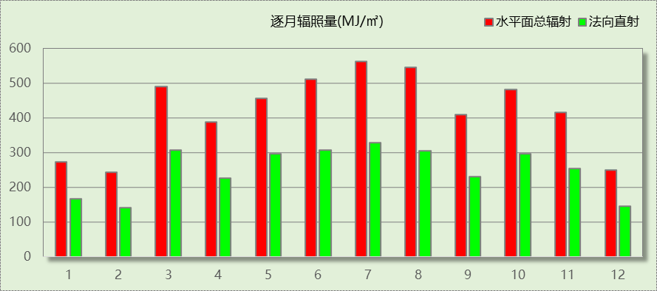

峰值工况
气象数据 | 时刻 | 干球温度(℃) | 湿球温度(℃) | 含湿量(g/kg) | 焓值(kj/kg)
最热 | 07月28日15时 | 35.6 | 26.1 | 17.9 | 81.7
最冷 | 01月14日02时 | -6.1 | -6.7 | 2.0 | -1.2

软件介绍
本报告采用的软件为绿建暖通负荷BECH2024，该软件紧密结合暖通和节能设计规范、可根据项目实际情况建立建筑热工模型，并可对围护结构材料、房间内扰发热、作息时间表、热回收方式等参数进行设置。
软件包含全国各地典型气象年数据，内置DOE2.1E内核，对于建筑的逐时负荷进行动态模拟，既可以模拟8760小时理想负荷，也可以根据设定好的采暖期/空调期进行逐时模拟。
软件还支持分析全年建筑能耗的来源构成，依据日射得热、新风负荷、围护传热和内扰得热进行归类分项，生成设计建筑全年负荷计算报告书，提供详实的数据和多样的图表，为设计师在设备选型、制定运行策略等方面提供参考和帮助。

围护结构

屋顶构造

屋顶构造一
材料名称  （由上到下） | 厚度δ | 导热系数λ | 蓄热系数S | 修正  系数 | 热阻R | 热惰性  指标
材料名称  （由上到下） | (mm) | W/(m.K) | W/(㎡.K) | α | (㎡K)/W | D=R*S
水泥砂浆 | 20 | 0.930 | 11.370 | 1.00 | 0.022 | 0.245
c20细石混凝土(ρ=2300) | 40 | 1.510 | 15.243 | 1.00 | 0.026 | 0.404
挤塑聚苯板(ρ=25-32) | 130 | 0.030 | 0.320 | 1.10 | 3.939 | 1.387
轻骨料混凝土(找坡层) | 30 | 0.300 | 5.000 | 1.50 | 0.067 | 0.500
钢筋混凝土 | 120 | 1.740 | 17.200 | 1.00 | 0.069 | 1.186
混合砂浆 | 20 | 0.870 | 10.750 | 1.00 | 0.023 | 0.247
各层之和∑ | 360 | － | － | － | 4.146 | 3.968
传热系数K=1/(0.15+∑R) | 0.23

外墙构造

填充墙构造一
材料名称  （由外到内） | 厚度δ | 导热系数λ | 蓄热系数S | 修正  系数 | 热阻R | 热惰性  指标
材料名称  （由外到内） | (mm) | W/(m.K) | W/(㎡.K) | α | (㎡K)/W | D=R*S
水泥砂浆 | 40 | 0.930 | 11.370 | 1.00 | 0.043 | 0.489
匀质防火保温板 | 70 | 0.065 | 1.500 | 1.20 | 0.897 | 1.615
煤矸石空心砖 | 240 | 0.580 | 7.920 | 1.00 | 0.414 | 3.277
混合砂浆 | 40 | 0.870 | 10.750 | 1.00 | 0.046 | 0.494
各层之和∑ | 390 | － | － | － | 1.400 | 5.876
传热系数K=1/(0.15+∑R) | 0.65

楼板构造

控温房间楼板构造一
材料名称 | 厚度δ | 导热系数λ | 蓄热系数S | 修正  系数 | 热阻R | 热惰性  指标
材料名称 | (mm) | W/(m.K) | W/(㎡.K) | α | (㎡K)/W | D=R*S
水泥砂浆 | 40 | 0.930 | 11.370 | 1.00 | 0.043 | 0.489
钢筋混凝土 | 150 | 1.740 | 17.200 | 1.00 | 0.086 | 1.483
石墨聚苯乙烯保温隔声板(b1级)（经压缩、覆膜处理） | 15 | 0.035 | 0.360 | 1.20 | 0.357 | 0.154
混合砂浆 | 40 | 0.870 | 10.750 | 1.00 | 0.046 | 0.494
各层之和∑ | 245 | － | － | － | 0.532 | 2.620
传热系数K=1/(0.22+∑R) | 1.33

周边地面构造

地面构造一
材料名称 | 厚度δ | 导热系数λ | 蓄热系数S | 修正  系数 | 热阻R | 热惰性  指标
材料名称 | (mm) | W/(m.K) | W/(㎡.K) | α | (㎡K)/W | D=R*S
水泥砂浆 | 20 | 0.930 | 11.370 | 1.00 | 0.022 | 0.245
钢筋混凝土 | 120 | 1.740 | 17.200 | 1.00 | 0.069 | 1.186
各层之和∑ | 140 | － | － | － | 0.090 | 1.431
传热系数K=1/(0.11+∑R) | 0.52

非周边地面构造

地面构造一
材料名称 | 厚度δ | 导热系数λ | 蓄热系数S | 修正  系数 | 热阻R | 热惰性  指标
材料名称 | (mm) | W/(m.K) | W/(㎡.K) | α | (㎡K)/W | D=R*S
水泥砂浆 | 20 | 0.930 | 11.370 | 1.00 | 0.022 | 0.245
钢筋混凝土 | 120 | 1.740 | 17.200 | 1.00 | 0.069 | 1.186
各层之和∑ | 140 | － | － | － | 0.090 | 1.431
传热系数K=1/(0.11+∑R) | 0.30

地下墙构造

地下墙构造一
材料名称 | 厚度δ | 导热系数λ | 蓄热系数S | 修正  系数 | 热阻R | 热惰性  指标
材料名称 | (mm) | W/(m.K) | W/(㎡.K) | α | (㎡K)/W | D=R*S
水泥砂浆 | 20 | 0.930 | 11.370 | 1.00 | 0.022 | 0.245
挤塑聚苯板(ρ=25-32) | 70 | 0.030 | 0.320 | 1.10 | 2.121 | 0.747
钢筋混凝土 | 200 | 1.740 | 17.200 | 1.00 | 0.115 | 1.977
混合砂浆 | 20 | 0.870 | 10.750 | 1.00 | 0.023 | 0.247
各层之和∑ | 310 | － | － | － | 2.281 | 3.215
传热系数K=1/(0.11+∑R) | 0.42

门构造
序号 | 构造名称 | 传热系数 | 备注
1 | 保温门（多功能门） | 6.250

窗构造
序号 | 构造名称 | 传热系数 | 窗遮阳系数 | 可见光透射比 | 备注
1 | 70系列内平开隔热铝合金窗(5+12Ar+5+12Ar+5Low-E) | 1.800 | 0.385 | 0.620
2 | 68系列内平开铝木复合(a型)门[5Low-E+12A+5+12A+5] | 1.800 | 0.385 | 0.620

房间类型

房间参数表
房间类型 | 空调温度  ℃ | 供暖温度  ℃ | 新风量 | 人员密度 | 照明功率  密度 | 电器设备  功率
会议室 | 26 | 18 | 14(m^3/h.人) | 2.5(m^2/人) | 8(W/m^2) | 15(W/m^2)
健身房 | 24 | 19 | 30(m^3/h.人) | 4(m^2/人) | 8(W/m^2) | 15(W/m^2)
办公-普通办公室 | 26 | 20 | 30(m^3/h.人) | 8(m^2/人) | 8(W/m^2) | 15(W/m^2)
卫生间 | 28 | 18 | 20(m^3/h.人) | 20(m^2/人) | 5(W/m^2) | 15(W/m^2)
多媒体区 | 26 | 20 | 30(m^3/h.人) | 2.5(m^2/人) | 13.5(W/m^2) | 15(W/m^2)
大厅 | 26 | 18 | 20(m^3/h.人) | 30(m^2/人) | 10(W/m^2) | 15(W/m^2)
展示区 | 26 | 20 | 30(m^3/h.人) | 2.5(m^2/人) | 8(W/m^2) | 15(W/m^2)
开水间 | 28 | 18 | 0(m^3/h.人) | 20(m^2/人) | 5(W/m^2) | 15(W/m^2)
接待室 | 26 | 20 | 30(m^3/h.人) | 8(m^2/人) | 8(W/m^2) | 15(W/m^2)
晒图室 | 27 | 18 | 10(次/h) | 20(m^2/人) | 8(W/m^2) | 15(W/m^2)
普通办公室 | 26 | 20 | 30(m^3/h.人) | 8(m^2/人) | 8(W/m^2) | 15(W/m^2)
楼梯间 | － | － | 0(m^3/h.人) | 0(人) | 3.5(W/m^2) | 15(W/m^2)
电子信息机房 | 23 | 23 | 0(m^3/h.人) | 20(m^2/人) | 13.5(W/m^2) | 15(W/m^2)
绘图室 | 26 | 20 | 30(m^3/h.人) | 8(m^2/人) | 8(W/m^2) | 15(W/m^2)
视屏工作室 | 26 | 18 | 30(m^3/h.人) | 8(m^2/人) | 13.5(W/m^2) | 15(W/m^2)
设备间 | － | － | 0(次/h) | 0(人) | 6(W/m^2) | 15(W/m^2)
设计室 | 26 | 18 | 30(m^3/h.人) | 8(m^2/人) | 13.5(W/m^2) | 15(W/m^2)
走廊 | 26 | 16 | 20(m^3/h.人) | 50(m^2/人) | 3.5(W/m^2) | 15(W/m^2)
阅览室 | 26 | 18 | 30(m^3/h.人) | 8(m^2/人) | 8(W/m^2) | 15(W/m^2)
餐厅 | 26 | 18 | 30(m^3/h.人) | 2.5(m^2/人) | 8(W/m^2) | 15(W/m^2)

作息时间表
详见附录

系统设置

系统划分
系统编号 | 热回收  类型 | 启动  条件 | 回收  效率 | 排风  比例 | 面积(m2) | 包含的房间
默认 | 全热回收 | 温差启动  冷:≥5.0(℃)  暖:≥5.0(℃) | 冷:0.50, 暖:0.55 | 0.60 | 13315.53 | 所有房间

运行时间表
详见附录

计算结果

模拟周期
全年8760小时模拟

全年冷暖需求
系统名称\负荷 | 供暖需求  (kWh) | 供暖指标  (kWh/㎡·a) | 供冷需求  (kWh) | 供冷指标  (kWh/㎡·a)
建筑总计 | 15931 | 0.98 | 1147524 | 70.46
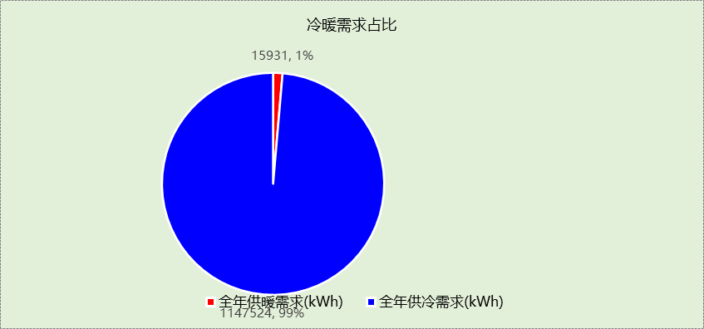

负荷分项统计
分类 | 围护传热 | 室内得热 | 窗日射 | 新风/渗透 | 热回收 | 合计
供暖(kWh/㎡) | -0.38 | 2.81 | 0.32 | -5.48 | 1.76 | -0.98
供冷(kWh/㎡) | 9.37 | 40.49 | 4.30 | 17.92 | -1.63 | 70.46
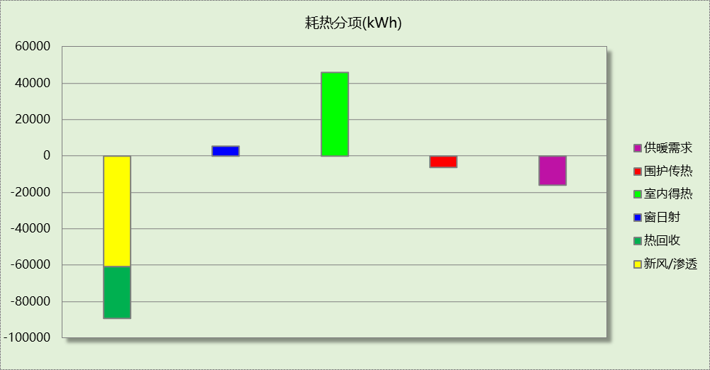
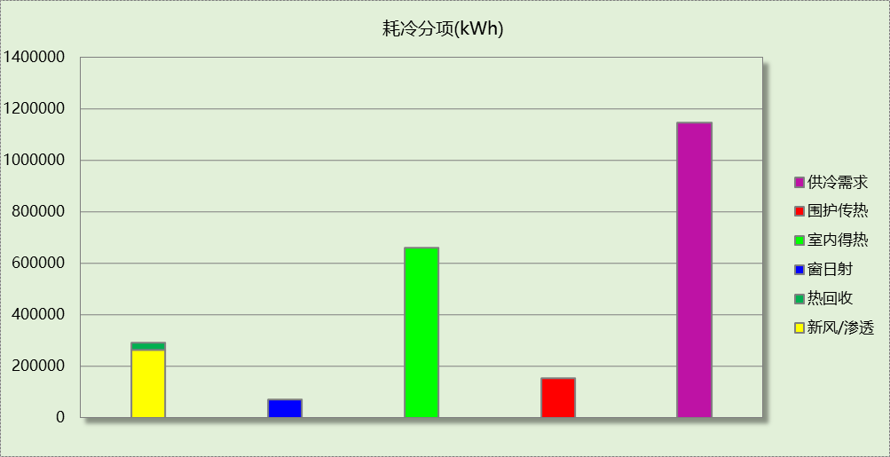

逐月负荷表
月份 | 供暖(kWh) | 供冷(kWh) | 热负荷  峰值(kW) | 热负荷  峰值时刻 | 冷负荷  峰值(kW) | 冷负荷  峰值时刻
1月 | 8661 | 319 | 297.797 | 1月2日7时 | 24.882 | 1月16日15时
2月 | 4157 | 635 | 309.843 | 2月14日7时 | 39.802 | 2月22日15时
3月 | 523 | 13647 | 102.163 | 3月1日7时 | 372.370 | 3月28日15时
4月 | 30 | 66006 | 2.788 | 4月26日7时 | 762.041 | 4月3日15时
5月 | 0 | 122900 | 0.000 | -- | 857.045 | 5月27日8时
6月 | 0 | 167243 | 0.000 | -- | 1154.347 | 6月28日8时
7月 | 0 | 245136 | 0.000 | -- | 1351.533 | 7月29日8时
8月 | 0 | 231805 | 0.000 | -- | 1351.761 | 8月12日8时
9月 | 0 | 156591 | 0.000 | -- | 1069.446 | 9月2日13时
10月 | 3 | 88400 | 1.697 | 10月30日7时 | 641.651 | 10月21日14时
11月 | 158 | 50521 | 6.434 | 11月27日8时 | 550.604 | 11月6日15时
12月 | 2400 | 4319 | 149.237 | 12月23日7时 | 111.655 | 12月10日15时
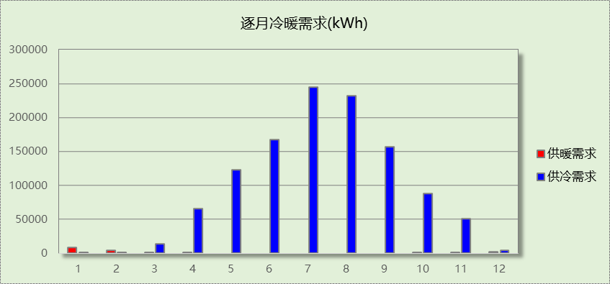
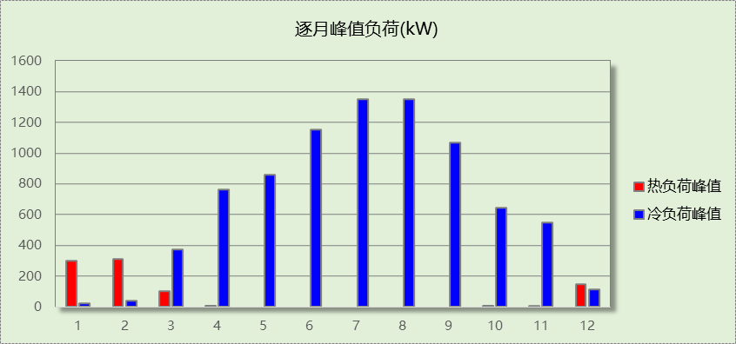

附录
工作日/节假日人员逐时在室率(%)

房间类型 | 1 | 2 | 3 | 4 | 5 | 6 | 7 | 8 | 9 | 10 | 11 | 12 | 13 | 14 | 15 | 16 | 17 | 18 | 19 | 20 | 21 | 22 | 23 | 24
会议室 | 0 | 0 | 0 | 0 | 0 | 0 | 10 | 50 | 100 | 100 | 100 | 30 | 100 | 100 | 100 | 100 | 50 | 20 | 10 | 0 | 0 | 0 | 0 | 0
会议室 | 0 | 0 | 0 | 0 | 0 | 0 | 0 | 20 | 45 | 0 | 0 | 0 | 0 | 0 | 0 | 0 | 0 | 0 | 0 | 0 | 0 | 0 | 0 | 0
健身房 | 0 | 0 | 0 | 0 | 0 | 0 | 10 | 50 | 100 | 100 | 100 | 30 | 100 | 100 | 100 | 100 | 50 | 20 | 10 | 0 | 0 | 0 | 0 | 0
健身房 | 0 | 0 | 0 | 0 | 0 | 0 | 0 | 20 | 45 | 0 | 0 | 0 | 0 | 0 | 0 | 0 | 0 | 0 | 0 | 0 | 0 | 0 | 0 | 0
办公-普通办公室 | 0 | 0 | 0 | 0 | 0 | 0 | 10 | 50 | 100 | 100 | 100 | 30 | 100 | 100 | 100 | 100 | 50 | 20 | 10 | 0 | 0 | 0 | 0 | 0
办公-普通办公室 | 0 | 0 | 0 | 0 | 0 | 0 | 0 | 20 | 45 | 0 | 0 | 0 | 0 | 0 | 0 | 0 | 0 | 0 | 0 | 0 | 0 | 0 | 0 | 0
卫生间 | 0 | 0 | 0 | 0 | 0 | 0 | 10 | 50 | 100 | 100 | 100 | 30 | 100 | 100 | 100 | 100 | 50 | 20 | 10 | 0 | 0 | 0 | 0 | 0
卫生间 | 0 | 0 | 0 | 0 | 0 | 0 | 0 | 20 | 45 | 0 | 0 | 0 | 0 | 0 | 0 | 0 | 0 | 0 | 0 | 0 | 0 | 0 | 0 | 0
多媒体区 | 0 | 0 | 0 | 0 | 0 | 0 | 10 | 50 | 100 | 100 | 100 | 30 | 100 | 100 | 100 | 100 | 50 | 20 | 10 | 0 | 0 | 0 | 0 | 0
多媒体区 | 0 | 0 | 0 | 0 | 0 | 0 | 0 | 20 | 45 | 0 | 0 | 0 | 0 | 0 | 0 | 0 | 0 | 0 | 0 | 0 | 0 | 0 | 0 | 0
大厅 | 0 | 0 | 0 | 0 | 0 | 0 | 10 | 50 | 100 | 100 | 100 | 30 | 100 | 100 | 100 | 100 | 50 | 20 | 10 | 0 | 0 | 0 | 0 | 0
大厅 | 0 | 0 | 0 | 0 | 0 | 0 | 0 | 20 | 45 | 0 | 0 | 0 | 0 | 0 | 0 | 0 | 0 | 0 | 0 | 0 | 0 | 0 | 0 | 0
展示区 | 0 | 0 | 0 | 0 | 0 | 0 | 10 | 50 | 100 | 100 | 100 | 30 | 100 | 100 | 100 | 100 | 50 | 20 | 10 | 0 | 0 | 0 | 0 | 0
展示区 | 0 | 0 | 0 | 0 | 0 | 0 | 0 | 20 | 45 | 0 | 0 | 0 | 0 | 0 | 0 | 0 | 0 | 0 | 0 | 0 | 0 | 0 | 0 | 0
开水间 | 0 | 0 | 0 | 0 | 0 | 0 | 10 | 50 | 100 | 100 | 100 | 30 | 100 | 100 | 100 | 100 | 50 | 20 | 10 | 0 | 0 | 0 | 0 | 0
开水间 | 0 | 0 | 0 | 0 | 0 | 0 | 0 | 20 | 45 | 0 | 0 | 0 | 0 | 0 | 0 | 0 | 0 | 0 | 0 | 0 | 0 | 0 | 0 | 0
接待室 | 0 | 0 | 0 | 0 | 0 | 0 | 10 | 50 | 100 | 100 | 100 | 30 | 100 | 100 | 100 | 100 | 50 | 20 | 10 | 0 | 0 | 0 | 0 | 0
接待室 | 0 | 0 | 0 | 0 | 0 | 0 | 0 | 20 | 45 | 0 | 0 | 0 | 0 | 0 | 0 | 0 | 0 | 0 | 0 | 0 | 0 | 0 | 0 | 0
晒图室 | 0 | 0 | 0 | 0 | 0 | 0 | 10 | 50 | 100 | 100 | 100 | 30 | 100 | 100 | 100 | 100 | 50 | 20 | 10 | 0 | 0 | 0 | 0 | 0
晒图室 | 0 | 0 | 0 | 0 | 0 | 0 | 0 | 20 | 45 | 0 | 0 | 0 | 0 | 0 | 0 | 0 | 0 | 0 | 0 | 0 | 0 | 0 | 0 | 0
普通办公室 | 0 | 0 | 0 | 0 | 0 | 0 | 10 | 50 | 100 | 100 | 100 | 30 | 100 | 100 | 100 | 100 | 50 | 20 | 10 | 0 | 0 | 0 | 0 | 0
普通办公室 | 0 | 0 | 0 | 0 | 0 | 0 | 0 | 20 | 45 | 0 | 0 | 0 | 0 | 0 | 0 | 0 | 0 | 0 | 0 | 0 | 0 | 0 | 0 | 0
楼梯间 | 0 | 0 | 0 | 0 | 0 | 0 | 0 | 20 | 50 | 80 | 80 | 80 | 80 | 80 | 80 | 80 | 80 | 80 | 80 | 70 | 50 | 0 | 0 | 0
楼梯间 | 0 | 0 | 0 | 0 | 0 | 0 | 0 | 0 | 0 | 0 | 0 | 0 | 0 | 0 | 0 | 0 | 0 | 0 | 0 | 0 | 0 | 0 | 0 | 0
电子信息机房 | 0 | 0 | 0 | 0 | 0 | 0 | 10 | 50 | 100 | 100 | 100 | 30 | 100 | 100 | 100 | 100 | 50 | 20 | 10 | 0 | 0 | 0 | 0 | 0
电子信息机房 | 0 | 0 | 0 | 0 | 0 | 0 | 0 | 20 | 45 | 0 | 0 | 0 | 0 | 0 | 0 | 0 | 0 | 0 | 0 | 0 | 0 | 0 | 0 | 0
绘图室 | 0 | 0 | 0 | 0 | 0 | 0 | 10 | 50 | 100 | 100 | 100 | 30 | 100 | 100 | 100 | 100 | 50 | 20 | 10 | 0 | 0 | 0 | 0 | 0
绘图室 | 0 | 0 | 0 | 0 | 0 | 0 | 0 | 20 | 45 | 0 | 0 | 0 | 0 | 0 | 0 | 0 | 0 | 0 | 0 | 0 | 0 | 0 | 0 | 0
视屏工作室 | 0 | 0 | 0 | 0 | 0 | 0 | 10 | 50 | 100 | 100 | 100 | 30 | 100 | 100 | 100 | 100 | 50 | 20 | 10 | 0 | 0 | 0 | 0 | 0
视屏工作室 | 0 | 0 | 0 | 0 | 0 | 0 | 0 | 20 | 45 | 0 | 0 | 0 | 0 | 0 | 0 | 0 | 0 | 0 | 0 | 0 | 0 | 0 | 0 | 0
设备间 | 0 | 0 | 0 | 0 | 0 | 0 | 0 | 0 | 0 | 0 | 0 | 0 | 0 | 0 | 0 | 0 | 0 | 0 | 0 | 0 | 0 | 0 | 0 | 0
设备间 | 0 | 0 | 0 | 0 | 0 | 0 | 0 | 0 | 0 | 0 | 0 | 0 | 0 | 0 | 0 | 0 | 0 | 0 | 0 | 0 | 0 | 0 | 0 | 0
设计室 | 0 | 0 | 0 | 0 | 0 | 0 | 10 | 50 | 100 | 100 | 100 | 30 | 100 | 100 | 100 | 100 | 50 | 20 | 10 | 0 | 0 | 0 | 0 | 0
设计室 | 0 | 0 | 0 | 0 | 0 | 0 | 0 | 20 | 45 | 0 | 0 | 0 | 0 | 0 | 0 | 0 | 0 | 0 | 0 | 0 | 0 | 0 | 0 | 0
走廊 | 0 | 0 | 0 | 0 | 0 | 0 | 10 | 50 | 95 | 95 | 95 | 80 | 80 | 95 | 95 | 95 | 95 | 30 | 30 | 0 | 0 | 0 | 0 | 0
走廊 | 0 | 0 | 0 | 0 | 0 | 0 | 0 | 0 | 0 | 0 | 0 | 0 | 0 | 0 | 0 | 0 | 0 | 0 | 0 | 0 | 0 | 0 | 0 | 0
阅览室 | 0 | 0 | 0 | 0 | 0 | 0 | 10 | 50 | 100 | 100 | 100 | 30 | 100 | 100 | 100 | 100 | 50 | 20 | 10 | 0 | 0 | 0 | 0 | 0
阅览室 | 0 | 0 | 0 | 0 | 0 | 0 | 0 | 20 | 45 | 0 | 0 | 0 | 0 | 0 | 0 | 0 | 0 | 0 | 0 | 0 | 0 | 0 | 0 | 0
餐厅 | 0 | 0 | 0 | 0 | 0 | 0 | 10 | 50 | 100 | 100 | 100 | 30 | 100 | 100 | 100 | 100 | 50 | 20 | 10 | 0 | 0 | 0 | 0 | 0
餐厅 | 0 | 0 | 0 | 0 | 0 | 0 | 0 | 20 | 45 | 0 | 0 | 0 | 0 | 0 | 0 | 0 | 0 | 0 | 0 | 0 | 0 | 0 | 0 | 0
注：上行：工作日；下行：节假日

工作日/节假日照明开关时间表(%)

房间类型 | 1 | 2 | 3 | 4 | 5 | 6 | 7 | 8 | 9 | 10 | 11 | 12 | 13 | 14 | 15 | 16 | 17 | 18 | 19 | 20 | 21 | 22 | 23 | 24
会议室 | 10 | 10 | 10 | 10 | 10 | 10 | 10 | 36 | 62 | 56 | 54 | 43 | 53 | 55 | 58 | 67 | 40 | 18 | 10 | 10 | 10 | 10 | 10 | 10
会议室 | 0 | 0 | 0 | 0 | 0 | 0 | 0 | 0 | 0 | 0 | 0 | 0 | 0 | 0 | 0 | 0 | 0 | 0 | 0 | 0 | 0 | 0 | 0 | 0
健身房 | 10 | 10 | 10 | 10 | 10 | 10 | 10 | 36 | 62 | 56 | 54 | 43 | 53 | 55 | 58 | 67 | 40 | 18 | 10 | 10 | 10 | 10 | 10 | 10
健身房 | 0 | 0 | 0 | 0 | 0 | 0 | 0 | 0 | 0 | 0 | 0 | 0 | 0 | 0 | 0 | 0 | 0 | 0 | 0 | 0 | 0 | 0 | 0 | 0
办公-普通办公室 | 10 | 10 | 10 | 10 | 10 | 10 | 10 | 36 | 62 | 56 | 54 | 43 | 53 | 55 | 58 | 67 | 40 | 18 | 10 | 10 | 10 | 10 | 10 | 10
办公-普通办公室 | 0 | 0 | 0 | 0 | 0 | 0 | 0 | 0 | 0 | 0 | 0 | 0 | 0 | 0 | 0 | 0 | 0 | 0 | 0 | 0 | 0 | 0 | 0 | 0
卫生间 | 10 | 10 | 10 | 10 | 10 | 10 | 10 | 36 | 62 | 56 | 54 | 43 | 53 | 55 | 58 | 67 | 40 | 18 | 10 | 10 | 10 | 10 | 10 | 10
卫生间 | 0 | 0 | 0 | 0 | 0 | 0 | 0 | 0 | 0 | 0 | 0 | 0 | 0 | 0 | 0 | 0 | 0 | 0 | 0 | 0 | 0 | 0 | 0 | 0
多媒体区 | 10 | 10 | 10 | 10 | 10 | 10 | 10 | 36 | 62 | 56 | 54 | 43 | 53 | 55 | 58 | 67 | 40 | 18 | 10 | 10 | 10 | 10 | 10 | 10
多媒体区 | 0 | 0 | 0 | 0 | 0 | 0 | 0 | 0 | 0 | 0 | 0 | 0 | 0 | 0 | 0 | 0 | 0 | 0 | 0 | 0 | 0 | 0 | 0 | 0
大厅 | 10 | 10 | 10 | 10 | 10 | 10 | 10 | 36 | 62 | 56 | 54 | 43 | 53 | 55 | 58 | 67 | 40 | 18 | 10 | 10 | 10 | 10 | 10 | 10
大厅 | 0 | 0 | 0 | 0 | 0 | 0 | 0 | 0 | 0 | 0 | 0 | 0 | 0 | 0 | 0 | 0 | 0 | 0 | 0 | 0 | 0 | 0 | 0 | 0
展示区 | 10 | 10 | 10 | 10 | 10 | 10 | 10 | 36 | 62 | 56 | 54 | 43 | 53 | 55 | 58 | 67 | 40 | 18 | 10 | 10 | 10 | 10 | 10 | 10
展示区 | 0 | 0 | 0 | 0 | 0 | 0 | 0 | 0 | 0 | 0 | 0 | 0 | 0 | 0 | 0 | 0 | 0 | 0 | 0 | 0 | 0 | 0 | 0 | 0
开水间 | 10 | 10 | 10 | 10 | 10 | 10 | 10 | 36 | 62 | 56 | 54 | 43 | 53 | 55 | 58 | 67 | 40 | 18 | 10 | 10 | 10 | 10 | 10 | 10
开水间 | 0 | 0 | 0 | 0 | 0 | 0 | 0 | 0 | 0 | 0 | 0 | 0 | 0 | 0 | 0 | 0 | 0 | 0 | 0 | 0 | 0 | 0 | 0 | 0
接待室 | 10 | 10 | 10 | 10 | 10 | 10 | 10 | 36 | 62 | 56 | 54 | 43 | 53 | 55 | 58 | 67 | 40 | 18 | 10 | 10 | 10 | 10 | 10 | 10
接待室 | 0 | 0 | 0 | 0 | 0 | 0 | 0 | 0 | 0 | 0 | 0 | 0 | 0 | 0 | 0 | 0 | 0 | 0 | 0 | 0 | 0 | 0 | 0 | 0
晒图室 | 10 | 10 | 10 | 10 | 10 | 10 | 10 | 36 | 62 | 56 | 54 | 43 | 53 | 55 | 58 | 67 | 40 | 18 | 10 | 10 | 10 | 10 | 10 | 10
晒图室 | 0 | 0 | 0 | 0 | 0 | 0 | 0 | 0 | 0 | 0 | 0 | 0 | 0 | 0 | 0 | 0 | 0 | 0 | 0 | 0 | 0 | 0 | 0 | 0
普通办公室 | 10 | 10 | 10 | 10 | 10 | 10 | 10 | 36 | 62 | 56 | 54 | 43 | 53 | 55 | 58 | 67 | 40 | 18 | 10 | 10 | 10 | 10 | 10 | 10
普通办公室 | 0 | 0 | 0 | 0 | 0 | 0 | 0 | 0 | 0 | 0 | 0 | 0 | 0 | 0 | 0 | 0 | 0 | 0 | 0 | 0 | 0 | 0 | 0 | 0
楼梯间 | 10 | 10 | 10 | 10 | 10 | 10 | 10 | 50 | 60 | 60 | 60 | 60 | 60 | 60 | 60 | 60 | 80 | 90 | 100 | 100 | 100 | 10 | 10 | 10
楼梯间 | 0 | 0 | 0 | 0 | 0 | 0 | 0 | 0 | 0 | 0 | 0 | 0 | 0 | 0 | 0 | 0 | 0 | 0 | 0 | 0 | 0 | 0 | 0 | 0
电子信息机房 | 10 | 10 | 10 | 10 | 10 | 10 | 10 | 36 | 62 | 56 | 54 | 43 | 53 | 55 | 58 | 67 | 40 | 18 | 10 | 10 | 10 | 10 | 10 | 10
电子信息机房 | 0 | 0 | 0 | 0 | 0 | 0 | 0 | 0 | 0 | 0 | 0 | 0 | 0 | 0 | 0 | 0 | 0 | 0 | 0 | 0 | 0 | 0 | 0 | 0
绘图室 | 10 | 10 | 10 | 10 | 10 | 10 | 10 | 36 | 62 | 56 | 54 | 43 | 53 | 55 | 58 | 67 | 40 | 18 | 10 | 10 | 10 | 10 | 10 | 10
绘图室 | 0 | 0 | 0 | 0 | 0 | 0 | 0 | 0 | 0 | 0 | 0 | 0 | 0 | 0 | 0 | 0 | 0 | 0 | 0 | 0 | 0 | 0 | 0 | 0
视屏工作室 | 10 | 10 | 10 | 10 | 10 | 10 | 10 | 36 | 62 | 56 | 54 | 43 | 53 | 55 | 58 | 67 | 40 | 18 | 10 | 10 | 10 | 10 | 10 | 10
视屏工作室 | 0 | 0 | 0 | 0 | 0 | 0 | 0 | 0 | 0 | 0 | 0 | 0 | 0 | 0 | 0 | 0 | 0 | 0 | 0 | 0 | 0 | 0 | 0 | 0
设备间 | 100 | 100 | 100 | 100 | 100 | 100 | 100 | 100 | 100 | 100 | 100 | 100 | 100 | 100 | 100 | 100 | 100 | 100 | 100 | 100 | 100 | 100 | 100 | 100
设备间 | 0 | 0 | 0 | 0 | 0 | 0 | 0 | 0 | 0 | 0 | 0 | 0 | 0 | 0 | 0 | 0 | 0 | 0 | 0 | 0 | 0 | 0 | 0 | 0
设计室 | 10 | 10 | 10 | 10 | 10 | 10 | 10 | 36 | 62 | 56 | 54 | 43 | 53 | 55 | 58 | 67 | 40 | 18 | 10 | 10 | 10 | 10 | 10 | 10
设计室 | 0 | 0 | 0 | 0 | 0 | 0 | 0 | 0 | 0 | 0 | 0 | 0 | 0 | 0 | 0 | 0 | 0 | 0 | 0 | 0 | 0 | 0 | 0 | 0
走廊 | 0 | 0 | 0 | 0 | 0 | 0 | 10 | 50 | 95 | 95 | 95 | 80 | 80 | 95 | 95 | 95 | 95 | 30 | 30 | 0 | 0 | 0 | 0 | 0
走廊 | 0 | 0 | 0 | 0 | 0 | 0 | 0 | 0 | 0 | 0 | 0 | 0 | 0 | 0 | 0 | 0 | 0 | 0 | 0 | 0 | 0 | 0 | 0 | 0
阅览室 | 10 | 10 | 10 | 10 | 10 | 10 | 10 | 36 | 62 | 56 | 54 | 43 | 53 | 55 | 58 | 67 | 40 | 18 | 10 | 10 | 10 | 10 | 10 | 10
阅览室 | 0 | 0 | 0 | 0 | 0 | 0 | 0 | 0 | 0 | 0 | 0 | 0 | 0 | 0 | 0 | 0 | 0 | 0 | 0 | 0 | 0 | 0 | 0 | 0
餐厅 | 10 | 10 | 10 | 10 | 10 | 10 | 10 | 36 | 62 | 56 | 54 | 43 | 53 | 55 | 58 | 67 | 40 | 18 | 10 | 10 | 10 | 10 | 10 | 10
餐厅 | 0 | 0 | 0 | 0 | 0 | 0 | 0 | 0 | 0 | 0 | 0 | 0 | 0 | 0 | 0 | 0 | 0 | 0 | 0 | 0 | 0 | 0 | 0 | 0
注：上行：工作日；下行：节假日

工作日/节假日设备逐时使用率(%)

房间类型 | 1 | 2 | 3 | 4 | 5 | 6 | 7 | 8 | 9 | 10 | 11 | 12 | 13 | 14 | 15 | 16 | 17 | 18 | 19 | 20 | 21 | 22 | 23 | 24
会议室 | 0 | 0 | 0 | 0 | 0 | 0 | 10 | 50 | 100 | 100 | 100 | 100 | 100 | 100 | 100 | 100 | 50 | 20 | 10 | 0 | 0 | 0 | 0 | 0
会议室 | 0 | 0 | 0 | 0 | 0 | 0 | 0 | 0 | 0 | 0 | 0 | 0 | 0 | 0 | 0 | 0 | 0 | 0 | 0 | 0 | 0 | 0 | 0 | 0
健身房 | 0 | 0 | 0 | 0 | 0 | 0 | 10 | 50 | 100 | 100 | 100 | 100 | 100 | 100 | 100 | 100 | 50 | 20 | 10 | 0 | 0 | 0 | 0 | 0
健身房 | 0 | 0 | 0 | 0 | 0 | 0 | 0 | 0 | 0 | 0 | 0 | 0 | 0 | 0 | 0 | 0 | 0 | 0 | 0 | 0 | 0 | 0 | 0 | 0
办公-普通办公室 | 0 | 0 | 0 | 0 | 0 | 0 | 10 | 50 | 100 | 100 | 100 | 100 | 100 | 100 | 100 | 100 | 50 | 20 | 10 | 0 | 0 | 0 | 0 | 0
办公-普通办公室 | 0 | 0 | 0 | 0 | 0 | 0 | 0 | 0 | 0 | 0 | 0 | 0 | 0 | 0 | 0 | 0 | 0 | 0 | 0 | 0 | 0 | 0 | 0 | 0
卫生间 | 0 | 0 | 0 | 0 | 0 | 0 | 10 | 50 | 100 | 100 | 100 | 100 | 100 | 100 | 100 | 100 | 50 | 20 | 10 | 0 | 0 | 0 | 0 | 0
卫生间 | 0 | 0 | 0 | 0 | 0 | 0 | 0 | 0 | 0 | 0 | 0 | 0 | 0 | 0 | 0 | 0 | 0 | 0 | 0 | 0 | 0 | 0 | 0 | 0
多媒体区 | 0 | 0 | 0 | 0 | 0 | 0 | 10 | 50 | 100 | 100 | 100 | 100 | 100 | 100 | 100 | 100 | 50 | 20 | 10 | 0 | 0 | 0 | 0 | 0
多媒体区 | 0 | 0 | 0 | 0 | 0 | 0 | 0 | 0 | 0 | 0 | 0 | 0 | 0 | 0 | 0 | 0 | 0 | 0 | 0 | 0 | 0 | 0 | 0 | 0
大厅 | 0 | 0 | 0 | 0 | 0 | 0 | 10 | 50 | 100 | 100 | 100 | 100 | 100 | 100 | 100 | 100 | 50 | 20 | 10 | 0 | 0 | 0 | 0 | 0
大厅 | 0 | 0 | 0 | 0 | 0 | 0 | 0 | 0 | 0 | 0 | 0 | 0 | 0 | 0 | 0 | 0 | 0 | 0 | 0 | 0 | 0 | 0 | 0 | 0
展示区 | 0 | 0 | 0 | 0 | 0 | 0 | 10 | 50 | 100 | 100 | 100 | 100 | 100 | 100 | 100 | 100 | 50 | 20 | 10 | 0 | 0 | 0 | 0 | 0
展示区 | 0 | 0 | 0 | 0 | 0 | 0 | 0 | 0 | 0 | 0 | 0 | 0 | 0 | 0 | 0 | 0 | 0 | 0 | 0 | 0 | 0 | 0 | 0 | 0
开水间 | 0 | 0 | 0 | 0 | 0 | 0 | 10 | 50 | 100 | 100 | 100 | 100 | 100 | 100 | 100 | 100 | 50 | 20 | 10 | 0 | 0 | 0 | 0 | 0
开水间 | 0 | 0 | 0 | 0 | 0 | 0 | 0 | 0 | 0 | 0 | 0 | 0 | 0 | 0 | 0 | 0 | 0 | 0 | 0 | 0 | 0 | 0 | 0 | 0
接待室 | 0 | 0 | 0 | 0 | 0 | 0 | 10 | 50 | 100 | 100 | 100 | 100 | 100 | 100 | 100 | 100 | 50 | 20 | 10 | 0 | 0 | 0 | 0 | 0
接待室 | 0 | 0 | 0 | 0 | 0 | 0 | 0 | 0 | 0 | 0 | 0 | 0 | 0 | 0 | 0 | 0 | 0 | 0 | 0 | 0 | 0 | 0 | 0 | 0
晒图室 | 0 | 0 | 0 | 0 | 0 | 0 | 10 | 50 | 100 | 100 | 100 | 100 | 100 | 100 | 100 | 100 | 50 | 20 | 10 | 0 | 0 | 0 | 0 | 0
晒图室 | 0 | 0 | 0 | 0 | 0 | 0 | 0 | 0 | 0 | 0 | 0 | 0 | 0 | 0 | 0 | 0 | 0 | 0 | 0 | 0 | 0 | 0 | 0 | 0
普通办公室 | 0 | 0 | 0 | 0 | 0 | 0 | 10 | 50 | 100 | 100 | 100 | 100 | 100 | 100 | 100 | 100 | 50 | 20 | 10 | 0 | 0 | 0 | 0 | 0
普通办公室 | 0 | 0 | 0 | 0 | 0 | 0 | 0 | 0 | 0 | 0 | 0 | 0 | 0 | 0 | 0 | 0 | 0 | 0 | 0 | 0 | 0 | 0 | 0 | 0
楼梯间 | 0 | 0 | 0 | 0 | 0 | 0 | 0 | 30 | 50 | 80 | 80 | 80 | 80 | 80 | 80 | 80 | 80 | 80 | 80 | 70 | 50 | 0 | 0 | 0
楼梯间 | 0 | 0 | 0 | 0 | 0 | 0 | 0 | 0 | 0 | 0 | 0 | 0 | 0 | 0 | 0 | 0 | 0 | 0 | 0 | 0 | 0 | 0 | 0 | 0
电子信息机房 | 0 | 0 | 0 | 0 | 0 | 0 | 10 | 50 | 100 | 100 | 100 | 100 | 100 | 100 | 100 | 100 | 50 | 20 | 10 | 0 | 0 | 0 | 0 | 0
电子信息机房 | 0 | 0 | 0 | 0 | 0 | 0 | 0 | 0 | 0 | 0 | 0 | 0 | 0 | 0 | 0 | 0 | 0 | 0 | 0 | 0 | 0 | 0 | 0 | 0
绘图室 | 0 | 0 | 0 | 0 | 0 | 0 | 10 | 50 | 100 | 100 | 100 | 100 | 100 | 100 | 100 | 100 | 50 | 20 | 10 | 0 | 0 | 0 | 0 | 0
绘图室 | 0 | 0 | 0 | 0 | 0 | 0 | 0 | 0 | 0 | 0 | 0 | 0 | 0 | 0 | 0 | 0 | 0 | 0 | 0 | 0 | 0 | 0 | 0 | 0
视屏工作室 | 0 | 0 | 0 | 0 | 0 | 0 | 10 | 50 | 100 | 100 | 100 | 100 | 100 | 100 | 100 | 100 | 50 | 20 | 10 | 0 | 0 | 0 | 0 | 0
视屏工作室 | 0 | 0 | 0 | 0 | 0 | 0 | 0 | 0 | 0 | 0 | 0 | 0 | 0 | 0 | 0 | 0 | 0 | 0 | 0 | 0 | 0 | 0 | 0 | 0
设备间 | 100 | 100 | 100 | 100 | 100 | 100 | 100 | 100 | 100 | 100 | 100 | 100 | 100 | 100 | 100 | 100 | 100 | 100 | 100 | 100 | 100 | 100 | 100 | 100
设备间 | 0 | 0 | 0 | 0 | 0 | 0 | 0 | 0 | 0 | 0 | 0 | 0 | 0 | 0 | 0 | 0 | 0 | 0 | 0 | 0 | 0 | 0 | 0 | 0
设计室 | 0 | 0 | 0 | 0 | 0 | 0 | 10 | 50 | 100 | 100 | 100 | 100 | 100 | 100 | 100 | 100 | 50 | 20 | 10 | 0 | 0 | 0 | 0 | 0
设计室 | 0 | 0 | 0 | 0 | 0 | 0 | 0 | 0 | 0 | 0 | 0 | 0 | 0 | 0 | 0 | 0 | 0 | 0 | 0 | 0 | 0 | 0 | 0 | 0
走廊 | 0 | 0 | 0 | 0 | 0 | 0 | 10 | 50 | 95 | 95 | 95 | 50 | 50 | 95 | 95 | 95 | 95 | 30 | 30 | 0 | 0 | 0 | 0 | 0
走廊 | 0 | 0 | 0 | 0 | 0 | 0 | 0 | 0 | 0 | 0 | 0 | 0 | 0 | 0 | 0 | 0 | 0 | 0 | 0 | 0 | 0 | 0 | 0 | 0
阅览室 | 0 | 0 | 0 | 0 | 0 | 0 | 10 | 50 | 100 | 100 | 100 | 100 | 100 | 100 | 100 | 100 | 50 | 20 | 10 | 0 | 0 | 0 | 0 | 0
阅览室 | 0 | 0 | 0 | 0 | 0 | 0 | 0 | 0 | 0 | 0 | 0 | 0 | 0 | 0 | 0 | 0 | 0 | 0 | 0 | 0 | 0 | 0 | 0 | 0
餐厅 | 0 | 0 | 0 | 0 | 0 | 0 | 10 | 50 | 100 | 100 | 100 | 100 | 100 | 100 | 100 | 100 | 50 | 20 | 10 | 0 | 0 | 0 | 0 | 0
餐厅 | 0 | 0 | 0 | 0 | 0 | 0 | 0 | 0 | 0 | 0 | 0 | 0 | 0 | 0 | 0 | 0 | 0 | 0 | 0 | 0 | 0 | 0 | 0 | 0
注：上行：工作日；下行：节假日

工作日/节假日空调系统开关时间表

系统编号 | 1 | 2 | 3 | 4 | 5 | 6 | 7 | 8 | 9 | 10 | 11 | 12 | 13 | 14 | 15 | 16 | 17 | 18 | 19 | 20 | 21 | 22 | 23 | 24
默认 | 0 | 0 | 0 | 0 | 0 | 0 | 1 | 1 | 1 | 1 | 1 | 1 | 1 | 1 | 1 | 1 | 1 | 1 | 0 | 0 | 0 | 0 | 0 | 0
默认 | 0 | 0 | 0 | 0 | 0 | 0 | 0 | 0 | 0 | 0 | 0 | 0 | 0 | 0 | 0 | 0 | 0 | 0 | 0 | 0 | 0 | 0 | 0 | 0
注：上行：工作日；下行：节假日

