**近零能耗**

**建筑能效报告书**

公共建筑

|  |  |
| --- | --- |
| 工程名称 | 止方-木叶之居 |
| 工程地点 | 河南-安阳 |
| 设计编号 | Design 1.0 |
| 建设单位 | 建筑单位 |
| 设计单位 | 设计小组 |
| 设 计 人 |  |
| 审 核 人 |  |
| 审 定 人 |  |
| 设计日期 | 2024年12月29日 |



|  |  |
| --- | --- |
| 采用软件 | 超低能耗PHES2024 |
| 软件版本 | 20240430(SP1) |
| 研发单位 | 北京绿建软件股份有限公司 |
| 正版授权码 | T17525907580 |

**目 录**

1 建筑概况 4

2 评估依据 4

3 气象数据 4

3.1 气象地点 4

3.2 逐日干球温度表 5

3.3 逐月辐照量表 5

3.4 峰值工况 5

4 建筑大样 6

5 围护结构 9

5.1 工程材料 9

5.2 屋顶 10

5.2.1 屋顶构造一 10

5.3 天窗类型 10

5.4 外墙 10

5.5 地面 10

5.6 挑空楼板 10

5.6.1 挑空楼板构造一 10

5.7 采暖与非采暖楼板 10

5.8 采暖与非采暖隔墙 11

5.8.1 控温与非控温空间隔墙构造一 11

5.9 外窗热工 11

5.10 外门 11

5.11 分隔采暖与非采暖空间的户门 11

5.12 外窗气密性 11

5.13 外门气密性 11

5.14 户门气密性 11

5.15 规定项检查 12

6 围护结构概况 12

7 设计建筑 13

7.1 房间类型 13

7.1.1 房间参数表 13

7.1.2 作息时间表 13

7.2 系统类型 13

7.2.1 系统分区 13

7.2.2 热回收参数 13

7.3 制冷系统 14

7.3.1 多联机/单元式空调能耗 14

7.4 供暖系统 14

7.4.1 多联机/单元式热泵能耗 14

7.5 照明 14

7.6 生活热水 14

7.6.1 热水需求 14

7.6.2 太阳能集热 15

7.6.3 热水设备 15

7.7 电梯 15

7.7.1 直梯 15

7.8 光伏发电 15

7.9 风力发电 15

7.10 负荷分项统计 16

7.11 逐月负荷表 16

8 基准建筑 18

8.1 房间类型 18

8.1.1 房间参数表 18

8.1.2 作息时间表 18

8.2 系统类型 18

8.3 制冷系统 18

8.3.1 默认冷源 18

8.4 供暖系统 19

8.4.1 默认热源 19

8.5 照明 20

8.6 生活热水 20

8.6.1 热水需求 20

8.6.2 热水设备 20

8.7 电梯 21

8.7.1 直梯 21

8.8 负荷分项统计 21

8.9 逐月负荷表 22

9 能效结果 23

9.1 建筑能耗 23

9.2 可再生能源利用 26

9.3 结论 26

10 附录 27

10.1 工作日/节假日人员逐时在室率(%) 27

10.2 工作日/节假日照明开关时间表(%) 28

10.3 工作日/节假日设备逐时使用率(%) 29

10.4 工作日/节假日空调系统运行时间表(1:开,0:关) 30

10.5 工作日/节假日新风运行时间表(%) 31

# 建筑概况

|  |  |  |
| --- | --- | --- |
| 工程名称 | 止方-木叶之居 | |
| 工程地点 | 河南-安阳 | |
| 地理位置 | 北纬：36.00° | 东经：114.36° |
| 建筑面积(m2) | 地上2753 地下0 | |
| 建筑层数 | 地上3 地下0 | |
| 建筑高度（m） | 地上17.1 地下0.0 | |
| 建筑体积(m3) | 12389.72 | |
| 建筑外表面积(m2) | 1211.20 | |
| 建筑气密性（换气次数N50） | 0.50 | |
| 建筑类型细化 | 商场建筑 | |
| 北向角度 | 90 | |
| 结构类型 | 框架结构 | |
| 外墙太阳辐射吸收系数 | 0.73 | |
| 屋顶太阳辐射吸收系数 | 0.75 | |
| 控温期 | 供冷期:7.1-9.1,供暖期:10.1-3.1 | |

# 评估依据

1. 《近零能耗建筑技术标准》(GB/T51350-2019)

2. 《公共建筑节能设计标准》(GB50189-2015)

3. 《民用建筑热工设计规范》(GB50176-2016-2016)

4. 《建筑幕墙、门窗通用技术条件》(GB/T31433-2015)

# 气象数据

## 气象地点

河南-安阳, 《建筑节能气象参数标准》

## 逐日干球温度表

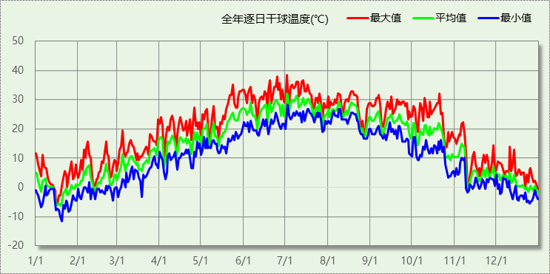

## 逐月辐照量表

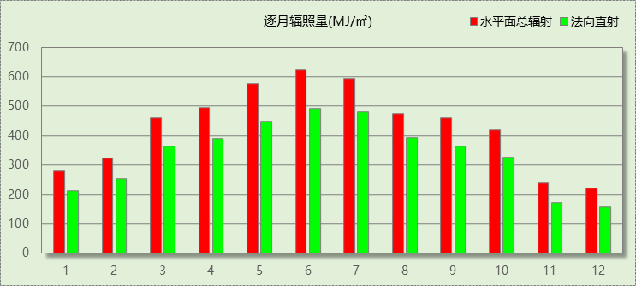

## 峰值工况

|  |  |  |  |  |  |
| --- | --- | --- | --- | --- | --- |
| 气象数据 | 时刻 | 干球温度(℃) | 湿球温度(℃) | 含湿量(g/kg) | 焓值(kj/kg) |
| 最热 | 07月01日14时 | 38.3 | 26.1 | 17.0 | 82.2 |
| 最冷 | 01月19日07时 | -11.7 | -12.2 | 1.1 | -9.0 |

# 建筑大样

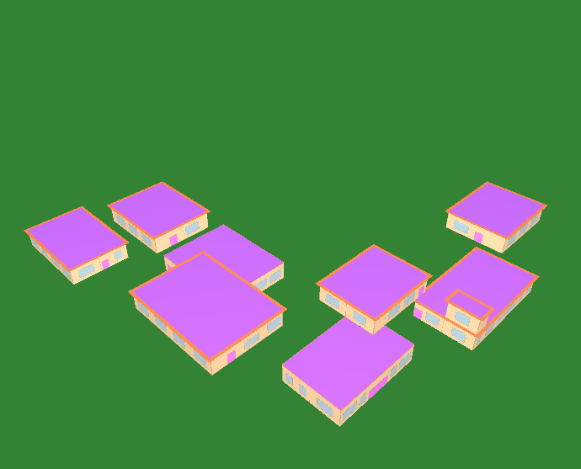

西南轴侧图

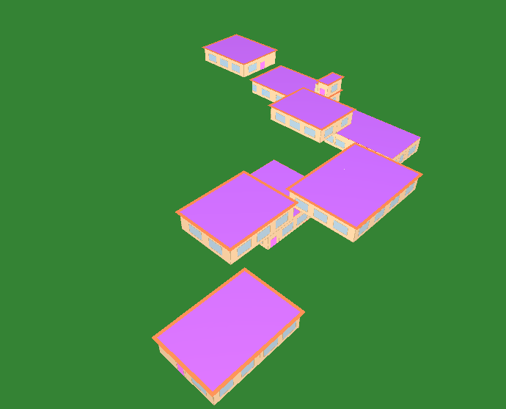

东南轴侧图

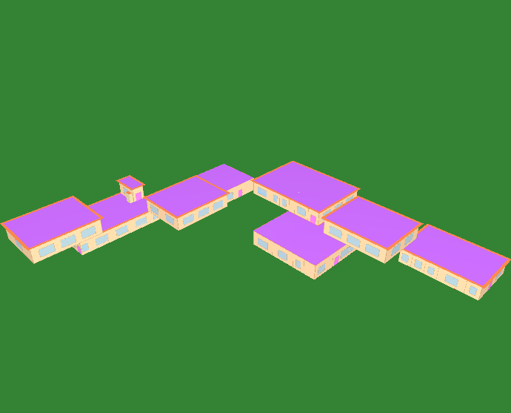

西北轴侧图

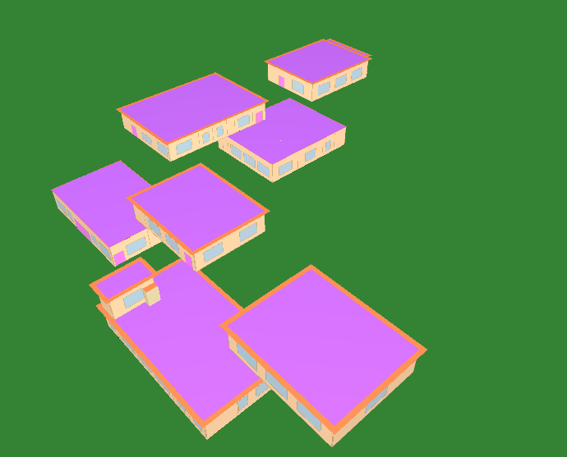

东北轴侧图

# 围护结构

## 工程材料

|  |  |  |  |  |  |  |
| --- | --- | --- | --- | --- | --- | --- |
| 材料名称 | 导热系数λ | 蓄热系数S | 密度ρ | 比热容Cp | 蒸汽渗透 系数u | 数据来源 |
| W/(m.K) | W/(㎡.K) | kg/m3 | J/(kg.K) | g/(m.h.kPa) |
| 水泥砂浆 | 0.930 | 11.370 | 1800.0 | 1050.0 | 0.0210 |  |
| 石灰砂浆 | 0.810 | 10.070 | 1600.0 | 1050.0 | 0.0443 |  |
| 钢筋混凝土 | 1.740 | 17.200 | 2500.0 | 920.0 | 0.0158 |  |
| 加气混凝土、泡沫混凝土(ρ=700) | 0.180 | 3.100 | 700.0 | 1050.0 | 0.0998 |  |
| 混凝土多孔砖(190六孔砖） | 0.750 | 7.490 | 1450.0 | 709.4 | 0.0140 |  |
| 聚苯颗粒保温砂浆 | 0.060 | 0.950 | 230.0 | 900.0 | 0.0210 |  |
| 岩棉带(ρ=80-120) | 0.045 | 0.632 | 100.0 | 1220.0 | 0.4880 | 民用建筑热工设计规范 GB50176-2016 |

## 屋顶

### 屋顶构造一

|  |  |  |  |  |  |  |
| --- | --- | --- | --- | --- | --- | --- |
| 材料名称 （由上到下） | 厚度δ | 导热系数λ | 蓄热系数S | 修正 系数 | 热阻R | 热惰性 指标 |
| (mm) | W/(m.K) | W/(㎡.K) | α | (㎡K)/W | D=R*S |
| 加气混凝土、泡沫混凝土(ρ=700) | 80 | 0.180 | 3.100 | 1.00 | 0.444 | 1.378 |
| 混凝土多孔砖(190六孔砖） | 120 | 0.750 | 7.490 | 1.00 | 0.160 | 1.198 |
| 钢筋混凝土 | 20 | 1.740 | 17.200 | 1.00 | 0.011 | 0.198 |
| 岩棉带(ρ=80-120) | 20 | 0.045 | 0.632 | 1.00 | 0.444 | 0.281 |
| 各层之和∑ | 240 | － | － | － | 1.060 | 3.055 |
| 外表面太阳辐射吸收系数 | 0.75[默认] | | | | | |
| 传热系数K=1/(0.15+∑R) | 0.83 | | | | | |

## 天窗类型

本工程无此项内容

## 外墙

本工程无此项内容

## 地面

本工程无此项内容

## 挑空楼板

### 挑空楼板构造一

|  |  |  |  |  |  |  |
| --- | --- | --- | --- | --- | --- | --- |
| 材料名称 （由上到下） | 厚度δ | 导热系数λ | 蓄热系数S | 修正 系数 | 热阻R | 热惰性 指标 |
| (mm) | W/(m.K) | W/(㎡.K) | α | (㎡K)/W | D=R*S |
| 混凝土多孔砖(190六孔砖） | 20 | 0.750 | 7.490 | 1.00 | 0.027 | 0.200 |
| 岩棉带(ρ=80-120) | 20 | 0.045 | 0.632 | 1.00 | 0.444 | 0.281 |
| 各层之和∑ | 40 | － | － | － | 0.471 | 0.481 |
| 传热系数K=1/(0.15+∑R) | 1.61 | | | | | |

## 采暖与非采暖楼板

本工程无此项内容

## 采暖与非采暖隔墙

### 控温与非控温空间隔墙构造一

|  |  |  |  |  |  |  |
| --- | --- | --- | --- | --- | --- | --- |
| 材料名称 | 厚度δ | 导热系数λ | 蓄热系数S | 修正 系数 | 热阻R | 热惰性 指标 |
| (mm) | W/(m.K) | W/(㎡.K) | α | (㎡K)/W | D=R*S |
| 加气混凝土、泡沫混凝土(ρ=700) | 190 | 0.180 | 3.100 | 1.00 | 1.056 | 3.272 |
| 各层之和∑ | 190 | － | － | － | 1.056 | 3.272 |
| 传热系数K=1/(0.17+∑R) | 0.82 | | | | | |

## 外窗热工

本工程无此项内容

## 外门

本工程无此项内容

## 分隔采暖与非采暖空间的户门

本工程无此项内容

## 外窗气密性

|  |  |
| --- | --- |
| 最不利气密性等级 | － |
| 外窗气密性措施 |  |
| 标准依据 | 《近零能耗建筑技术标准》第6.1.4条，分级与检测方法《建筑幕墙、门窗通用技术条件》(GB/T31433-2015) |
| 标准要求 | 外窗及外门户门气密性不宜低于《建筑幕墙、门窗通用技术条件》(GB/T31433-2015)的8级 |
| 结论 | － |

## 外门气密性

|  |  |
| --- | --- |
| 最不利气密性等级 | － |
| 外门气密性措施 |  |
| 标准依据 | 《近零能耗建筑技术标准》第6.1.4条，分级与检测方法《建筑幕墙、门窗通用技术条件》(GB/T31433-2015) |
| 标准要求 | 外窗及外门户门气密性不宜低于《建筑幕墙、门窗通用技术条件》(GB/T31433-2015)的6级 |
| 结论 | － |

## 户门气密性

|  |  |
| --- | --- |
| 最不利气密性等级 | － |
| 户门气密性措施 |  |
| 标准依据 | 《近零能耗建筑技术标准》第6.1.4条，分级与检测方法《建筑幕墙、门窗通用技术条件》(GB/T31433-2015) |
| 标准要求 | 外窗及外门户门气密性不宜低于《建筑幕墙、门窗通用技术条件》(GB/T31433-2015)的6级 |
| 结论 | － |

## 规定项检查

|  |  |  |
| --- | --- | --- |
| 序号 | 检查项 | 结论 |
| 1 | 屋顶 | 不需要 |
| 2 | 天窗类型 | 无屋顶透光部分 |
| 3 | 挑空楼板 | 不需要 |
| 4 | 采暖与非采暖隔墙 | 不需要 |
| 5 | 外窗气密性 | 适宜 |
| 6 | 外门气密性 | 适宜 |
| 7 | 户门气密性 | 适宜 |

# 围护结构概况

|  |  |  |  |  |  |  |  |
| --- | --- | --- | --- | --- | --- | --- | --- |
|  | | 设计建筑 | | | 基准建筑 | | |
| 屋顶传热系数K  和热惰性指标 D | | 0.83  3.06 | | | 0.45  3.69 | | |
| 外墙传热系数K  和热惰性指标 D | | —  0.00 | | | －  － | | |
| 挑空(或架空)楼板传热系数K  和热惰性指标 D | | 1.61  0.48 | | | 0.50  1.35 | | |
| 天窗传热系数K  和太阳得热系数 SHGC | | －  － | | | －  － | | |
| 外窗（包括透明幕墙） | 朝向 | 窗墙比 | 传热  系数 | 太阳得热系数 | 窗墙比 | 传热  系数 | 太阳得热系数 |
| 南向 | － | － | － | － | － | － |
| 北向 | － | － | － | － | － | － |
| 东向 | － | － | － | － | － | － |
| 西向 | － | － | － | － | － | － |

备注：

1. 传热系数的单位W/(m2.k)，其他参数无量纲.

2. 屋顶和外墙的传热系数K和热情性指标D指平均值.

3. 设计建筑：“—”代表本工程无对应项.

# 设计建筑

## 房间类型

### 房间参数表

|  |  |  |  |  |  |  |  |
| --- | --- | --- | --- | --- | --- | --- | --- |
| 房间类型 | 空调 温度℃ | 供暖 温度℃ | 新风量 | 渗透风 换气次数 | 人员密度 | 照明功率 密度 | 电器设备 功率 |
| 会议室 | 26 | 20 | 30(m3/h.人) | 0(次/h) | 3.33(㎡/人) | 8(W/㎡) | 5(W/㎡) |
| 卫生间 | 26 | 20 | 30(m3/h.人) | 0(次/h) | 10(㎡/人) | 8(W/㎡) | 13(W/㎡) |
| 卫生间 | 26 | 20 | 30(m3/h.人) | 0(次/h) | 10(㎡/人) | 8(W/㎡) | 13(W/㎡) |
| 卫生间 | 26 | 20 | 30(m3/h.人) | 0(次/h) | 10(㎡/人) | 8(W/㎡) | 13(W/㎡) |
| 厨房 | 26 | 20 | 30(m3/h.人) | 0(次/h) | 10(㎡/人) | 6(W/㎡) | 0(W/㎡) |
| 大厅 | 26 | 20 | 30(m3/h.人) | 0(次/h) | 10(㎡/人) | 8(W/㎡) | 13(W/㎡) |
| 展览馆 | 26 | 20 | 30(m3/h.人) | 0(次/h) | 5(㎡/人) | 9(W/㎡) | 20(W/㎡) |
| 库房 | 26 | 20 | 30(m3/h.人) | 0(次/h) | 10(㎡/人) | 8(W/㎡) | 13(W/㎡) |
| 开水间 | 26 | 20 | 30(m3/h.人) | 0(次/h) | 10(㎡/人) | 8(W/㎡) | 13(W/㎡) |
| 文印间 | 26 | 20 | 30(m3/h.人) | 0(次/h) | 10(㎡/人) | 8(W/㎡) | 13(W/㎡) |
| 楼梯间 | － | － | 20(m3/h.人) | 0(次/h) | 50(㎡/人) | 0(W/㎡) | 0(W/㎡) |
| 电子信息机房 | 26 | 20 | 30(m3/h.人) | 0(次/h) | 4(㎡/人) | 13.5(W/㎡) | 20(W/㎡) |
| 设备间 | － | － | 0(m3/h.人) | 0(次/h) | 0(人) | 5(W/㎡) | 0(W/㎡) |
| 走廊 | 26 | 20 | 30(m3/h.人) | 0(次/h) | 20(㎡/人) | 5(W/㎡) | 0(W/㎡) |
| 走廊 | 26 | 20 | 30(m3/h.人) | 0(次/h) | 20(㎡/人) | 8(W/㎡) | 0(W/㎡) |
| 酒吧、茶座 | 26 | 20 | 30(m3/h.人) | 0(次/h) | 2(㎡/人) | 8(W/㎡) | 0(W/㎡) |
| 餐厅 | 26 | 20 | 30(m3/h.人) | 0(次/h) | 2(㎡/人) | 8(W/㎡) | 0(W/㎡) |
| 高档办公室 | 26 | 20 | 30(m3/h.人) | 0(次/h) | 10(㎡/人) | 8(W/㎡) | 13(W/㎡) |

### 作息时间表

详见附录

## 系统类型

### 系统分区

|  |  |  |  |  |  |
| --- | --- | --- | --- | --- | --- |
| 系统编号 | 系统类型 | 制冷 SEER | 制热 HSPF | 面积(㎡) | 包含的房间 |
| 默认 | 单元式房间空调器 | 4.00[全年能源消耗效率(APF)] | | 2393.99 | 所有房间 |

### 热回收参数

|  |  |  |  |  |  |
| --- | --- | --- | --- | --- | --- |
| 系统编号 | 热回收 | 供冷 | | 供暖 | |
| 回收效率 | 启动温(焓)差 | 回收效率 | 启动温(焓)差 |
| 默认 | 全热回收 | 0.70 | 5℃ | 0.70 | 5(℃) |

## 制冷系统

### 多联机/单元式空调能耗

|  |  |  |  |
| --- | --- | --- | --- |
| 系统编号 | 制冷SEER | 耗冷量(kWh) | 耗电量(kWh) |
| 默认 | 4.00[全年能源消耗效率(APF)] | 79517 | 19879 |

## 供暖系统

### 多联机/单元式热泵能耗

|  |  |  |  |
| --- | --- | --- | --- |
| 系统编号 | 制热HSPF | 耗热量(kWh) | 耗电量(kWh) |
| 默认 | 4.00[全年能源消耗效率(APF)] | 127580 | 31895 |

## 照明

|  |  |  |  |  |
| --- | --- | --- | --- | --- |
| 房间类型 | 单位面积电耗 (kWh/㎡) | 房间个数 | 房间合计面积 (㎡) | 合计电耗 (kWh) |
| 会议室 | 18.04 | 1 | 78 | 1403 |
| 卫生间 | 18.04 | 12 | 180 | 3256 |
| 厨房 | 21.92 | 2 | 166 | 3646 |
| 大厅 | 24.00 | 1 | 254 | 6088 |
| 展览馆 | 32.88 | 3 | 797 | 26209 |
| 库房 | 24.00 | 1 | 78 | 1866 |
| 开水间 | 18.04 | 1 | 52 | 935 |
| 文印间 | 24.00 | 1 | 17 | 414 |
| 楼梯间 | 0.00 | 8 | 119 | 0 |
| 电子信息机房 | 40.50 | 1 | 35 | 1398 |
| 设备间 | 0.00 | 1 | 17 | 0 |
| 走廊 | 15.00 | 2 | 134 | 2010 |
| 酒吧、茶座 | 29.23 | 1 | 259 | 7576 |
| 餐厅 | 29.23 | 1 | 367 | 10733 |
| 高档办公室 | 24.00 | 1 | 78 | 1866 |
| 总计 | | | | 67401 |

## 生活热水

### 热水需求

|  |  |  |  |  |  |
| --- | --- | --- | --- | --- | --- |
| 分区 | 用水定额 (L/人·d) | 热水温差(℃) | 用水人数 | 年使用天数 | 所需热量 (kWh/a) |
| 办公 | 6 | 45 | 15 | 365 | 1690 |
| 总计 | | | | | 1690 |

### 太阳能集热

|  |  |  |  |
| --- | --- | --- | --- |
| 年集热量(MJ) | 年均集热效率 | 热量损失率 | 太阳能提供热量(kWh/a) |
| 0 | 0.4 | 0.2 | 0 |

### 热水设备

|  |  |  |  |  |  |
| --- | --- | --- | --- | --- | --- |
| 热水设备 | 供热比例 | 供热量(kWh/a) | 能源 | 效率 | 耗电量(kWh/a) |
| 电加热 | 0.5 | 845 | 电 | 0.9 | 938.922 |
| 备注 |  | | | | |

|  |  |  |  |  |  |
| --- | --- | --- | --- | --- | --- |
| 热水设备 | 供热比例 | 供热量(kWh/a) | 能源 | 效率 | 耗气量(m3/a) |
| 锅炉 | 0.5 | 845 | 天然气 | 0.9 | 95.322 |
| 备注 |  | | | | |

注：

1.设计建筑热水设备承担的热水全年累计负荷=需求热量－太阳能供热量。

2.使用天然气锅炉时，按照《公共建筑节能设计标准》GB50189-2015附录B.0.6中有关数据折算标煤和折电。

## 电梯

### 直梯

|  |  |  |  |  |  |  |  |  |
| --- | --- | --- | --- | --- | --- | --- | --- | --- |
| 名称 | 特定能量消耗(mWh/kgm) | 额定载重量(kg) | 速度(m/s) | 待机功率(W) | 运行时长(h/天) | 年运行天数 | 数量 | 全年电耗 (kWh) |
| 直梯1 | 1.26 | 1250 | 1.75 | 200 | 2 | 216 | 2 | 10474 |
| 总计 | | | | | | | | 10474 |

## 光伏发电

日照辐照量(kJ/㎡.天)：15842，年运行天数：365

|  |  |  |  |  |
| --- | --- | --- | --- | --- |
| 光伏板面积 (㎡) | 光电转换 效率(%) | 光伏系统效率 | 光伏电池性能衰减修正系数 | 全年供电 (kWh) |
| 718.74 | 20 | 0.75 | 0.85 | 147192 |
| 总计 | | | | 147192 |

## 风力发电

|  |  |  |  |  |  |  |
| --- | --- | --- | --- | --- | --- | --- |
| 地形 | 叶片直径 (m) | 叶片离地高度(m) | 年可利用平均风速(m/s) | 转换 效率 | 台数 | 年供电(kWh) |
| 有护栏的农村,临时的农村建筑、房屋 | 54 | 65 | 5 | 0.35 | 3 | 489 |
| 总计 | | | | | | 489 |

## 负荷分项统计

|  |  |  |  |  |  |  |
| --- | --- | --- | --- | --- | --- | --- |
| 分类 | 围护传热 | 室内得热 | 窗日射 | 新风/渗透 | 热回收 | 合计 |
| 供暖(kWh/㎡) | -41.77 | 10.07 | 0.00 | -32.99 | 18.34 | -46.34 |
| 供冷(kWh/㎡) | 6.86 | 6.98 | 0.00 | 19.35 | -4.31 | 28.88 |

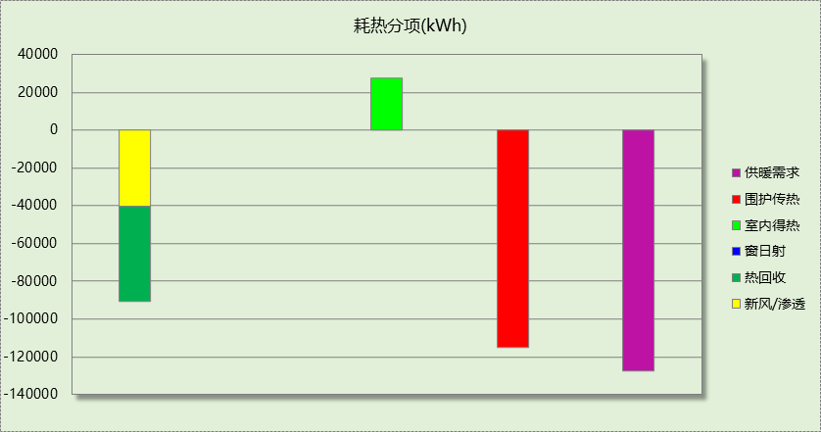

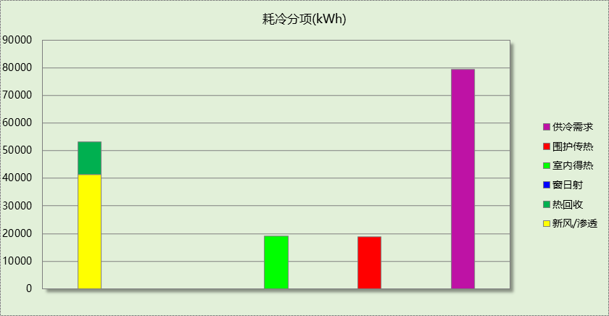

## 逐月负荷表

|  |  |  |  |  |  |  |
| --- | --- | --- | --- | --- | --- | --- |
| 月份 | 供暖(kWh) | 供冷(kWh) | 热负荷 峰值(kW) | 热负荷 峰值时刻 | 冷负荷 峰值(kW) | 冷负荷 峰值时刻 |
| 1月 | 41694 | 0 | 372.349 | 1月21日9时 | 0.000 | -- |
| 2月 | 23743 | 0 | 370.594 | 2月14日9时 | 0.000 | -- |
| 3月 | 1048 | 0 | 141.667 | 3月1日9时 | 0.000 | -- |
| 4月 | 0 | 0 | 0.000 | -- | 0.000 | -- |
| 5月 | 0 | 0 | 0.000 | -- | 0.000 | -- |
| 6月 | 0 | 0 | 0.000 | -- | 0.000 | -- |
| 7月 | 0 | 42671 | 0.000 | -- | 312.290 | 7月26日11时 |
| 8月 | 0 | 36845 | 0.000 | -- | 342.249 | 8月5日14时 |
| 9月 | 0 | 0 | 0.000 | -- | 0.000 | -- |
| 10月 | 1999 | 0 | 98.041 | 10月28日9时 | 0.000 | -- |
| 11月 | 22326 | 0 | 288.864 | 11月11日9时 | 0.000 | -- |
| 12月 | 36771 | 0 | 340.540 | 12月30日9时 | 0.000 | -- |

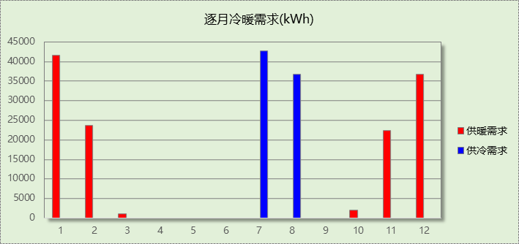

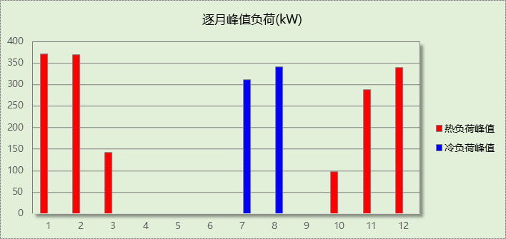

# 基准建筑

## 房间类型

### 房间参数表

|  |  |  |  |  |  |  |  |
| --- | --- | --- | --- | --- | --- | --- | --- |
| 房间类型 | 空调 温度℃ | 供暖 温度℃ | 新风量 | 渗透风 换气次数 | 人员密度 | 照明功率 密度 | 电器设备 功率 |
| 会议室 | 26 | 20 | 30(m3/h.人) | 0(次/h) | 3.33(㎡/人) | 9(W/㎡) | 5(W/㎡) |
| 卫生间 | 26 | 20 | 30(m3/h.人) | 0(次/h) | 10(㎡/人) | 8(W/㎡) | 13(W/㎡) |
| 卫生间 | 26 | 20 | 30(m3/h.人) | 0(次/h) | 10(㎡/人) | 9(W/㎡) | 13(W/㎡) |
| 卫生间 | 26 | 20 | 30(m3/h.人) | 0(次/h) | 10(㎡/人) | 9(W/㎡) | 13(W/㎡) |
| 厨房 | 26 | 20 | 30(m3/h.人) | 0(次/h) | 10(㎡/人) | 6(W/㎡) | 0(W/㎡) |
| 大厅 | 26 | 20 | 30(m3/h.人) | 0(次/h) | 10(㎡/人) | 9(W/㎡) | 13(W/㎡) |
| 展览馆 | 26 | 20 | 30(m3/h.人) | 0(次/h) | 5(㎡/人) | 9(W/㎡) | 20(W/㎡) |
| 库房 | 26 | 20 | 30(m3/h.人) | 0(次/h) | 10(㎡/人) | 9(W/㎡) | 13(W/㎡) |
| 开水间 | 26 | 20 | 30(m3/h.人) | 0(次/h) | 10(㎡/人) | 8(W/㎡) | 13(W/㎡) |
| 文印间 | 26 | 20 | 30(m3/h.人) | 0(次/h) | 10(㎡/人) | 9(W/㎡) | 13(W/㎡) |
| 楼梯间 | － | － | 20(m3/h.人) | 0(次/h) | 50(㎡/人) | 0(W/㎡) | 0(W/㎡) |
| 电子信息机房 | 26 | 20 | 30(m3/h.人) | 0(次/h) | 4(㎡/人) | 15(W/㎡) | 20(W/㎡) |
| 设备间 | － | － | 0(m3/h.人) | 0(次/h) | 0(人) | 5(W/㎡) | 0(W/㎡) |
| 走廊 | 26 | 20 | 30(m3/h.人) | 0(次/h) | 20(㎡/人) | 5(W/㎡) | 0(W/㎡) |
| 走廊 | 26 | 20 | 30(m3/h.人) | 0(次/h) | 20(㎡/人) | 9(W/㎡) | 0(W/㎡) |
| 酒吧、茶座 | 26 | 20 | 30(m3/h.人) | 0(次/h) | 2(㎡/人) | 8(W/㎡) | 0(W/㎡) |
| 餐厅 | 26 | 20 | 30(m3/h.人) | 0(次/h) | 2(㎡/人) | 9(W/㎡) | 0(W/㎡) |
| 高档办公室 | 26 | 20 | 30(m3/h.人) | 0(次/h) | 10(㎡/人) | 9(W/㎡) | 13(W/㎡) |

### 作息时间表

同设计建筑

## 系统类型

|  |  |  |  |  |  |
| --- | --- | --- | --- | --- | --- |
| 系统编号 | 系统类型 | 制冷 SEER | 制热 HSPF | 面积(㎡) | 包含的房间 |
| 默认 | 全空气定风量(CAV)机组 | － | － | 同设计建筑 | 同设计建筑 |

## 制冷系统

### 默认冷源

#### 供应的系统

|  |  |
| --- | --- |
| 系统编号 | 默认 |

#### 冷水机组

|  |  |  |  |  |  |  |  |  |
| --- | --- | --- | --- | --- | --- | --- | --- | --- |
| 名称 | 类型 | 额定 耗电量(kW) | 额定 制冷量(kW) | 额定性 能系数 (COP) | 台数 | 全年 供冷量(kWh) | 综合部分 负荷性能系数(IPLV) | 电耗 (kWh) |
| 机组1 | 水冷-螺杆式冷水机组 | 70.75 | 332.50 | 4.70 | 1 | 95541 | 5.45 | 17530 |
| 合计 | | | | | | | | 17530 |

#### 冷却水泵

|  |  |  |  |  |  |  |
| --- | --- | --- | --- | --- | --- | --- |
| 机组名称 | 冷水机组 制冷量(kW) | 机组性能 系数(COP) | 冷凝负荷(kW) | 输送能效比 | 运行时长 (h) | 水泵电耗 (kWh) |
| 机组1 | 333 | 4.70 | 403 | 0.0214 | 450 | 3883 |
| 合计 | 333 |  | 403 |  |  | 3883 |

#### 冷冻水泵

|  |  |  |  |  |
| --- | --- | --- | --- | --- |
| 机组名称 | 机组制冷量(kW) | 输送能效比 | 运行时长(h) | 水泵电耗(kWh) |
| 机组1 | 333 | 0.0241 | 450 | 3606 |
| 合计 | 333 |  |  | 3606 |

#### 冷却塔

|  |  |  |  |  |  |
| --- | --- | --- | --- | --- | --- |
| 类型 | 机组制冷量(kW) | 冷却塔风机单位 电耗制冷量(kW/kW) | 冷却塔风机 功率(kW) | 运行时长(h) | 冷却塔电耗 (kWh) |
| 冷却塔 | 333 | 170 | 1.96 | 450 | 880 |

## 供暖系统

### 默认热源

#### 供应的系统

|  |  |
| --- | --- |
| 系统编号 | 默认 |

#### 热水锅炉能耗

|  |  |  |  |  |  |  |  |
| --- | --- | --- | --- | --- | --- | --- | --- |
| 燃料类型 | 容量 (MW) | 台数 | 累计热负荷 (kWh) | 锅炉 热效率 | 外网热 输送效率 | 标准煤热值(kWh/kg) | 标准煤消耗(kgce) |
| 烟煤III | 0.25 | 1 | 152190 | 0.80 | 0.92 | 8.14 | 25402.94 |

#### 热水循环水泵能耗

|  |  |  |  |
| --- | --- | --- | --- |
| 锅炉制热量(kW) | 输送能效比 | 运行时长(h) | 供暖水泵电耗(kWh) |
| 247 | 0.00433 | 899 | 962 |

## 照明

|  |  |  |  |  |
| --- | --- | --- | --- | --- |
| 房间类型 | 单位面积电耗 (kWh/㎡) | 房间个数 | 房间合计面积 (㎡) | 合计电耗 (kWh) |
| 会议室 | 20.30 | 1 | 78 | 1578 |
| 卫生间 | 18.04 | 12 | 180 | 3256 |
| 厨房 | 21.92 | 2 | 166 | 3646 |
| 大厅 | 27.00 | 1 | 254 | 6849 |
| 展览馆 | 32.88 | 3 | 797 | 26209 |
| 库房 | 27.00 | 1 | 78 | 2100 |
| 开水间 | 18.04 | 1 | 52 | 935 |
| 文印间 | 27.00 | 1 | 17 | 466 |
| 楼梯间 | 0.00 | 8 | 119 | 0 |
| 电子信息机房 | 45.00 | 1 | 35 | 1554 |
| 设备间 | 0.00 | 1 | 17 | 0 |
| 走廊 | 15.00 | 2 | 134 | 2010 |
| 酒吧、茶座 | 29.23 | 1 | 259 | 7576 |
| 餐厅 | 32.88 | 1 | 367 | 12074 |
| 高档办公室 | 27.00 | 1 | 78 | 2100 |
| 总计 | | | | 70352 |

## 生活热水

### 热水需求

|  |  |  |  |  |  |
| --- | --- | --- | --- | --- | --- |
| 分区 | 用水定额 (L/人·d) | 热水温差(℃) | 用水人数 | 年使用天数 | 所需热量 (kWh/a) |
| 办公 | 6 | 45 | 15 | 365 | 1690 |
| 总计 | | | | | 1690 |

### 热水设备

|  |  |  |  |  |  |
| --- | --- | --- | --- | --- | --- |
| 热水设备 | 供热比例 | 供热量(kWh/a) | 能源 | 效率 | 耗气量(m3/a) |
| 锅炉 | 0.5 | 845 | 天然气 | 0.9 | 95.322 |
| 备注 |  | | | | |

|  |  |  |  |  |  |
| --- | --- | --- | --- | --- | --- |
| 热水设备 | 供热比例 | 供热量(kWh/a) | 能源 | 效率 | 耗气量(m3/a) |
| 锅炉 | 0.5 | 845 | 天然气 | 0.9 | 95.322 |
| 备注 |  | | | | |

注：

1.按照《近零能耗建筑技术标准》GB51350附录A.1.4，基准建筑生活热水热源为燃气锅炉，锅炉效率等有关参数按照《公共建筑节能设计标准》GB50189计算。

## 电梯

### 直梯

|  |  |  |  |  |  |  |  |  |
| --- | --- | --- | --- | --- | --- | --- | --- | --- |
| 名称 | 特定能量消耗(mWh/kgm) | 额定载重量(kg) | 速度(m/s) | 待机功率(W) | 运行时长(h/天) | 年运行天数 | 数量 | 全年电耗 (kWh) |
| 直梯1 | 1.26 | 1250 | 1.75 | 200 | 2 | 216 | 2 | 10474 |
| 总计 | | | | | | | | 10474 |

## 负荷分项统计

|  |  |  |  |  |  |  |
| --- | --- | --- | --- | --- | --- | --- |
| 分类 | 围护传热 | 室内得热 | 窗日射 | 新风/渗透 | 热回收 | 合计 |
| 供暖(kWh/㎡) | -32.66 | 10.22 | 0.00 | -32.84 | 0.00 | -55.28 |
| 供冷(kWh/㎡) | 6.44 | 7.76 | 0.00 | 20.49 | 0.00 | 34.70 |

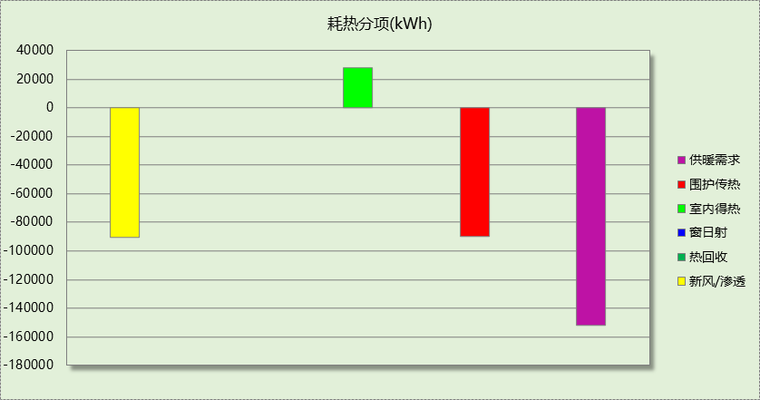

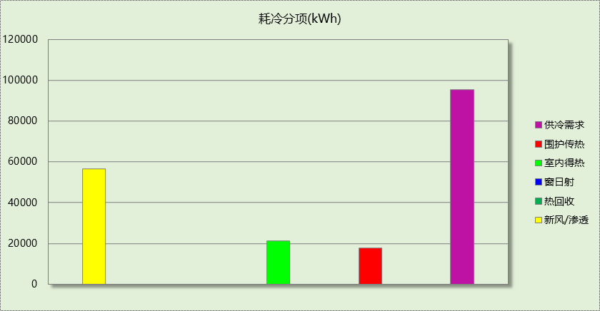

## 逐月负荷表

|  |  |  |  |  |  |  |
| --- | --- | --- | --- | --- | --- | --- |
| 月份 | 供暖(kWh) | 供冷(kWh) | 热负荷 峰值(kW) | 热负荷 峰值时刻 | 冷负荷 峰值(kW) | 冷负荷 峰值时刻 |
| 1月 | 50022 | 0 | 422.924 | 1月21日9时 | 0.000 | -- |
| 2月 | 28225 | 0 | 406.413 | 2月14日9时 | 0.000 | -- |
| 3月 | 1278 | 0 | 167.233 | 3月1日9时 | 0.000 | -- |
| 4月 | 0 | 0 | 0.000 | -- | 0.000 | -- |
| 5月 | 0 | 0 | 0.000 | -- | 0.000 | -- |
| 6月 | 0 | 0 | 0.000 | -- | 0.000 | -- |
| 7月 | 0 | 53470 | 0.000 | -- | 357.086 | 7月9日13时 |
| 8月 | 0 | 42072 | 0.000 | -- | 336.910 | 8月5日14时 |
| 9月 | 0 | 0 | 0.000 | -- | 0.000 | -- |
| 10月 | 2313 | 0 | 123.160 | 10月28日9时 | 0.000 | -- |
| 11月 | 26674 | 0 | 312.875 | 11月11日9时 | 0.000 | -- |
| 12月 | 43678 | 0 | 378.349 | 12月30日9时 | 0.000 | -- |

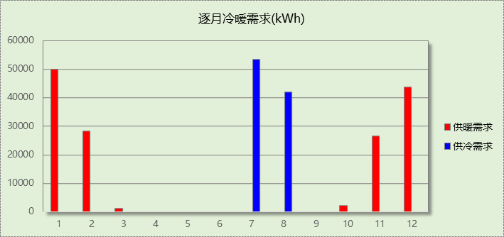

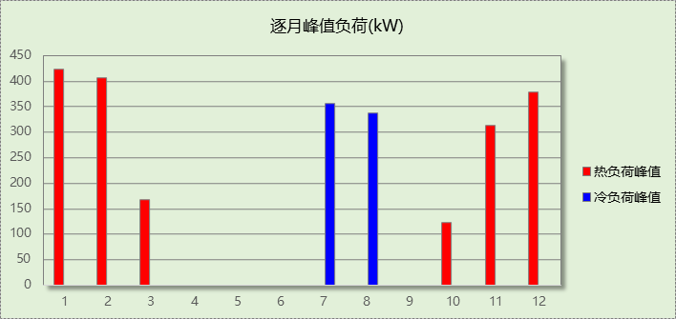

# 能效结果

## 建筑能耗

|  |  |  |  |  |
| --- | --- | --- | --- | --- |
| **设计建筑** | | | | |
| 用能分类 | | | 能耗值 | 一次能源(kWh/㎡) |
| 电力(kWh/㎡) | 供  冷 | 中央冷源 | 0.00 | 0.00 |
| 冷却水泵 | 0.00 | 0.00 |
| 冷冻水泵 | 0.00 | 0.00 |
| 冷却塔 | 0.00 | 0.00 |
| 多联机/单元式空调 | 7.22 | 18.77 |
| 供  暖 | 中央热源 | 0.00 | 0.00 |
| 供暖水泵 | 0.00 | 0.00 |
| 多联机/单元式热泵 | 11.58 | 30.11 |
| 热源侧水泵 | 0.00 | 0.00 |
| 照明 | | 24.48 | 63.65 |
| 生活热水 | | 0.34 | 0.88 |
| 电梯 | | 3.80 | 9.88 |
| 标准煤(kgce/㎡) | 供暖锅炉 | | 0.00 | 0.00 |
| 天然气(m³/㎡) | 供暖锅炉 | | 0.00 | 0.00 |
| 生活热水 | | 0.03 | 0.30 |
| 市政热力(kWh/㎡) | 市政热力 | | 0.00 | 0.00 |
| 可再生发电  (kWh/㎡) | 光伏发电 | | 53.46 | 139.00 |
| 风力发电 | | 0.18 | 0.47 |
| 建筑本体能耗(一次能源) (kWh/㎡) | | | 123.66 | |
| 建筑综合能耗(一次能源) (kWh/㎡) | | | 0.00 | |

|  |  |  |  |  |
| --- | --- | --- | --- | --- |
| **基准建筑** | | | | |
| 用能分类 | | | 能耗值 | 一次能源(kWh/㎡) |
| 电力(kWh/㎡) | 供  冷 | 中央冷源 | 6.37 | 16.56 |
| 冷却水泵 | 1.41 | 3.67 |
| 冷冻水泵 | 1.31 | 3.41 |
| 冷却塔 | 0.32 | 0.83 |
| 多联机/单元式空调 | 0.00 | 0.00 |
| 供  暖 | 中央热源 | 0.00 | 0.00 |
| 供暖水泵 | 0.35 | 0.91 |
| 多联机/单元式热泵 | 0.00 | 0.00 |
| 照明 | | 25.55 | 66.43 |
| 生活热水 | | 0.00 | 0.00 |
| 电梯 | | 3.80 | 9.88 |
| 标准煤(kgce/㎡) | 供暖锅炉 | | 9.23 | 75.13 |
| 天然气(m³/㎡) | 供暖锅炉 | | 0.00 | 0.00 |
| 生活热水 | | 0.07 | 0.69 |
| 市政热力(kWh/㎡) | 市政热力 | | 0.00 | 0.00 |
| 建筑本体能耗(一次能源) (kWh/㎡) | | | 177.48 | |
| 建筑综合能耗(一次能源) (kWh/㎡) | | | 177.48 | |

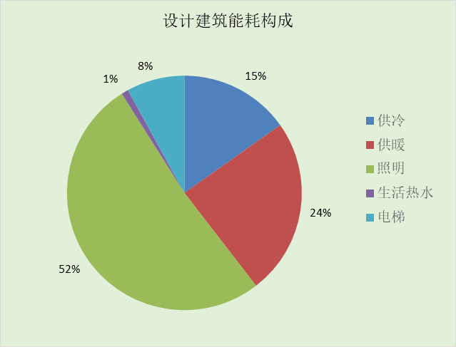

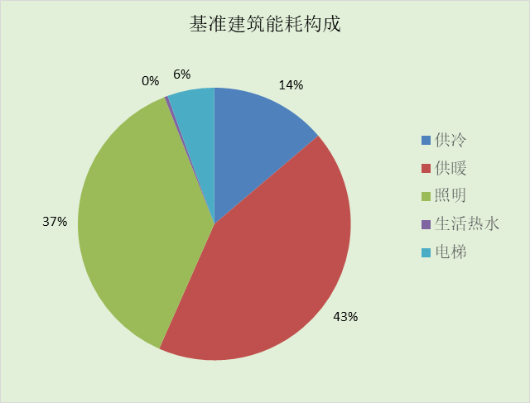

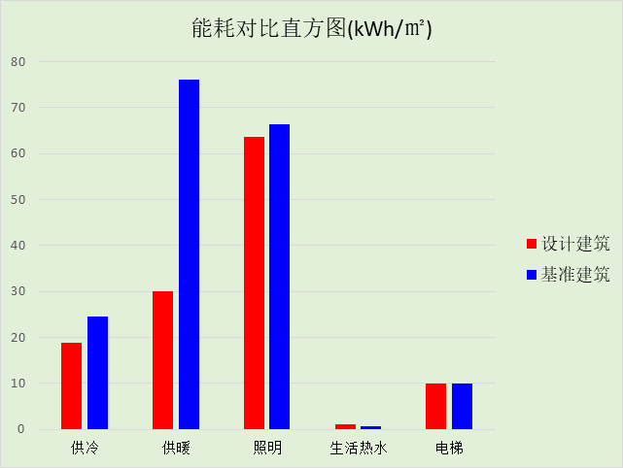

## 可再生能源利用

|  |  |  |
| --- | --- | --- |
| 能耗分项 | 需求量（电）(kWh/㎡) | 需求量（热）(kWh/㎡) |
| 耗冷量 | ­- | 28.88 |
| 耗热量 | - | 46.34 |
| 照明 | 24.48 | 63.65 |
| 空调风机 | - | - |
| 电梯 | 3.80 | 9.88 |
| 生活热水 | - | 0.61 |
| 合计 | | 149.37 |
| 可再生分项 | 可再生发电 (kWh/㎡) | 可再生利用（热）(kWh/㎡) |
| 地源\空气源供热 | - | 0.00 |
| 单体空调\多联机供热 | - | 34.76 |
| 太阳能热水 | - | 0.00 |
| 热泵热水 | - | 0.00 |
| 光伏发电 | 53.46 | 139.00 |
| 风力发电 | 0.18 | 0.47 |
| 合计 | | 174.21 |
| 可再生能源利用率(%) | 117 | |

## 结论

|  |  |  |
| --- | --- | --- |
|  | 设计建筑 | 基准建筑 |
| 建筑本体能耗(一次能源) (kWh/㎡) | 123.66 | 177.48 |
| 建筑综合能耗(一次能源) (kWh/㎡) | 0.00 | 177.48 |
|  | 值 | 限值 |
| 建筑本体能耗节能率(%) | 30.32 | 30.00 |
| 建筑综合能耗节能率(%) | 100.00 | 60.00 |
| 可再生能源利用率(%) | 117 | 10 |
| 标准依据 | 《近零能耗建筑技术标准》(GB/T51350-2019)表5.0.2 | |
| 标准要求 | 建筑本体节能率、综合节能率应符合表5.0.2 | |
| 结论 | 满足 | |

# 附录

## 工作日/节假日人员逐时在室率(%)

|  |  |  |  |  |  |  |  |  |  |  |  |  |  |  |  |  |  |  |  |  |  |  |  |  |
| --- | --- | --- | --- | --- | --- | --- | --- | --- | --- | --- | --- | --- | --- | --- | --- | --- | --- | --- | --- | --- | --- | --- | --- | --- |
| 房间类型 | 1 | 2 | 3 | 4 | 5 | 6 | 7 | 8 | 9 | 10 | 11 | 12 | 13 | 14 | 15 | 16 | 17 | 18 | 19 | 20 | 21 | 22 | 23 | 24 |
| 会议室 | 0 | 0 | 0 | 0 | 0 | 0 | 0 | 17 | 17 | 17 | 17 | 17 | 17 | 17 | 17 | 17 | 17 | 17 | 0 | 0 | 0 | 0 | 0 | 0 |
| 0 | 0 | 0 | 0 | 0 | 0 | 0 | 0 | 0 | 0 | 0 | 0 | 0 | 0 | 0 | 0 | 0 | 0 | 0 | 0 | 0 | 0 | 0 | 0 |
| 卫生间 | 0 | 0 | 0 | 0 | 0 | 0 | 0 | 33 | 33 | 33 | 33 | 33 | 33 | 33 | 33 | 33 | 33 | 33 | 0 | 0 | 0 | 0 | 0 | 0 |
| 0 | 0 | 0 | 0 | 0 | 0 | 0 | 0 | 0 | 0 | 0 | 0 | 0 | 0 | 0 | 0 | 0 | 0 | 0 | 0 | 0 | 0 | 0 | 0 |
| 卫生间 | 0 | 0 | 0 | 0 | 0 | 0 | 0 | 33 | 33 | 33 | 33 | 33 | 33 | 33 | 33 | 33 | 33 | 33 | 0 | 0 | 0 | 0 | 0 | 0 |
| 0 | 0 | 0 | 0 | 0 | 0 | 0 | 0 | 0 | 0 | 0 | 0 | 0 | 0 | 0 | 0 | 0 | 0 | 0 | 0 | 0 | 0 | 0 | 0 |
| 卫生间 | 0 | 0 | 0 | 0 | 0 | 0 | 0 | 33 | 33 | 33 | 33 | 33 | 33 | 33 | 33 | 33 | 33 | 33 | 0 | 0 | 0 | 0 | 0 | 0 |
| 0 | 0 | 0 | 0 | 0 | 0 | 0 | 0 | 0 | 0 | 0 | 0 | 0 | 0 | 0 | 0 | 0 | 0 | 0 | 0 | 0 | 0 | 0 | 0 |
| 厨房 | 0 | 0 | 0 | 0 | 0 | 0 | 0 | 0 | 28 | 28 | 28 | 28 | 28 | 28 | 28 | 28 | 28 | 28 | 28 | 28 | 28 | 0 | 0 | 0 |
| 0 | 0 | 0 | 0 | 0 | 0 | 0 | 0 | 28 | 28 | 28 | 28 | 28 | 28 | 28 | 28 | 28 | 28 | 28 | 28 | 28 | 0 | 0 | 0 |
| 大厅 | 0 | 0 | 0 | 0 | 0 | 0 | 0 | 33 | 33 | 33 | 33 | 33 | 33 | 33 | 33 | 33 | 33 | 33 | 0 | 0 | 0 | 0 | 0 | 0 |
| 0 | 0 | 0 | 0 | 0 | 0 | 0 | 0 | 0 | 0 | 0 | 0 | 0 | 0 | 0 | 0 | 0 | 0 | 0 | 0 | 0 | 0 | 0 | 0 |
| 展览馆 | 0 | 0 | 0 | 0 | 0 | 0 | 0 | 0 | 24 | 24 | 24 | 24 | 24 | 24 | 24 | 24 | 24 | 24 | 24 | 24 | 24 | 0 | 0 | 0 |
| 0 | 0 | 0 | 0 | 0 | 0 | 0 | 0 | 24 | 24 | 24 | 24 | 24 | 24 | 24 | 24 | 24 | 24 | 24 | 24 | 24 | 0 | 0 | 0 |
| 库房 | 0 | 0 | 0 | 0 | 0 | 0 | 0 | 33 | 33 | 33 | 33 | 33 | 33 | 33 | 33 | 33 | 33 | 33 | 0 | 0 | 0 | 0 | 0 | 0 |
| 0 | 0 | 0 | 0 | 0 | 0 | 0 | 0 | 0 | 0 | 0 | 0 | 0 | 0 | 0 | 0 | 0 | 0 | 0 | 0 | 0 | 0 | 0 | 0 |
| 开水间 | 0 | 0 | 0 | 0 | 0 | 0 | 0 | 33 | 33 | 33 | 33 | 33 | 33 | 33 | 33 | 33 | 33 | 33 | 0 | 0 | 0 | 0 | 0 | 0 |
| 0 | 0 | 0 | 0 | 0 | 0 | 0 | 0 | 0 | 0 | 0 | 0 | 0 | 0 | 0 | 0 | 0 | 0 | 0 | 0 | 0 | 0 | 0 | 0 |
| 文印间 | 0 | 0 | 0 | 0 | 0 | 0 | 0 | 33 | 33 | 33 | 33 | 33 | 33 | 33 | 33 | 33 | 33 | 33 | 0 | 0 | 0 | 0 | 0 | 0 |
| 0 | 0 | 0 | 0 | 0 | 0 | 0 | 0 | 0 | 0 | 0 | 0 | 0 | 0 | 0 | 0 | 0 | 0 | 0 | 0 | 0 | 0 | 0 | 0 |
| 楼梯间 | 0 | 0 | 0 | 0 | 0 | 0 | 0 | 20 | 50 | 80 | 80 | 80 | 80 | 80 | 80 | 80 | 80 | 80 | 80 | 70 | 50 | 0 | 0 | 0 |
| 0 | 0 | 0 | 0 | 0 | 0 | 0 | 20 | 50 | 80 | 80 | 80 | 80 | 80 | 80 | 80 | 80 | 80 | 80 | 70 | 50 | 0 | 0 | 0 |
| 电子信息机房 | 0 | 0 | 0 | 0 | 0 | 0 | 0 | 33 | 33 | 33 | 33 | 33 | 33 | 33 | 33 | 33 | 33 | 33 | 0 | 0 | 0 | 0 | 0 | 0 |
| 0 | 0 | 0 | 0 | 0 | 0 | 0 | 0 | 0 | 0 | 0 | 0 | 0 | 0 | 0 | 0 | 0 | 0 | 0 | 0 | 0 | 0 | 0 | 0 |
| 设备间 | 0 | 0 | 0 | 0 | 0 | 0 | 0 | 0 | 0 | 0 | 0 | 0 | 0 | 0 | 0 | 0 | 0 | 0 | 0 | 0 | 0 | 0 | 0 | 0 |
| 0 | 0 | 0 | 0 | 0 | 0 | 0 | 0 | 0 | 0 | 0 | 0 | 0 | 0 | 0 | 0 | 0 | 0 | 0 | 0 | 0 | 0 | 0 | 0 |
| 走廊 | 0 | 0 | 0 | 0 | 0 | 0 | 0 | 33 | 33 | 33 | 33 | 33 | 33 | 33 | 33 | 33 | 33 | 33 | 0 | 0 | 0 | 0 | 0 | 0 |
| 0 | 0 | 0 | 0 | 0 | 0 | 0 | 0 | 0 | 0 | 0 | 0 | 0 | 0 | 0 | 0 | 0 | 0 | 0 | 0 | 0 | 0 | 0 | 0 |
| 走廊 | 55 | 55 | 55 | 55 | 55 | 55 | 55 | 55 | 55 | 55 | 55 | 55 | 55 | 55 | 55 | 55 | 55 | 55 | 55 | 55 | 55 | 55 | 55 | 55 |
| 0 | 0 | 0 | 0 | 0 | 0 | 0 | 0 | 0 | 0 | 0 | 0 | 0 | 0 | 0 | 0 | 0 | 0 | 0 | 0 | 0 | 0 | 0 | 0 |
| 酒吧、茶座 | 0 | 0 | 0 | 0 | 0 | 0 | 0 | 0 | 37 | 37 | 37 | 37 | 37 | 37 | 37 | 37 | 37 | 37 | 37 | 37 | 37 | 0 | 0 | 0 |
| 0 | 0 | 0 | 0 | 0 | 0 | 0 | 0 | 37 | 37 | 37 | 37 | 37 | 37 | 37 | 37 | 37 | 37 | 37 | 37 | 37 | 0 | 0 | 0 |
| 餐厅 | 0 | 0 | 0 | 0 | 0 | 0 | 0 | 0 | 28 | 28 | 28 | 28 | 28 | 28 | 28 | 28 | 28 | 28 | 28 | 28 | 28 | 0 | 0 | 0 |
| 0 | 0 | 0 | 0 | 0 | 0 | 0 | 0 | 28 | 28 | 28 | 28 | 28 | 28 | 28 | 28 | 28 | 28 | 28 | 28 | 28 | 0 | 0 | 0 |
| 高档办公室 | 0 | 0 | 0 | 0 | 0 | 0 | 0 | 33 | 33 | 33 | 33 | 33 | 33 | 33 | 33 | 33 | 33 | 33 | 0 | 0 | 0 | 0 | 0 | 0 |
| 0 | 0 | 0 | 0 | 0 | 0 | 0 | 0 | 0 | 0 | 0 | 0 | 0 | 0 | 0 | 0 | 0 | 0 | 0 | 0 | 0 | 0 | 0 | 0 |

注：上行：工作日；下行：节假日

## 工作日/节假日照明开关时间表(%)

|  |  |  |  |  |  |  |  |  |  |  |  |  |  |  |  |  |  |  |  |  |  |  |  |  |
| --- | --- | --- | --- | --- | --- | --- | --- | --- | --- | --- | --- | --- | --- | --- | --- | --- | --- | --- | --- | --- | --- | --- | --- | --- |
| 房间类型 | 1 | 2 | 3 | 4 | 5 | 6 | 7 | 8 | 9 | 10 | 11 | 12 | 13 | 14 | 15 | 16 | 17 | 18 | 19 | 20 | 21 | 22 | 23 | 24 |
| 会议室 | 0 | 0 | 0 | 0 | 0 | 0 | 0 | 82 | 82 | 82 | 82 | 82 | 82 | 82 | 82 | 82 | 82 | 82 | 0 | 0 | 0 | 0 | 0 | 0 |
| 0 | 0 | 0 | 0 | 0 | 0 | 0 | 0 | 0 | 0 | 0 | 0 | 0 | 0 | 0 | 0 | 0 | 0 | 0 | 0 | 0 | 0 | 0 | 0 |
| 卫生间 | 0 | 0 | 0 | 0 | 0 | 0 | 0 | 82 | 82 | 82 | 82 | 82 | 82 | 82 | 82 | 82 | 82 | 82 | 0 | 0 | 0 | 0 | 0 | 0 |
| 0 | 0 | 0 | 0 | 0 | 0 | 0 | 0 | 0 | 0 | 0 | 0 | 0 | 0 | 0 | 0 | 0 | 0 | 0 | 0 | 0 | 0 | 0 | 0 |
| 卫生间 | 0 | 0 | 0 | 0 | 0 | 0 | 0 | 100 | 100 | 100 | 100 | 100 | 100 | 100 | 100 | 100 | 100 | 100 | 100 | 0 | 0 | 0 | 0 | 0 |
| 0 | 0 | 0 | 0 | 0 | 0 | 0 | 0 | 0 | 0 | 0 | 0 | 0 | 0 | 0 | 0 | 0 | 0 | 0 | 0 | 0 | 0 | 0 | 0 |
| 卫生间 | 0 | 0 | 0 | 0 | 0 | 0 | 0 | 100 | 100 | 100 | 100 | 100 | 100 | 100 | 100 | 100 | 100 | 100 | 100 | 0 | 0 | 0 | 0 | 0 |
| 0 | 0 | 0 | 0 | 0 | 0 | 0 | 0 | 0 | 0 | 0 | 0 | 0 | 0 | 0 | 0 | 0 | 0 | 0 | 0 | 0 | 0 | 0 | 0 |
| 厨房 | 0 | 0 | 0 | 0 | 0 | 0 | 0 | 0 | 77 | 77 | 77 | 77 | 77 | 77 | 77 | 77 | 77 | 77 | 77 | 77 | 77 | 0 | 0 | 0 |
| 0 | 0 | 0 | 0 | 0 | 0 | 0 | 0 | 77 | 77 | 77 | 77 | 77 | 77 | 77 | 77 | 77 | 77 | 77 | 77 | 77 | 0 | 0 | 0 |
| 大厅 | 0 | 0 | 0 | 0 | 0 | 0 | 0 | 100 | 100 | 100 | 100 | 100 | 100 | 100 | 100 | 100 | 100 | 100 | 100 | 0 | 0 | 0 | 0 | 0 |
| 0 | 0 | 0 | 0 | 0 | 0 | 0 | 0 | 0 | 0 | 0 | 0 | 0 | 0 | 0 | 0 | 0 | 0 | 0 | 0 | 0 | 0 | 0 | 0 |
| 展览馆 | 0 | 0 | 0 | 0 | 0 | 0 | 0 | 0 | 77 | 77 | 77 | 77 | 77 | 77 | 77 | 77 | 77 | 77 | 77 | 77 | 77 | 0 | 0 | 0 |
| 0 | 0 | 0 | 0 | 0 | 0 | 0 | 0 | 77 | 77 | 77 | 77 | 77 | 77 | 77 | 77 | 77 | 77 | 77 | 77 | 77 | 0 | 0 | 0 |
| 库房 | 0 | 0 | 0 | 0 | 0 | 0 | 0 | 100 | 100 | 100 | 100 | 100 | 100 | 100 | 100 | 100 | 100 | 100 | 100 | 0 | 0 | 0 | 0 | 0 |
| 0 | 0 | 0 | 0 | 0 | 0 | 0 | 0 | 0 | 0 | 0 | 0 | 0 | 0 | 0 | 0 | 0 | 0 | 0 | 0 | 0 | 0 | 0 | 0 |
| 开水间 | 0 | 0 | 0 | 0 | 0 | 0 | 0 | 82 | 82 | 82 | 82 | 82 | 82 | 82 | 82 | 82 | 82 | 82 | 0 | 0 | 0 | 0 | 0 | 0 |
| 0 | 0 | 0 | 0 | 0 | 0 | 0 | 0 | 0 | 0 | 0 | 0 | 0 | 0 | 0 | 0 | 0 | 0 | 0 | 0 | 0 | 0 | 0 | 0 |
| 文印间 | 0 | 0 | 0 | 0 | 0 | 0 | 0 | 100 | 100 | 100 | 100 | 100 | 100 | 100 | 100 | 100 | 100 | 100 | 100 | 0 | 0 | 0 | 0 | 0 |
| 0 | 0 | 0 | 0 | 0 | 0 | 0 | 0 | 0 | 0 | 0 | 0 | 0 | 0 | 0 | 0 | 0 | 0 | 0 | 0 | 0 | 0 | 0 | 0 |
| 楼梯间 | 10 | 10 | 10 | 10 | 10 | 10 | 10 | 50 | 60 | 60 | 60 | 60 | 60 | 60 | 60 | 60 | 80 | 90 | 100 | 100 | 100 | 10 | 10 | 10 |
| 10 | 10 | 10 | 10 | 10 | 10 | 10 | 50 | 60 | 60 | 60 | 60 | 60 | 60 | 60 | 60 | 80 | 90 | 100 | 100 | 100 | 10 | 10 | 10 |
| 电子信息机房 | 0 | 0 | 0 | 0 | 0 | 0 | 0 | 100 | 100 | 100 | 100 | 100 | 100 | 100 | 100 | 100 | 100 | 100 | 100 | 0 | 0 | 0 | 0 | 0 |
| 0 | 0 | 0 | 0 | 0 | 0 | 0 | 0 | 0 | 0 | 0 | 0 | 0 | 0 | 0 | 0 | 0 | 0 | 0 | 0 | 0 | 0 | 0 | 0 |
| 设备间 | 0 | 0 | 0 | 0 | 0 | 0 | 0 | 0 | 0 | 0 | 0 | 0 | 0 | 0 | 0 | 0 | 0 | 0 | 0 | 0 | 0 | 0 | 0 | 0 |
| 0 | 0 | 0 | 0 | 0 | 0 | 0 | 0 | 0 | 0 | 0 | 0 | 0 | 0 | 0 | 0 | 0 | 0 | 0 | 0 | 0 | 0 | 0 | 0 |
| 走廊 | 0 | 0 | 0 | 0 | 0 | 0 | 0 | 100 | 100 | 100 | 100 | 100 | 100 | 100 | 100 | 100 | 100 | 100 | 100 | 0 | 0 | 0 | 0 | 0 |
| 0 | 0 | 0 | 0 | 0 | 0 | 0 | 0 | 0 | 0 | 0 | 0 | 0 | 0 | 0 | 0 | 0 | 0 | 0 | 0 | 0 | 0 | 0 | 0 |
| 走廊 | 42 | 42 | 42 | 42 | 42 | 42 | 42 | 42 | 42 | 42 | 42 | 42 | 42 | 42 | 42 | 42 | 42 | 42 | 42 | 42 | 42 | 42 | 42 | 42 |
| 0 | 0 | 0 | 0 | 0 | 0 | 0 | 0 | 0 | 0 | 0 | 0 | 0 | 0 | 0 | 0 | 0 | 0 | 0 | 0 | 0 | 0 | 0 | 0 |
| 酒吧、茶座 | 0 | 0 | 0 | 0 | 0 | 0 | 0 | 0 | 77 | 77 | 77 | 77 | 77 | 77 | 77 | 77 | 77 | 77 | 77 | 77 | 77 | 0 | 0 | 0 |
| 0 | 0 | 0 | 0 | 0 | 0 | 0 | 0 | 77 | 77 | 77 | 77 | 77 | 77 | 77 | 77 | 77 | 77 | 77 | 77 | 77 | 0 | 0 | 0 |
| 餐厅 | 0 | 0 | 0 | 0 | 0 | 0 | 0 | 0 | 77 | 77 | 77 | 77 | 77 | 77 | 77 | 77 | 77 | 77 | 77 | 77 | 77 | 0 | 0 | 0 |
| 0 | 0 | 0 | 0 | 0 | 0 | 0 | 0 | 77 | 77 | 77 | 77 | 77 | 77 | 77 | 77 | 77 | 77 | 77 | 77 | 77 | 0 | 0 | 0 |
| 高档办公室 | 0 | 0 | 0 | 0 | 0 | 0 | 0 | 100 | 100 | 100 | 100 | 100 | 100 | 100 | 100 | 100 | 100 | 100 | 100 | 0 | 0 | 0 | 0 | 0 |
| 0 | 0 | 0 | 0 | 0 | 0 | 0 | 0 | 0 | 0 | 0 | 0 | 0 | 0 | 0 | 0 | 0 | 0 | 0 | 0 | 0 | 0 | 0 | 0 |

注：上行：工作日；下行：节假日

## 工作日/节假日设备逐时使用率(%)

|  |  |  |  |  |  |  |  |  |  |  |  |  |  |  |  |  |  |  |  |  |  |  |  |  |
| --- | --- | --- | --- | --- | --- | --- | --- | --- | --- | --- | --- | --- | --- | --- | --- | --- | --- | --- | --- | --- | --- | --- | --- | --- |
| 房间类型 | 1 | 2 | 3 | 4 | 5 | 6 | 7 | 8 | 9 | 10 | 11 | 12 | 13 | 14 | 15 | 16 | 17 | 18 | 19 | 20 | 21 | 22 | 23 | 24 |
| 会议室 | 0 | 0 | 0 | 0 | 0 | 0 | 0 | 62 | 62 | 62 | 62 | 62 | 62 | 62 | 62 | 62 | 62 | 62 | 0 | 0 | 0 | 0 | 0 | 0 |
| 0 | 0 | 0 | 0 | 0 | 0 | 0 | 0 | 0 | 0 | 0 | 0 | 0 | 0 | 0 | 0 | 0 | 0 | 0 | 0 | 0 | 0 | 0 | 0 |
| 卫生间 | 0 | 0 | 0 | 0 | 0 | 0 | 0 | 33 | 33 | 33 | 33 | 33 | 33 | 33 | 33 | 33 | 33 | 33 | 0 | 0 | 0 | 0 | 0 | 0 |
| 0 | 0 | 0 | 0 | 0 | 0 | 0 | 0 | 0 | 0 | 0 | 0 | 0 | 0 | 0 | 0 | 0 | 0 | 0 | 0 | 0 | 0 | 0 | 0 |
| 卫生间 | 0 | 0 | 0 | 0 | 0 | 0 | 0 | 33 | 33 | 33 | 33 | 33 | 33 | 33 | 33 | 33 | 33 | 33 | 0 | 0 | 0 | 0 | 0 | 0 |
| 0 | 0 | 0 | 0 | 0 | 0 | 0 | 0 | 0 | 0 | 0 | 0 | 0 | 0 | 0 | 0 | 0 | 0 | 0 | 0 | 0 | 0 | 0 | 0 |
| 卫生间 | 0 | 0 | 0 | 0 | 0 | 0 | 0 | 33 | 33 | 33 | 33 | 33 | 33 | 33 | 33 | 33 | 33 | 33 | 0 | 0 | 0 | 0 | 0 | 0 |
| 0 | 0 | 0 | 0 | 0 | 0 | 0 | 0 | 0 | 0 | 0 | 0 | 0 | 0 | 0 | 0 | 0 | 0 | 0 | 0 | 0 | 0 | 0 | 0 |
| 厨房 | 0 | 0 | 0 | 0 | 0 | 0 | 0 | 0 | 0 | 0 | 0 | 0 | 0 | 0 | 0 | 0 | 0 | 0 | 0 | 0 | 0 | 0 | 0 | 0 |
| 0 | 0 | 0 | 0 | 0 | 0 | 0 | 0 | 0 | 0 | 0 | 0 | 0 | 0 | 0 | 0 | 0 | 0 | 0 | 0 | 0 | 0 | 0 | 0 |
| 大厅 | 0 | 0 | 0 | 0 | 0 | 0 | 0 | 33 | 33 | 33 | 33 | 33 | 33 | 33 | 33 | 33 | 33 | 33 | 0 | 0 | 0 | 0 | 0 | 0 |
| 0 | 0 | 0 | 0 | 0 | 0 | 0 | 0 | 0 | 0 | 0 | 0 | 0 | 0 | 0 | 0 | 0 | 0 | 0 | 0 | 0 | 0 | 0 | 0 |
| 展览馆 | 0 | 0 | 0 | 0 | 0 | 0 | 0 | 0 | 42 | 42 | 42 | 42 | 42 | 42 | 42 | 42 | 42 | 42 | 42 | 42 | 42 | 0 | 0 | 0 |
| 0 | 0 | 0 | 0 | 0 | 0 | 0 | 0 | 42 | 42 | 42 | 42 | 42 | 42 | 42 | 42 | 42 | 42 | 42 | 42 | 42 | 0 | 0 | 0 |
| 库房 | 0 | 0 | 0 | 0 | 0 | 0 | 0 | 33 | 33 | 33 | 33 | 33 | 33 | 33 | 33 | 33 | 33 | 33 | 0 | 0 | 0 | 0 | 0 | 0 |
| 0 | 0 | 0 | 0 | 0 | 0 | 0 | 0 | 0 | 0 | 0 | 0 | 0 | 0 | 0 | 0 | 0 | 0 | 0 | 0 | 0 | 0 | 0 | 0 |
| 开水间 | 0 | 0 | 0 | 0 | 0 | 0 | 0 | 33 | 33 | 33 | 33 | 33 | 33 | 33 | 33 | 33 | 33 | 33 | 0 | 0 | 0 | 0 | 0 | 0 |
| 0 | 0 | 0 | 0 | 0 | 0 | 0 | 0 | 0 | 0 | 0 | 0 | 0 | 0 | 0 | 0 | 0 | 0 | 0 | 0 | 0 | 0 | 0 | 0 |
| 文印间 | 0 | 0 | 0 | 0 | 0 | 0 | 0 | 33 | 33 | 33 | 33 | 33 | 33 | 33 | 33 | 33 | 33 | 33 | 0 | 0 | 0 | 0 | 0 | 0 |
| 0 | 0 | 0 | 0 | 0 | 0 | 0 | 0 | 0 | 0 | 0 | 0 | 0 | 0 | 0 | 0 | 0 | 0 | 0 | 0 | 0 | 0 | 0 | 0 |
| 楼梯间 | 0 | 0 | 0 | 0 | 0 | 0 | 0 | 30 | 50 | 80 | 80 | 80 | 80 | 80 | 80 | 80 | 80 | 80 | 80 | 70 | 50 | 0 | 0 | 0 |
| 0 | 0 | 0 | 0 | 0 | 0 | 0 | 30 | 50 | 80 | 80 | 80 | 80 | 80 | 80 | 80 | 80 | 80 | 80 | 70 | 50 | 0 | 0 | 0 |
| 电子信息机房 | 0 | 0 | 0 | 0 | 0 | 0 | 0 | 33 | 33 | 33 | 33 | 33 | 33 | 33 | 33 | 33 | 33 | 33 | 0 | 0 | 0 | 0 | 0 | 0 |
| 0 | 0 | 0 | 0 | 0 | 0 | 0 | 0 | 0 | 0 | 0 | 0 | 0 | 0 | 0 | 0 | 0 | 0 | 0 | 0 | 0 | 0 | 0 | 0 |
| 设备间 | 0 | 0 | 0 | 0 | 0 | 0 | 0 | 0 | 0 | 0 | 0 | 0 | 0 | 0 | 0 | 0 | 0 | 0 | 0 | 0 | 0 | 0 | 0 | 0 |
| 0 | 0 | 0 | 0 | 0 | 0 | 0 | 0 | 0 | 0 | 0 | 0 | 0 | 0 | 0 | 0 | 0 | 0 | 0 | 0 | 0 | 0 | 0 | 0 |
| 走廊 | 0 | 0 | 0 | 0 | 0 | 0 | 0 | 0 | 0 | 0 | 0 | 0 | 0 | 0 | 0 | 0 | 0 | 0 | 0 | 0 | 0 | 0 | 0 | 0 |
| 0 | 0 | 0 | 0 | 0 | 0 | 0 | 0 | 0 | 0 | 0 | 0 | 0 | 0 | 0 | 0 | 0 | 0 | 0 | 0 | 0 | 0 | 0 | 0 |
| 走廊 | 0 | 0 | 0 | 0 | 0 | 0 | 0 | 0 | 0 | 0 | 0 | 0 | 0 | 0 | 0 | 0 | 0 | 0 | 0 | 0 | 0 | 0 | 0 | 0 |
| 0 | 0 | 0 | 0 | 0 | 0 | 0 | 0 | 0 | 0 | 0 | 0 | 0 | 0 | 0 | 0 | 0 | 0 | 0 | 0 | 0 | 0 | 0 | 0 |
| 酒吧、茶座 | 0 | 0 | 0 | 0 | 0 | 0 | 0 | 0 | 0 | 0 | 0 | 0 | 0 | 0 | 0 | 0 | 0 | 0 | 0 | 0 | 0 | 0 | 0 | 0 |
| 0 | 0 | 0 | 0 | 0 | 0 | 0 | 0 | 0 | 0 | 0 | 0 | 0 | 0 | 0 | 0 | 0 | 0 | 0 | 0 | 0 | 0 | 0 | 0 |
| 餐厅 | 0 | 0 | 0 | 0 | 0 | 0 | 0 | 0 | 0 | 0 | 0 | 0 | 0 | 0 | 0 | 0 | 0 | 0 | 0 | 0 | 0 | 0 | 0 | 0 |
| 0 | 0 | 0 | 0 | 0 | 0 | 0 | 0 | 0 | 0 | 0 | 0 | 0 | 0 | 0 | 0 | 0 | 0 | 0 | 0 | 0 | 0 | 0 | 0 |
| 高档办公室 | 0 | 0 | 0 | 0 | 0 | 0 | 0 | 33 | 33 | 33 | 33 | 33 | 33 | 33 | 33 | 33 | 33 | 33 | 0 | 0 | 0 | 0 | 0 | 0 |
| 0 | 0 | 0 | 0 | 0 | 0 | 0 | 0 | 0 | 0 | 0 | 0 | 0 | 0 | 0 | 0 | 0 | 0 | 0 | 0 | 0 | 0 | 0 | 0 |

注：上行：工作日；下行：节假日

## 工作日/节假日空调系统运行时间表(1:开,0:关)

采暖期：

|  |  |  |  |  |  |  |  |  |  |  |  |  |  |  |  |  |  |  |  |  |  |  |  |  |
| --- | --- | --- | --- | --- | --- | --- | --- | --- | --- | --- | --- | --- | --- | --- | --- | --- | --- | --- | --- | --- | --- | --- | --- | --- |
| 系统编号 | 1 | 2 | 3 | 4 | 5 | 6 | 7 | 8 | 9 | 10 | 11 | 12 | 13 | 14 | 15 | 16 | 17 | 18 | 19 | 20 | 21 | 22 | 23 | 24 |
| 默认 | 0 | 0 | 0 | 0 | 0 | 0 | 0 | 1 | 1 | 1 | 1 | 1 | 1 | 1 | 1 | 1 | 1 | 0 | 0 | 0 | 0 | 0 | 0 | 0 |
| 0 | 0 | 0 | 0 | 0 | 0 | 0 | 0 | 0 | 0 | 0 | 0 | 0 | 0 | 0 | 0 | 0 | 0 | 0 | 0 | 0 | 0 | 0 | 0 |

供冷期：

|  |  |  |  |  |  |  |  |  |  |  |  |  |  |  |  |  |  |  |  |  |  |  |  |  |
| --- | --- | --- | --- | --- | --- | --- | --- | --- | --- | --- | --- | --- | --- | --- | --- | --- | --- | --- | --- | --- | --- | --- | --- | --- |
| 系统编号 | 1 | 2 | 3 | 4 | 5 | 6 | 7 | 8 | 9 | 10 | 11 | 12 | 13 | 14 | 15 | 16 | 17 | 18 | 19 | 20 | 21 | 22 | 23 | 24 |
| 默认 | 0 | 0 | 0 | 0 | 0 | 0 | 0 | 1 | 1 | 1 | 1 | 1 | 1 | 1 | 1 | 1 | 1 | 0 | 0 | 0 | 0 | 0 | 0 | 0 |
| 0 | 0 | 0 | 0 | 0 | 0 | 0 | 0 | 0 | 0 | 0 | 0 | 0 | 0 | 0 | 0 | 0 | 0 | 0 | 0 | 0 | 0 | 0 | 0 |

注：上行：工作日；下行：节假日

## 工作日/节假日新风运行时间表(%)

|  |  |  |  |  |  |  |  |  |  |  |  |  |  |  |  |  |  |  |  |  |  |  |  |  |
| --- | --- | --- | --- | --- | --- | --- | --- | --- | --- | --- | --- | --- | --- | --- | --- | --- | --- | --- | --- | --- | --- | --- | --- | --- |
| 房间类型 | 1 | 2 | 3 | 4 | 5 | 6 | 7 | 8 | 9 | 10 | 11 | 12 | 13 | 14 | 15 | 16 | 17 | 18 | 19 | 20 | 21 | 22 | 23 | 24 |
| 会议室 | 0 | 0 | 0 | 0 | 0 | 0 | 100 | 100 | 100 | 100 | 100 | 100 | 100 | 100 | 100 | 100 | 100 | 100 | 0 | 0 | 0 | 0 | 0 | 0 |
| 0 | 0 | 0 | 0 | 0 | 0 | 0 | 0 | 0 | 0 | 0 | 0 | 0 | 0 | 0 | 0 | 0 | 0 | 0 | 0 | 0 | 0 | 0 | 0 |
| 卫生间 | 100 | 100 | 100 | 100 | 100 | 100 | 100 | 100 | 100 | 100 | 100 | 100 | 100 | 100 | 100 | 100 | 100 | 100 | 100 | 100 | 100 | 100 | 100 | 100 |
| 0 | 0 | 0 | 0 | 0 | 0 | 0 | 0 | 0 | 0 | 0 | 0 | 0 | 0 | 0 | 0 | 0 | 0 | 0 | 0 | 0 | 0 | 0 | 0 |
| 卫生间 | 0 | 0 | 0 | 0 | 0 | 0 | 100 | 100 | 100 | 100 | 100 | 100 | 100 | 100 | 100 | 100 | 100 | 100 | 0 | 0 | 0 | 0 | 0 | 0 |
| 0 | 0 | 0 | 0 | 0 | 0 | 0 | 0 | 0 | 0 | 0 | 0 | 0 | 0 | 0 | 0 | 0 | 0 | 0 | 0 | 0 | 0 | 0 | 0 |
| 卫生间 | 0 | 0 | 0 | 0 | 0 | 0 | 100 | 100 | 100 | 100 | 100 | 100 | 100 | 100 | 100 | 100 | 100 | 100 | 0 | 0 | 0 | 0 | 0 | 0 |
| 0 | 0 | 0 | 0 | 0 | 0 | 0 | 0 | 0 | 0 | 0 | 0 | 0 | 0 | 0 | 0 | 0 | 0 | 0 | 0 | 0 | 0 | 0 | 0 |
| 厨房 | 0 | 0 | 0 | 0 | 0 | 0 | 0 | 100 | 100 | 100 | 100 | 100 | 100 | 100 | 100 | 100 | 100 | 100 | 100 | 100 | 100 | 0 | 0 | 0 |
| 0 | 0 | 0 | 0 | 0 | 0 | 0 | 100 | 100 | 100 | 100 | 100 | 100 | 100 | 100 | 100 | 100 | 100 | 100 | 100 | 100 | 0 | 0 | 0 |
| 大厅 | 0 | 0 | 0 | 0 | 0 | 0 | 100 | 100 | 100 | 100 | 100 | 100 | 100 | 100 | 100 | 100 | 100 | 100 | 0 | 0 | 0 | 0 | 0 | 0 |
| 0 | 0 | 0 | 0 | 0 | 0 | 0 | 0 | 0 | 0 | 0 | 0 | 0 | 0 | 0 | 0 | 0 | 0 | 0 | 0 | 0 | 0 | 0 | 0 |
| 展览馆 | 0 | 0 | 0 | 0 | 0 | 0 | 0 | 100 | 100 | 100 | 100 | 100 | 100 | 100 | 100 | 100 | 100 | 100 | 100 | 100 | 100 | 0 | 0 | 0 |
| 0 | 0 | 0 | 0 | 0 | 0 | 0 | 100 | 100 | 100 | 100 | 100 | 100 | 100 | 100 | 100 | 100 | 100 | 100 | 100 | 100 | 0 | 0 | 0 |
| 库房 | 0 | 0 | 0 | 0 | 0 | 0 | 100 | 100 | 100 | 100 | 100 | 100 | 100 | 100 | 100 | 100 | 100 | 100 | 0 | 0 | 0 | 0 | 0 | 0 |
| 0 | 0 | 0 | 0 | 0 | 0 | 0 | 0 | 0 | 0 | 0 | 0 | 0 | 0 | 0 | 0 | 0 | 0 | 0 | 0 | 0 | 0 | 0 | 0 |
| 开水间 | 100 | 100 | 100 | 100 | 100 | 100 | 100 | 100 | 100 | 100 | 100 | 100 | 100 | 100 | 100 | 100 | 100 | 100 | 100 | 100 | 100 | 100 | 100 | 100 |
| 0 | 0 | 0 | 0 | 0 | 0 | 0 | 0 | 0 | 0 | 0 | 0 | 0 | 0 | 0 | 0 | 0 | 0 | 0 | 0 | 0 | 0 | 0 | 0 |
| 文印间 | 0 | 0 | 0 | 0 | 0 | 0 | 100 | 100 | 100 | 100 | 100 | 100 | 100 | 100 | 100 | 100 | 100 | 100 | 0 | 0 | 0 | 0 | 0 | 0 |
| 0 | 0 | 0 | 0 | 0 | 0 | 0 | 0 | 0 | 0 | 0 | 0 | 0 | 0 | 0 | 0 | 0 | 0 | 0 | 0 | 0 | 0 | 0 | 0 |
| 楼梯间 | 0 | 0 | 0 | 0 | 0 | 0 | 0 | 100 | 100 | 100 | 100 | 100 | 100 | 100 | 100 | 100 | 100 | 100 | 100 | 100 | 100 | 0 | 0 | 0 |
| 0 | 0 | 0 | 0 | 0 | 0 | 0 | 100 | 100 | 100 | 100 | 100 | 100 | 100 | 100 | 100 | 100 | 100 | 100 | 100 | 100 | 0 | 0 | 0 |
| 电子信息机房 | 0 | 0 | 0 | 0 | 0 | 0 | 100 | 100 | 100 | 100 | 100 | 100 | 100 | 100 | 100 | 100 | 100 | 100 | 0 | 0 | 0 | 0 | 0 | 0 |
| 0 | 0 | 0 | 0 | 0 | 0 | 0 | 0 | 0 | 0 | 0 | 0 | 0 | 0 | 0 | 0 | 0 | 0 | 0 | 0 | 0 | 0 | 0 | 0 |
| 设备间 | 0 | 0 | 0 | 0 | 0 | 0 | 100 | 100 | 100 | 100 | 100 | 100 | 100 | 100 | 100 | 100 | 100 | 100 | 0 | 0 | 0 | 0 | 0 | 0 |
| 0 | 0 | 0 | 0 | 0 | 0 | 0 | 0 | 0 | 0 | 0 | 0 | 0 | 0 | 0 | 0 | 0 | 0 | 0 | 0 | 0 | 0 | 0 | 0 |
| 走廊 | 0 | 0 | 0 | 0 | 0 | 0 | 100 | 100 | 100 | 100 | 100 | 100 | 100 | 100 | 100 | 100 | 100 | 100 | 0 | 0 | 0 | 0 | 0 | 0 |
| 0 | 0 | 0 | 0 | 0 | 0 | 0 | 0 | 0 | 0 | 0 | 0 | 0 | 0 | 0 | 0 | 0 | 0 | 0 | 0 | 0 | 0 | 0 | 0 |
| 走廊 | 0 | 0 | 0 | 0 | 0 | 0 | 0 | 100 | 100 | 100 | 100 | 100 | 100 | 100 | 100 | 100 | 100 | 100 | 100 | 100 | 100 | 0 | 0 | 0 |
| 0 | 0 | 0 | 0 | 0 | 0 | 0 | 0 | 0 | 0 | 0 | 0 | 0 | 0 | 0 | 0 | 0 | 0 | 0 | 0 | 0 | 0 | 0 | 0 |
| 酒吧、茶座 | 0 | 0 | 0 | 0 | 0 | 0 | 0 | 100 | 100 | 100 | 100 | 100 | 100 | 100 | 100 | 100 | 100 | 100 | 100 | 100 | 100 | 0 | 0 | 0 |
| 0 | 0 | 0 | 0 | 0 | 0 | 0 | 100 | 100 | 100 | 100 | 100 | 100 | 100 | 100 | 100 | 100 | 100 | 100 | 100 | 100 | 0 | 0 | 0 |
| 餐厅 | 0 | 0 | 0 | 0 | 0 | 0 | 0 | 100 | 100 | 100 | 100 | 100 | 100 | 100 | 100 | 100 | 100 | 100 | 100 | 100 | 100 | 0 | 0 | 0 |
| 0 | 0 | 0 | 0 | 0 | 0 | 0 | 100 | 100 | 100 | 100 | 100 | 100 | 100 | 100 | 100 | 100 | 100 | 100 | 100 | 100 | 0 | 0 | 0 |
| 高档办公室 | 0 | 0 | 0 | 0 | 0 | 0 | 100 | 100 | 100 | 100 | 100 | 100 | 100 | 100 | 100 | 100 | 100 | 100 | 0 | 0 | 0 | 0 | 0 | 0 |
| 0 | 0 | 0 | 0 | 0 | 0 | 0 | 0 | 0 | 0 | 0 | 0 | 0 | 0 | 0 | 0 | 0 | 0 | 0 | 0 | 0 | 0 | 0 | 0 |

注：上行：工作日；下行：节假日