空调房间：东向逐时温度
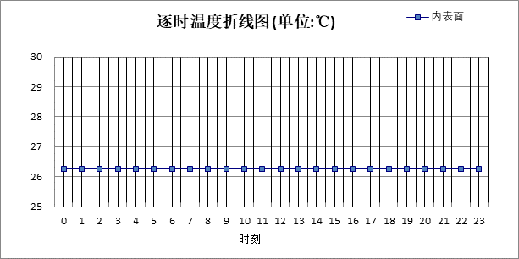

0:00 | 1:00 | 2:00 | 3:00 | 4:00 | 5:00 | 6:00 | 7:00 | 8:00 | 9:00 | 10:00 | 11:00
26.26 | 26.26 | 26.26 | 26.26 | 26.26 | 26.26 | 26.26 | 26.26 | 26.26 | 26.26 | 26.26 | 26.26
12:00 | 13:00 | 14:00 | 15:00 | 16:00 | 17:00 | 18:00 | 19:00 | 20:00 | 21:00 | 22:00 | 23:00
26.26 | 26.26 | 26.26 | 26.26 | 26.26 | 26.26 | 26.26 | 26.26 | 26.26 | 26.26 | 26.26 | 26.26

空调房间：西向逐时温度
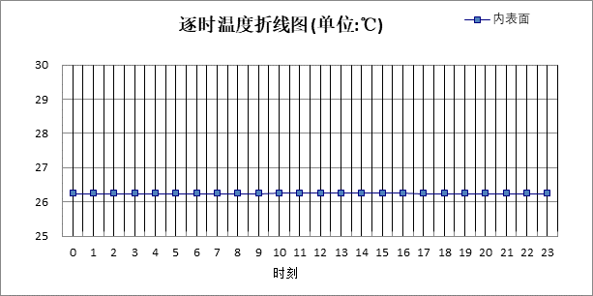

0:00 | 1:00 | 2:00 | 3:00 | 4:00 | 5:00 | 6:00 | 7:00 | 8:00 | 9:00 | 10:00 | 11:00
26.26 | 26.26 | 26.26 | 26.26 | 26.26 | 26.26 | 26.26 | 26.26 | 26.26 | 26.26 | 26.27 | 26.27
12:00 | 13:00 | 14:00 | 15:00 | 16:00 | 17:00 | 18:00 | 19:00 | 20:00 | 21:00 | 22:00 | 23:00
26.27 | 26.27 | 26.27 | 26.27 | 26.27 | 26.26 | 26.26 | 26.26 | 26.26 | 26.26 | 26.26 | 26.26

空调房间：南向逐时温度
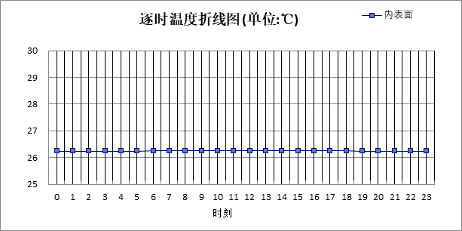

0:00 | 1:00 | 2:00 | 3:00 | 4:00 | 5:00 | 6:00 | 7:00 | 8:00 | 9:00 | 10:00 | 11:00
26.25 | 26.25 | 26.25 | 26.25 | 26.25 | 26.25 | 26.26 | 26.26 | 26.26 | 26.26 | 26.26 | 26.26
12:00 | 13:00 | 14:00 | 15:00 | 16:00 | 17:00 | 18:00 | 19:00 | 20:00 | 21:00 | 22:00 | 23:00
26.26 | 26.26 | 26.26 | 26.26 | 26.26 | 26.26 | 26.26 | 26.25 | 26.25 | 26.25 | 26.25 | 26.25

空调房间：北向逐时温度
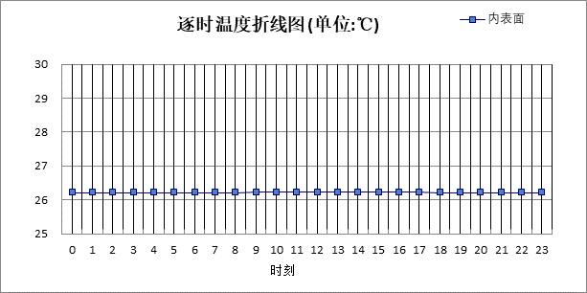

0:00 | 1:00 | 2:00 | 3:00 | 4:00 | 5:00 | 6:00 | 7:00 | 8:00 | 9:00 | 10:00 | 11:00
26.22 | 26.22 | 26.22 | 26.22 | 26.22 | 26.22 | 26.22 | 26.22 | 26.22 | 26.23 | 26.23 | 26.23
12:00 | 13:00 | 14:00 | 15:00 | 16:00 | 17:00 | 18:00 | 19:00 | 20:00 | 21:00 | 22:00 | 23:00
26.23 | 26.23 | 26.23 | 26.23 | 26.23 | 26.23 | 26.22 | 26.22 | 26.22 | 26.22 | 26.22 | 26.22

验算结论
类型 | 构造 | 时刻 | 最高温度(℃) | 限值(℃) | 结论
屋顶 | 上:XPS保温屋面 | 0:25 | 26.42 | 28.50 | 满足
外墙（填充墙） | 东:外墙（填充墙）构造一 | 11:10 | 26.26 | 28.00 | 满足
外墙（填充墙） | 西:外墙（填充墙）构造一 | 12:35 | 26.27 | 28.00 | 满足
外墙（填充墙） | 南:外墙（填充墙）构造一 | 11:55 | 26.26 | 28.00 | 满足
外墙（填充墙） | 北:外墙（填充墙）构造一 | 12:40 | 26.23 | 28.00 | 满足

