**隔热检查计算书**

公共建筑

|  |  |
| --- | --- |
| 工程名称 | 新建项目 |
| 工程地点 | 浙江-杭州 |
| 设计编号 |  |
| 建设单位 |  |
| 设计单位 |  |
| 设 计 人 |  |
| 校 对 人 |  |
| 审 核 人 |  |
| 计算日期 | 2024年1月7日 |



|  |  |
| --- | --- |
| 采用软件 | 斯维尔节能设计BECS2023 |
| 软件版本 | 20220923 |
| 研发单位 | 北京绿建软件股份有限公司 |
| 正版授权码 | T13868190699 |

**目 录**

1 建筑概况 3

2 评价依据 3

3 评价目标与方法 3

3.1 评价目标 3

3.2 评价方法 3

4 边界条件参数设置 4

4.1 基本设置 4

4.2 室外空气温度 5

4.3 室外太阳辐射照度 5

4.4 室内空气温度 6

5 工程材料 6

6 工程构造 7

6.1 屋顶构造 7

6.1.1 屋顶构造一 7

6.2 外墙构造 8

6.2.1 砖墙（外保温） 8

6.2.2 光伏+筒仓 11

6.2.3 筒仓（内保温） 14

6.2.4 活动墙 17

6.2.5 筒仓（钢筋混凝土） 20

6.2.6 砖墙+光伏幕墙 23

6.3 热桥柱构造 26

6.3.1 热桥柱构造一 26

7 验算结论 29

7.1 空调房间 29

# 建筑概况

|  |  |  |
| --- | --- | --- |
| 工程名称 | 新建项目 | |
| 工程地点 | 浙江-杭州 | |
| 地理位置 | 北纬：30.23° | 东经：120.17° |
| 气候子区 | 夏热冬冷 | |
| 大气透明度等级 | 5 | |
| 建筑面积 | 地上4414㎡ 地下0㎡ | |
| 建筑层数 | 地上7 地下0 | |
| 建筑高度 | 25.2m | |
| 结构类型 |  | |

# 评价依据

1. 《公共建筑节能设计标准》GB50189-2015

2. 《民用建筑热工设计规范》GB50176

3. 《绿色建筑评价标准》GB/T 50378-2019

4. 《绿色建筑评价技术细则》

5. 施工图、设计说明、节能计算书

# 评价目标与方法

## 评价目标

1. 依据《民用建筑热工设计规范》和《绿色建筑评价标准》GB/T 50378-2019的要求和规定，屋顶和外墙的隔热性能应满足要求。
2. 通过房间围护结构的内表面温度计算，判断是否不大于《民用建筑热工设计规范》给出的内表面最高温度。

## 评价方法

1. 在给定两侧空气温度及变化规律的情况下，外墙内表面最高温度应符合表3.2.1的要求：

**表3.2.1 外墙内表面最高温度的限值**

|  |  |  |  |
| --- | --- | --- | --- |
| **房间类型** | **自然通风房间** | **空调房间** | |
| **重质围护结构**  **（D≥2.5）** | **轻质围护结构**  **（D＜2.5）** |
| **内表面最高温度** | ≤ te.max | ≤ti+2 | ≤ti+3 |

1. 在给定两侧空气温度及变化规律的情况下，屋面内表面最高温度应符合表3.2.2的要求：

**表3.2.2 屋顶内表面最高温度的限值**

|  |  |  |  |
| --- | --- | --- | --- |
| **房间类型** | **自然通风房间** | **空调房间** | |
| **重质围护结构**  **（D≥2.5）** | **轻质围护结构**  **（D＜2.5）** |
| **内表面最高温度** | ≤ te.max | ≤ti+2.5 | ≤ti+3.5 |

表中：—围护结构内表面最高温度（），应按《民用建筑热工设计规范》 GB50176-2016附录C.3 的规定计算；



$t_{i}$—室内空气温度，（）。



te.max—累年日平均温度最高日的最高温度（）,应按《民用建筑热工设计规范》



GB50176-2016配套软件气象数据取用。

1. 外围护结构内表面最高温度按照规范《民用建筑热工设计规范》(GB50176-2016)附录C.3 的规定计算：
2. 按式3.2.3-1建立常物性、无内热源的一维非稳态导热的内部微分方程，微分方程的求解可采用有限差分法：

（3.2.3-1）



式中： —温度对于时间的导数，/s。



—材料的导温系数，，m2/s。



1. 按式3.2.3-2建立第三类边界条件隐式差分格式边界节点方程（边界节点1，节点n 可参照）：

（3.2.3-2）



式中： $C_{p}$—材料的比热， J /(kg·K)；

$ρ$—材料的密度，kg/m³；

—材料的导温系数，，m2/s；



—差分步长，m；

—材料的导热系数，［W/(m·K)］；



$t_{f}^{k}$—对流换热温度，。



1. 按式3.2.3-3列出各内部节点和边界点的节点方程，并求解节点方程组得到外墙、屋顶内表面温度值。

,i=1,2,……n （3.2.3-3）



式中： $t_{i}$—差分节点温度值，。



# 边界条件参数设置

## 基本设置

|  |  |  |  |  |
| --- | --- | --- | --- | --- |
| **公式及变量** | **变量名** | | **数值** | **说明** |
| **（一）内表面边界条件（第三类边界条件）** | | | | |
|  | | 夏季室内温度， |  | 按《民用建筑热工设计规范》GB50176-2016第3.3.2条的规定取值。 |
|  | | 室内侧对流换热系数，W/(m2·K) | 8.7 | 按《民用建筑热工设计规范》 GB50176-2016附录B.4.1，表B.4.1-1取值。 |
| **（二）外表面边界条件（第三类边界条件）** | | | | |
|  | | 室外侧对流换热系数，(m2·K) | 19.0 | 按《民用建筑热工设计规范》 GB50176-2016附录B.4.1，表B.4.1-2取值。 |
|  | | 室外空气逐时温度， |  | 按《民用建筑热工设计规范》 GB50176-2016配套软件气象数据取用。 |
|  | | 表面法向太阳总辐射强度，包括直射和散射，W/m2 |  | 按《民用建筑热工设计规范》 GB50176-2016配套软件气象参数取值。 |
|  | | 外表面太阳辐射吸收系数 |  | 根据工程构造取值。 |

## 室外空气温度

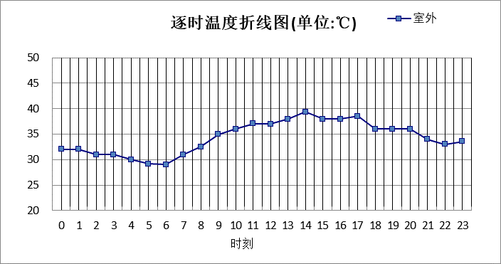

|  |  |  |  |  |  |  |  |  |  |  |  |
| --- | --- | --- | --- | --- | --- | --- | --- | --- | --- | --- | --- |
| 0:00 | 1:00 | 2:00 | 3:00 | 4:00 | 5:00 | 6:00 | 7:00 | 8:00 | 9:00 | 10:00 | 11:00 |
| 32.00 | 32.00 | 31.00 | 31.00 | 30.00 | 29.20 | 29.00 | 31.00 | 32.50 | 35.00 | 36.00 | 37.10 |
| 12:00 | 13:00 | 14:00 | 15:00 | 16:00 | 17:00 | 18:00 | 19:00 | 20:00 | 21:00 | 22:00 | 23:00 |
| 37.00 | 38.00 | 39.40 | 38.00 | 38.00 | 38.50 | 36.00 | 36.00 | 36.00 | 34.00 | 33.00 | 33.60 |

## 室外太阳辐射照度

|  |  |  |
| --- | --- | --- |
| **变量** | **变量名** | **公式来源** |
|  | 表面法向太阳总辐射强度，包括直射和散射，W/ m2 | 按《民用建筑热工设计规范GB  50176-2016》配套软件气象数据取用。 |

|  |  |  |  |  |  |
| --- | --- | --- | --- | --- | --- |
| 时刻\朝向 | 东 | 南 | 西 | 北 | 水平 |
| 0:00 | 0.00 | 0.00 | 0.00 | 0.00 | 0.00 |
| 1:00 | 0.00 | 0.00 | 0.00 | 0.00 | 0.00 |
| 2:00 | 0.00 | 0.00 | 0.00 | 0.00 | 0.00 |
| 3:00 | 0.00 | 0.00 | 0.00 | 0.00 | 0.00 |
| 4:00 | 0.00 | 0.00 | 0.00 | 0.00 | 0.00 |
| 5:00 | 70.85 | 26.81 | 32.11 | 13.20 | 59.40 |
| 6:00 | 190.25 | 88.60 | 89.24 | 51.77 | 184.10 |
| 7:00 | 405.15 | 176.04 | 161.82 | 113.40 | 413.50 |
| 8:00 | 534.65 | 274.41 | 215.82 | 176.80 | 657.70 |
| 9:00 | 579.36 | 401.88 | 279.38 | 230.95 | 930.80 |
| 10:00 | 438.88 | 443.70 | 295.72 | 243.83 | 961.50 |
| 11:00 | 298.92 | 453.76 | 298.92 | 246.29 | 965.00 |
| 12:00 | 251.21 | 370.11 | 361.22 | 206.14 | 778.80 |
| 13:00 | 232.76 | 325.82 | 439.16 | 190.65 | 708.00 |
| 14:00 | 206.86 | 262.24 | 491.38 | 168.95 | 610.70 |
| 15:00 | 161.07 | 174.93 | 406.85 | 112.68 | 413.70 |
| 16:00 | 104.83 | 94.95 | 269.60 | 52.52 | 232.40 |
| 17:00 | 35.48 | 25.73 | 90.59 | 10.79 | 67.50 |
| 18:00 | 0.00 | 0.00 | 0.00 | 0.00 | 0.00 |
| 19:00 | 0.00 | 0.00 | 0.00 | 0.00 | 0.00 |
| 20:00 | 0.00 | 0.00 | 0.00 | 0.00 | 0.00 |
| 21:00 | 0.00 | 0.00 | 0.00 | 0.00 | 0.00 |
| 22:00 | 0.00 | 0.00 | 0.00 | 0.00 | 0.00 |
| 23:00 | 0.00 | 0.00 | 0.00 | 0.00 | 0.00 |

## 室内空气温度

根据《民用建筑热工设计规范》GB50176-2016第3.3.2条的规定取26摄氏度

# 工程材料

|  |  |  |  |  |  |  |
| --- | --- | --- | --- | --- | --- | --- |
| 材料名称 | 导热系数λ | 蓄热系数S | 密度ρ | 比热容Cp | 蒸汽渗透系数u | 备注 |
| W/(m.K) | W/(㎡.K) | kg/m3 | J/(kg.K) | g/(m.h.kPa) |
| 水泥砂浆 | 0.930 | 11.306 | 1800.0 | 1050.0 | 0.0000 | 蒸汽渗透系数为测定值 |
| 石灰砂浆 | 0.810 | 10.070 | 1600.0 | 1050.0 | 0.0443 | 来源：《民用建筑热工设计规范》GB50176-2016 |
| 重砂浆砌筑粘土砖砌体（1） | 0.810 | 10.551 | 1800.0 | 1050.0 | 0.0000 | 蒸汽渗透系数为测定值 |
| 碎石、卵石混凝土(ρ=2300) | 1.510 | 15.360 | 2300.0 | 920.0 | 0.0173 | 来源：《民用建筑热工设计规范》GB50176-2016 |
| 岩棉板 | 0.045 | 0.684 | 150.0 | 1340.0 | 0.0000 |  |
| 玻璃幕墙 | 0.760 | 10.773 | 2500.0 | 840.0 | 0.0000 | 蒸汽渗透系数没有给出 |
| 混凝土多孔砖(190六孔砖） | 0.750 | 7.490 | 1450.0 | 709.4 | 0.0000 |  |
| 防水层 | 0.170 | 3.302 | 600.0 | 1470.0 | 0.0000 |  |
| 混合砂浆 | 0.870 | 10.750 | 1700.0 | 1074.4 | 0.0000 |  |
| 钢筋混凝土屋面板 | 1.740 | 17.060 | 2500.0 | 920.0 | 0.0040 |  |
| 钢筋混凝土（1） | 1.740 | 17.060 | 2500.0 | 920.0 | 0.0000 | 蒸汽渗透系数为测定值 |
| 混合砂浆（1） | 0.870 | 10.627 | 1700.0 | 1050.0 | 0.0000 |  |
| 聚合物水泥石灰砂浆 | 0.930 | 11.306 | 1800.0 | 1050.0 | 0.0000 |  |

# 工程构造

## 屋顶构造

### 屋顶构造一

|  |  |  |  |  |  |  |  |
| --- | --- | --- | --- | --- | --- | --- | --- |
| 材料名称 由外到内 | 厚度 | 差分 步长 | 导热 系数 | 蓄热 系数 | 修正 系数 | 热阻 | 热惰性 指标 |
| (mm) | (mm) | W/(m.K) | W/(㎡.K) | α | (㎡K)/W | D=R*S |
| 碎石、卵石混凝土(ρ=2300) | 40 | 10.0 | 1.510 | 15.360 | 1.00 | 0.026 | 0.407 |
| 水泥砂浆 | 20 | 10.0 | 0.930 | 11.306 | 1.00 | 0.022 | 0.243 |
| 防水层 | 20 | 5.0 | 0.170 | 3.302 | 1.00 | 0.118 | 0.388 |
| 岩棉板 | 80 | 6.7 | 0.045 | 0.684 | 1.20 | 1.481 | 1.216 |
| 防水层 | 20 | 5.0 | 0.170 | 3.302 | 1.00 | 0.118 | 0.388 |
| 水泥砂浆 | 20 | 10.0 | 0.930 | 11.306 | 1.00 | 0.022 | 0.243 |
| 玻璃幕墙 | 30 | 7.5 | 0.760 | 10.773 | 1.00 | 0.039 | 0.425 |
| 钢筋混凝土屋面板 | 120 | 12.0 | 1.740 | 17.060 | 1.00 | 0.069 | 1.177 |
| 混合砂浆 | 15 | 7.5 | 0.870 | 10.750 | 1.00 | 0.017 | 0.185 |
| 各层之和∑ | 365 | － | － | － | － | 1.912 | 4.673 |
| 差分时间步长(分钟) | 5.0 | | | | | | |
| 外表面太阳辐射吸收系数 | 0.75 | | | | | | |
| 传热系数K=1/(0.16+∑R) | 0.48 | | | | | | |
| 重质/轻质 | 重质围护结构 | | | | | | |

#### 空调房间：逐时温度

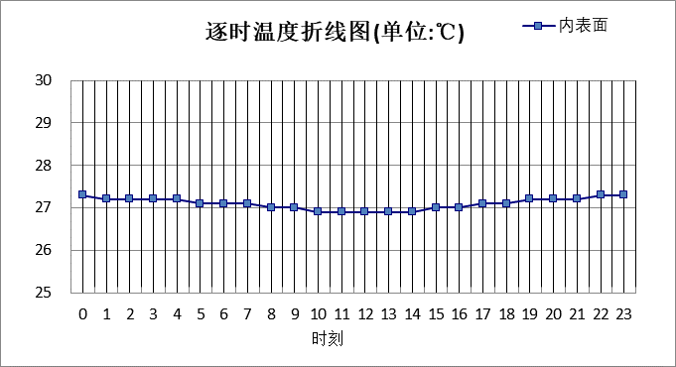

|  |  |  |  |  |  |  |  |  |  |  |  |
| --- | --- | --- | --- | --- | --- | --- | --- | --- | --- | --- | --- |
| 0:00 | 1:00 | 2:00 | 3:00 | 4:00 | 5:00 | 6:00 | 7:00 | 8:00 | 9:00 | 10:00 | 11:00 |
| 27.25 | 27.24 | 27.21 | 27.19 | 27.16 | 27.12 | 27.09 | 27.05 | 27.02 | 26.98 | 26.95 | 26.92 |
| 12:00 | 13:00 | 14:00 | 15:00 | 16:00 | 17:00 | 18:00 | 19:00 | 20:00 | 21:00 | 22:00 | 23:00 |
| 26.91 | 26.92 | 26.94 | 26.97 | 27.02 | 27.07 | 27.12 | 27.17 | 27.21 | 27.24 | 27.25 | 27.26 |

## 外墙构造

### 砖墙（外保温）

|  |  |  |  |  |  |  |  |
| --- | --- | --- | --- | --- | --- | --- | --- |
| 材料名称 由外到内 | 厚度 | 差分 步长 | 导热 系数 | 蓄热 系数 | 修正 系数 | 热阻 | 热惰性 指标 |
| (mm) | (mm) | W/(m.K) | W/(㎡.K) | α | (㎡K)/W | D=R*S |
| 水泥砂浆 | 5 | 5.0 | 0.930 | 11.306 | 1.00 | 0.005 | 0.061 |
| 岩棉板 | 55 | 6.9 | 0.045 | 0.684 | 1.00 | 1.222 | 0.836 |
| 水泥砂浆 | 20 | 10.0 | 0.930 | 11.306 | 1.00 | 0.022 | 0.243 |
| 重砂浆砌筑粘土砖砌体（1） | 240 | 9.6 | 0.810 | 10.551 | 1.00 | 0.296 | 3.126 |
| 混合砂浆 | 20 | 10.0 | 0.870 | 10.750 | 1.00 | 0.023 | 0.247 |
| 各层之和∑ | 340 | － | － | － | － | 1.568 | 4.513 |
| 差分时间步长(分钟) | 5.0 | | | | | | |
| 外表面太阳辐射吸收系数 | 0.73 | | | | | | |
| 传热系数K=1/(0.16+∑R) | 0.58 | | | | | | |
| 重质/轻质 | 重质围护结构 | | | | | | |

#### 空调房间：东向逐时温度

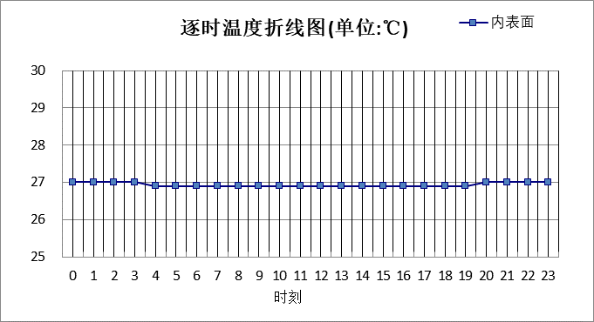

|  |  |  |  |  |  |  |  |  |  |  |  |
| --- | --- | --- | --- | --- | --- | --- | --- | --- | --- | --- | --- |
| 0:00 | 1:00 | 2:00 | 3:00 | 4:00 | 5:00 | 6:00 | 7:00 | 8:00 | 9:00 | 10:00 | 11:00 |
| 26.98 | 26.97 | 26.97 | 26.96 | 26.95 | 26.93 | 26.92 | 26.91 | 26.89 | 26.87 | 26.86 | 26.85 |
| 12:00 | 13:00 | 14:00 | 15:00 | 16:00 | 17:00 | 18:00 | 19:00 | 20:00 | 21:00 | 22:00 | 23:00 |
| 26.85 | 26.86 | 26.87 | 26.88 | 26.90 | 26.92 | 26.93 | 26.95 | 26.96 | 26.97 | 26.98 | 26.98 |

#### 空调房间：西向逐时温度

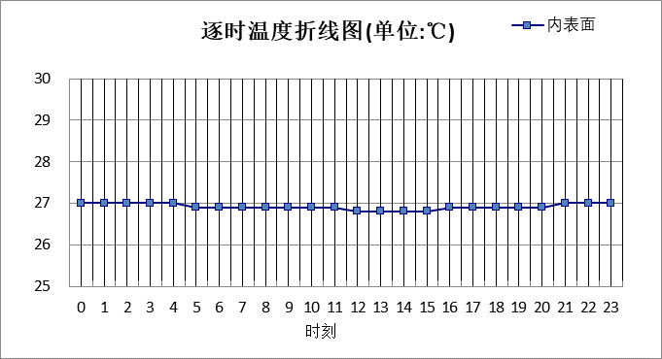

|  |  |  |  |  |  |  |  |  |  |  |  |
| --- | --- | --- | --- | --- | --- | --- | --- | --- | --- | --- | --- |
| 0:00 | 1:00 | 2:00 | 3:00 | 4:00 | 5:00 | 6:00 | 7:00 | 8:00 | 9:00 | 10:00 | 11:00 |
| 26.98 | 26.98 | 26.98 | 26.97 | 26.96 | 26.95 | 26.94 | 26.92 | 26.90 | 26.89 | 26.87 | 26.86 |
| 12:00 | 13:00 | 14:00 | 15:00 | 16:00 | 17:00 | 18:00 | 19:00 | 20:00 | 21:00 | 22:00 | 23:00 |
| 26.85 | 26.84 | 26.84 | 26.85 | 26.86 | 26.87 | 26.89 | 26.91 | 26.93 | 26.95 | 26.97 | 26.97 |

#### 空调房间：南向逐时温度

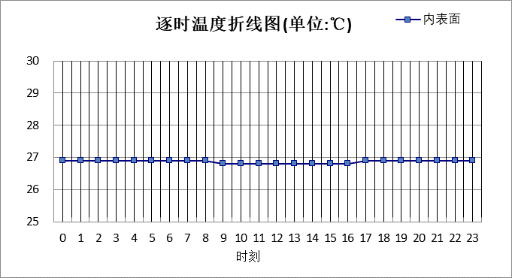

|  |  |  |  |  |  |  |  |  |  |  |  |
| --- | --- | --- | --- | --- | --- | --- | --- | --- | --- | --- | --- |
| 0:00 | 1:00 | 2:00 | 3:00 | 4:00 | 5:00 | 6:00 | 7:00 | 8:00 | 9:00 | 10:00 | 11:00 |
| 26.94 | 26.94 | 26.93 | 26.92 | 26.91 | 26.90 | 26.89 | 26.88 | 26.86 | 26.85 | 26.83 | 26.82 |
| 12:00 | 13:00 | 14:00 | 15:00 | 16:00 | 17:00 | 18:00 | 19:00 | 20:00 | 21:00 | 22:00 | 23:00 |
| 26.81 | 26.81 | 26.82 | 26.83 | 26.84 | 26.86 | 26.88 | 26.90 | 26.91 | 26.92 | 26.93 | 26.94 |

#### 空调房间：北向逐时温度

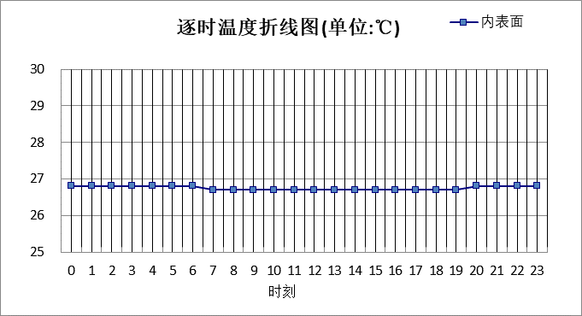

|  |  |  |  |  |  |  |  |  |  |  |  |
| --- | --- | --- | --- | --- | --- | --- | --- | --- | --- | --- | --- |
| 0:00 | 1:00 | 2:00 | 3:00 | 4:00 | 5:00 | 6:00 | 7:00 | 8:00 | 9:00 | 10:00 | 11:00 |
| 26.78 | 26.78 | 26.78 | 26.78 | 26.77 | 26.77 | 26.76 | 26.75 | 26.74 | 26.72 | 26.71 | 26.70 |
| 12:00 | 13:00 | 14:00 | 15:00 | 16:00 | 17:00 | 18:00 | 19:00 | 20:00 | 21:00 | 22:00 | 23:00 |
| 26.70 | 26.69 | 26.69 | 26.70 | 26.71 | 26.72 | 26.73 | 26.75 | 26.76 | 26.77 | 26.78 | 26.78 |

### 光伏+筒仓

|  |  |  |  |  |  |  |  |
| --- | --- | --- | --- | --- | --- | --- | --- |
| 材料名称 由外到内 | 厚度 | 差分 步长 | 导热 系数 | 蓄热 系数 | 修正 系数 | 热阻 | 热惰性 指标 |
| (mm) | (mm) | W/(m.K) | W/(㎡.K) | α | (㎡K)/W | D=R*S |
| 玻璃幕墙 | 120 | 8.6 | 0.760 | 10.773 | 1.00 | 0.158 | 1.701 |
| 岩棉板 | 55 | 6.9 | 0.045 | 0.684 | 1.00 | 1.222 | 0.836 |
| 水泥砂浆 | 20 | 10.0 | 0.930 | 11.306 | 1.00 | 0.022 | 0.243 |
| 钢筋混凝土（1） | 240 | 12.6 | 1.740 | 17.060 | 1.00 | 0.138 | 2.353 |
| 混合砂浆（1） | 20 | 10.0 | 0.870 | 10.627 | 1.00 | 0.023 | 0.244 |
| 各层之和∑ | 455 | － | － | － | － | 1.563 | 5.378 |
| 差分时间步长(分钟) | 5.0 | | | | | | |
| 外表面太阳辐射吸收系数 | 0.73 | | | | | | |
| 传热系数K=1/(0.16+∑R) | 0.58 | | | | | | |
| 重质/轻质 | 重质围护结构 | | | | | | |

#### 空调房间：东向逐时温度

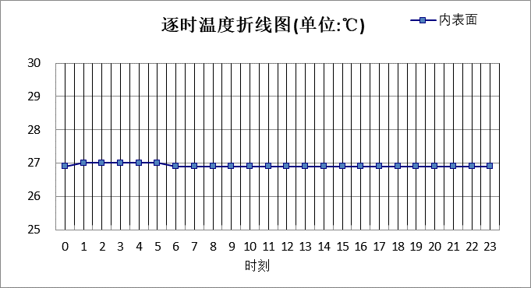

|  |  |  |  |  |  |  |  |  |  |  |  |
| --- | --- | --- | --- | --- | --- | --- | --- | --- | --- | --- | --- |
| 0:00 | 1:00 | 2:00 | 3:00 | 4:00 | 5:00 | 6:00 | 7:00 | 8:00 | 9:00 | 10:00 | 11:00 |
| 26.95 | 26.95 | 26.96 | 26.96 | 26.96 | 26.95 | 26.95 | 26.94 | 26.93 | 26.93 | 26.92 | 26.91 |
| 12:00 | 13:00 | 14:00 | 15:00 | 16:00 | 17:00 | 18:00 | 19:00 | 20:00 | 21:00 | 22:00 | 23:00 |
| 26.90 | 26.89 | 26.89 | 26.89 | 26.89 | 26.90 | 26.90 | 26.91 | 26.92 | 26.93 | 26.94 | 26.94 |

#### 空调房间：西向逐时温度

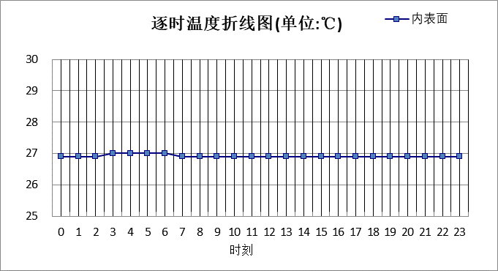

|  |  |  |  |  |  |  |  |  |  |  |  |
| --- | --- | --- | --- | --- | --- | --- | --- | --- | --- | --- | --- |
| 0:00 | 1:00 | 2:00 | 3:00 | 4:00 | 5:00 | 6:00 | 7:00 | 8:00 | 9:00 | 10:00 | 11:00 |
| 26.93 | 26.94 | 26.95 | 26.95 | 26.95 | 26.95 | 26.95 | 26.95 | 26.94 | 26.93 | 26.92 | 26.91 |
| 12:00 | 13:00 | 14:00 | 15:00 | 16:00 | 17:00 | 18:00 | 19:00 | 20:00 | 21:00 | 22:00 | 23:00 |
| 26.90 | 26.89 | 26.89 | 26.88 | 26.88 | 26.87 | 26.88 | 26.88 | 26.89 | 26.90 | 26.91 | 26.92 |

#### 空调房间：南向逐时温度

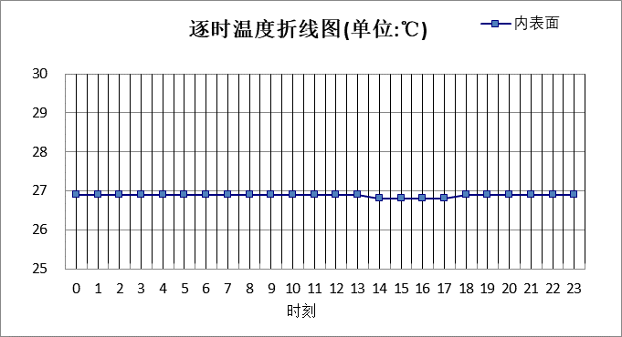

|  |  |  |  |  |  |  |  |  |  |  |  |
| --- | --- | --- | --- | --- | --- | --- | --- | --- | --- | --- | --- |
| 0:00 | 1:00 | 2:00 | 3:00 | 4:00 | 5:00 | 6:00 | 7:00 | 8:00 | 9:00 | 10:00 | 11:00 |
| 26.90 | 26.91 | 26.91 | 26.92 | 26.92 | 26.91 | 26.91 | 26.91 | 26.90 | 26.89 | 26.88 | 26.87 |
| 12:00 | 13:00 | 14:00 | 15:00 | 16:00 | 17:00 | 18:00 | 19:00 | 20:00 | 21:00 | 22:00 | 23:00 |
| 26.86 | 26.86 | 26.85 | 26.85 | 26.84 | 26.85 | 26.85 | 26.86 | 26.87 | 26.88 | 26.89 | 26.90 |

#### 空调房间：北向逐时温度

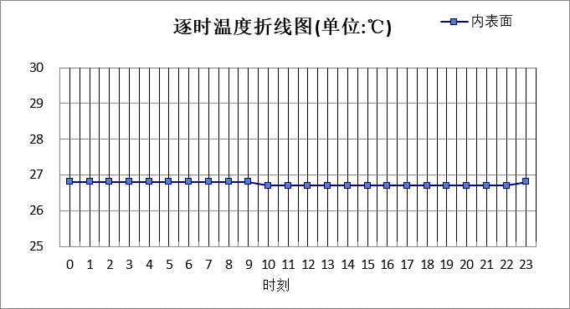

|  |  |  |  |  |  |  |  |  |  |  |  |
| --- | --- | --- | --- | --- | --- | --- | --- | --- | --- | --- | --- |
| 0:00 | 1:00 | 2:00 | 3:00 | 4:00 | 5:00 | 6:00 | 7:00 | 8:00 | 9:00 | 10:00 | 11:00 |
| 26.76 | 26.76 | 26.76 | 26.77 | 26.77 | 26.77 | 26.77 | 26.76 | 26.76 | 26.76 | 26.75 | 26.74 |
| 12:00 | 13:00 | 14:00 | 15:00 | 16:00 | 17:00 | 18:00 | 19:00 | 20:00 | 21:00 | 22:00 | 23:00 |
| 26.73 | 26.73 | 26.72 | 26.72 | 26.72 | 26.72 | 26.72 | 26.73 | 26.73 | 26.74 | 26.74 | 26.75 |

### 筒仓（内保温）

|  |  |  |  |  |  |  |  |
| --- | --- | --- | --- | --- | --- | --- | --- |
| 材料名称 由外到内 | 厚度 | 差分 步长 | 导热 系数 | 蓄热 系数 | 修正 系数 | 热阻 | 热惰性 指标 |
| (mm) | (mm) | W/(m.K) | W/(㎡.K) | α | (㎡K)/W | D=R*S |
| 钢筋混凝土（1） | 200 | 12.5 | 1.740 | 17.060 | 1.00 | 0.115 | 1.961 |
| 岩棉板 | 60 | 6.7 | 0.045 | 0.684 | 1.20 | 1.111 | 0.912 |
| 各层之和∑ | 260 | － | － | － | － | 1.226 | 2.873 |
| 差分时间步长(分钟) | 5.0 | | | | | | |
| 外表面太阳辐射吸收系数 | 0.73 | | | | | | |
| 传热系数K=1/(0.16+∑R) | 0.72 | | | | | | |
| 重质/轻质 | 重质围护结构 | | | | | | |

#### 空调房间：东向逐时温度

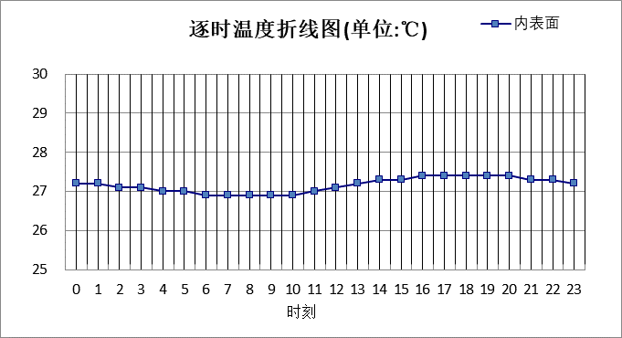

|  |  |  |  |  |  |  |  |  |  |  |  |
| --- | --- | --- | --- | --- | --- | --- | --- | --- | --- | --- | --- |
| 0:00 | 1:00 | 2:00 | 3:00 | 4:00 | 5:00 | 6:00 | 7:00 | 8:00 | 9:00 | 10:00 | 11:00 |
| 27.20 | 27.15 | 27.11 | 27.06 | 27.01 | 26.96 | 26.91 | 26.87 | 26.85 | 26.87 | 26.93 | 27.02 |
| 12:00 | 13:00 | 14:00 | 15:00 | 16:00 | 17:00 | 18:00 | 19:00 | 20:00 | 21:00 | 22:00 | 23:00 |
| 27.12 | 27.20 | 27.26 | 27.31 | 27.35 | 27.38 | 27.39 | 27.39 | 27.36 | 27.33 | 27.29 | 27.25 |

#### 空调房间：西向逐时温度

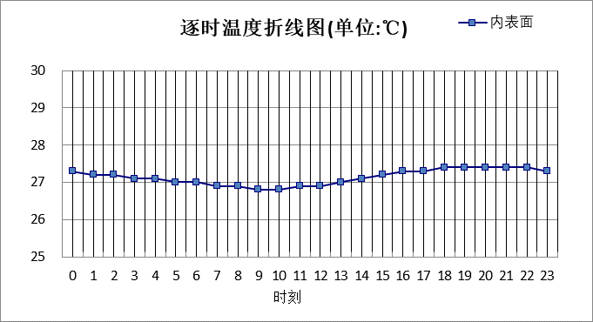

|  |  |  |  |  |  |  |  |  |  |  |  |
| --- | --- | --- | --- | --- | --- | --- | --- | --- | --- | --- | --- |
| 0:00 | 1:00 | 2:00 | 3:00 | 4:00 | 5:00 | 6:00 | 7:00 | 8:00 | 9:00 | 10:00 | 11:00 |
| 27.27 | 27.22 | 27.17 | 27.11 | 27.06 | 27.00 | 26.95 | 26.90 | 26.87 | 26.85 | 26.85 | 26.88 |
| 12:00 | 13:00 | 14:00 | 15:00 | 16:00 | 17:00 | 18:00 | 19:00 | 20:00 | 21:00 | 22:00 | 23:00 |
| 26.93 | 26.99 | 27.07 | 27.16 | 27.25 | 27.35 | 27.42 | 27.45 | 27.45 | 27.42 | 27.38 | 27.33 |

#### 空调房间：南向逐时温度

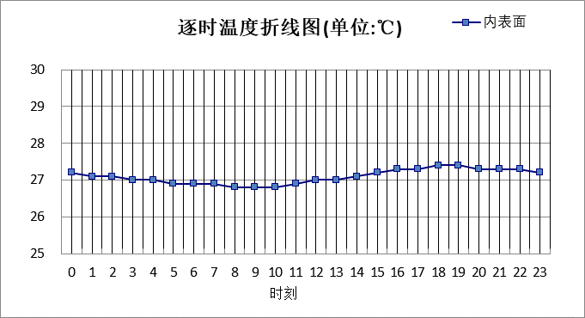

|  |  |  |  |  |  |  |  |  |  |  |  |
| --- | --- | --- | --- | --- | --- | --- | --- | --- | --- | --- | --- |
| 0:00 | 1:00 | 2:00 | 3:00 | 4:00 | 5:00 | 6:00 | 7:00 | 8:00 | 9:00 | 10:00 | 11:00 |
| 27.18 | 27.14 | 27.09 | 27.04 | 26.99 | 26.95 | 26.90 | 26.86 | 26.82 | 26.81 | 26.82 | 26.87 |
| 12:00 | 13:00 | 14:00 | 15:00 | 16:00 | 17:00 | 18:00 | 19:00 | 20:00 | 21:00 | 22:00 | 23:00 |
| 26.95 | 27.05 | 27.14 | 27.22 | 27.29 | 27.33 | 27.36 | 27.36 | 27.34 | 27.31 | 27.27 | 27.23 |

#### 空调房间：北向逐时温度

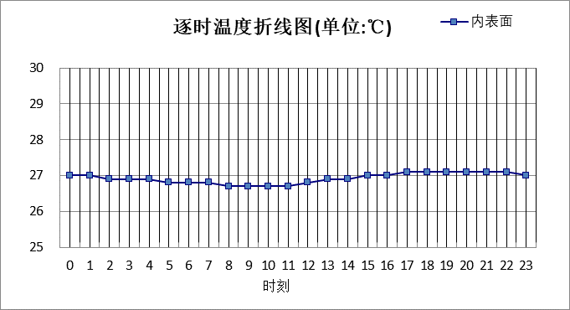

|  |  |  |  |  |  |  |  |  |  |  |  |
| --- | --- | --- | --- | --- | --- | --- | --- | --- | --- | --- | --- |
| 0:00 | 1:00 | 2:00 | 3:00 | 4:00 | 5:00 | 6:00 | 7:00 | 8:00 | 9:00 | 10:00 | 11:00 |
| 27.01 | 26.98 | 26.95 | 26.91 | 26.88 | 26.84 | 26.80 | 26.76 | 26.73 | 26.71 | 26.72 | 26.75 |
| 12:00 | 13:00 | 14:00 | 15:00 | 16:00 | 17:00 | 18:00 | 19:00 | 20:00 | 21:00 | 22:00 | 23:00 |
| 26.80 | 26.86 | 26.92 | 26.98 | 27.03 | 27.07 | 27.09 | 27.11 | 27.10 | 27.09 | 27.07 | 27.04 |

### 活动墙

|  |  |  |  |  |  |  |  |
| --- | --- | --- | --- | --- | --- | --- | --- |
| 材料名称 由外到内 | 厚度 | 差分 步长 | 导热 系数 | 蓄热 系数 | 修正 系数 | 热阻 | 热惰性 指标 |
| (mm) | (mm) | W/(m.K) | W/(㎡.K) | α | (㎡K)/W | D=R*S |
| 玻璃幕墙 | 300 | 8.8 | 0.760 | 10.773 | 1.00 | 0.395 | 4.252 |
| 岩棉板 | 55 | 6.9 | 0.045 | 0.684 | 1.00 | 1.222 | 0.836 |
| 水泥砂浆 | 20 | 10.0 | 0.930 | 11.306 | 1.00 | 0.022 | 0.243 |
| 重砂浆砌筑粘土砖砌体（1） | 240 | 9.6 | 0.810 | 10.551 | 1.20 | 0.247 | 3.126 |
| 混合砂浆（1） | 20 | 10.0 | 0.870 | 10.627 | 1.00 | 0.023 | 0.244 |
| 各层之和∑ | 635 | － | － | － | － | 1.908 | 8.702 |
| 差分时间步长(分钟) | 5.0 | | | | | | |
| 外表面太阳辐射吸收系数 | 0.73 | | | | | | |
| 传热系数K=1/(0.16+∑R) | 0.48 | | | | | | |
| 重质/轻质 | 重质围护结构 | | | | | | |

#### 空调房间：东向逐时温度

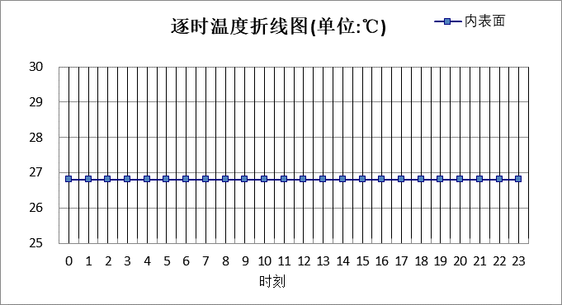

|  |  |  |  |  |  |  |  |  |  |  |  |
| --- | --- | --- | --- | --- | --- | --- | --- | --- | --- | --- | --- |
| 0:00 | 1:00 | 2:00 | 3:00 | 4:00 | 5:00 | 6:00 | 7:00 | 8:00 | 9:00 | 10:00 | 11:00 |
| 26.77 | 26.77 | 26.77 | 26.77 | 26.77 | 26.77 | 26.77 | 26.77 | 26.77 | 26.77 | 26.77 | 26.77 |
| 12:00 | 13:00 | 14:00 | 15:00 | 16:00 | 17:00 | 18:00 | 19:00 | 20:00 | 21:00 | 22:00 | 23:00 |
| 26.77 | 26.77 | 26.77 | 26.77 | 26.77 | 26.77 | 26.77 | 26.77 | 26.77 | 26.77 | 26.77 | 26.77 |

#### 空调房间：西向逐时温度



|  |  |  |  |  |  |  |  |  |  |  |  |
| --- | --- | --- | --- | --- | --- | --- | --- | --- | --- | --- | --- |
| 0:00 | 1:00 | 2:00 | 3:00 | 4:00 | 5:00 | 6:00 | 7:00 | 8:00 | 9:00 | 10:00 | 11:00 |
| 26.76 | 26.76 | 26.76 | 26.76 | 26.76 | 26.76 | 26.76 | 26.76 | 26.77 | 26.77 | 26.77 | 26.77 |
| 12:00 | 13:00 | 14:00 | 15:00 | 16:00 | 17:00 | 18:00 | 19:00 | 20:00 | 21:00 | 22:00 | 23:00 |
| 26.77 | 26.77 | 26.77 | 26.77 | 26.77 | 26.77 | 26.76 | 26.76 | 26.76 | 26.76 | 26.76 | 26.76 |

#### 空调房间：南向逐时温度

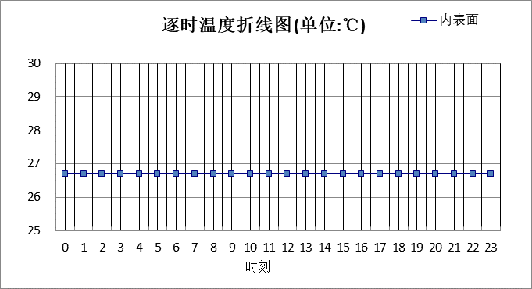

|  |  |  |  |  |  |  |  |  |  |  |  |
| --- | --- | --- | --- | --- | --- | --- | --- | --- | --- | --- | --- |
| 0:00 | 1:00 | 2:00 | 3:00 | 4:00 | 5:00 | 6:00 | 7:00 | 8:00 | 9:00 | 10:00 | 11:00 |
| 26.73 | 26.73 | 26.73 | 26.73 | 26.73 | 26.73 | 26.74 | 26.74 | 26.74 | 26.74 | 26.74 | 26.74 |
| 12:00 | 13:00 | 14:00 | 15:00 | 16:00 | 17:00 | 18:00 | 19:00 | 20:00 | 21:00 | 22:00 | 23:00 |
| 26.74 | 26.74 | 26.74 | 26.74 | 26.74 | 26.74 | 26.74 | 26.73 | 26.73 | 26.73 | 26.73 | 26.73 |

#### 空调房间：北向逐时温度

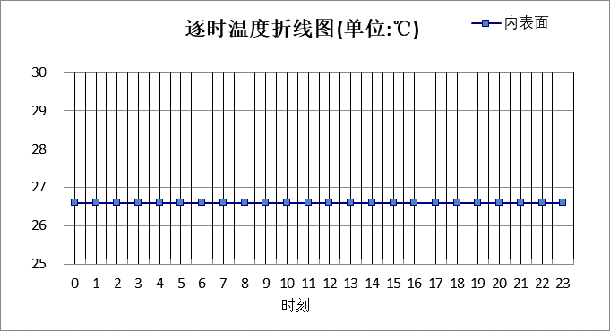

|  |  |  |  |  |  |  |  |  |  |  |  |
| --- | --- | --- | --- | --- | --- | --- | --- | --- | --- | --- | --- |
| 0:00 | 1:00 | 2:00 | 3:00 | 4:00 | 5:00 | 6:00 | 7:00 | 8:00 | 9:00 | 10:00 | 11:00 |
| 26.62 | 26.62 | 26.62 | 26.62 | 26.62 | 26.62 | 26.62 | 26.62 | 26.62 | 26.62 | 26.62 | 26.62 |
| 12:00 | 13:00 | 14:00 | 15:00 | 16:00 | 17:00 | 18:00 | 19:00 | 20:00 | 21:00 | 22:00 | 23:00 |
| 26.62 | 26.62 | 26.62 | 26.62 | 26.62 | 26.62 | 26.62 | 26.62 | 26.62 | 26.62 | 26.62 | 26.62 |

### 筒仓（钢筋混凝土）

|  |  |  |  |  |  |  |  |
| --- | --- | --- | --- | --- | --- | --- | --- |
| 材料名称 由外到内 | 厚度 | 差分 步长 | 导热 系数 | 蓄热 系数 | 修正 系数 | 热阻 | 热惰性 指标 |
| (mm) | (mm) | W/(m.K) | W/(㎡.K) | α | (㎡K)/W | D=R*S |
| 钢筋混凝土（1） | 200 | 12.5 | 1.740 | 17.060 | 1.00 | 0.115 | 1.961 |
| 混合砂浆（1） | 20 | 10.0 | 0.870 | 10.627 | 1.00 | 0.023 | 0.244 |
| 各层之和∑ | 220 | － | － | － | － | 0.138 | 2.205 |
| 差分时间步长(分钟) | 5.0 | | | | | | |
| 外表面太阳辐射吸收系数 | 0.73 | | | | | | |
| 传热系数K=1/(0.16+∑R) | 3.36 | | | | | | |
| 重质/轻质 | 轻质围护结构 | | | | | | |

#### 空调房间：东向逐时温度

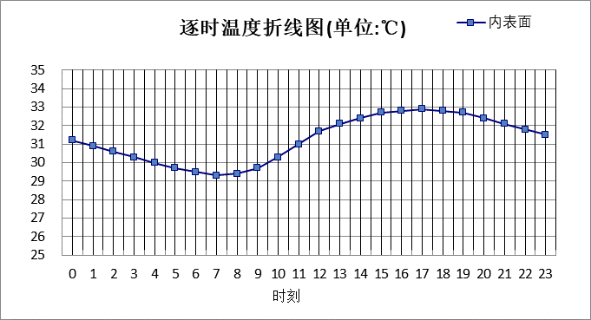

|  |  |  |  |  |  |  |  |  |  |  |  |
| --- | --- | --- | --- | --- | --- | --- | --- | --- | --- | --- | --- |
| 0:00 | 1:00 | 2:00 | 3:00 | 4:00 | 5:00 | 6:00 | 7:00 | 8:00 | 9:00 | 10:00 | 11:00 |
| 31.17 | 30.86 | 30.56 | 30.26 | 29.98 | 29.71 | 29.47 | 29.32 | 29.37 | 29.72 | 30.33 | 31.05 |
| 12:00 | 13:00 | 14:00 | 15:00 | 16:00 | 17:00 | 18:00 | 19:00 | 20:00 | 21:00 | 22:00 | 23:00 |
| 31.68 | 32.13 | 32.44 | 32.66 | 32.82 | 32.87 | 32.82 | 32.66 | 32.41 | 32.11 | 31.81 | 31.49 |

#### 空调房间：西向逐时温度

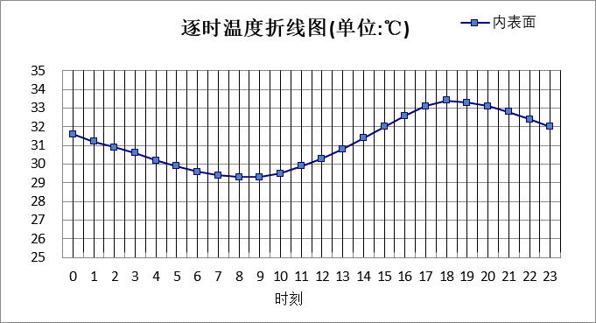

|  |  |  |  |  |  |  |  |  |  |  |  |
| --- | --- | --- | --- | --- | --- | --- | --- | --- | --- | --- | --- |
| 0:00 | 1:00 | 2:00 | 3:00 | 4:00 | 5:00 | 6:00 | 7:00 | 8:00 | 9:00 | 10:00 | 11:00 |
| 31.61 | 31.25 | 30.89 | 30.56 | 30.24 | 29.93 | 29.65 | 29.41 | 29.28 | 29.31 | 29.51 | 29.87 |
| 12:00 | 13:00 | 14:00 | 15:00 | 16:00 | 17:00 | 18:00 | 19:00 | 20:00 | 21:00 | 22:00 | 23:00 |
| 30.31 | 30.81 | 31.36 | 31.98 | 32.61 | 33.10 | 33.35 | 33.33 | 33.09 | 32.75 | 32.39 | 32.00 |

#### 空调房间：南向逐时温度

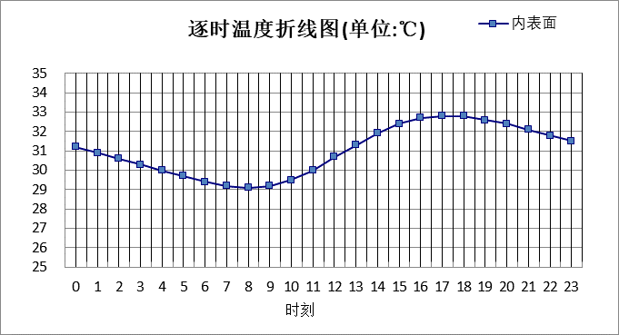

|  |  |  |  |  |  |  |  |  |  |  |  |
| --- | --- | --- | --- | --- | --- | --- | --- | --- | --- | --- | --- |
| 0:00 | 1:00 | 2:00 | 3:00 | 4:00 | 5:00 | 6:00 | 7:00 | 8:00 | 9:00 | 10:00 | 11:00 |
| 31.16 | 30.85 | 30.55 | 30.26 | 29.98 | 29.71 | 29.45 | 29.24 | 29.13 | 29.21 | 29.51 | 30.03 |
| 12:00 | 13:00 | 14:00 | 15:00 | 16:00 | 17:00 | 18:00 | 19:00 | 20:00 | 21:00 | 22:00 | 23:00 |
| 30.68 | 31.34 | 31.90 | 32.36 | 32.67 | 32.82 | 32.80 | 32.65 | 32.39 | 32.10 | 31.80 | 31.48 |

#### 空调房间：北向逐时温度

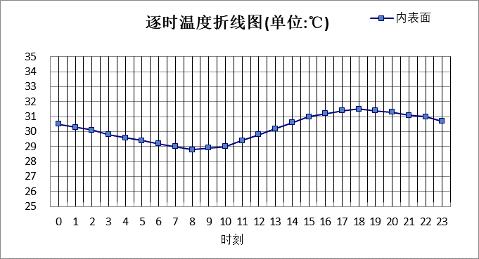

|  |  |  |  |  |  |  |  |  |  |  |  |
| --- | --- | --- | --- | --- | --- | --- | --- | --- | --- | --- | --- |
| 0:00 | 1:00 | 2:00 | 3:00 | 4:00 | 5:00 | 6:00 | 7:00 | 8:00 | 9:00 | 10:00 | 11:00 |
| 30.52 | 30.30 | 30.07 | 29.84 | 29.61 | 29.39 | 29.17 | 28.97 | 28.85 | 28.86 | 29.05 | 29.38 |
| 12:00 | 13:00 | 14:00 | 15:00 | 16:00 | 17:00 | 18:00 | 19:00 | 20:00 | 21:00 | 22:00 | 23:00 |
| 29.79 | 30.22 | 30.61 | 30.96 | 31.24 | 31.41 | 31.47 | 31.42 | 31.30 | 31.14 | 30.96 | 30.75 |

### 砖墙+光伏幕墙

|  |  |  |  |  |  |  |  |
| --- | --- | --- | --- | --- | --- | --- | --- |
| 材料名称 由外到内 | 厚度 | 差分 步长 | 导热 系数 | 蓄热 系数 | 修正 系数 | 热阻 | 热惰性 指标 |
| (mm) | (mm) | W/(m.K) | W/(㎡.K) | α | (㎡K)/W | D=R*S |
| 玻璃幕墙 | 120 | 8.6 | 0.760 | 10.773 | 1.00 | 0.158 | 1.701 |
| 重砂浆砌筑粘土砖砌体（1） | 240 | 9.6 | 0.810 | 10.551 | 1.00 | 0.296 | 3.126 |
| 聚合物水泥石灰砂浆 | 20 | 10.0 | 0.930 | 11.306 | 1.00 | 0.022 | 0.243 |
| 各层之和∑ | 380 | － | － | － | － | 0.476 | 5.070 |
| 差分时间步长(分钟) | 5.0 | | | | | | |
| 外表面太阳辐射吸收系数 | 0.73 | | | | | | |
| 传热系数K=1/(0.16+∑R) | 1.57 | | | | | | |
| 重质/轻质 | 重质围护结构 | | | | | | |

#### 空调房间：东向逐时温度

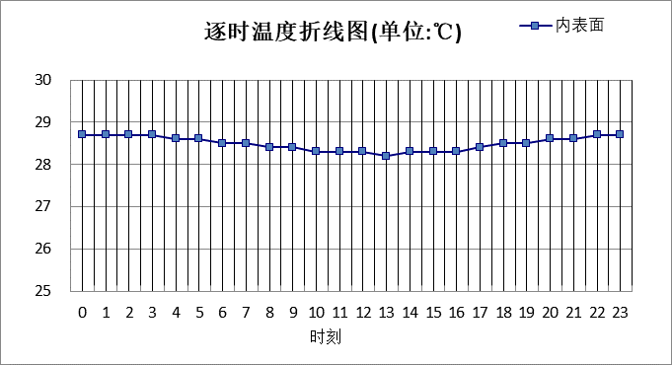

|  |  |  |  |  |  |  |  |  |  |  |  |
| --- | --- | --- | --- | --- | --- | --- | --- | --- | --- | --- | --- |
| 0:00 | 1:00 | 2:00 | 3:00 | 4:00 | 5:00 | 6:00 | 7:00 | 8:00 | 9:00 | 10:00 | 11:00 |
| 28.69 | 28.70 | 28.69 | 28.66 | 28.63 | 28.60 | 28.55 | 28.50 | 28.44 | 28.38 | 28.33 | 28.28 |
| 12:00 | 13:00 | 14:00 | 15:00 | 16:00 | 17:00 | 18:00 | 19:00 | 20:00 | 21:00 | 22:00 | 23:00 |
| 28.25 | 28.24 | 28.26 | 28.29 | 28.34 | 28.39 | 28.45 | 28.51 | 28.57 | 28.62 | 28.65 | 28.68 |

#### 空调房间：西向逐时温度

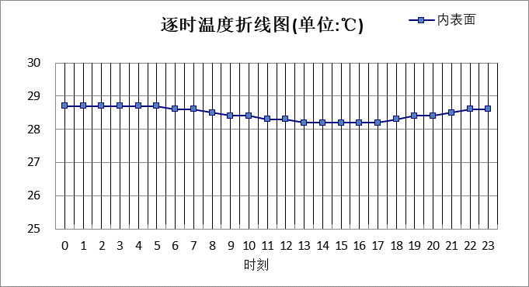

|  |  |  |  |  |  |  |  |  |  |  |  |
| --- | --- | --- | --- | --- | --- | --- | --- | --- | --- | --- | --- |
| 0:00 | 1:00 | 2:00 | 3:00 | 4:00 | 5:00 | 6:00 | 7:00 | 8:00 | 9:00 | 10:00 | 11:00 |
| 28.68 | 28.70 | 28.71 | 28.70 | 28.68 | 28.65 | 28.61 | 28.56 | 28.51 | 28.45 | 28.39 | 28.33 |
| 12:00 | 13:00 | 14:00 | 15:00 | 16:00 | 17:00 | 18:00 | 19:00 | 20:00 | 21:00 | 22:00 | 23:00 |
| 28.28 | 28.24 | 28.21 | 28.20 | 28.21 | 28.25 | 28.30 | 28.36 | 28.44 | 28.51 | 28.58 | 28.64 |

#### 空调房间：南向逐时温度

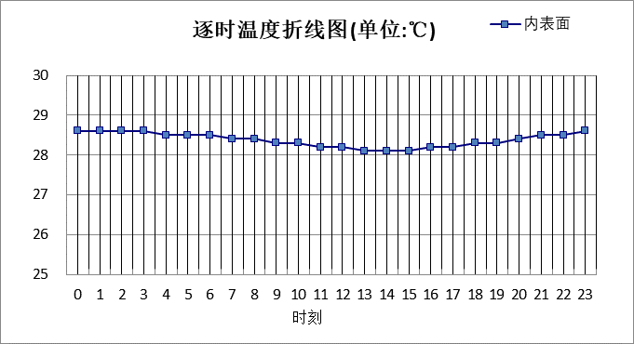

|  |  |  |  |  |  |  |  |  |  |  |  |
| --- | --- | --- | --- | --- | --- | --- | --- | --- | --- | --- | --- |
| 0:00 | 1:00 | 2:00 | 3:00 | 4:00 | 5:00 | 6:00 | 7:00 | 8:00 | 9:00 | 10:00 | 11:00 |
| 28.58 | 28.59 | 28.59 | 28.57 | 28.55 | 28.52 | 28.48 | 28.43 | 28.38 | 28.32 | 28.26 | 28.21 |
| 12:00 | 13:00 | 14:00 | 15:00 | 16:00 | 17:00 | 18:00 | 19:00 | 20:00 | 21:00 | 22:00 | 23:00 |
| 28.16 | 28.13 | 28.13 | 28.14 | 28.17 | 28.22 | 28.28 | 28.35 | 28.41 | 28.47 | 28.52 | 28.56 |

#### 空调房间：北向逐时温度

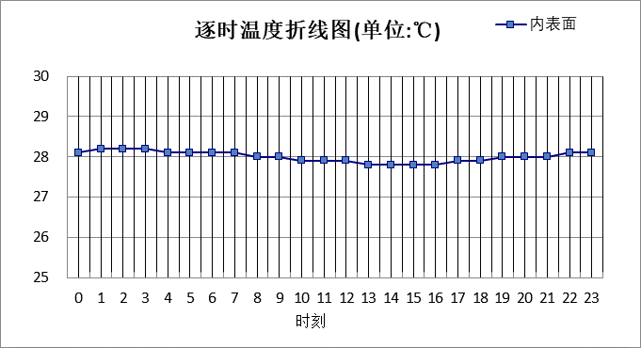

|  |  |  |  |  |  |  |  |  |  |  |  |
| --- | --- | --- | --- | --- | --- | --- | --- | --- | --- | --- | --- |
| 0:00 | 1:00 | 2:00 | 3:00 | 4:00 | 5:00 | 6:00 | 7:00 | 8:00 | 9:00 | 10:00 | 11:00 |
| 28.14 | 28.15 | 28.16 | 28.15 | 28.14 | 28.12 | 28.10 | 28.07 | 28.03 | 27.99 | 27.95 | 27.90 |
| 12:00 | 13:00 | 14:00 | 15:00 | 16:00 | 17:00 | 18:00 | 19:00 | 20:00 | 21:00 | 22:00 | 23:00 |
| 27.87 | 27.84 | 27.83 | 27.83 | 27.84 | 27.87 | 27.91 | 27.95 | 28.00 | 28.04 | 28.08 | 28.11 |

## 热桥柱构造

### 热桥柱构造一

|  |  |  |  |  |  |  |  |
| --- | --- | --- | --- | --- | --- | --- | --- |
| 材料名称 由外到内 | 厚度 | 差分 步长 | 导热 系数 | 蓄热 系数 | 修正 系数 | 热阻 | 热惰性 指标 |
| (mm) | (mm) | W/(m.K) | W/(㎡.K) | α | (㎡K)/W | D=R*S |
| 玻璃幕墙 | 120 | 8.6 | 0.760 | 10.773 | 1.00 | 0.158 | 1.701 |
| 岩棉板 | 55 | 6.9 | 0.045 | 0.684 | 1.20 | 1.019 | 0.836 |
| 水泥砂浆 | 20 | 10.0 | 0.930 | 11.306 | 1.00 | 0.022 | 0.243 |
| 重砂浆砌筑粘土砖砌体（1） | 200 | 9.5 | 0.810 | 10.551 | 1.00 | 0.247 | 2.605 |
| 混合砂浆 | 20 | 10.0 | 0.870 | 10.750 | 1.00 | 0.023 | 0.247 |
| 各层之和∑ | 415 | － | － | － | － | 1.468 | 5.632 |
| 差分时间步长(分钟) | 5.0 | | | | | | |
| 外表面太阳辐射吸收系数 | 0.73 | | | | | | |
| 传热系数K=1/(0.16+∑R) | 0.61 | | | | | | |
| 重质/轻质 | 重质围护结构 | | | | | | |

#### 空调房间：东向逐时温度

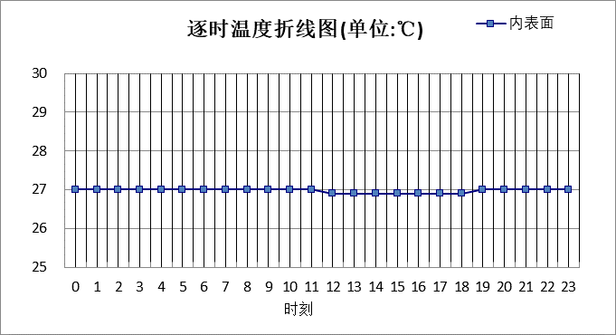

|  |  |  |  |  |  |  |  |  |  |  |  |
| --- | --- | --- | --- | --- | --- | --- | --- | --- | --- | --- | --- |
| 0:00 | 1:00 | 2:00 | 3:00 | 4:00 | 5:00 | 6:00 | 7:00 | 8:00 | 9:00 | 10:00 | 11:00 |
| 27.01 | 27.01 | 27.02 | 27.02 | 27.02 | 27.02 | 27.01 | 27.00 | 27.00 | 26.98 | 26.97 | 26.96 |
| 12:00 | 13:00 | 14:00 | 15:00 | 16:00 | 17:00 | 18:00 | 19:00 | 20:00 | 21:00 | 22:00 | 23:00 |
| 26.95 | 26.94 | 26.93 | 26.93 | 26.93 | 26.94 | 26.95 | 26.96 | 26.97 | 26.98 | 26.99 | 27.00 |

#### 空调房间：西向逐时温度

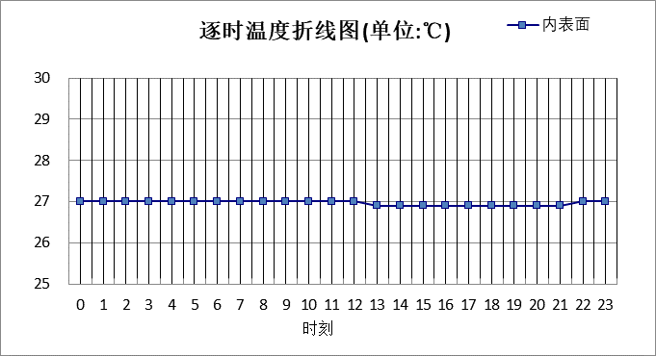

|  |  |  |  |  |  |  |  |  |  |  |  |
| --- | --- | --- | --- | --- | --- | --- | --- | --- | --- | --- | --- |
| 0:00 | 1:00 | 2:00 | 3:00 | 4:00 | 5:00 | 6:00 | 7:00 | 8:00 | 9:00 | 10:00 | 11:00 |
| 26.98 | 27.00 | 27.00 | 27.01 | 27.02 | 27.02 | 27.01 | 27.01 | 27.00 | 26.99 | 26.98 | 26.97 |
| 12:00 | 13:00 | 14:00 | 15:00 | 16:00 | 17:00 | 18:00 | 19:00 | 20:00 | 21:00 | 22:00 | 23:00 |
| 26.96 | 26.95 | 26.94 | 26.93 | 26.92 | 26.92 | 26.92 | 26.92 | 26.93 | 26.95 | 26.96 | 26.97 |

#### 空调房间：南向逐时温度

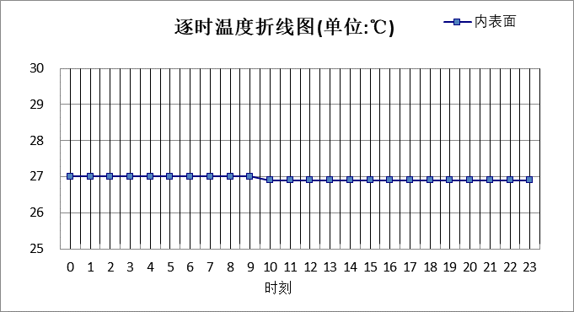

|  |  |  |  |  |  |  |  |  |  |  |  |
| --- | --- | --- | --- | --- | --- | --- | --- | --- | --- | --- | --- |
| 0:00 | 1:00 | 2:00 | 3:00 | 4:00 | 5:00 | 6:00 | 7:00 | 8:00 | 9:00 | 10:00 | 11:00 |
| 26.96 | 26.96 | 26.97 | 26.97 | 26.98 | 26.98 | 26.97 | 26.97 | 26.96 | 26.95 | 26.94 | 26.93 |
| 12:00 | 13:00 | 14:00 | 15:00 | 16:00 | 17:00 | 18:00 | 19:00 | 20:00 | 21:00 | 22:00 | 23:00 |
| 26.92 | 26.90 | 26.90 | 26.89 | 26.89 | 26.89 | 26.89 | 26.90 | 26.91 | 26.92 | 26.94 | 26.95 |

#### 空调房间：北向逐时温度



|  |  |  |  |  |  |  |  |  |  |  |  |
| --- | --- | --- | --- | --- | --- | --- | --- | --- | --- | --- | --- |
| 0:00 | 1:00 | 2:00 | 3:00 | 4:00 | 5:00 | 6:00 | 7:00 | 8:00 | 9:00 | 10:00 | 11:00 |
| 26.80 | 26.81 | 26.81 | 26.81 | 26.82 | 26.82 | 26.82 | 26.81 | 26.81 | 26.80 | 26.80 | 26.79 |
| 12:00 | 13:00 | 14:00 | 15:00 | 16:00 | 17:00 | 18:00 | 19:00 | 20:00 | 21:00 | 22:00 | 23:00 |
| 26.78 | 26.77 | 26.76 | 26.76 | 26.76 | 26.75 | 26.76 | 26.76 | 26.77 | 26.77 | 26.78 | 26.79 |

# 验算结论

## 空调房间

|  |  |  |  |  |  |
| --- | --- | --- | --- | --- | --- |
| 类型 | 构造 | 时刻 | 最高温度(℃) | 限值(℃) | 结论 |
| 屋顶 | 上:屋顶构造一 | 22:50 | 27.26 | 28.50 | 满足 |
| 外墙 | 东:砖墙（外保温） | 23:15 | 26.98 | 28.00 | 满足 |
| 西:砖墙（外保温） | 0:35 | 26.98 | 28.00 | 满足 |
| 南:砖墙（外保温） | 23:50 | 26.94 | 28.00 | 满足 |
| 北:砖墙（外保温） | 0:40 | 26.78 | 28.00 | 满足 |
| 东:光伏+筒仓 | 2:55 | 26.96 | 28.00 | 满足 |
| 西:光伏+筒仓 | 4:20 | 26.95 | 28.00 | 满足 |
| 南:光伏+筒仓 | 3:40 | 26.92 | 28.00 | 满足 |
| 北:光伏+筒仓 | 4:25 | 26.77 | 28.00 | 满足 |
| 东:筒仓（内保温） | 18:15 | 27.39 | 28.00 | 满足 |
| 西:筒仓（内保温） | 19:25 | 27.45 | 28.00 | 满足 |
| 南:筒仓（内保温） | 18:30 | 27.36 | 28.00 | 满足 |
| 北:筒仓（内保温） | 19:10 | 27.11 | 28.00 | 满足 |
| 东:活动墙 | 11:15 | 26.77 | 28.00 | 满足 |
| 西:活动墙 | 12:50 | 26.77 | 28.00 | 满足 |
| 南:活动墙 | 12:05 | 26.74 | 28.00 | 满足 |
| 北:活动墙 | 12:40 | 26.62 | 28.00 | 满足 |
| 东:筒仓（钢筋混凝土） | 17:00 | 32.87 | 29.00 | 不满足 |
| 西:筒仓（钢筋混凝土） | 18:25 | 33.38 | 29.00 | 不满足 |
| 南:筒仓（钢筋混凝土） | 17:20 | 32.83 | 29.00 | 不满足 |
| 北:筒仓（钢筋混凝土） | 18:05 | 31.47 | 29.00 | 不满足 |
| 东:砖墙+光伏幕墙 | 0:35 | 28.70 | 28.00 | 不满足 |
| 西:砖墙+光伏幕墙 | 2:00 | 28.71 | 28.00 | 不满足 |
| 南:砖墙+光伏幕墙 | 1:15 | 28.59 | 28.00 | 不满足 |
| 北:砖墙+光伏幕墙 | 2:05 | 28.16 | 28.00 | 不满足 |
| 热桥柱 | 东:热桥柱构造一 | 3:25 | 27.02 | 28.00 | 满足 |
| 西:热桥柱构造一 | 4:50 | 27.02 | 28.00 | 满足 |
| 南:热桥柱构造一 | 4:10 | 26.98 | 28.00 | 满足 |
| 北:热桥柱构造一 | 4:55 | 26.82 | 28.00 | 满足 |