**南昌某幼儿园**

**全年负荷计算书**

|  |  |
| --- | --- |
| 工程名称 | 南昌某幼儿园 |
| 设计编号 |  |
| 建设单位 |  |
| 设计单位 |  |
| 计 算 人 |  |
| 校 对 人 |  |
| 审 核 人 |  |
| 计算日期 | 2024年12月11日 |



|  |  |
| --- | --- |
| 采用软件 | 暖通负荷BECH2024 |
| 软件版本 | 20240430(SP1) |
| 研发单位 | 北京绿建软件股份有限公司 |
| 正版授权码 | T18270851291 |

**目 录**

1 建筑概况 1

2 气象数据 1

2.1 气象地点 1

2.2 逐日干球温度表 1

2.3 逐月辐照量表 2

2.4 峰值工况 2

3 软件介绍 2

4 围护结构 2

4.1 屋顶构造 2

4.1.1 屋顶构造一 2

4.2 外墙构造 3

4.2.1 外墙构造一 3

4.3 楼板构造 3

4.3.1 控温房间楼板构造一 3

4.4 非周边地面构造 3

4.4.1 非周边地面构造一 3

4.5 门构造 4

4.6 窗构造 4

5 房间类型 4

5.1 房间参数表 4

5.2 作息时间表 5

6 系统设置 5

6.1 系统划分 5

6.2 运行时间表 5

7 计算结果 5

7.1 模拟周期 5

7.2 全年冷暖需求 5

7.3 负荷分项统计 6

7.4 逐月负荷表 6

8 附录 8

# 建筑概况

|  |  |  |
| --- | --- | --- |
| 地理位置 | 江西-南昌 | |
| 气候分区 | 夏热冬冷A区 | |
| 北纬 | 28.68 | |
| 东经 | 115.86 | |
| 建筑名称 | 南昌某幼儿园 | |
| 建筑类型 | 公共建筑 |  |
| 建筑面积 | 地上 2593.79 ㎡ | 地下 0.00 ㎡ |
| 建筑高度 | 地上 11.70 m | 地下0.00 |
| 建筑层数 | 地上 3 | 地下 0 |
| 北向角度 | 90° | |

# 气象数据

## 气象地点

江西-南昌, 《建筑节能气象参数标准》JGJ346-2014

## 逐日干球温度表

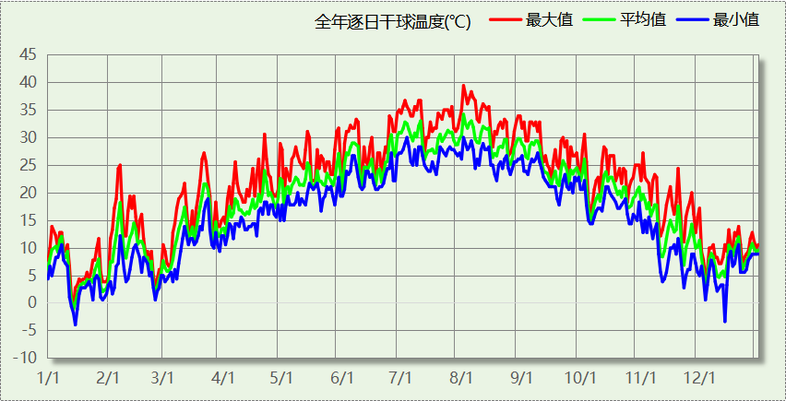

## 逐月辐照量表

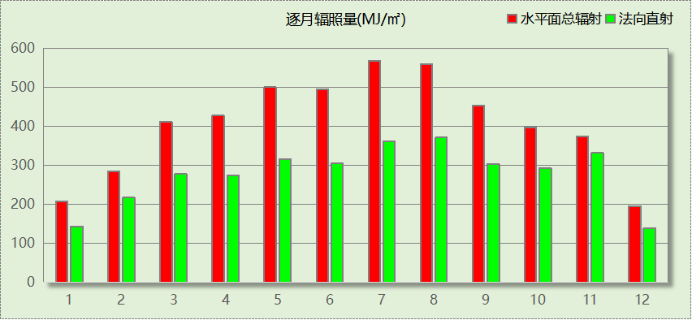

## 峰值工况

|  |  |  |  |  |  |
| --- | --- | --- | --- | --- | --- |
| 气象数据 | 时刻 | 干球温度(℃) | 湿球温度(℃) | 含湿量(g/kg) | 焓值(kj/kg) |
| 最热 | 08月01日15时 | 39.4 | 27.8 | 19.3 | 89.3 |
| 最冷 | 01月14日08时 | -3.9 | -3.9 | 2.7 | 2.8 |

# 软件介绍

本报告采用的软件为绿建暖通负荷BECH2024，该软件紧密结合暖通和节能设计规范、可根据项目实际情况建立建筑热工模型，并可对围护结构材料、房间内扰发热、作息时间表、热回收方式等参数进行设置。

软件包含全国各地典型气象年数据，内置DOE2.1E内核，对于建筑的逐时负荷进行动态模拟，既可以模拟8760小时理想负荷，也可以根据设定好的采暖期/空调期进行逐时模拟。

软件还支持分析全年建筑能耗的来源构成，依据日射得热、新风负荷、围护传热和内扰得热进行归类分项，生成设计建筑全年负荷计算报告书，提供详实的数据和多样的图表，为设计师在设备选型、制定运行策略等方面提供参考和帮助。

# 围护结构

## 屋顶构造

### 屋顶构造一

|  |  |  |  |  |  |  |
| --- | --- | --- | --- | --- | --- | --- |
| 材料名称 （由上到下） | 厚度δ | 导热系数λ | 蓄热系数S | 修正 系数 | 热阻R | 热惰性 指标 |
| (mm) | W/(m.K) | W/(㎡.K) | α | (㎡K)/W | D=R*S |
| 改性粉煤灰保温砂浆 | 25 | 0.035 | 1.070 | 1.00 | 0.714 | 0.764 |
| 沥青油毡、油毡纸 | 10 | 0.170 | 3.302 | 1.00 | 0.059 | 0.194 |
| 膨胀矿渣珠混凝土(ρ=2000) | 30 | 0.770 | 10.369 | 1.00 | 0.039 | 0.404 |
| 挤塑聚苯板（1） | 90 | 0.033 | 0.347 | 1.00 | 2.727 | 0.946 |
| 加气混凝土、泡沫混凝土(ρ=300) | 120 | 0.100 | 1.514 | 1.00 | 1.200 | 1.817 |
| 各层之和∑ | 275 | － | － | － | 4.739 | 4.126 |
| 传热系数K=1/(0.15+∑R) | 0.21 | | | | | |

## 外墙构造

### 外墙构造一

|  |  |  |  |  |  |  |
| --- | --- | --- | --- | --- | --- | --- |
| 材料名称 （由外到内） | 厚度δ | 导热系数λ | 蓄热系数S | 修正 系数 | 热阻R | 热惰性 指标 |
| (mm) | W/(m.K) | W/(㎡.K) | α | (㎡K)/W | D=R*S |
| 改性粉煤灰保温砂浆 | 5 | 0.035 | 1.070 | 1.00 | 0.143 | 0.153 |
| 岩棉板(ρ=60-160) | 10 | 0.041 | 0.615 | 1.00 | 0.244 | 0.150 |
| 蒸压砂加气混凝土砌块b06 | 150 | 0.160 | 3.280 | 1.25 | 0.750 | 3.075 |
| 加气混凝土、泡沫混凝土(ρ=300) | 100 | 0.100 | 1.514 | 1.00 | 1.000 | 1.514 |
| 水泥砂浆 | 20 | 0.930 | 11.370 | 1.00 | 0.022 | 0.245 |
| 各层之和∑ | 285 | － | － | － | 2.158 | 5.136 |
| 传热系数K=1/(0.15+∑R) | 0.43 | | | | | |

## 楼板构造

### 控温房间楼板构造一

|  |  |  |  |  |  |  |
| --- | --- | --- | --- | --- | --- | --- |
| 材料名称 | 厚度δ | 导热系数λ | 蓄热系数S | 修正 系数 | 热阻R | 热惰性 指标 |
| (mm) | W/(m.K) | W/(㎡.K) | α | (㎡K)/W | D=R*S |
| 水泥砂浆（1） | 15 | 0.930 | 11.306 | 1.00 | 0.016 | 0.182 |
| 砂加气砌块（B05级） | 200 | 0.194 | 3.335 | 1.00 | 1.031 | 3.438 |
| 水泥砂浆（1） | 15 | 0.930 | 11.306 | 1.00 | 0.016 | 0.182 |
| 各层之和∑ | 230 | － | － | － | 1.063 | 3.803 |
| 传热系数K=1/(0.22+∑R) | 0.78 | | | | | |
| 修正后K, D | K = 0.82, D = 3.28 | | | | | |
| 修正原因 |  | | | | | |

## 非周边地面构造

### 非周边地面构造一

|  |  |  |  |  |  |  |
| --- | --- | --- | --- | --- | --- | --- |
| 材料名称 | 厚度δ | 导热系数λ | 蓄热系数S | 修正 系数 | 热阻R | 热惰性 指标 |
| (mm) | W/(m.K) | W/(㎡.K) | α | (㎡K)/W | D=R*S |
| 水泥砂浆 | 20 | 0.930 | 11.370 | 1.00 | 0.022 | 0.245 |
| 加气混凝土、泡沫混凝土(ρ=300) | 120 | 0.100 | 1.514 | 1.00 | 1.200 | 1.817 |
| 各层之和∑ | 140 | － | － | － | 1.222 | 2.061 |
| 传热系数K=1/(0.11+∑R) | 0.22 | | | | | |

## 门构造

|  |  |  |  |
| --- | --- | --- | --- |
| 序号 | 构造名称 | 传热系数 | 备注 |
| 1 | 保温门（多功能门） | 1.972 |  |

## 窗构造

|  |  |  |  |  |  |
| --- | --- | --- | --- | --- | --- |
| 序号 | 构造名称 | 传热系数 | 窗遮阳系数 | 可见光透射比 | 备注 |
| 1 | Low-E中空玻璃窗高 | 2.400 | 0.251 | 0.710 |  |

# 房间类型

## 房间参数表

|  |  |  |  |  |  |  |
| --- | --- | --- | --- | --- | --- | --- |
| 房间类型 | 空调温度 ℃ | 供暖温度 ℃ | 新风量 | 人员密度 | 照明功率 密度 | 电器设备 功率 |
| 主食库 | － | － | 0(m^3/h.人) | 0(m^2/人) | 10(W/m^2) | 0(W/m^2) |
| 会议室 | 26 | 22 | 30(m^3/h.人) | 6(人) | 8(W/m^2) | 5(W/m^2) |
| 储藏间 | － | － | 0(m^3/h.人) | 0(m^2/人) | 9(W/m^2) | 5(W/m^2) |
| 冷库 | 0 | 0 | 0(m^3/h.人) | 0(m^2/人) | 10(W/m^2) | 0(W/m^2) |
| 副食库 | － | － | 0(m^3/h.人) | 0(m^2/人) | 10(W/m^2) | 5(W/m^2) |
| 卫生间 | 26 | 22 | 0(m^3/h.人) | 6(人) | 5(W/m^2) | 5(W/m^2) |
| 厨房 | 27 | 22 | 0(次/h) | 4(人) | 8(W/m^2) | 5(W/m^2) |
| 开水间 | 26 | 18 | 0(m^3/h.人) | 2(人) | 9(W/m^2) | 5(W/m^2) |
| 教具制作室 | － | － | 30(m^3/h.人) | 4(人) | 9(W/m^2) | 5(W/m^2) |
| 普通办公室 | 26 | 22 | 30(m^3/h.人) | 6(人) | 8(W/m^2) | 5(W/m^2) |
| 普通教室 | 26 | 22 | 30(m^3/h.人) | 30(人) | 8(W/m^2) | 5(W/m^2) |
| 更衣室 | 26 | 20 | 30(m^3/h.人) | 2(人) | 5(W/m^2) | 5(W/m^2) |
| 洗消间 | － | － | 0(m^3/h.人) | 1(人) | 10(W/m^2) | 5(W/m^2) |
| 消毒室 | － | － | 0(m^3/h.人) | 0(m^2/人) | 9(W/m^2) | 5(W/m^2) |
| 空房间 | － | － | 20(m^3/h.人) | 0(人) | 0(W/m^2) | 0(W/m^2) |
| 设备间 | － | － | 0(次/h) | 0(人) | 6(W/m^2) | 15(W/m^2) |
| 走廊 | － | － | 0(m^3/h.人) | 0(人) | 5(W/m^2) | 5(W/m^2) |
| 配电间 | － | － | 0(m^3/h.人) | 0(m^2/人) | 10(W/m^2) | 5(W/m^2) |
| 阅览室 | 26 | 22 | 30(m^3/h.人) | 30(人) | 8(W/m^2) | 5(W/m^2) |

## 作息时间表

详见附录

# 系统设置

## 系统划分

|  |  |  |  |  |  |  |
| --- | --- | --- | --- | --- | --- | --- |
| 系统编号 | 热回收 类型 | 启动 条件 | 回收 效率 | 排风 比例 | 面积(m2) | 包含的房间 |
| 默认 | 无 | -- | -- | -- | 2203.06 | 所有房间 |

## 运行时间表

详见附录

# 计算结果

## 模拟周期

供冷季(6.14-9.30) 供暖季(11.30-2.28)

## 全年冷暖需求

|  |  |  |  |  |
| --- | --- | --- | --- | --- |
| 系统名称\负荷 | 供暖需求 (kWh) | 供暖指标 (kWh/㎡·a) | 供冷需求 (kWh) | 供冷指标 (kWh/㎡·a) |
| 建筑总计 | 36049 | 13.90 | 179373 | 69.15 |

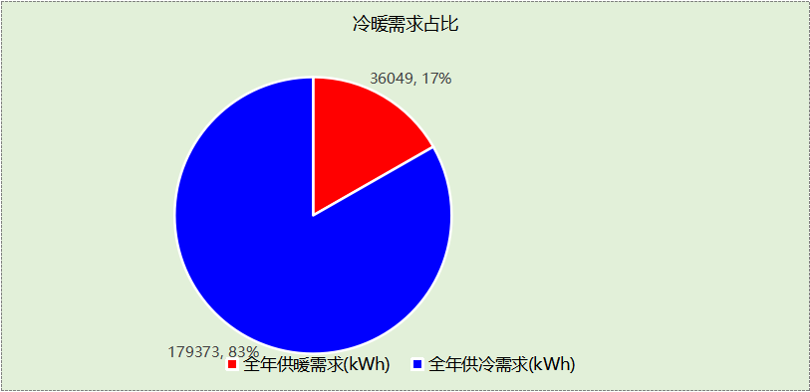

## 负荷分项统计

|  |  |  |  |  |  |  |
| --- | --- | --- | --- | --- | --- | --- |
| 分类 | 围护传热 | 室内得热 | 窗日射 | 新风/渗透 | 热回收 | 合计 |
| 供暖(kWh/㎡) | -5.57 | 8.48 | 0.96 | -17.77 | 0.00 | -13.90 |
| 供冷(kWh/㎡) | 12.23 | 19.25 | 1.79 | 35.88 | 0.00 | 69.15 |

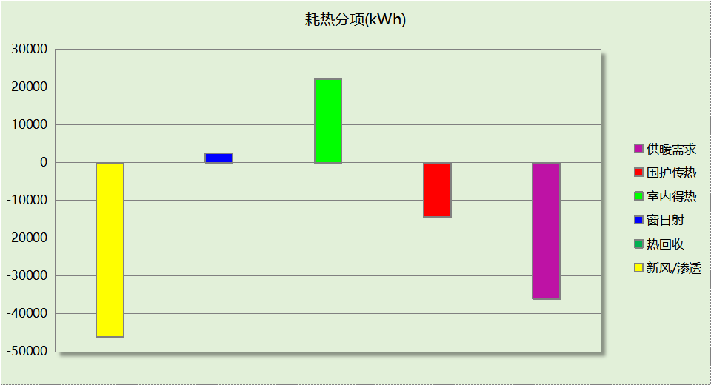

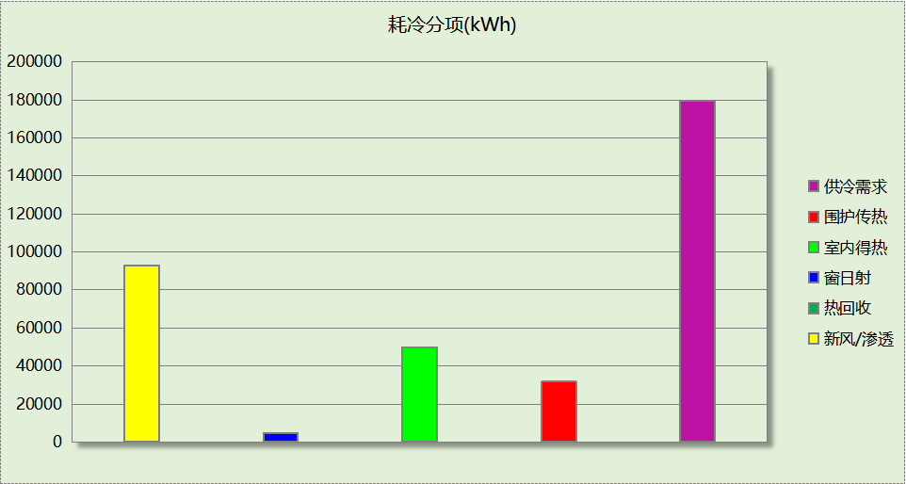

## 逐月负荷表

|  |  |  |  |  |  |  |
| --- | --- | --- | --- | --- | --- | --- |
| 月份 | 供暖(kWh) | 供冷(kWh) | 热负荷 峰值(kW) | 热负荷 峰值时刻 | 冷负荷 峰值(kW) | 冷负荷 峰值时刻 |
| 1月 | 18179 | 0 | 175.252 | 1月14日7时 | 0.000 | -- |
| 2月 | 7567 | 0 | 131.560 | 2月25日7时 | 0.000 | -- |
| 3月 | 0 | 0 | 0.000 | -- | 0.000 | -- |
| 4月 | 0 | 0 | 0.000 | -- | 0.000 | -- |
| 5月 | 0 | 0 | 0.000 | -- | 0.000 | -- |
| 6月 | 0 | 26526 | 0.000 | -- | 447.301 | 6月14日7时 |
| 7月 | 0 | 62245 | 0.000 | -- | 269.554 | 7月2日8时 |
| 8月 | 0 | 55774 | 0.000 | -- | 285.164 | 8月5日10时 |
| 9月 | 0 | 34827 | 0.000 | -- | 226.262 | 9月9日14时 |
| 10月 | 0 | 0 | 0.000 | -- | 0.000 | -- |
| 11月 | 0 | 0 | 0.000 | -- | 0.000 | -- |
| 12月 | 10303 | 0 | 115.232 | 12月9日7时 | 0.000 | -- |

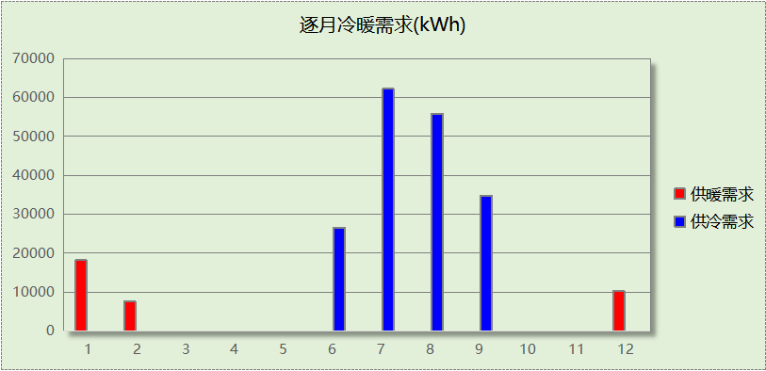

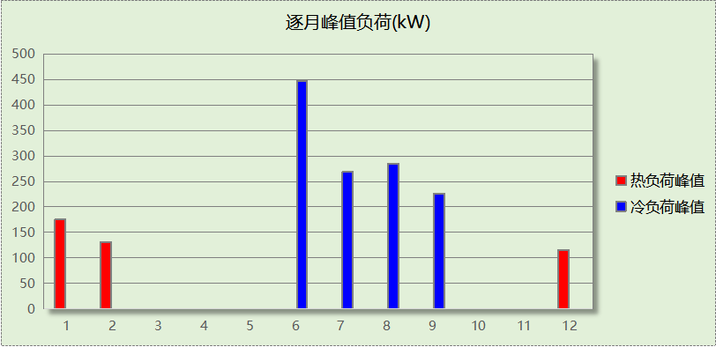

# 附录

**工作日/节假日人员逐时在室率(%)**

|  |  |  |  |  |  |  |  |  |  |  |  |  |  |  |  |  |  |  |  |  |  |  |  |  |
| --- | --- | --- | --- | --- | --- | --- | --- | --- | --- | --- | --- | --- | --- | --- | --- | --- | --- | --- | --- | --- | --- | --- | --- | --- |
| 房间类型 | 1 | 2 | 3 | 4 | 5 | 6 | 7 | 8 | 9 | 10 | 11 | 12 | 13 | 14 | 15 | 16 | 17 | 18 | 19 | 20 | 21 | 22 | 23 | 24 |
| 主食库 | 0 | 0 | 0 | 0 | 0 | 0 | 10 | 50 | 95 | 95 | 95 | 80 | 80 | 95 | 95 | 95 | 95 | 30 | 30 | 0 | 0 | 0 | 0 | 0 |
| 0 | 0 | 0 | 0 | 0 | 0 | 0 | 0 | 0 | 0 | 0 | 0 | 0 | 0 | 0 | 0 | 0 | 0 | 0 | 0 | 0 | 0 | 0 | 0 |
| 会议室 | 0 | 0 | 0 | 0 | 0 | 0 | 10 | 50 | 95 | 95 | 95 | 80 | 80 | 95 | 95 | 95 | 95 | 30 | 30 | 0 | 0 | 0 | 0 | 0 |
| 0 | 0 | 0 | 0 | 0 | 0 | 0 | 0 | 0 | 0 | 0 | 0 | 0 | 0 | 0 | 0 | 0 | 0 | 0 | 0 | 0 | 0 | 0 | 0 |
| 储藏间 | 0 | 0 | 0 | 0 | 0 | 0 | 10 | 50 | 95 | 95 | 95 | 80 | 80 | 95 | 95 | 95 | 95 | 30 | 30 | 0 | 0 | 0 | 0 | 0 |
| 0 | 0 | 0 | 0 | 0 | 0 | 0 | 0 | 0 | 0 | 0 | 0 | 0 | 0 | 0 | 0 | 0 | 0 | 0 | 0 | 0 | 0 | 0 | 0 |
| 冷库 | 0 | 0 | 0 | 0 | 0 | 0 | 10 | 50 | 95 | 95 | 95 | 80 | 80 | 95 | 95 | 95 | 95 | 30 | 30 | 0 | 0 | 0 | 0 | 0 |
| 0 | 0 | 0 | 0 | 0 | 0 | 0 | 0 | 0 | 0 | 0 | 0 | 0 | 0 | 0 | 0 | 0 | 0 | 0 | 0 | 0 | 0 | 0 | 0 |
| 副食库 | 0 | 0 | 0 | 0 | 0 | 0 | 10 | 50 | 95 | 95 | 95 | 80 | 80 | 95 | 95 | 95 | 95 | 30 | 30 | 0 | 0 | 0 | 0 | 0 |
| 0 | 0 | 0 | 0 | 0 | 0 | 0 | 0 | 0 | 0 | 0 | 0 | 0 | 0 | 0 | 0 | 0 | 0 | 0 | 0 | 0 | 0 | 0 | 0 |
| 卫生间 | 0 | 0 | 0 | 0 | 0 | 0 | 10 | 50 | 95 | 95 | 95 | 80 | 80 | 95 | 95 | 95 | 95 | 30 | 30 | 0 | 0 | 0 | 0 | 0 |
| 0 | 0 | 0 | 0 | 0 | 0 | 0 | 0 | 0 | 0 | 0 | 0 | 0 | 0 | 0 | 0 | 0 | 0 | 0 | 0 | 0 | 0 | 0 | 0 |
| 厨房 | 0 | 0 | 0 | 0 | 0 | 0 | 10 | 50 | 95 | 95 | 95 | 80 | 80 | 95 | 95 | 95 | 95 | 30 | 30 | 0 | 0 | 0 | 0 | 0 |
| 0 | 0 | 0 | 0 | 0 | 0 | 0 | 0 | 0 | 0 | 0 | 0 | 0 | 0 | 0 | 0 | 0 | 0 | 0 | 0 | 0 | 0 | 0 | 0 |
| 开水间 | 0 | 0 | 0 | 0 | 0 | 0 | 10 | 50 | 95 | 95 | 95 | 80 | 80 | 95 | 95 | 95 | 95 | 30 | 30 | 0 | 0 | 0 | 0 | 0 |
| 0 | 0 | 0 | 0 | 0 | 0 | 0 | 0 | 0 | 0 | 0 | 0 | 0 | 0 | 0 | 0 | 0 | 0 | 0 | 0 | 0 | 0 | 0 | 0 |
| 教具制作室 | 0 | 0 | 0 | 0 | 0 | 0 | 10 | 50 | 95 | 95 | 95 | 80 | 80 | 95 | 95 | 95 | 95 | 30 | 30 | 0 | 0 | 0 | 0 | 0 |
| 0 | 0 | 0 | 0 | 0 | 0 | 0 | 0 | 0 | 0 | 0 | 0 | 0 | 0 | 0 | 0 | 0 | 0 | 0 | 0 | 0 | 0 | 0 | 0 |
| 普通办公室 | 0 | 0 | 0 | 0 | 0 | 0 | 10 | 50 | 95 | 95 | 95 | 80 | 80 | 95 | 95 | 95 | 95 | 30 | 30 | 0 | 0 | 0 | 0 | 0 |
| 0 | 0 | 0 | 0 | 0 | 0 | 0 | 0 | 0 | 0 | 0 | 0 | 0 | 0 | 0 | 0 | 0 | 0 | 0 | 0 | 0 | 0 | 0 | 0 |
| 普通教室 | 0 | 0 | 0 | 0 | 0 | 0 | 10 | 50 | 95 | 95 | 95 | 80 | 80 | 95 | 95 | 95 | 95 | 30 | 30 | 0 | 0 | 0 | 0 | 0 |
| 0 | 0 | 0 | 0 | 0 | 0 | 0 | 0 | 0 | 0 | 0 | 0 | 0 | 0 | 0 | 0 | 0 | 0 | 0 | 0 | 0 | 0 | 0 | 0 |
| 更衣室 | 0 | 0 | 0 | 0 | 0 | 0 | 10 | 50 | 95 | 95 | 95 | 80 | 80 | 95 | 95 | 95 | 95 | 30 | 30 | 0 | 0 | 0 | 0 | 0 |
| 0 | 0 | 0 | 0 | 0 | 0 | 0 | 0 | 0 | 0 | 0 | 0 | 0 | 0 | 0 | 0 | 0 | 0 | 0 | 0 | 0 | 0 | 0 | 0 |
| 洗消间 | 0 | 0 | 0 | 0 | 0 | 0 | 10 | 50 | 95 | 95 | 95 | 80 | 80 | 95 | 95 | 95 | 95 | 30 | 30 | 0 | 0 | 0 | 0 | 0 |
| 0 | 0 | 0 | 0 | 0 | 0 | 0 | 0 | 0 | 0 | 0 | 0 | 0 | 0 | 0 | 0 | 0 | 0 | 0 | 0 | 0 | 0 | 0 | 0 |
| 消毒室 | 0 | 0 | 0 | 0 | 0 | 0 | 10 | 50 | 95 | 95 | 95 | 80 | 80 | 95 | 95 | 95 | 95 | 30 | 30 | 0 | 0 | 0 | 0 | 0 |
| 0 | 0 | 0 | 0 | 0 | 0 | 0 | 0 | 0 | 0 | 0 | 0 | 0 | 0 | 0 | 0 | 0 | 0 | 0 | 0 | 0 | 0 | 0 | 0 |
| 空房间 | 0 | 0 | 0 | 0 | 0 | 0 | 0 | 20 | 50 | 80 | 80 | 80 | 80 | 80 | 80 | 80 | 80 | 80 | 80 | 70 | 50 | 0 | 0 | 0 |
| 0 | 0 | 0 | 0 | 0 | 0 | 0 | 0 | 0 | 0 | 0 | 0 | 0 | 0 | 0 | 0 | 0 | 0 | 0 | 0 | 0 | 0 | 0 | 0 |
| 设备间 | 0 | 0 | 0 | 0 | 0 | 0 | 0 | 0 | 0 | 0 | 0 | 0 | 0 | 0 | 0 | 0 | 0 | 0 | 0 | 0 | 0 | 0 | 0 | 0 |
| 0 | 0 | 0 | 0 | 0 | 0 | 0 | 0 | 0 | 0 | 0 | 0 | 0 | 0 | 0 | 0 | 0 | 0 | 0 | 0 | 0 | 0 | 0 | 0 |
| 走廊 | 0 | 0 | 0 | 0 | 0 | 0 | 10 | 50 | 95 | 95 | 95 | 80 | 80 | 95 | 95 | 95 | 95 | 30 | 30 | 0 | 0 | 0 | 0 | 0 |
| 0 | 0 | 0 | 0 | 0 | 0 | 0 | 0 | 0 | 0 | 0 | 0 | 0 | 0 | 0 | 0 | 0 | 0 | 0 | 0 | 0 | 0 | 0 | 0 |
| 配电间 | 0 | 0 | 0 | 0 | 0 | 0 | 10 | 50 | 95 | 95 | 95 | 80 | 80 | 95 | 95 | 95 | 95 | 30 | 30 | 0 | 0 | 0 | 0 | 0 |
| 0 | 0 | 0 | 0 | 0 | 0 | 0 | 0 | 0 | 0 | 0 | 0 | 0 | 0 | 0 | 0 | 0 | 0 | 0 | 0 | 0 | 0 | 0 | 0 |
| 阅览室 | 0 | 0 | 0 | 0 | 0 | 0 | 10 | 50 | 95 | 95 | 95 | 80 | 80 | 95 | 95 | 95 | 95 | 30 | 30 | 0 | 0 | 0 | 0 | 0 |
| 0 | 0 | 0 | 0 | 0 | 0 | 0 | 0 | 0 | 0 | 0 | 0 | 0 | 0 | 0 | 0 | 0 | 0 | 0 | 0 | 0 | 0 | 0 | 0 |

注：上行：工作日；下行：节假日

**工作日/节假日照明开关时间表(%)**

|  |  |  |  |  |  |  |  |  |  |  |  |  |  |  |  |  |  |  |  |  |  |  |  |  |
| --- | --- | --- | --- | --- | --- | --- | --- | --- | --- | --- | --- | --- | --- | --- | --- | --- | --- | --- | --- | --- | --- | --- | --- | --- |
| 房间类型 | 1 | 2 | 3 | 4 | 5 | 6 | 7 | 8 | 9 | 10 | 11 | 12 | 13 | 14 | 15 | 16 | 17 | 18 | 19 | 20 | 21 | 22 | 23 | 24 |
| 主食库 | 0 | 0 | 0 | 0 | 0 | 0 | 10 | 50 | 95 | 95 | 95 | 80 | 80 | 95 | 95 | 95 | 95 | 30 | 30 | 0 | 0 | 0 | 0 | 0 |
| 0 | 0 | 0 | 0 | 0 | 0 | 0 | 0 | 0 | 0 | 0 | 0 | 0 | 0 | 0 | 0 | 0 | 0 | 0 | 0 | 0 | 0 | 0 | 0 |
| 会议室 | 0 | 0 | 0 | 0 | 0 | 0 | 10 | 50 | 95 | 95 | 95 | 80 | 80 | 95 | 95 | 95 | 95 | 30 | 30 | 0 | 0 | 0 | 0 | 0 |
| 0 | 0 | 0 | 0 | 0 | 0 | 0 | 0 | 0 | 0 | 0 | 0 | 0 | 0 | 0 | 0 | 0 | 0 | 0 | 0 | 0 | 0 | 0 | 0 |
| 储藏间 | 0 | 0 | 0 | 0 | 0 | 0 | 10 | 50 | 95 | 95 | 95 | 80 | 80 | 95 | 95 | 95 | 95 | 30 | 30 | 0 | 0 | 0 | 0 | 0 |
| 0 | 0 | 0 | 0 | 0 | 0 | 0 | 0 | 0 | 0 | 0 | 0 | 0 | 0 | 0 | 0 | 0 | 0 | 0 | 0 | 0 | 0 | 0 | 0 |
| 冷库 | 0 | 0 | 0 | 0 | 0 | 0 | 10 | 50 | 95 | 95 | 95 | 80 | 80 | 95 | 95 | 95 | 95 | 30 | 30 | 0 | 0 | 0 | 0 | 0 |
| 0 | 0 | 0 | 0 | 0 | 0 | 0 | 0 | 0 | 0 | 0 | 0 | 0 | 0 | 0 | 0 | 0 | 0 | 0 | 0 | 0 | 0 | 0 | 0 |
| 副食库 | 0 | 0 | 0 | 0 | 0 | 0 | 10 | 50 | 95 | 95 | 95 | 80 | 80 | 95 | 95 | 95 | 95 | 30 | 30 | 0 | 0 | 0 | 0 | 0 |
| 0 | 0 | 0 | 0 | 0 | 0 | 0 | 0 | 0 | 0 | 0 | 0 | 0 | 0 | 0 | 0 | 0 | 0 | 0 | 0 | 0 | 0 | 0 | 0 |
| 卫生间 | 0 | 0 | 0 | 0 | 0 | 0 | 10 | 50 | 95 | 95 | 95 | 80 | 80 | 95 | 95 | 95 | 95 | 30 | 30 | 0 | 0 | 0 | 0 | 0 |
| 0 | 0 | 0 | 0 | 0 | 0 | 0 | 0 | 0 | 0 | 0 | 0 | 0 | 0 | 0 | 0 | 0 | 0 | 0 | 0 | 0 | 0 | 0 | 0 |
| 厨房 | 0 | 0 | 0 | 0 | 0 | 0 | 10 | 50 | 95 | 95 | 95 | 80 | 80 | 95 | 95 | 95 | 95 | 30 | 30 | 0 | 0 | 0 | 0 | 0 |
| 0 | 0 | 0 | 0 | 0 | 0 | 0 | 0 | 0 | 0 | 0 | 0 | 0 | 0 | 0 | 0 | 0 | 0 | 0 | 0 | 0 | 0 | 0 | 0 |
| 开水间 | 0 | 0 | 0 | 0 | 0 | 0 | 10 | 50 | 95 | 95 | 95 | 80 | 80 | 95 | 95 | 95 | 95 | 30 | 30 | 0 | 0 | 0 | 0 | 0 |
| 0 | 0 | 0 | 0 | 0 | 0 | 0 | 0 | 0 | 0 | 0 | 0 | 0 | 0 | 0 | 0 | 0 | 0 | 0 | 0 | 0 | 0 | 0 | 0 |
| 教具制作室 | 0 | 0 | 0 | 0 | 0 | 0 | 10 | 50 | 95 | 95 | 95 | 80 | 80 | 95 | 95 | 95 | 95 | 30 | 30 | 0 | 0 | 0 | 0 | 0 |
| 0 | 0 | 0 | 0 | 0 | 0 | 0 | 0 | 0 | 0 | 0 | 0 | 0 | 0 | 0 | 0 | 0 | 0 | 0 | 0 | 0 | 0 | 0 | 0 |
| 普通办公室 | 0 | 0 | 0 | 0 | 0 | 0 | 10 | 50 | 95 | 95 | 95 | 80 | 80 | 95 | 95 | 95 | 95 | 30 | 30 | 0 | 0 | 0 | 0 | 0 |
| 0 | 0 | 0 | 0 | 0 | 0 | 0 | 0 | 0 | 0 | 0 | 0 | 0 | 0 | 0 | 0 | 0 | 0 | 0 | 0 | 0 | 0 | 0 | 0 |
| 普通教室 | 0 | 0 | 0 | 0 | 0 | 0 | 10 | 50 | 95 | 95 | 95 | 80 | 80 | 95 | 95 | 95 | 95 | 30 | 30 | 0 | 0 | 0 | 0 | 0 |
| 0 | 0 | 0 | 0 | 0 | 0 | 0 | 0 | 0 | 0 | 0 | 0 | 0 | 0 | 0 | 0 | 0 | 0 | 0 | 0 | 0 | 0 | 0 | 0 |
| 更衣室 | 0 | 0 | 0 | 0 | 0 | 0 | 10 | 50 | 95 | 95 | 95 | 80 | 80 | 95 | 95 | 95 | 95 | 30 | 30 | 0 | 0 | 0 | 0 | 0 |
| 0 | 0 | 0 | 0 | 0 | 0 | 0 | 0 | 0 | 0 | 0 | 0 | 0 | 0 | 0 | 0 | 0 | 0 | 0 | 0 | 0 | 0 | 0 | 0 |
| 洗消间 | 0 | 0 | 0 | 0 | 0 | 0 | 10 | 50 | 95 | 95 | 95 | 80 | 80 | 95 | 95 | 95 | 95 | 30 | 30 | 0 | 0 | 0 | 0 | 0 |
| 0 | 0 | 0 | 0 | 0 | 0 | 0 | 0 | 0 | 0 | 0 | 0 | 0 | 0 | 0 | 0 | 0 | 0 | 0 | 0 | 0 | 0 | 0 | 0 |
| 消毒室 | 0 | 0 | 0 | 0 | 0 | 0 | 10 | 50 | 95 | 95 | 95 | 80 | 80 | 95 | 95 | 95 | 95 | 30 | 30 | 0 | 0 | 0 | 0 | 0 |
| 0 | 0 | 0 | 0 | 0 | 0 | 0 | 0 | 0 | 0 | 0 | 0 | 0 | 0 | 0 | 0 | 0 | 0 | 0 | 0 | 0 | 0 | 0 | 0 |
| 空房间 | 10 | 10 | 10 | 10 | 10 | 10 | 10 | 50 | 60 | 60 | 60 | 60 | 60 | 60 | 60 | 60 | 80 | 90 | 100 | 100 | 100 | 10 | 10 | 10 |
| 0 | 0 | 0 | 0 | 0 | 0 | 0 | 0 | 0 | 0 | 0 | 0 | 0 | 0 | 0 | 0 | 0 | 0 | 0 | 0 | 0 | 0 | 0 | 0 |
| 设备间 | 100 | 100 | 100 | 100 | 100 | 100 | 100 | 100 | 100 | 100 | 100 | 100 | 100 | 100 | 100 | 100 | 100 | 100 | 100 | 100 | 100 | 100 | 100 | 100 |
| 0 | 0 | 0 | 0 | 0 | 0 | 0 | 0 | 0 | 0 | 0 | 0 | 0 | 0 | 0 | 0 | 0 | 0 | 0 | 0 | 0 | 0 | 0 | 0 |
| 走廊 | 0 | 0 | 0 | 0 | 0 | 0 | 10 | 50 | 95 | 95 | 95 | 80 | 80 | 95 | 95 | 95 | 95 | 30 | 30 | 0 | 0 | 0 | 0 | 0 |
| 0 | 0 | 0 | 0 | 0 | 0 | 0 | 0 | 0 | 0 | 0 | 0 | 0 | 0 | 0 | 0 | 0 | 0 | 0 | 0 | 0 | 0 | 0 | 0 |
| 配电间 | 0 | 0 | 0 | 0 | 0 | 0 | 10 | 50 | 95 | 95 | 95 | 80 | 80 | 95 | 95 | 95 | 95 | 30 | 30 | 0 | 0 | 0 | 0 | 0 |
| 0 | 0 | 0 | 0 | 0 | 0 | 0 | 0 | 0 | 0 | 0 | 0 | 0 | 0 | 0 | 0 | 0 | 0 | 0 | 0 | 0 | 0 | 0 | 0 |
| 阅览室 | 0 | 0 | 0 | 0 | 0 | 0 | 10 | 50 | 95 | 95 | 95 | 80 | 80 | 95 | 95 | 95 | 95 | 30 | 30 | 0 | 0 | 0 | 0 | 0 |
| 0 | 0 | 0 | 0 | 0 | 0 | 0 | 0 | 0 | 0 | 0 | 0 | 0 | 0 | 0 | 0 | 0 | 0 | 0 | 0 | 0 | 0 | 0 | 0 |

注：上行：工作日；下行：节假日

**工作日/节假日设备逐时使用率(%)**

|  |  |  |  |  |  |  |  |  |  |  |  |  |  |  |  |  |  |  |  |  |  |  |  |  |
| --- | --- | --- | --- | --- | --- | --- | --- | --- | --- | --- | --- | --- | --- | --- | --- | --- | --- | --- | --- | --- | --- | --- | --- | --- |
| 房间类型 | 1 | 2 | 3 | 4 | 5 | 6 | 7 | 8 | 9 | 10 | 11 | 12 | 13 | 14 | 15 | 16 | 17 | 18 | 19 | 20 | 21 | 22 | 23 | 24 |
| 主食库 | 0 | 0 | 0 | 0 | 0 | 0 | 10 | 50 | 95 | 95 | 95 | 50 | 50 | 95 | 95 | 95 | 95 | 30 | 30 | 0 | 0 | 0 | 0 | 0 |
| 0 | 0 | 0 | 0 | 0 | 0 | 0 | 0 | 0 | 0 | 0 | 0 | 0 | 0 | 0 | 0 | 0 | 0 | 0 | 0 | 0 | 0 | 0 | 0 |
| 会议室 | 0 | 0 | 0 | 0 | 0 | 0 | 10 | 50 | 95 | 95 | 95 | 50 | 50 | 95 | 95 | 95 | 95 | 30 | 30 | 0 | 0 | 0 | 0 | 0 |
| 0 | 0 | 0 | 0 | 0 | 0 | 0 | 0 | 0 | 0 | 0 | 0 | 0 | 0 | 0 | 0 | 0 | 0 | 0 | 0 | 0 | 0 | 0 | 0 |
| 储藏间 | 0 | 0 | 0 | 0 | 0 | 0 | 10 | 50 | 95 | 95 | 95 | 50 | 50 | 95 | 95 | 95 | 95 | 30 | 30 | 0 | 0 | 0 | 0 | 0 |
| 0 | 0 | 0 | 0 | 0 | 0 | 0 | 0 | 0 | 0 | 0 | 0 | 0 | 0 | 0 | 0 | 0 | 0 | 0 | 0 | 0 | 0 | 0 | 0 |
| 冷库 | 0 | 0 | 0 | 0 | 0 | 0 | 10 | 50 | 95 | 95 | 95 | 50 | 50 | 95 | 95 | 95 | 95 | 30 | 30 | 0 | 0 | 0 | 0 | 0 |
| 0 | 0 | 0 | 0 | 0 | 0 | 0 | 0 | 0 | 0 | 0 | 0 | 0 | 0 | 0 | 0 | 0 | 0 | 0 | 0 | 0 | 0 | 0 | 0 |
| 副食库 | 0 | 0 | 0 | 0 | 0 | 0 | 10 | 50 | 95 | 95 | 95 | 50 | 50 | 95 | 95 | 95 | 95 | 30 | 30 | 0 | 0 | 0 | 0 | 0 |
| 0 | 0 | 0 | 0 | 0 | 0 | 0 | 0 | 0 | 0 | 0 | 0 | 0 | 0 | 0 | 0 | 0 | 0 | 0 | 0 | 0 | 0 | 0 | 0 |
| 卫生间 | 0 | 0 | 0 | 0 | 0 | 0 | 10 | 50 | 95 | 95 | 95 | 50 | 50 | 95 | 95 | 95 | 95 | 30 | 30 | 0 | 0 | 0 | 0 | 0 |
| 0 | 0 | 0 | 0 | 0 | 0 | 0 | 0 | 0 | 0 | 0 | 0 | 0 | 0 | 0 | 0 | 0 | 0 | 0 | 0 | 0 | 0 | 0 | 0 |
| 厨房 | 0 | 0 | 0 | 0 | 0 | 0 | 10 | 50 | 95 | 95 | 95 | 50 | 50 | 95 | 95 | 95 | 95 | 30 | 30 | 0 | 0 | 0 | 0 | 0 |
| 0 | 0 | 0 | 0 | 0 | 0 | 0 | 0 | 0 | 0 | 0 | 0 | 0 | 0 | 0 | 0 | 0 | 0 | 0 | 0 | 0 | 0 | 0 | 0 |
| 开水间 | 0 | 0 | 0 | 0 | 0 | 0 | 10 | 50 | 95 | 95 | 95 | 50 | 50 | 95 | 95 | 95 | 95 | 30 | 30 | 0 | 0 | 0 | 0 | 0 |
| 0 | 0 | 0 | 0 | 0 | 0 | 0 | 0 | 0 | 0 | 0 | 0 | 0 | 0 | 0 | 0 | 0 | 0 | 0 | 0 | 0 | 0 | 0 | 0 |
| 教具制作室 | 0 | 0 | 0 | 0 | 0 | 0 | 10 | 50 | 95 | 95 | 95 | 50 | 50 | 95 | 95 | 95 | 95 | 30 | 30 | 0 | 0 | 0 | 0 | 0 |
| 0 | 0 | 0 | 0 | 0 | 0 | 0 | 0 | 0 | 0 | 0 | 0 | 0 | 0 | 0 | 0 | 0 | 0 | 0 | 0 | 0 | 0 | 0 | 0 |
| 普通办公室 | 0 | 0 | 0 | 0 | 0 | 0 | 10 | 50 | 95 | 95 | 95 | 50 | 50 | 95 | 95 | 95 | 95 | 30 | 30 | 0 | 0 | 0 | 0 | 0 |
| 0 | 0 | 0 | 0 | 0 | 0 | 0 | 0 | 0 | 0 | 0 | 0 | 0 | 0 | 0 | 0 | 0 | 0 | 0 | 0 | 0 | 0 | 0 | 0 |
| 普通教室 | 0 | 0 | 0 | 0 | 0 | 0 | 10 | 50 | 95 | 95 | 95 | 50 | 50 | 95 | 95 | 95 | 95 | 30 | 30 | 0 | 0 | 0 | 0 | 0 |
| 0 | 0 | 0 | 0 | 0 | 0 | 0 | 0 | 0 | 0 | 0 | 0 | 0 | 0 | 0 | 0 | 0 | 0 | 0 | 0 | 0 | 0 | 0 | 0 |
| 更衣室 | 0 | 0 | 0 | 0 | 0 | 0 | 10 | 50 | 95 | 95 | 95 | 50 | 50 | 95 | 95 | 95 | 95 | 30 | 30 | 0 | 0 | 0 | 0 | 0 |
| 0 | 0 | 0 | 0 | 0 | 0 | 0 | 0 | 0 | 0 | 0 | 0 | 0 | 0 | 0 | 0 | 0 | 0 | 0 | 0 | 0 | 0 | 0 | 0 |
| 洗消间 | 0 | 0 | 0 | 0 | 0 | 0 | 10 | 50 | 95 | 95 | 95 | 50 | 50 | 95 | 95 | 95 | 95 | 30 | 30 | 0 | 0 | 0 | 0 | 0 |
| 0 | 0 | 0 | 0 | 0 | 0 | 0 | 0 | 0 | 0 | 0 | 0 | 0 | 0 | 0 | 0 | 0 | 0 | 0 | 0 | 0 | 0 | 0 | 0 |
| 消毒室 | 0 | 0 | 0 | 0 | 0 | 0 | 10 | 50 | 95 | 95 | 95 | 50 | 50 | 95 | 95 | 95 | 95 | 30 | 30 | 0 | 0 | 0 | 0 | 0 |
| 0 | 0 | 0 | 0 | 0 | 0 | 0 | 0 | 0 | 0 | 0 | 0 | 0 | 0 | 0 | 0 | 0 | 0 | 0 | 0 | 0 | 0 | 0 | 0 |
| 空房间 | 0 | 0 | 0 | 0 | 0 | 0 | 0 | 30 | 50 | 80 | 80 | 80 | 80 | 80 | 80 | 80 | 80 | 80 | 80 | 70 | 50 | 0 | 0 | 0 |
| 0 | 0 | 0 | 0 | 0 | 0 | 0 | 0 | 0 | 0 | 0 | 0 | 0 | 0 | 0 | 0 | 0 | 0 | 0 | 0 | 0 | 0 | 0 | 0 |
| 设备间 | 100 | 100 | 100 | 100 | 100 | 100 | 100 | 100 | 100 | 100 | 100 | 100 | 100 | 100 | 100 | 100 | 100 | 100 | 100 | 100 | 100 | 100 | 100 | 100 |
| 0 | 0 | 0 | 0 | 0 | 0 | 0 | 0 | 0 | 0 | 0 | 0 | 0 | 0 | 0 | 0 | 0 | 0 | 0 | 0 | 0 | 0 | 0 | 0 |
| 走廊 | 0 | 0 | 0 | 0 | 0 | 0 | 10 | 50 | 95 | 95 | 95 | 50 | 50 | 95 | 95 | 95 | 95 | 30 | 30 | 0 | 0 | 0 | 0 | 0 |
| 0 | 0 | 0 | 0 | 0 | 0 | 0 | 0 | 0 | 0 | 0 | 0 | 0 | 0 | 0 | 0 | 0 | 0 | 0 | 0 | 0 | 0 | 0 | 0 |
| 配电间 | 0 | 0 | 0 | 0 | 0 | 0 | 10 | 50 | 95 | 95 | 95 | 50 | 50 | 95 | 95 | 95 | 95 | 30 | 30 | 0 | 0 | 0 | 0 | 0 |
| 0 | 0 | 0 | 0 | 0 | 0 | 0 | 0 | 0 | 0 | 0 | 0 | 0 | 0 | 0 | 0 | 0 | 0 | 0 | 0 | 0 | 0 | 0 | 0 |
| 阅览室 | 0 | 0 | 0 | 0 | 0 | 0 | 10 | 50 | 95 | 95 | 95 | 50 | 50 | 95 | 95 | 95 | 95 | 30 | 30 | 0 | 0 | 0 | 0 | 0 |
| 0 | 0 | 0 | 0 | 0 | 0 | 0 | 0 | 0 | 0 | 0 | 0 | 0 | 0 | 0 | 0 | 0 | 0 | 0 | 0 | 0 | 0 | 0 | 0 |

注：上行：工作日；下行：节假日

**工作日/节假日空调系统开关时间表**

采暖期：

|  |  |  |  |  |  |  |  |  |  |  |  |  |  |  |  |  |  |  |  |  |  |  |  |  |
| --- | --- | --- | --- | --- | --- | --- | --- | --- | --- | --- | --- | --- | --- | --- | --- | --- | --- | --- | --- | --- | --- | --- | --- | --- |
| 系统编号 | 1 | 2 | 3 | 4 | 5 | 6 | 7 | 8 | 9 | 10 | 11 | 12 | 13 | 14 | 15 | 16 | 17 | 18 | 19 | 20 | 21 | 22 | 23 | 24 |
| 默认 | 0 | 0 | 0 | 0 | 0 | 0 | 1 | 1 | 1 | 1 | 1 | 1 | 1 | 1 | 1 | 1 | 1 | 1 | 1 | 0 | 0 | 0 | 0 | 0 |
| 0 | 0 | 0 | 0 | 0 | 0 | 0 | 0 | 0 | 0 | 0 | 0 | 0 | 0 | 0 | 0 | 0 | 0 | 0 | 0 | 0 | 0 | 0 | 0 |

供冷期：

|  |  |  |  |  |  |  |  |  |  |  |  |  |  |  |  |  |  |  |  |  |  |  |  |  |
| --- | --- | --- | --- | --- | --- | --- | --- | --- | --- | --- | --- | --- | --- | --- | --- | --- | --- | --- | --- | --- | --- | --- | --- | --- |
| 系统编号 | 1 | 2 | 3 | 4 | 5 | 6 | 7 | 8 | 9 | 10 | 11 | 12 | 13 | 14 | 15 | 16 | 17 | 18 | 19 | 20 | 21 | 22 | 23 | 24 |
| 默认 | 0 | 0 | 0 | 0 | 0 | 0 | 1 | 1 | 1 | 1 | 1 | 1 | 1 | 1 | 1 | 1 | 1 | 1 | 1 | 0 | 0 | 0 | 0 | 0 |
| 0 | 0 | 0 | 0 | 0 | 0 | 0 | 0 | 0 | 0 | 0 | 0 | 0 | 0 | 0 | 0 | 0 | 0 | 0 | 0 | 0 | 0 | 0 | 0 |

注：上行：工作日；下行：节假日