**空调照明系统节能率计算书**

公共建筑

|  |  |
| --- | --- |
| 工程名称 | 基于绿色建筑理念的医院设计 |
| 工程地点 | 重庆-重庆 |
| 设计编号 | BKA70514 |
| 建设单位 |  |
| 设计单位 |  |
| 设 计 人 |  |
| 审 核 人 |  |
| 审 定 人 |  |
| 设计日期 | 2024年12月26日 |



|  |  |
| --- | --- |
| 采用软件 | 能耗计算BESI2024 |
| 软件版本 | 20240430(SP1) |
| 研发单位 | 北京绿建软件股份有限公司 |
| 正版授权码 | T18996272798 |

**目 录**

1 建筑概况 4

2 计算依据 4

3 计算要求 4

3.1 计算目标 4

3.2 计算方法 5

4 软件介绍 5

5 气象数据 5

5.1 气象地点 5

5.2 逐日干球温度表 6

5.3 逐月辐照量表 6

5.4 峰值工况 6

6 围护结构 6

6.1 工程材料 6

6.2 围护结构作法简要说明 7

7 围护结构概况 7

8 设计建筑 8

8.1 房间类型 8

8.1.1 房间参数表 8

8.1.2 作息时间表 9

8.2 系统类型 9

8.2.1 系统分区 9

8.2.2 热回收参数 9

8.3 制冷系统 9

8.3.1 默认冷源 9

8.4 供暖系统 10

8.4.1 默认热源 10

8.5 空调风机 10

8.5.1 独立新排风 10

8.5.2 风机盘管 11

8.6 照明 11

8.7 负荷分项统计 12

8.8 逐月负荷表 12

8.9 逐月电耗 13

9 参照建筑 14

9.1 房间类型 14

9.1.1 房间参数表 14

9.1.2 作息时间表 15

9.2 制冷系统 15

9.3 供暖系统 15

9.4 照明 15

9.5 负荷分项统计 16

9.6 逐月负荷表 17

9.7 逐月电耗 18

10 计算结果 19

11 绿色建筑性能评估得分 19

12 附录 23

12.1 工作日/节假日人员逐时在室率(%) 23

12.2 工作日/节假日照明开关时间表(%) 24

12.3 工作日/节假日设备逐时使用率(%) 26

12.4 工作日/节假日空调系统运行时间表(1:开,0:关) 28

12.5 工作日/节假日新风运行时间表(%) 28

# 建筑概况

|  |  |  |
| --- | --- | --- |
| 工程名称 | 基于绿色建筑理念的医院设计 | |
| 工程地点 | 重庆-重庆 | |
| 地理位置 | 北纬：29.58° | 东经：106.47° |
| 建筑面积(m2) | 地上43039 地下0 | |
| 建筑层数 | 地上16 地下0 | |
| 建筑高度（m） | 地上72.6 地下0.0 | |
| 建筑体积(m3) | 197670.68 | |
| 建筑外表面积(m2) | 31640.39 | |
| 北向角度 | 90 | |
| 结构类型 | 框架剪力墙结构 | |
| 外墙太阳辐射吸收系数 | 0.70 | |
| 屋顶太阳辐射吸收系数 | 0.70 | |
| 控温期 | 全年控温 | |

# 计算依据

1. 《绿色建筑评价标准》(GB/T50378-2019)

2. 《民用建筑绿色性能计算标准》(JGJ/T 449-2018)

3. 《建筑能效标识技术标准》(JGJ/T 288-2012)

4. 《公共建筑节能设计标准》(GB50189-2015)

5. 《民用建筑热工设计规范》(GB50176)

# 计算要求

## 计算目标

《绿色建筑评价标准》(GB/T50378-2019) 第7.2.8条：采取措施降低建筑能耗，评价总分值10分。建筑能耗相比国家现行有关建筑节能标准降低10%，得5分；降低20%，得10分。

《绿色建筑评价标准》(GB/T50378-2019) 第9.2.1条：采取措施进一步降低建筑供暖空调系统的能耗，评价总分值30分。建筑供暖空调系统能耗相比国家现行有关建筑节能标准降低40%，得10分；每再降低10%，再得5分；最高得30分。

## 计算方法

建立参照建筑，参照建筑的热工参数、采暖空调照明形式及设备满足现行国家节能标准要求。

根据现行行业标准《民用建筑绿色性能计算标准》JGJ/T449的相关规定，分别计算设计建筑及参照建筑的供暖空调和照明系统能耗，计算其节能率并进行得分判定。

即：建筑综合节能率 （7.2.8条）＝ （参照建筑全年采暖空调照明耗电量 － 设计建筑全年采暖空调照明耗电量） / 参照建筑全年采暖空调照明耗电量 × 100%

建筑采暖空调节能率 （9.2.1条）＝ （参照建筑全年采暖空调耗电量 － 设计建筑全年采暖空调耗电量） / 参照建筑全年采暖空调耗电量 × 100%

# 软件介绍

本报告内容由能耗计算BESI2024计算并输出，能耗计算BESI以CAD为平台，内置DOE2内核，可与建筑节能模型无缝对接，精准快速得到动态理想负荷，完美支持从《建筑能效标识技术标准》到《绿色建筑评价标准》要求的节能率，以及建筑全能耗的计算；软件充分考虑工程实际需求，从冷热源、输配水泵到末端风机，覆盖了常见暖通设备的能耗计算；并支持灵活的采暖供冷期、系统划分、运行策略设置等功能以及强大的结果数据分析。

# 气象数据

## 气象地点

重庆-重庆, 《建筑节能气象参数标准》

## 逐日干球温度表

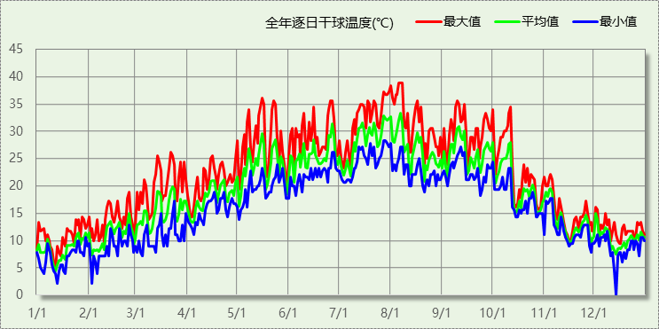

## 逐月辐照量表

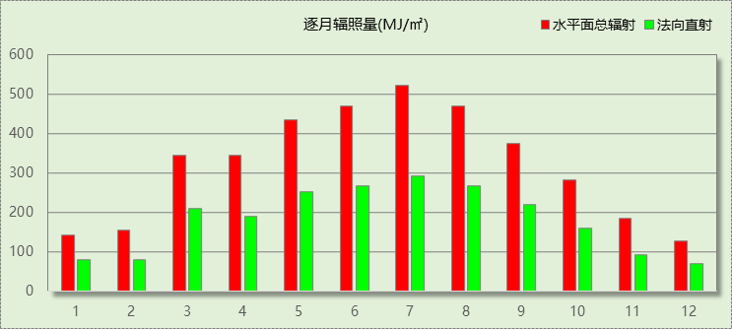

## 峰值工况

|  |  |  |  |  |  |
| --- | --- | --- | --- | --- | --- |
| 气象数据 | 时刻 | 干球温度(℃) | 湿球温度(℃) | 含湿量(g/kg) | 焓值(kj/kg) |
| 最热 | 08月05日17时 | 38.9 | 25.6 | 16.3 | 81.0 |
| 最冷 | 12月13日05时 | 0.0 | 0.0 | 3.7 | 9.3 |

# 围护结构

## 工程材料

|  |  |  |  |  |  |  |
| --- | --- | --- | --- | --- | --- | --- |
| 材料名称 | 导热系数λ | 蓄热系数S | 密度ρ | 比热容Cp | 蒸汽渗透 系数u | 数据来源 |
| W/(m.K) | W/(㎡.K) | kg/m3 | J/(kg.K) | g/(m.h.kPa) |
| 水泥砂浆 | 0.930 | 11.370 | 1800.0 | 1050.0 | 0.0210 |  |
| 钢筋混凝土 | 1.740 | 17.200 | 2500.0 | 920.0 | 0.0158 |  |
| 蒸压加气混凝土砌块526～625(外墙灰缝≤3mm) | 0.190 | 3.010 | 600.0 | 1050.0 | 0.0000 |  |
| 蒸压加气混凝土ALC板 | 0.190 | 3.010 | 600.0 | 1050.0 | 0.0000 |  |
| 碎石、卵石混凝土(ρ=2300) | 1.510 | 15.360 | 2300.0 | 920.0 | 0.0173 |  |
| 难燃型挤塑聚苯板 | 0.030 | 0.270 | 35.0 | 1380.0 | 0.0000 |  |
| 增强型改性发泡水泥保温板A型 | 0.055 | 0.900 | 180.0 | 1000.0 | 0.0000 |  |
| 增强型水泥基泡沫保温隔声板 | 0.070 | 1.070 | 250.0 | 1000.0 | 0.0000 |  |
| 岩棉板（垂直纤维） | 0.048 | 0.750 | 140.0 | 1000.0 | 0.0000 |  |

## 围护结构作法简要说明

**1. 屋顶：**屋顶构造一 (K=0.398,D=2.680)：（由上到下）

碎石、卵石混凝土(ρ=2300) 40mm＋水泥砂浆 10mm＋难燃型挤塑聚苯板 80mm＋水泥砂浆 20mm＋钢筋混凝土 120mm

**2. 外墙：**外墙（填充墙）构造一 (K=0.658,D=4.450)：（由外到内）

水泥砂浆 20mm＋蒸压加气混凝土砌块526～625(外墙灰缝≤3mm) 250mm＋水泥砂浆 20mm

**3. 挑空楼板：**挑空楼板构造一 (K=0.700,D=2.422)：（由上到下）

碎石、卵石混凝土(ρ=2300) 30mm＋钢筋混凝土 100mm＋岩棉板（垂直纤维） 68.3mm＋水泥砂浆 5mm

**4. 外窗：**穿条式隔热铝合 24mm≤隔热条截面高度<30mm {6高透光单银Low-E+12Ar+6高隔热本体着色玻璃+12A+6透明（全自动化封装暖边条）} (K=2.000)：

传热系数2.000W/㎡.K，窗太阳得热系数0.280

**5. 幕墙：**穿条式隔热铝合 24mm≤隔热条截面高度<30mm {6高透光三银Low-E+12Ar +6透明+12A+6透明（全自动化封装暖边条）} (K=2.000)：

传热系数2.000W/㎡.K，窗太阳得热系数0.200

# 围护结构概况

|  |  |  |  |  |  |
| --- | --- | --- | --- | --- | --- |
|  | | | 设计建筑 | | |
| 屋顶传热系数K  和热情性指标 D | | | 0.40  2.68 | | |
| 外墙传热系数K  和热情性指标 D | | | 0.73  4.45 | | |
| 挑空(或架空)楼板传热系数K  和热惰性指标 D | | | 0.70  2.42 | | |
| 天窗传热系数K  和太阳得热系数 SHGC | | | －  － | | |
| 外窗（包括透明幕墙） | 朝向 | 立面 | 窗墙比 | 传热  系数 | 太阳得热系数 |
| 南向 | 南-默认立面 | 0.60 | 2.00 | 0.26 |
| 北向 | 北-默认立面 | 0.59 | 2.00 | 0.26 |
| 东向 | 东-默认立面 | 0.32 | 2.00 | 0.24 |
| 西向 | 西-默认立面 | 0.47 | 2.00 | 0.23 |

# 设计建筑

## 房间类型

### 房间参数表

|  |  |  |  |  |  |  |  |
| --- | --- | --- | --- | --- | --- | --- | --- |
| 房间类型 | 空调 温度℃ | 供暖 温度℃ | 新风量 | 渗透风 换气次数 | 人员密度 | 照明功率 密度 | 电器设备 功率 |
| 休息室 | 26 | 20 | 30(m3/h.人) | 0(次/h) | 8(㎡/人) | 3.5(W/㎡) | 20(W/㎡) |
| 会议室 | 26 | 20 | 14(m3/h.人) | 0(次/h) | 2.5(㎡/人) | 8(W/㎡) | 20(W/㎡) |
| 候诊、挂号大厅 | 27 | 18 | 60(m3/h.人) | 0(次/h) | 4(㎡/人) | 5.5(W/㎡) | 20(W/㎡) |
| 分析实验室 | 26 | 20 | 30(m3/h.人) | 0(次/h) | 6(㎡/人) | 8(W/㎡) | 20(W/㎡) |
| 办公室 | 26 | 20 | 30(m3/h.人) | 0(次/h) | 6(㎡/人) | 8(W/㎡) | 20(W/㎡) |
| 化验室 | 26 | 20 | 2(次/h) | 0(次/h) | 10(㎡/人) | 13.5(W/㎡) | 20(W/㎡) |
| 卫生间 | 28 | 18 | 0(m3/h.人) | 0(次/h) | 20(㎡/人) | 5(W/㎡) | 20(W/㎡) |
| 厨房 | 26 | 20 | 30(m3/h.人) | 0(次/h) | 6(㎡/人) | 8(W/㎡) | 20(W/㎡) |
| 库房 | 28 | 15 | 0(m3/h.人) | 0(次/h) | 0(人) | 3.5(W/㎡) | 20(W/㎡) |
| 急诊室 | 26 | 20 | 2(次/h) | 0(次/h) | 4(㎡/人) | 8(W/㎡) | 20(W/㎡) |
| 手术室 | 26 | 22 | 60(m3/h.人) | 0(次/h) | 10(㎡/人) | 25(W/㎡) | 20(W/㎡) |
| 抢救室 | 26 | 20 | 2(次/h) | 0(次/h) | 4(㎡/人) | 8(W/㎡) | 20(W/㎡) |
| 挂号室 | 26 | 20 | 30(m3/h.人) | 0(次/h) | 6(㎡/人) | 8(W/㎡) | 20(W/㎡) |
| 更衣室 | 26 | 20 | 2(次/h) | 0(次/h) | 4(㎡/人) | 5(W/㎡) | 20(W/㎡) |
| 更衣室 | 26 | 22 | 6(次/h) | 0(次/h) | 4(㎡/人) | 5(W/㎡) | 20(W/㎡) |
| 核磁共振室 | 26 | 20 | 30(m3/h.人) | 0(次/h) | 6(㎡/人) | 8(W/㎡) | 20(W/㎡) |
| 楼梯间 | 28 | 15 | 0(次/h) | 0(次/h) | 0(人) | 4(W/㎡) | 20(W/㎡) |
| 治疗室、诊室 | 26 | 22 | 2(次/h) | 0(次/h) | 6(㎡/人) | 8(W/㎡) | 20(W/㎡) |
| 灭菌室 | 20 | 18 | 6(次/h) | 0(次/h) | 10(㎡/人) | 8(W/㎡) | 20(W/㎡) |
| 病例中心 | 26 | 20 | 30(m3/h.人) | 0(次/h) | 10(㎡/人) | 8(W/㎡) | 20(W/㎡) |
| 病房 | 26 | 21 | 2(次/h) | 0(次/h) | 5(㎡/人) | 5.5(W/㎡) | 20(W/㎡) |
| 空房间 | － | － | 0(m3/h.人) | 0(次/h) | 0(人) | 0(W/㎡) | 0(W/㎡) |
| 药房 | 26 | 20 | 2(次/h) | 0(次/h) | 10(㎡/人) | 13.5(W/㎡) | 20(W/㎡) |
| 设备间 | － | － | 0(次/h) | 0(次/h) | 0(人) | 6(W/㎡) | 15(W/㎡) |
| 走廊 | － | － | 0(m3/h.人) | 0(次/h) | 50(㎡/人) | 3.5(W/㎡) | 20(W/㎡) |
| 输液室 | 26 | 20 | 2(次/h) | 0(次/h) | 2.5(㎡/人) | 8(W/㎡) | 20(W/㎡) |
| 重症ICU | 26 | 21 | 60(m3/h.人) | 0(次/h) | 8(㎡/人) | 8(W/㎡) | 20(W/㎡) |
| 餐厅 | 26 | 20 | 30(m3/h.人) | 0(次/h) | 2.5(㎡/人) | 8(W/㎡) | 20(W/㎡) |

### 作息时间表

详见附录

## 系统类型

### 系统分区

|  |  |  |  |  |  |
| --- | --- | --- | --- | --- | --- |
| 系统编号 | 系统类型 | 制冷 SEER | 制热 HSPF | 面积(㎡) | 包含的房间 |
| 默认 | 双管制风机盘管 | － | － | 31612.17 | 所有房间 |

### 热回收参数

|  |  |  |  |  |  |
| --- | --- | --- | --- | --- | --- |
| 系统编号 | 热回收 | 供冷 | | 供暖 | |
| 回收效率 | 启动温(焓)差 | 回收效率 | 启动温(焓)差 |
| 默认 | 无 | － | － | － | － |

## 制冷系统

### 默认冷源

#### 供应的系统

|  |  |
| --- | --- |
| 系统编号 | 默认 |

#### 冷水机组

|  |  |  |  |  |  |
| --- | --- | --- | --- | --- | --- |
| 名称 | 类型 | 额定耗电量 (kW) | 额定制冷量 (kW) | 额定性能系数 (COP) | 台数 |
| 机组1 | 水冷-螺杆式冷水机组 | 100 | 500 | 5.00 | 1 |

#### 水泵系统

|  |  |  |  |  |  |  |  |
| --- | --- | --- | --- | --- | --- | --- | --- |
| 类型 | 调节 | 流量 (m3/h) | 扬程 (m) | 设计工作效率(%) | 输入功率 (kW) | 冷却塔耗电比 (kWh/m3) | 台数 |
| 冷却水泵 | 单速 | 320 | 25 | 80 | 31.3 | 0.03 | 1 |
| 冷冻水泵 | 单速 | 320 | 30 | 80 | 37.6 | － | 1 |

#### 运行工况

|  |  |  |  |  |  |  |
| --- | --- | --- | --- | --- | --- | --- |
| 负载率 (%) | 机组制冷量 (kW) | 机组功率 (kW) | 性能系数 (COP) | 冷却水泵功率 (kW) | 冷冻水泵功率 (kW) | 冷却塔功率 (kW) |
| 20 | 100 | 25 | 4.00 | 31.3 | 37.6 | 10 |
| 40 | 200 | 48 | 4.17 | 31.3 | 37.6 | 10 |
| 60 | 300 | 68 | 4.41 | 31.3 | 37.6 | 10 |
| 80 | 400 | 80 | 5.00 | 31.3 | 37.6 | 10 |
| 100 | 500 | 100 | 5.00 | 31.3 | 37.6 | 10 |

#### 制冷能耗

|  |  |  |  |  |  |  |  |
| --- | --- | --- | --- | --- | --- | --- | --- |
| 负荷区间 (%) | 区间负荷 (kWh) | 运行时长(h) | 制冷机组 (kWh) | 平均性能系数(COP) | 冷却水泵 (kWh) | 冷冻水泵 (kWh) | 冷却塔 (kWh) |
| 0~20 | 13891 | 188 | 3473 | 4.00 | 5884 | 7069 | 1880 |
| 20~40 | 36484 | 255 | 8940 | 4.08 | 7982 | 9588 | 2550 |
| 40~60 | 56963 | 225 | 13210 | 4.31 | 7043 | 8460 | 2250 |
| 60~80 | 94923 | 274 | 20227 | 4.69 | 8576 | 10302 | 2740 |
| 80~100 | 118881 | 266 | 23776 | 5.00 | 8326 | 10002 | 2660 |
| >100 | 5187900 | 2143 | 214300 | － | 67076 | 80577 | 21430 |
| 合计 | 5509041 | 3351 | 283926 |  | 104886 | 125998 | 33510 |

## 供暖系统

### 默认热源

#### 供应的系统

|  |  |
| --- | --- |
| 系统编号 | 默认 |

#### 市政热力系统能耗

|  |  |  |  |  |  |  |
| --- | --- | --- | --- | --- | --- | --- |
| 累计 热负荷 (kWh) | 外网热 输送效率 | 耗电 输热比 EHR | 热/电 转换系数 (kWh/kWh) | 热源折合 电耗 (kWh) | 供暖水 泵电耗 (kWh) | 合计 电耗 (kWh) |
| 744703 | 0.92 | 0.00433 | 2.93 | 276228 | 3225 | 279453 |

## 空调风机

### 独立新排风

|  |  |  |  |  |  |
| --- | --- | --- | --- | --- | --- |
| 系统编号 | 新风量 (m3/h) | 单位风量耗功率 W/(m3/h) | 风机功率(W) | 运行时长(h) | 新风电耗(kWh) |
| 默认 | 335701 | 0.24 | 80568 | 6000 | 483410 |
| 合计 | | | | | 483410 |

|  |  |  |  |  |  |  |
| --- | --- | --- | --- | --- | --- | --- |
| 系统编号 | 排风量 (m3/h) | 排风比 | 单位风量耗功率W/(m3/h) | 风机功率(W) | 运行时长(h) | 排风电耗 (kWh) |
| 默认 | 268561 | 0.8 | 0.24 | 64455 | 6000 | 386728 |
| 合计 | | | | | | 386728 |

### 风机盘管

|  |  |  |  |  |
| --- | --- | --- | --- | --- |
| 系统编号 | 总功率(W) | 同时使用系数 | 运行时长(h) | 风机盘管电耗(kWh) |
| 默认 | 400 | 1 | 2727 | 1091 |
| 合计 | | | | 1091 |

## 照明

|  |  |  |  |  |
| --- | --- | --- | --- | --- |
| 房间类型 | 单位面积电耗 (kWh/㎡) | 房间个数 | 房间合计面积 (㎡) | 合计电耗 (kWh) |
| 休息室 | 14.05 | 16 | 926 | 13017 |
| 会议室 | 32.12 | 3 | 114 | 3650 |
| 候诊、挂号大厅 | 22.08 | 7 | 6024 | 133014 |
| 分析实验室 | 32.12 | 8 | 177 | 5694 |
| 办公室 | 32.12 | 63 | 1328 | 42658 |
| 化验室 | 54.20 | 48 | 2494 | 135208 |
| 卫生间 | 20.08 | 262 | 1781 | 35758 |
| 厨房 | 32.12 | 10 | 961 | 30877 |
| 库房 | 14.05 | 17 | 581 | 8170 |
| 急诊室 | 32.12 | 1 | 101 | 3248 |
| 手术室 | 100.38 | 10 | 335 | 33627 |
| 抢救室 | 32.12 | 5 | 225 | 7212 |
| 挂号室 | 32.12 | 5 | 237 | 7609 |
| 更衣室 | 20.08 | 106 | 4111 | 82523 |
| 核磁共振室 | 32.12 | 11 | 576 | 18495 |
| 楼梯间 | 16.06 | 294 | 3048 | 48945 |
| 治疗室、诊室 | 32.12 | 173 | 3073 | 98705 |
| 灭菌室 | 32.12 | 23 | 512 | 16438 |
| 病例中心 | 32.12 | 5 | 662 | 21254 |
| 病房 | 18.47 | 198 | 5497 | 101530 |
| 空房间 | 0.00 | 12 | 42 | 0 |
| 药房 | 54.20 | 3 | 459 | 24904 |
| 设备间 | 52.56 | 23 | 1474 | 77474 |
| 走廊 | 14.05 | 50 | 7001 | 98378 |
| 输液室 | 32.12 | 2 | 334 | 10727 |
| 重症ICU | 26.86 | 3 | 242 | 6490 |
| 餐厅 | 32.12 | 6 | 428 | 13756 |
| 总计 | | | | 1079361 |

## 负荷分项统计

|  |  |  |  |  |  |  |
| --- | --- | --- | --- | --- | --- | --- |
| 分类 | 围护传热 | 室内得热 | 窗日射 | 新风/渗透 | 热回收 | 合计 |
| 供暖(kWh/㎡) | 2.92 | 8.16 | 1.12 | -29.50 | 0.00 | -17.30 |
| 供冷(kWh/㎡) | 46.55 | 32.12 | 5.78 | 43.55 | 0.00 | 128.00 |

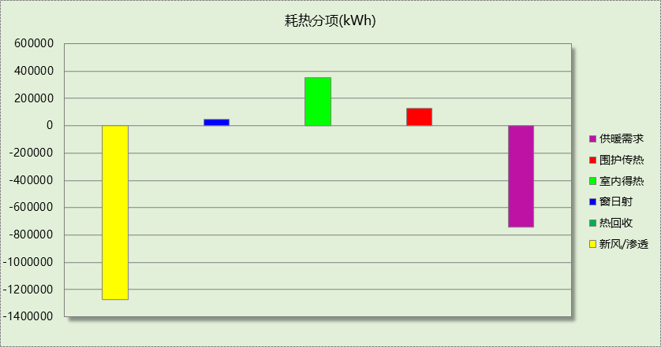

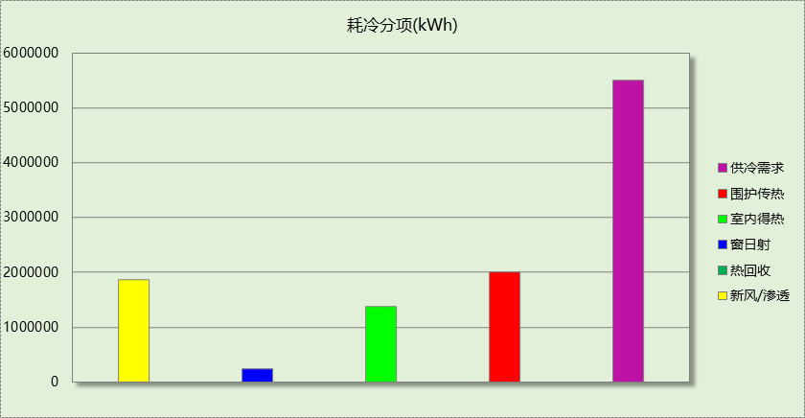

## 逐月负荷表

|  |  |  |  |  |  |  |
| --- | --- | --- | --- | --- | --- | --- |
| 月份 | 供暖(kWh) | 供冷(kWh) | 热负荷 峰值(kW) | 热负荷 峰值时刻 | 冷负荷 峰值(kW) | 冷负荷 峰值时刻 |
| 1月 | 268267 | 3583 | 2053.039 | 1月11日8时 | 661.287 | 1月2日1时 |
| 2月 | 138757 | 14457 | 1705.904 | 2月5日8时 | 818.579 | 2月14日1时 |
| 3月 | 32805 | 38304 | 1220.769 | 3月1日8时 | 1063.454 | 3月15日16时 |
| 4月 | 6556 | 119992 | 263.939 | 4月3日8时 | 1979.392 | 4月15日10时 |
| 5月 | 0 | 574074 | 0.000 | -- | 4497.068 | 5月27日10时 |
| 6月 | 0 | 776548 | 0.000 | -- | 5596.452 | 6月24日10时 |
| 7月 | 0 | 1389075 | 0.000 | -- | 6650.398 | 7月15日11时 |
| 8月 | 0 | 1208604 | 0.000 | -- | 6878.069 | 8月5日10时 |
| 9月 | 0 | 937214 | 0.000 | -- | 6032.926 | 9月9日11时 |
| 10月 | 2868 | 378988 | 191.792 | 10月31日10时 | 4184.845 | 10月4日10时 |
| 11月 | 89986 | 62875 | 999.963 | 11月28日8时 | 1864.552 | 11月4日10时 |
| 12月 | 205462 | 5331 | 1922.564 | 12月13日8时 | 384.939 | 12月2日10时 |

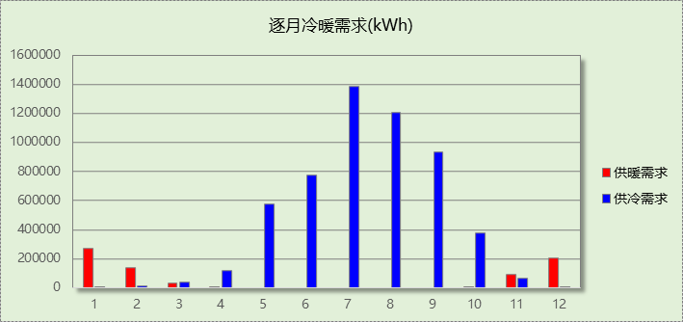

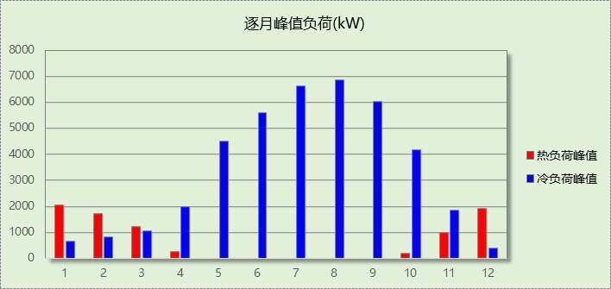

## 逐月电耗

注:供冷供暖为冷热源及输配水泵电耗，热水为扣减太阳能后电耗，所有数据单位kWh/㎡。

|  |  |  |  |  |  |  |  |  |
| --- | --- | --- | --- | --- | --- | --- | --- | --- |
| 月 | 供冷 | 供暖 | 空调风机 | 照明 | 插座设备 | 排风机 | 电梯 | 热水 |
| 1 | 0.04 | 2.34 | 1.78 | 2.13 | － | － | － | － |
| 2 | 0.17 | 1.21 | 1.38 | 1.92 | － |
| 3 | 0.42 | 0.29 | 1.70 | 2.13 | － |
| 4 | 0.93 | 0.06 | 1.70 | 2.06 | － |
| 5 | 1.59 | 0.00 | 1.78 | 2.13 | － |
| 6 | 1.58 | 0.00 | 1.54 | 2.06 | － |
| 7 | 2.22 | 0.00 | 1.86 | 2.13 | － |
| 8 | 2.11 | 0.00 | 1.78 | 2.13 | － |
| 9 | 1.75 | 0.00 | 1.62 | 2.06 | － |
| 10 | 1.38 | 0.03 | 1.62 | 2.13 | － |
| 11 | 0.45 | 0.78 | 1.70 | 2.06 | － |
| 12 | 0.08 | 1.79 | 1.78 | 2.13 | － |
| 合计 | 12.74 | 6.49 | 20.24 | 25.08 | － | － | － | － |

# 参照建筑

## 房间类型

### 房间参数表

|  |  |  |  |  |  |  |  |
| --- | --- | --- | --- | --- | --- | --- | --- |
| 房间类型 | 空调 温度℃ | 供暖 温度℃ | 新风量 | 渗透风 换气次数 | 人员密度 | 照明功率 密度 | 电器设备 功率 |
| 休息室 | 26 | 20 | 30(m3/h.人) | 0(次/h) | 8(㎡/人) | 5(W/㎡) | 20(W/㎡) |
| 会议室 | 26 | 20 | 14(m3/h.人) | 0(次/h) | 2.5(㎡/人) | 9(W/㎡) | 20(W/㎡) |
| 候诊、挂号大厅 | 27 | 18 | 60(m3/h.人) | 0(次/h) | 4(㎡/人) | 6(W/㎡) | 20(W/㎡) |
| 分析实验室 | 26 | 20 | 30(m3/h.人) | 0(次/h) | 6(㎡/人) | 9(W/㎡) | 20(W/㎡) |
| 办公室 | 26 | 20 | 30(m3/h.人) | 0(次/h) | 6(㎡/人) | 9(W/㎡) | 20(W/㎡) |
| 化验室 | 26 | 20 | 2(次/h) | 0(次/h) | 10(㎡/人) | 15(W/㎡) | 20(W/㎡) |
| 卫生间 | 28 | 18 | 0(m3/h.人) | 0(次/h) | 20(㎡/人) | 6(W/㎡) | 20(W/㎡) |
| 厨房 | 26 | 20 | 30(m3/h.人) | 0(次/h) | 6(㎡/人) | 9(W/㎡) | 20(W/㎡) |
| 库房 | 28 | 15 | 0(m3/h.人) | 0(次/h) | 0(人) | 5(W/㎡) | 20(W/㎡) |
| 急诊室 | 26 | 20 | 2(次/h) | 0(次/h) | 4(㎡/人) | 9(W/㎡) | 20(W/㎡) |
| 手术室 | 26 | 22 | 60(m3/h.人) | 0(次/h) | 10(㎡/人) | 25(W/㎡) | 20(W/㎡) |
| 抢救室 | 26 | 20 | 2(次/h) | 0(次/h) | 4(㎡/人) | 9(W/㎡) | 20(W/㎡) |
| 挂号室 | 26 | 20 | 30(m3/h.人) | 0(次/h) | 6(㎡/人) | 9(W/㎡) | 20(W/㎡) |
| 更衣室 | 26 | 20 | 2(次/h) | 0(次/h) | 4(㎡/人) | 6(W/㎡) | 20(W/㎡) |
| 更衣室 | 26 | 22 | 6(次/h) | 0(次/h) | 4(㎡/人) | 6(W/㎡) | 20(W/㎡) |
| 核磁共振室 | 26 | 20 | 30(m3/h.人) | 0(次/h) | 6(㎡/人) | 9(W/㎡) | 20(W/㎡) |
| 楼梯间 | 28 | 15 | 0(次/h) | 0(次/h) | 0(人) | 5(W/㎡) | 20(W/㎡) |
| 治疗室、诊室 | 26 | 22 | 2(次/h) | 0(次/h) | 6(㎡/人) | 9(W/㎡) | 20(W/㎡) |
| 灭菌室 | 20 | 18 | 6(次/h) | 0(次/h) | 10(㎡/人) | 9(W/㎡) | 20(W/㎡) |
| 病例中心 | 26 | 20 | 30(m3/h.人) | 0(次/h) | 10(㎡/人) | 9(W/㎡) | 20(W/㎡) |
| 病房 | 26 | 21 | 2(次/h) | 0(次/h) | 5(㎡/人) | 5(W/㎡) | 20(W/㎡) |
| 空房间 | － | － | 0(m3/h.人) | 0(次/h) | 0(人) | 0(W/㎡) | 0(W/㎡) |
| 药房 | 26 | 20 | 2(次/h) | 0(次/h) | 10(㎡/人) | 17(W/㎡) | 20(W/㎡) |
| 设备间 | － | － | 0(次/h) | 0(次/h) | 0(人) | 6(W/㎡) | 15(W/㎡) |
| 走廊 | － | － | 0(m3/h.人) | 0(次/h) | 50(㎡/人) | 5(W/㎡) | 20(W/㎡) |
| 输液室 | 26 | 20 | 2(次/h) | 0(次/h) | 2.5(㎡/人) | 9(W/㎡) | 20(W/㎡) |
| 重症ICU | 26 | 21 | 60(m3/h.人) | 0(次/h) | 8(㎡/人) | 9(W/㎡) | 20(W/㎡) |
| 餐厅 | 26 | 20 | 30(m3/h.人) | 0(次/h) | 2.5(㎡/人) | 9(W/㎡) | 20(W/㎡) |

### 作息时间表

同设计建筑

## 制冷系统

|  |  |  |
| --- | --- | --- |
| 负荷(kWh/a) | 系统综合性能系数 | 耗电(kWh/a) |
| 6195370 | 2.50 | 2478148 |

## 供暖系统

|  |  |  |
| --- | --- | --- |
| 负荷(kWh/a) | 系统综合性能系数 | 耗电(kWh/a) |
| 716581 | 1.80 | 325719 |

## 照明

|  |  |  |  |  |
| --- | --- | --- | --- | --- |
| 房间类型 | 单位面积电耗 (kWh/㎡) | 房间个数 | 房间合计面积 (㎡) | 合计电耗 (kWh) |
| 休息室 | 20.08 | 16 | 926 | 18596 |
| 会议室 | 36.14 | 3 | 114 | 4106 |
| 候诊、挂号大厅 | 24.09 | 7 | 6024 | 145106 |
| 分析实验室 | 36.14 | 8 | 177 | 6406 |
| 办公室 | 36.14 | 63 | 1328 | 47990 |
| 化验室 | 60.23 | 48 | 2494 | 150231 |
| 卫生间 | 24.09 | 262 | 1781 | 42910 |
| 厨房 | 36.14 | 10 | 961 | 34736 |
| 库房 | 20.08 | 17 | 581 | 11672 |
| 急诊室 | 36.14 | 1 | 101 | 3654 |
| 手术室 | 100.38 | 10 | 335 | 33627 |
| 抢救室 | 36.14 | 5 | 225 | 8113 |
| 挂号室 | 36.14 | 5 | 237 | 8561 |
| 更衣室 | 24.09 | 106 | 4111 | 99028 |
| 核磁共振室 | 36.14 | 11 | 576 | 20807 |
| 楼梯间 | 20.08 | 294 | 3048 | 61181 |
| 治疗室、诊室 | 36.14 | 173 | 3073 | 111043 |
| 灭菌室 | 36.14 | 23 | 512 | 18492 |
| 病例中心 | 36.14 | 5 | 662 | 23911 |
| 病房 | 16.79 | 198 | 5497 | 92300 |
| 空房间 | 0.00 | 12 | 42 | 0 |
| 药房 | 68.26 | 3 | 459 | 31360 |
| 设备间 | 52.56 | 23 | 1474 | 77474 |
| 走廊 | 20.08 | 50 | 7001 | 140540 |
| 输液室 | 36.14 | 2 | 334 | 12068 |
| 重症ICU | 30.22 | 3 | 242 | 7301 |
| 餐厅 | 36.14 | 6 | 428 | 15475 |
| 总计 | | | | 1226689 |

## 负荷分项统计

|  |  |  |  |  |  |  |
| --- | --- | --- | --- | --- | --- | --- |
| 分类 | 围护传热 | 室内得热 | 窗日射 | 新风/渗透 | 热回收 | 合计 |
| 供暖(kWh/㎡) | 3.09 | 7.98 | 1.07 | -28.79 | 0.00 | -16.65 |
| 供冷(kWh/㎡) | 51.32 | 39.82 | 7.18 | 45.63 | 0.00 | 143.95 |

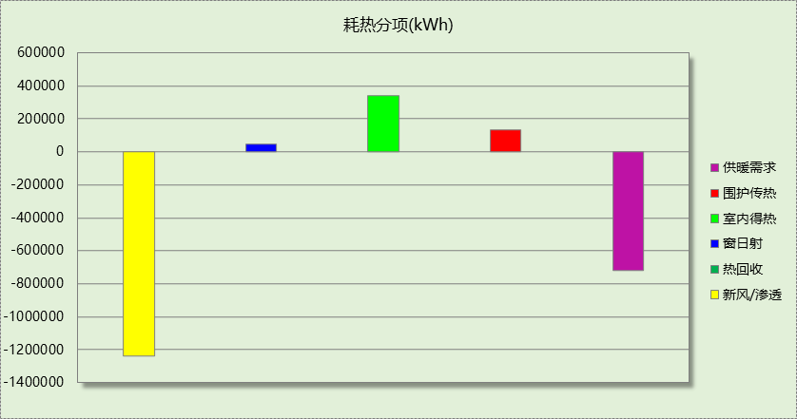

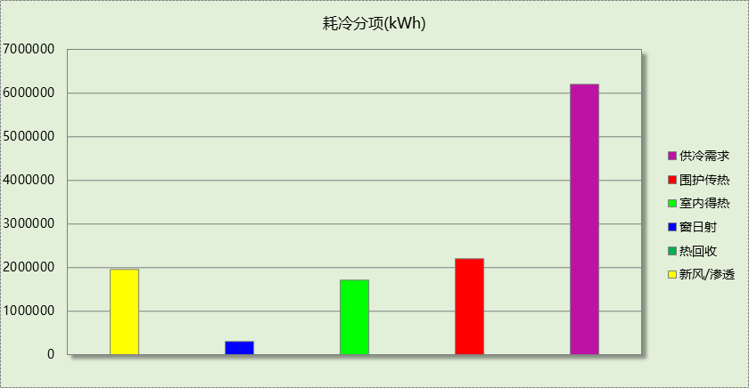

## 逐月负荷表

|  |  |  |  |  |  |  |
| --- | --- | --- | --- | --- | --- | --- |
| 月份 | 供暖(kWh) | 供冷(kWh) | 热负荷 峰值(kW) | 热负荷 峰值时刻 | 冷负荷 峰值(kW) | 冷负荷 峰值时刻 |
| 1月 | 259271 | 5208 | 2019.394 | 1月11日8时 | 675.563 | 1月2日1时 |
| 2月 | 133943 | 15508 | 1656.765 | 2月5日8时 | 834.361 | 2月14日1时 |
| 3月 | 30180 | 92176 | 1180.829 | 3月1日8时 | 1694.638 | 3月22日16时 |
| 4月 | 6115 | 229201 | 250.478 | 4月3日8时 | 2336.664 | 4月16日10时 |
| 5月 | 0 | 732398 | 0.000 | -- | 4553.615 | 5月27日10时 |
| 6月 | 0 | 898935 | 0.000 | -- | 5653.228 | 6月24日10时 |
| 7月 | 0 | 1424327 | 0.000 | -- | 6704.157 | 7月15日11时 |
| 8月 | 0 | 1232455 | 0.000 | -- | 6934.419 | 8月5日10时 |
| 9月 | 0 | 1031255 | 0.000 | -- | 6086.826 | 9月9日11时 |
| 10月 | 2775 | 456246 | 184.987 | 10月31日10时 | 4259.441 | 10月4日10时 |
| 11月 | 86236 | 71786 | 948.235 | 11月28日8时 | 2061.860 | 11月4日15时 |
| 12月 | 198061 | 5876 | 1885.987 | 12月13日8时 | 419.412 | 12月2日10时 |

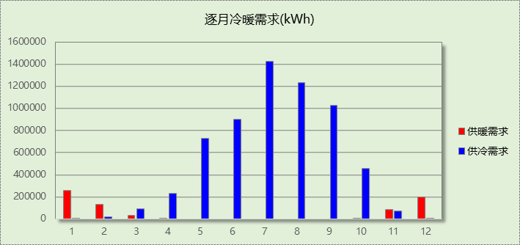

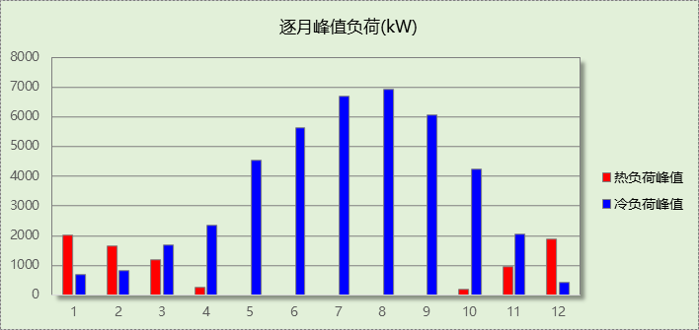

## 逐月电耗

注:供冷供暖为冷热源及输配水泵电耗，热水为扣减太阳能后电耗，所有数据单位kWh/㎡。

|  |  |  |  |  |  |  |  |  |
| --- | --- | --- | --- | --- | --- | --- | --- | --- |
| 月 | 供冷 | 供暖 | 空调风机 | 照明 | 插座设备 | 排风机 | 电梯 | 热水 |
| 1 | 0.00 | 0.00 | 0.00 | 2.42 | － | － | － | － |
| 2 | 0.00 | 0.00 | 0.00 | 2.19 | － |
| 3 | 0.00 | 0.00 | 0.00 | 2.42 | － |
| 4 | 0.00 | 0.00 | 0.00 | 2.34 | － |
| 5 | 0.00 | 0.00 | 0.00 | 2.42 | － |
| 6 | 0.00 | 0.00 | 0.00 | 2.34 | － |
| 7 | 0.00 | 0.00 | 0.00 | 2.42 | － |
| 8 | 0.00 | 0.00 | 0.00 | 2.42 | － |
| 9 | 0.00 | 0.00 | 0.00 | 2.34 | － |
| 10 | 0.00 | 0.00 | 0.00 | 2.42 | － |
| 11 | 0.00 | 0.00 | 0.00 | 2.34 | － |
| 12 | 0.00 | 0.00 | 0.00 | 2.42 | － |
| 合计 | 0.00 | 0.00 | 0.00 | 28.50 | － | － | － | － |

# 计算结果

|  |  |  |  |  |
| --- | --- | --- | --- | --- |
| 能耗分类 | 能耗子类 | 设计建筑  (kWh/㎡) | 参照建筑  (kWh/㎡) | 节能率  （%） |
| 建筑负荷 | 耗冷量 | 128.00 | 143.95 | 9.52% |
| 耗热量 | 17.30 | 16.65 |
| 冷热合计 | 145.31 | 160.60 |
| 热回收负荷 | 供冷 | 0.00 | － |  |
| 供暖 | 0.00 | － |  |
| 冷热合计 | 0.00 | － |  |
| 供冷电耗 | 中央冷源 | 6.60 | － | 77.87% |
| 冷却水泵 | 2.44 | － |
| 冷冻水泵 | 2.93 | － |
| 冷却塔 | 0.78 | － |
| 多联机/单元式空调 | 0.00 | － |
| 供冷合计 | 12.74 | 57.58 |
| 供暖电耗 | 中央热源 | 6.42 | － | 14.20% |
| 供暖水泵 | 0.07 | － |
| 热源侧水泵 | 0.00 | － |
| 多联机/单元式热泵 | 0.00 | － |
| 供暖合计 | 6.49 | 7.57 |
| 空调风机电耗 | 独立新排风 | 20.22 | － | - |
| 风机盘管 | 0.03 | － |
| 全空气系统 | 0.00 | － |
| 风机合计 | 20.24 | － |
| 采暖空调电耗 | | 39.47 | 65.15 | 39.41% |
| 照明电耗 | | 25.08 | 28.50 | 12.01% |
| 建筑综合电耗 | | 64.55 | 93.65 | 31.07% |

# 绿色建筑性能评估得分

|  |  |  |  |
| --- | --- | --- | --- |
| 标准条文 | 得分评价 | 节能率 | 得分 |
| 7.2.8 采取措施降低建筑能耗 | 建筑能耗相比国家现行有关建筑节能标准降低10%, 得5 分；降低20%,得10 分。 | 31.07% | 10 |
| 标准依据 | 《绿色建筑评价标准》GB-T 50378-2019 | | |

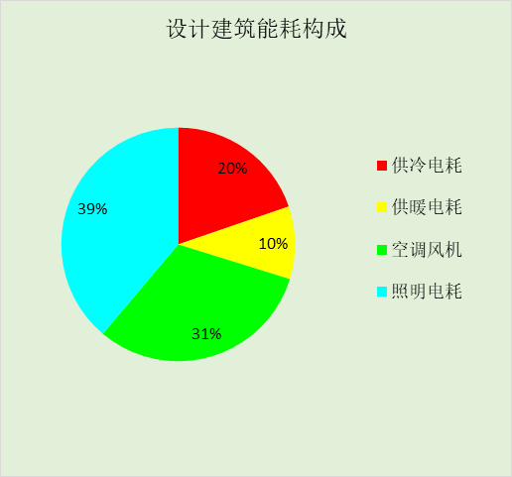

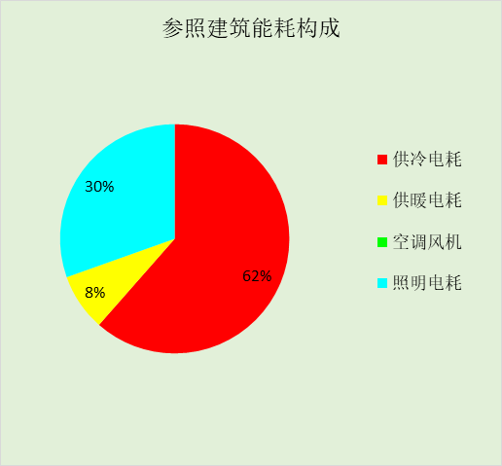

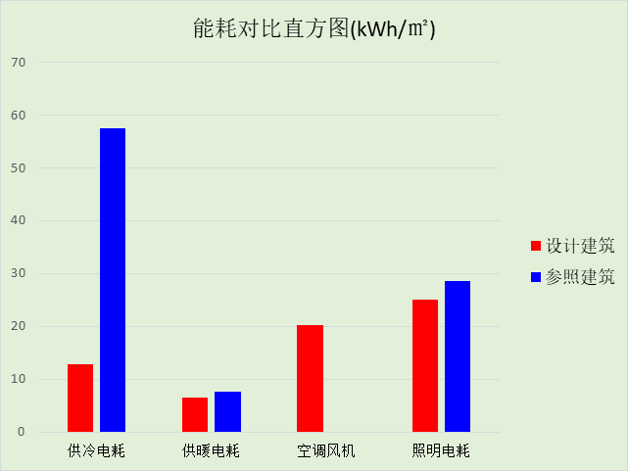

# 附录

## 工作日/节假日人员逐时在室率(%)

|  |  |  |  |  |  |  |  |  |  |  |  |  |  |  |  |  |  |  |  |  |  |  |  |  |
| --- | --- | --- | --- | --- | --- | --- | --- | --- | --- | --- | --- | --- | --- | --- | --- | --- | --- | --- | --- | --- | --- | --- | --- | --- |
| 房间类型 | 1 | 2 | 3 | 4 | 5 | 6 | 7 | 8 | 9 | 10 | 11 | 12 | 13 | 14 | 15 | 16 | 17 | 18 | 19 | 20 | 21 | 22 | 23 | 24 |
| 休息室 | 0 | 0 | 0 | 0 | 0 | 0 | 0 | 20 | 50 | 95 | 80 | 40 | 20 | 50 | 60 | 60 | 20 | 20 | 0 | 0 | 0 | 0 | 0 | 0 |
| 0 | 0 | 0 | 0 | 0 | 0 | 0 | 20 | 50 | 95 | 80 | 40 | 20 | 50 | 60 | 60 | 20 | 20 | 0 | 0 | 0 | 0 | 0 | 0 |
| 会议室 | 0 | 0 | 0 | 0 | 0 | 0 | 0 | 20 | 50 | 95 | 80 | 40 | 20 | 50 | 60 | 60 | 20 | 20 | 0 | 0 | 0 | 0 | 0 | 0 |
| 0 | 0 | 0 | 0 | 0 | 0 | 0 | 20 | 50 | 95 | 80 | 40 | 20 | 50 | 60 | 60 | 20 | 20 | 0 | 0 | 0 | 0 | 0 | 0 |
| 候诊、挂号大厅 | 0 | 0 | 0 | 0 | 0 | 0 | 0 | 20 | 50 | 95 | 80 | 40 | 20 | 50 | 60 | 60 | 20 | 20 | 0 | 0 | 0 | 0 | 0 | 0 |
| 0 | 0 | 0 | 0 | 0 | 0 | 0 | 20 | 50 | 95 | 80 | 40 | 20 | 50 | 60 | 60 | 20 | 20 | 0 | 0 | 0 | 0 | 0 | 0 |
| 分析实验室 | 0 | 0 | 0 | 0 | 0 | 0 | 0 | 20 | 50 | 95 | 80 | 40 | 20 | 50 | 60 | 60 | 20 | 20 | 0 | 0 | 0 | 0 | 0 | 0 |
| 0 | 0 | 0 | 0 | 0 | 0 | 0 | 20 | 50 | 95 | 80 | 40 | 20 | 50 | 60 | 60 | 20 | 20 | 0 | 0 | 0 | 0 | 0 | 0 |
| 办公室 | 0 | 0 | 0 | 0 | 0 | 0 | 0 | 20 | 50 | 95 | 80 | 40 | 20 | 50 | 60 | 60 | 20 | 20 | 0 | 0 | 0 | 0 | 0 | 0 |
| 0 | 0 | 0 | 0 | 0 | 0 | 0 | 20 | 50 | 95 | 80 | 40 | 20 | 50 | 60 | 60 | 20 | 20 | 0 | 0 | 0 | 0 | 0 | 0 |
| 化验室 | 0 | 0 | 0 | 0 | 0 | 0 | 0 | 20 | 50 | 95 | 80 | 40 | 20 | 50 | 60 | 60 | 20 | 20 | 0 | 0 | 0 | 0 | 0 | 0 |
| 0 | 0 | 0 | 0 | 0 | 0 | 0 | 20 | 50 | 95 | 80 | 40 | 20 | 50 | 60 | 60 | 20 | 20 | 0 | 0 | 0 | 0 | 0 | 0 |
| 卫生间 | 0 | 0 | 0 | 0 | 0 | 0 | 0 | 20 | 50 | 95 | 80 | 40 | 20 | 50 | 60 | 60 | 20 | 20 | 0 | 0 | 0 | 0 | 0 | 0 |
| 0 | 0 | 0 | 0 | 0 | 0 | 0 | 20 | 50 | 95 | 80 | 40 | 20 | 50 | 60 | 60 | 20 | 20 | 0 | 0 | 0 | 0 | 0 | 0 |
| 厨房 | 0 | 0 | 0 | 0 | 0 | 0 | 0 | 20 | 50 | 95 | 80 | 40 | 20 | 50 | 60 | 60 | 20 | 20 | 0 | 0 | 0 | 0 | 0 | 0 |
| 0 | 0 | 0 | 0 | 0 | 0 | 0 | 20 | 50 | 95 | 80 | 40 | 20 | 50 | 60 | 60 | 20 | 20 | 0 | 0 | 0 | 0 | 0 | 0 |
| 库房 | 0 | 0 | 0 | 0 | 0 | 0 | 0 | 20 | 50 | 95 | 80 | 40 | 20 | 50 | 60 | 60 | 20 | 20 | 0 | 0 | 0 | 0 | 0 | 0 |
| 0 | 0 | 0 | 0 | 0 | 0 | 0 | 20 | 50 | 95 | 80 | 40 | 20 | 50 | 60 | 60 | 20 | 20 | 0 | 0 | 0 | 0 | 0 | 0 |
| 急诊室 | 0 | 0 | 0 | 0 | 0 | 0 | 0 | 20 | 50 | 95 | 80 | 40 | 20 | 50 | 60 | 60 | 20 | 20 | 0 | 0 | 0 | 0 | 0 | 0 |
| 0 | 0 | 0 | 0 | 0 | 0 | 0 | 20 | 50 | 95 | 80 | 40 | 20 | 50 | 60 | 60 | 20 | 20 | 0 | 0 | 0 | 0 | 0 | 0 |
| 手术室 | 0 | 0 | 0 | 0 | 0 | 0 | 0 | 20 | 50 | 95 | 80 | 40 | 20 | 50 | 60 | 60 | 20 | 20 | 0 | 0 | 0 | 0 | 0 | 0 |
| 0 | 0 | 0 | 0 | 0 | 0 | 0 | 20 | 50 | 95 | 80 | 40 | 20 | 50 | 60 | 60 | 20 | 20 | 0 | 0 | 0 | 0 | 0 | 0 |
| 抢救室 | 0 | 0 | 0 | 0 | 0 | 0 | 0 | 20 | 50 | 95 | 80 | 40 | 20 | 50 | 60 | 60 | 20 | 20 | 0 | 0 | 0 | 0 | 0 | 0 |
| 0 | 0 | 0 | 0 | 0 | 0 | 0 | 20 | 50 | 95 | 80 | 40 | 20 | 50 | 60 | 60 | 20 | 20 | 0 | 0 | 0 | 0 | 0 | 0 |
| 挂号室 | 0 | 0 | 0 | 0 | 0 | 0 | 0 | 20 | 50 | 95 | 80 | 40 | 20 | 50 | 60 | 60 | 20 | 20 | 0 | 0 | 0 | 0 | 0 | 0 |
| 0 | 0 | 0 | 0 | 0 | 0 | 0 | 20 | 50 | 95 | 80 | 40 | 20 | 50 | 60 | 60 | 20 | 20 | 0 | 0 | 0 | 0 | 0 | 0 |
| 更衣室 | 0 | 0 | 0 | 0 | 0 | 0 | 0 | 20 | 50 | 95 | 80 | 40 | 20 | 50 | 60 | 60 | 20 | 20 | 0 | 0 | 0 | 0 | 0 | 0 |
| 0 | 0 | 0 | 0 | 0 | 0 | 0 | 20 | 50 | 95 | 80 | 40 | 20 | 50 | 60 | 60 | 20 | 20 | 0 | 0 | 0 | 0 | 0 | 0 |
| 更衣室 | 95 | 95 | 95 | 95 | 95 | 95 | 95 | 95 | 95 | 95 | 95 | 95 | 95 | 95 | 95 | 95 | 95 | 95 | 95 | 95 | 95 | 95 | 95 | 95 |
| 95 | 95 | 95 | 95 | 95 | 95 | 95 | 95 | 95 | 95 | 95 | 95 | 95 | 95 | 95 | 95 | 95 | 95 | 95 | 95 | 95 | 95 | 95 | 95 |
| 核磁共振室 | 0 | 0 | 0 | 0 | 0 | 0 | 0 | 20 | 50 | 95 | 80 | 40 | 20 | 50 | 60 | 60 | 20 | 20 | 0 | 0 | 0 | 0 | 0 | 0 |
| 0 | 0 | 0 | 0 | 0 | 0 | 0 | 20 | 50 | 95 | 80 | 40 | 20 | 50 | 60 | 60 | 20 | 20 | 0 | 0 | 0 | 0 | 0 | 0 |
| 楼梯间 | 0 | 0 | 0 | 0 | 0 | 0 | 0 | 20 | 50 | 95 | 80 | 40 | 20 | 50 | 60 | 60 | 20 | 20 | 0 | 0 | 0 | 0 | 0 | 0 |
| 0 | 0 | 0 | 0 | 0 | 0 | 0 | 20 | 50 | 95 | 80 | 40 | 20 | 50 | 60 | 60 | 20 | 20 | 0 | 0 | 0 | 0 | 0 | 0 |
| 治疗室、诊室 | 0 | 0 | 0 | 0 | 0 | 0 | 0 | 20 | 50 | 95 | 80 | 40 | 20 | 50 | 60 | 60 | 20 | 20 | 0 | 0 | 0 | 0 | 0 | 0 |
| 0 | 0 | 0 | 0 | 0 | 0 | 0 | 20 | 50 | 95 | 80 | 40 | 20 | 50 | 60 | 60 | 20 | 20 | 0 | 0 | 0 | 0 | 0 | 0 |
| 灭菌室 | 0 | 0 | 0 | 0 | 0 | 0 | 0 | 20 | 50 | 95 | 80 | 40 | 20 | 50 | 60 | 60 | 20 | 20 | 0 | 0 | 0 | 0 | 0 | 0 |
| 0 | 0 | 0 | 0 | 0 | 0 | 0 | 20 | 50 | 95 | 80 | 40 | 20 | 50 | 60 | 60 | 20 | 20 | 0 | 0 | 0 | 0 | 0 | 0 |
| 病例中心 | 0 | 0 | 0 | 0 | 0 | 0 | 0 | 20 | 50 | 95 | 80 | 40 | 20 | 50 | 60 | 60 | 20 | 20 | 0 | 0 | 0 | 0 | 0 | 0 |
| 0 | 0 | 0 | 0 | 0 | 0 | 0 | 20 | 50 | 95 | 80 | 40 | 20 | 50 | 60 | 60 | 20 | 20 | 0 | 0 | 0 | 0 | 0 | 0 |
| 病房 | 95 | 95 | 95 | 95 | 95 | 95 | 95 | 95 | 95 | 95 | 95 | 95 | 95 | 95 | 95 | 95 | 95 | 95 | 95 | 95 | 95 | 95 | 95 | 95 |
| 95 | 95 | 95 | 95 | 95 | 95 | 95 | 95 | 95 | 95 | 95 | 95 | 95 | 95 | 95 | 95 | 95 | 95 | 95 | 95 | 95 | 95 | 95 | 95 |
| 空房间 | 0 | 0 | 0 | 0 | 0 | 0 | 0 | 20 | 50 | 80 | 80 | 80 | 80 | 80 | 80 | 80 | 80 | 80 | 80 | 70 | 50 | 0 | 0 | 0 |
| 0 | 0 | 0 | 0 | 0 | 0 | 0 | 20 | 50 | 80 | 80 | 80 | 80 | 80 | 80 | 80 | 80 | 80 | 80 | 70 | 50 | 0 | 0 | 0 |
| 药房 | 0 | 0 | 0 | 0 | 0 | 0 | 0 | 20 | 50 | 95 | 80 | 40 | 20 | 50 | 60 | 60 | 20 | 20 | 0 | 0 | 0 | 0 | 0 | 0 |
| 0 | 0 | 0 | 0 | 0 | 0 | 0 | 20 | 50 | 95 | 80 | 40 | 20 | 50 | 60 | 60 | 20 | 20 | 0 | 0 | 0 | 0 | 0 | 0 |
| 设备间 | 0 | 0 | 0 | 0 | 0 | 0 | 0 | 0 | 0 | 0 | 0 | 0 | 0 | 0 | 0 | 0 | 0 | 0 | 0 | 0 | 0 | 0 | 0 | 0 |
| 0 | 0 | 0 | 0 | 0 | 0 | 0 | 0 | 0 | 0 | 0 | 0 | 0 | 0 | 0 | 0 | 0 | 0 | 0 | 0 | 0 | 0 | 0 | 0 |
| 走廊 | 0 | 0 | 0 | 0 | 0 | 0 | 0 | 20 | 50 | 95 | 80 | 40 | 20 | 50 | 60 | 60 | 20 | 20 | 0 | 0 | 0 | 0 | 0 | 0 |
| 0 | 0 | 0 | 0 | 0 | 0 | 0 | 20 | 50 | 95 | 80 | 40 | 20 | 50 | 60 | 60 | 20 | 20 | 0 | 0 | 0 | 0 | 0 | 0 |
| 输液室 | 0 | 0 | 0 | 0 | 0 | 0 | 0 | 20 | 50 | 95 | 80 | 40 | 20 | 50 | 60 | 60 | 20 | 20 | 0 | 0 | 0 | 0 | 0 | 0 |
| 0 | 0 | 0 | 0 | 0 | 0 | 0 | 20 | 50 | 95 | 80 | 40 | 20 | 50 | 60 | 60 | 20 | 20 | 0 | 0 | 0 | 0 | 0 | 0 |
| 重症ICU | 95 | 95 | 95 | 95 | 95 | 95 | 95 | 95 | 95 | 95 | 95 | 95 | 95 | 95 | 95 | 95 | 95 | 95 | 95 | 95 | 95 | 95 | 95 | 95 |
| 95 | 95 | 95 | 95 | 95 | 95 | 95 | 95 | 95 | 95 | 95 | 95 | 95 | 95 | 95 | 95 | 95 | 95 | 95 | 95 | 95 | 95 | 95 | 95 |
| 餐厅 | 0 | 0 | 0 | 0 | 0 | 0 | 0 | 20 | 50 | 95 | 80 | 40 | 20 | 50 | 60 | 60 | 20 | 20 | 0 | 0 | 0 | 0 | 0 | 0 |
| 0 | 0 | 0 | 0 | 0 | 0 | 0 | 20 | 50 | 95 | 80 | 40 | 20 | 50 | 60 | 60 | 20 | 20 | 0 | 0 | 0 | 0 | 0 | 0 |

注：上行：工作日；下行：节假日

## 工作日/节假日照明开关时间表(%)

|  |  |  |  |  |  |  |  |  |  |  |  |  |  |  |  |  |  |  |  |  |  |  |  |  |
| --- | --- | --- | --- | --- | --- | --- | --- | --- | --- | --- | --- | --- | --- | --- | --- | --- | --- | --- | --- | --- | --- | --- | --- | --- |
| 房间类型 | 1 | 2 | 3 | 4 | 5 | 6 | 7 | 8 | 9 | 10 | 11 | 12 | 13 | 14 | 15 | 16 | 17 | 18 | 19 | 20 | 21 | 22 | 23 | 24 |
| 休息室 | 10 | 10 | 10 | 10 | 10 | 10 | 10 | 50 | 60 | 60 | 60 | 60 | 60 | 60 | 60 | 60 | 80 | 90 | 100 | 100 | 100 | 10 | 10 | 10 |
| 10 | 10 | 10 | 10 | 10 | 10 | 10 | 50 | 60 | 60 | 60 | 60 | 60 | 60 | 60 | 60 | 80 | 90 | 100 | 100 | 100 | 10 | 10 | 10 |
| 会议室 | 10 | 10 | 10 | 10 | 10 | 10 | 10 | 50 | 60 | 60 | 60 | 60 | 60 | 60 | 60 | 60 | 80 | 90 | 100 | 100 | 100 | 10 | 10 | 10 |
| 10 | 10 | 10 | 10 | 10 | 10 | 10 | 50 | 60 | 60 | 60 | 60 | 60 | 60 | 60 | 60 | 80 | 90 | 100 | 100 | 100 | 10 | 10 | 10 |
| 候诊、挂号大厅 | 10 | 10 | 10 | 10 | 10 | 10 | 10 | 50 | 60 | 60 | 60 | 60 | 60 | 60 | 60 | 60 | 80 | 90 | 100 | 100 | 100 | 10 | 10 | 10 |
| 10 | 10 | 10 | 10 | 10 | 10 | 10 | 50 | 60 | 60 | 60 | 60 | 60 | 60 | 60 | 60 | 80 | 90 | 100 | 100 | 100 | 10 | 10 | 10 |
| 分析实验室 | 10 | 10 | 10 | 10 | 10 | 10 | 10 | 50 | 60 | 60 | 60 | 60 | 60 | 60 | 60 | 60 | 80 | 90 | 100 | 100 | 100 | 10 | 10 | 10 |
| 10 | 10 | 10 | 10 | 10 | 10 | 10 | 50 | 60 | 60 | 60 | 60 | 60 | 60 | 60 | 60 | 80 | 90 | 100 | 100 | 100 | 10 | 10 | 10 |
| 办公室 | 10 | 10 | 10 | 10 | 10 | 10 | 10 | 50 | 60 | 60 | 60 | 60 | 60 | 60 | 60 | 60 | 80 | 90 | 100 | 100 | 100 | 10 | 10 | 10 |
| 10 | 10 | 10 | 10 | 10 | 10 | 10 | 50 | 60 | 60 | 60 | 60 | 60 | 60 | 60 | 60 | 80 | 90 | 100 | 100 | 100 | 10 | 10 | 10 |
| 化验室 | 10 | 10 | 10 | 10 | 10 | 10 | 10 | 50 | 60 | 60 | 60 | 60 | 60 | 60 | 60 | 60 | 80 | 90 | 100 | 100 | 100 | 10 | 10 | 10 |
| 10 | 10 | 10 | 10 | 10 | 10 | 10 | 50 | 60 | 60 | 60 | 60 | 60 | 60 | 60 | 60 | 80 | 90 | 100 | 100 | 100 | 10 | 10 | 10 |
| 卫生间 | 10 | 10 | 10 | 10 | 10 | 10 | 10 | 50 | 60 | 60 | 60 | 60 | 60 | 60 | 60 | 60 | 80 | 90 | 100 | 100 | 100 | 10 | 10 | 10 |
| 10 | 10 | 10 | 10 | 10 | 10 | 10 | 50 | 60 | 60 | 60 | 60 | 60 | 60 | 60 | 60 | 80 | 90 | 100 | 100 | 100 | 10 | 10 | 10 |
| 厨房 | 10 | 10 | 10 | 10 | 10 | 10 | 10 | 50 | 60 | 60 | 60 | 60 | 60 | 60 | 60 | 60 | 80 | 90 | 100 | 100 | 100 | 10 | 10 | 10 |
| 10 | 10 | 10 | 10 | 10 | 10 | 10 | 50 | 60 | 60 | 60 | 60 | 60 | 60 | 60 | 60 | 80 | 90 | 100 | 100 | 100 | 10 | 10 | 10 |
| 库房 | 10 | 10 | 10 | 10 | 10 | 10 | 10 | 50 | 60 | 60 | 60 | 60 | 60 | 60 | 60 | 60 | 80 | 90 | 100 | 100 | 100 | 10 | 10 | 10 |
| 10 | 10 | 10 | 10 | 10 | 10 | 10 | 50 | 60 | 60 | 60 | 60 | 60 | 60 | 60 | 60 | 80 | 90 | 100 | 100 | 100 | 10 | 10 | 10 |
| 急诊室 | 10 | 10 | 10 | 10 | 10 | 10 | 10 | 50 | 60 | 60 | 60 | 60 | 60 | 60 | 60 | 60 | 80 | 90 | 100 | 100 | 100 | 10 | 10 | 10 |
| 10 | 10 | 10 | 10 | 10 | 10 | 10 | 50 | 60 | 60 | 60 | 60 | 60 | 60 | 60 | 60 | 80 | 90 | 100 | 100 | 100 | 10 | 10 | 10 |
| 手术室 | 10 | 10 | 10 | 10 | 10 | 10 | 10 | 50 | 60 | 60 | 60 | 60 | 60 | 60 | 60 | 60 | 80 | 90 | 100 | 100 | 100 | 10 | 10 | 10 |
| 10 | 10 | 10 | 10 | 10 | 10 | 10 | 50 | 60 | 60 | 60 | 60 | 60 | 60 | 60 | 60 | 80 | 90 | 100 | 100 | 100 | 10 | 10 | 10 |
| 抢救室 | 10 | 10 | 10 | 10 | 10 | 10 | 10 | 50 | 60 | 60 | 60 | 60 | 60 | 60 | 60 | 60 | 80 | 90 | 100 | 100 | 100 | 10 | 10 | 10 |
| 10 | 10 | 10 | 10 | 10 | 10 | 10 | 50 | 60 | 60 | 60 | 60 | 60 | 60 | 60 | 60 | 80 | 90 | 100 | 100 | 100 | 10 | 10 | 10 |
| 挂号室 | 10 | 10 | 10 | 10 | 10 | 10 | 10 | 50 | 60 | 60 | 60 | 60 | 60 | 60 | 60 | 60 | 80 | 90 | 100 | 100 | 100 | 10 | 10 | 10 |
| 10 | 10 | 10 | 10 | 10 | 10 | 10 | 50 | 60 | 60 | 60 | 60 | 60 | 60 | 60 | 60 | 80 | 90 | 100 | 100 | 100 | 10 | 10 | 10 |
| 更衣室 | 10 | 10 | 10 | 10 | 10 | 10 | 10 | 50 | 60 | 60 | 60 | 60 | 60 | 60 | 60 | 60 | 80 | 90 | 100 | 100 | 100 | 10 | 10 | 10 |
| 10 | 10 | 10 | 10 | 10 | 10 | 10 | 50 | 60 | 60 | 60 | 60 | 60 | 60 | 60 | 60 | 80 | 90 | 100 | 100 | 100 | 10 | 10 | 10 |
| 更衣室 | 10 | 10 | 10 | 10 | 10 | 10 | 30 | 30 | 30 | 30 | 30 | 30 | 30 | 30 | 50 | 50 | 60 | 90 | 90 | 90 | 90 | 80 | 10 | 10 |
| 10 | 10 | 10 | 10 | 10 | 10 | 30 | 30 | 30 | 30 | 30 | 30 | 30 | 30 | 50 | 50 | 60 | 90 | 90 | 90 | 90 | 80 | 10 | 10 |
| 核磁共振室 | 10 | 10 | 10 | 10 | 10 | 10 | 10 | 50 | 60 | 60 | 60 | 60 | 60 | 60 | 60 | 60 | 80 | 90 | 100 | 100 | 100 | 10 | 10 | 10 |
| 10 | 10 | 10 | 10 | 10 | 10 | 10 | 50 | 60 | 60 | 60 | 60 | 60 | 60 | 60 | 60 | 80 | 90 | 100 | 100 | 100 | 10 | 10 | 10 |
| 楼梯间 | 10 | 10 | 10 | 10 | 10 | 10 | 10 | 50 | 60 | 60 | 60 | 60 | 60 | 60 | 60 | 60 | 80 | 90 | 100 | 100 | 100 | 10 | 10 | 10 |
| 10 | 10 | 10 | 10 | 10 | 10 | 10 | 50 | 60 | 60 | 60 | 60 | 60 | 60 | 60 | 60 | 80 | 90 | 100 | 100 | 100 | 10 | 10 | 10 |
| 治疗室、诊室 | 10 | 10 | 10 | 10 | 10 | 10 | 10 | 50 | 60 | 60 | 60 | 60 | 60 | 60 | 60 | 60 | 80 | 90 | 100 | 100 | 100 | 10 | 10 | 10 |
| 10 | 10 | 10 | 10 | 10 | 10 | 10 | 50 | 60 | 60 | 60 | 60 | 60 | 60 | 60 | 60 | 80 | 90 | 100 | 100 | 100 | 10 | 10 | 10 |
| 灭菌室 | 10 | 10 | 10 | 10 | 10 | 10 | 10 | 50 | 60 | 60 | 60 | 60 | 60 | 60 | 60 | 60 | 80 | 90 | 100 | 100 | 100 | 10 | 10 | 10 |
| 10 | 10 | 10 | 10 | 10 | 10 | 10 | 50 | 60 | 60 | 60 | 60 | 60 | 60 | 60 | 60 | 80 | 90 | 100 | 100 | 100 | 10 | 10 | 10 |
| 病例中心 | 10 | 10 | 10 | 10 | 10 | 10 | 10 | 50 | 60 | 60 | 60 | 60 | 60 | 60 | 60 | 60 | 80 | 90 | 100 | 100 | 100 | 10 | 10 | 10 |
| 10 | 10 | 10 | 10 | 10 | 10 | 10 | 50 | 60 | 60 | 60 | 60 | 60 | 60 | 60 | 60 | 80 | 90 | 100 | 100 | 100 | 10 | 10 | 10 |
| 病房 | 10 | 10 | 10 | 10 | 10 | 10 | 30 | 30 | 30 | 30 | 30 | 30 | 30 | 30 | 50 | 50 | 60 | 90 | 90 | 90 | 90 | 80 | 10 | 10 |
| 10 | 10 | 10 | 10 | 10 | 10 | 30 | 30 | 30 | 30 | 30 | 30 | 30 | 30 | 50 | 50 | 60 | 90 | 90 | 90 | 90 | 80 | 10 | 10 |
| 空房间 | 10 | 10 | 10 | 10 | 10 | 10 | 10 | 50 | 60 | 60 | 60 | 60 | 60 | 60 | 60 | 60 | 80 | 90 | 100 | 100 | 100 | 10 | 10 | 10 |
| 10 | 10 | 10 | 10 | 10 | 10 | 10 | 50 | 60 | 60 | 60 | 60 | 60 | 60 | 60 | 60 | 80 | 90 | 100 | 100 | 100 | 10 | 10 | 10 |
| 药房 | 10 | 10 | 10 | 10 | 10 | 10 | 10 | 50 | 60 | 60 | 60 | 60 | 60 | 60 | 60 | 60 | 80 | 90 | 100 | 100 | 100 | 10 | 10 | 10 |
| 10 | 10 | 10 | 10 | 10 | 10 | 10 | 50 | 60 | 60 | 60 | 60 | 60 | 60 | 60 | 60 | 80 | 90 | 100 | 100 | 100 | 10 | 10 | 10 |
| 设备间 | 100 | 100 | 100 | 100 | 100 | 100 | 100 | 100 | 100 | 100 | 100 | 100 | 100 | 100 | 100 | 100 | 100 | 100 | 100 | 100 | 100 | 100 | 100 | 100 |
| 100 | 100 | 100 | 100 | 100 | 100 | 100 | 100 | 100 | 100 | 100 | 100 | 100 | 100 | 100 | 100 | 100 | 100 | 100 | 100 | 100 | 100 | 100 | 100 |
| 走廊 | 10 | 10 | 10 | 10 | 10 | 10 | 10 | 50 | 60 | 60 | 60 | 60 | 60 | 60 | 60 | 60 | 80 | 90 | 100 | 100 | 100 | 10 | 10 | 10 |
| 10 | 10 | 10 | 10 | 10 | 10 | 10 | 50 | 60 | 60 | 60 | 60 | 60 | 60 | 60 | 60 | 80 | 90 | 100 | 100 | 100 | 10 | 10 | 10 |
| 输液室 | 10 | 10 | 10 | 10 | 10 | 10 | 10 | 50 | 60 | 60 | 60 | 60 | 60 | 60 | 60 | 60 | 80 | 90 | 100 | 100 | 100 | 10 | 10 | 10 |
| 10 | 10 | 10 | 10 | 10 | 10 | 10 | 50 | 60 | 60 | 60 | 60 | 60 | 60 | 60 | 60 | 80 | 90 | 100 | 100 | 100 | 10 | 10 | 10 |
| 重症ICU | 10 | 10 | 10 | 10 | 10 | 10 | 30 | 30 | 30 | 30 | 30 | 30 | 30 | 30 | 50 | 50 | 60 | 90 | 90 | 90 | 90 | 80 | 10 | 10 |
| 10 | 10 | 10 | 10 | 10 | 10 | 30 | 30 | 30 | 30 | 30 | 30 | 30 | 30 | 50 | 50 | 60 | 90 | 90 | 90 | 90 | 80 | 10 | 10 |
| 餐厅 | 10 | 10 | 10 | 10 | 10 | 10 | 10 | 50 | 60 | 60 | 60 | 60 | 60 | 60 | 60 | 60 | 80 | 90 | 100 | 100 | 100 | 10 | 10 | 10 |
| 10 | 10 | 10 | 10 | 10 | 10 | 10 | 50 | 60 | 60 | 60 | 60 | 60 | 60 | 60 | 60 | 80 | 90 | 100 | 100 | 100 | 10 | 10 | 10 |

注：上行：工作日；下行：节假日

## 工作日/节假日设备逐时使用率(%)

|  |  |  |  |  |  |  |  |  |  |  |  |  |  |  |  |  |  |  |  |  |  |  |  |  |
| --- | --- | --- | --- | --- | --- | --- | --- | --- | --- | --- | --- | --- | --- | --- | --- | --- | --- | --- | --- | --- | --- | --- | --- | --- |
| 房间类型 | 1 | 2 | 3 | 4 | 5 | 6 | 7 | 8 | 9 | 10 | 11 | 12 | 13 | 14 | 15 | 16 | 17 | 18 | 19 | 20 | 21 | 22 | 23 | 24 |
| 休息室 | 0 | 0 | 0 | 0 | 0 | 0 | 0 | 20 | 50 | 95 | 80 | 40 | 20 | 50 | 60 | 60 | 20 | 20 | 0 | 0 | 0 | 0 | 0 | 0 |
| 0 | 0 | 0 | 0 | 0 | 0 | 0 | 20 | 50 | 95 | 80 | 40 | 20 | 50 | 60 | 60 | 20 | 20 | 0 | 0 | 0 | 0 | 0 | 0 |
| 会议室 | 0 | 0 | 0 | 0 | 0 | 0 | 0 | 20 | 50 | 95 | 80 | 40 | 20 | 50 | 60 | 60 | 20 | 20 | 0 | 0 | 0 | 0 | 0 | 0 |
| 0 | 0 | 0 | 0 | 0 | 0 | 0 | 20 | 50 | 95 | 80 | 40 | 20 | 50 | 60 | 60 | 20 | 20 | 0 | 0 | 0 | 0 | 0 | 0 |
| 候诊、挂号大厅 | 0 | 0 | 0 | 0 | 0 | 0 | 0 | 20 | 50 | 95 | 80 | 40 | 20 | 50 | 60 | 60 | 20 | 20 | 0 | 0 | 0 | 0 | 0 | 0 |
| 0 | 0 | 0 | 0 | 0 | 0 | 0 | 20 | 50 | 95 | 80 | 40 | 20 | 50 | 60 | 60 | 20 | 20 | 0 | 0 | 0 | 0 | 0 | 0 |
| 分析实验室 | 0 | 0 | 0 | 0 | 0 | 0 | 0 | 20 | 50 | 95 | 80 | 40 | 20 | 50 | 60 | 60 | 20 | 20 | 0 | 0 | 0 | 0 | 0 | 0 |
| 0 | 0 | 0 | 0 | 0 | 0 | 0 | 20 | 50 | 95 | 80 | 40 | 20 | 50 | 60 | 60 | 20 | 20 | 0 | 0 | 0 | 0 | 0 | 0 |
| 办公室 | 0 | 0 | 0 | 0 | 0 | 0 | 0 | 20 | 50 | 95 | 80 | 40 | 20 | 50 | 60 | 60 | 20 | 20 | 0 | 0 | 0 | 0 | 0 | 0 |
| 0 | 0 | 0 | 0 | 0 | 0 | 0 | 20 | 50 | 95 | 80 | 40 | 20 | 50 | 60 | 60 | 20 | 20 | 0 | 0 | 0 | 0 | 0 | 0 |
| 化验室 | 0 | 0 | 0 | 0 | 0 | 0 | 0 | 20 | 50 | 95 | 80 | 40 | 20 | 50 | 60 | 60 | 20 | 20 | 0 | 0 | 0 | 0 | 0 | 0 |
| 0 | 0 | 0 | 0 | 0 | 0 | 0 | 20 | 50 | 95 | 80 | 40 | 20 | 50 | 60 | 60 | 20 | 20 | 0 | 0 | 0 | 0 | 0 | 0 |
| 卫生间 | 0 | 0 | 0 | 0 | 0 | 0 | 0 | 20 | 50 | 95 | 80 | 40 | 20 | 50 | 60 | 60 | 20 | 20 | 0 | 0 | 0 | 0 | 0 | 0 |
| 0 | 0 | 0 | 0 | 0 | 0 | 0 | 20 | 50 | 95 | 80 | 40 | 20 | 50 | 60 | 60 | 20 | 20 | 0 | 0 | 0 | 0 | 0 | 0 |
| 厨房 | 0 | 0 | 0 | 0 | 0 | 0 | 0 | 20 | 50 | 95 | 80 | 40 | 20 | 50 | 60 | 60 | 20 | 20 | 0 | 0 | 0 | 0 | 0 | 0 |
| 0 | 0 | 0 | 0 | 0 | 0 | 0 | 20 | 50 | 95 | 80 | 40 | 20 | 50 | 60 | 60 | 20 | 20 | 0 | 0 | 0 | 0 | 0 | 0 |
| 库房 | 0 | 0 | 0 | 0 | 0 | 0 | 0 | 20 | 50 | 95 | 80 | 40 | 20 | 50 | 60 | 60 | 20 | 20 | 0 | 0 | 0 | 0 | 0 | 0 |
| 0 | 0 | 0 | 0 | 0 | 0 | 0 | 20 | 50 | 95 | 80 | 40 | 20 | 50 | 60 | 60 | 20 | 20 | 0 | 0 | 0 | 0 | 0 | 0 |
| 急诊室 | 0 | 0 | 0 | 0 | 0 | 0 | 0 | 20 | 50 | 95 | 80 | 40 | 20 | 50 | 60 | 60 | 20 | 20 | 0 | 0 | 0 | 0 | 0 | 0 |
| 0 | 0 | 0 | 0 | 0 | 0 | 0 | 20 | 50 | 95 | 80 | 40 | 20 | 50 | 60 | 60 | 20 | 20 | 0 | 0 | 0 | 0 | 0 | 0 |
| 手术室 | 0 | 0 | 0 | 0 | 0 | 0 | 0 | 20 | 50 | 95 | 80 | 40 | 20 | 50 | 60 | 60 | 20 | 20 | 0 | 0 | 0 | 0 | 0 | 0 |
| 0 | 0 | 0 | 0 | 0 | 0 | 0 | 20 | 50 | 95 | 80 | 40 | 20 | 50 | 60 | 60 | 20 | 20 | 0 | 0 | 0 | 0 | 0 | 0 |
| 抢救室 | 0 | 0 | 0 | 0 | 0 | 0 | 0 | 20 | 50 | 95 | 80 | 40 | 20 | 50 | 60 | 60 | 20 | 20 | 0 | 0 | 0 | 0 | 0 | 0 |
| 0 | 0 | 0 | 0 | 0 | 0 | 0 | 20 | 50 | 95 | 80 | 40 | 20 | 50 | 60 | 60 | 20 | 20 | 0 | 0 | 0 | 0 | 0 | 0 |
| 挂号室 | 0 | 0 | 0 | 0 | 0 | 0 | 0 | 20 | 50 | 95 | 80 | 40 | 20 | 50 | 60 | 60 | 20 | 20 | 0 | 0 | 0 | 0 | 0 | 0 |
| 0 | 0 | 0 | 0 | 0 | 0 | 0 | 20 | 50 | 95 | 80 | 40 | 20 | 50 | 60 | 60 | 20 | 20 | 0 | 0 | 0 | 0 | 0 | 0 |
| 更衣室 | 0 | 0 | 0 | 0 | 0 | 0 | 0 | 20 | 50 | 95 | 80 | 40 | 20 | 50 | 60 | 60 | 20 | 20 | 0 | 0 | 0 | 0 | 0 | 0 |
| 0 | 0 | 0 | 0 | 0 | 0 | 0 | 20 | 50 | 95 | 80 | 40 | 20 | 50 | 60 | 60 | 20 | 20 | 0 | 0 | 0 | 0 | 0 | 0 |
| 更衣室 | 95 | 95 | 95 | 95 | 95 | 95 | 95 | 95 | 95 | 95 | 95 | 95 | 95 | 95 | 95 | 95 | 95 | 95 | 95 | 95 | 95 | 95 | 95 | 95 |
| 95 | 95 | 95 | 95 | 95 | 95 | 95 | 95 | 95 | 95 | 95 | 95 | 95 | 95 | 95 | 95 | 95 | 95 | 95 | 95 | 95 | 95 | 95 | 95 |
| 核磁共振室 | 0 | 0 | 0 | 0 | 0 | 0 | 0 | 20 | 50 | 95 | 80 | 40 | 20 | 50 | 60 | 60 | 20 | 20 | 0 | 0 | 0 | 0 | 0 | 0 |
| 0 | 0 | 0 | 0 | 0 | 0 | 0 | 20 | 50 | 95 | 80 | 40 | 20 | 50 | 60 | 60 | 20 | 20 | 0 | 0 | 0 | 0 | 0 | 0 |
| 楼梯间 | 0 | 0 | 0 | 0 | 0 | 0 | 0 | 20 | 50 | 95 | 80 | 40 | 20 | 50 | 60 | 60 | 20 | 20 | 0 | 0 | 0 | 0 | 0 | 0 |
| 0 | 0 | 0 | 0 | 0 | 0 | 0 | 20 | 50 | 95 | 80 | 40 | 20 | 50 | 60 | 60 | 20 | 20 | 0 | 0 | 0 | 0 | 0 | 0 |
| 治疗室、诊室 | 0 | 0 | 0 | 0 | 0 | 0 | 0 | 20 | 50 | 95 | 80 | 40 | 20 | 50 | 60 | 60 | 20 | 20 | 0 | 0 | 0 | 0 | 0 | 0 |
| 0 | 0 | 0 | 0 | 0 | 0 | 0 | 20 | 50 | 95 | 80 | 40 | 20 | 50 | 60 | 60 | 20 | 20 | 0 | 0 | 0 | 0 | 0 | 0 |
| 灭菌室 | 0 | 0 | 0 | 0 | 0 | 0 | 0 | 20 | 50 | 95 | 80 | 40 | 20 | 50 | 60 | 60 | 20 | 20 | 0 | 0 | 0 | 0 | 0 | 0 |
| 0 | 0 | 0 | 0 | 0 | 0 | 0 | 20 | 50 | 95 | 80 | 40 | 20 | 50 | 60 | 60 | 20 | 20 | 0 | 0 | 0 | 0 | 0 | 0 |
| 病例中心 | 0 | 0 | 0 | 0 | 0 | 0 | 0 | 20 | 50 | 95 | 80 | 40 | 20 | 50 | 60 | 60 | 20 | 20 | 0 | 0 | 0 | 0 | 0 | 0 |
| 0 | 0 | 0 | 0 | 0 | 0 | 0 | 20 | 50 | 95 | 80 | 40 | 20 | 50 | 60 | 60 | 20 | 20 | 0 | 0 | 0 | 0 | 0 | 0 |
| 病房 | 95 | 95 | 95 | 95 | 95 | 95 | 95 | 95 | 95 | 95 | 95 | 95 | 95 | 95 | 95 | 95 | 95 | 95 | 95 | 95 | 95 | 95 | 95 | 95 |
| 95 | 95 | 95 | 95 | 95 | 95 | 95 | 95 | 95 | 95 | 95 | 95 | 95 | 95 | 95 | 95 | 95 | 95 | 95 | 95 | 95 | 95 | 95 | 95 |
| 空房间 | 0 | 0 | 0 | 0 | 0 | 0 | 0 | 30 | 50 | 80 | 80 | 80 | 80 | 80 | 80 | 80 | 80 | 80 | 80 | 70 | 50 | 0 | 0 | 0 |
| 0 | 0 | 0 | 0 | 0 | 0 | 0 | 30 | 50 | 80 | 80 | 80 | 80 | 80 | 80 | 80 | 80 | 80 | 80 | 70 | 50 | 0 | 0 | 0 |
| 药房 | 0 | 0 | 0 | 0 | 0 | 0 | 0 | 20 | 50 | 95 | 80 | 40 | 20 | 50 | 60 | 60 | 20 | 20 | 0 | 0 | 0 | 0 | 0 | 0 |
| 0 | 0 | 0 | 0 | 0 | 0 | 0 | 20 | 50 | 95 | 80 | 40 | 20 | 50 | 60 | 60 | 20 | 20 | 0 | 0 | 0 | 0 | 0 | 0 |
| 设备间 | 100 | 100 | 100 | 100 | 100 | 100 | 100 | 100 | 100 | 100 | 100 | 100 | 100 | 100 | 100 | 100 | 100 | 100 | 100 | 100 | 100 | 100 | 100 | 100 |
| 100 | 100 | 100 | 100 | 100 | 100 | 100 | 100 | 100 | 100 | 100 | 100 | 100 | 100 | 100 | 100 | 100 | 100 | 100 | 100 | 100 | 100 | 100 | 100 |
| 走廊 | 0 | 0 | 0 | 0 | 0 | 0 | 0 | 20 | 50 | 95 | 80 | 40 | 20 | 50 | 60 | 60 | 20 | 20 | 0 | 0 | 0 | 0 | 0 | 0 |
| 0 | 0 | 0 | 0 | 0 | 0 | 0 | 20 | 50 | 95 | 80 | 40 | 20 | 50 | 60 | 60 | 20 | 20 | 0 | 0 | 0 | 0 | 0 | 0 |
| 输液室 | 0 | 0 | 0 | 0 | 0 | 0 | 0 | 20 | 50 | 95 | 80 | 40 | 20 | 50 | 60 | 60 | 20 | 20 | 0 | 0 | 0 | 0 | 0 | 0 |
| 0 | 0 | 0 | 0 | 0 | 0 | 0 | 20 | 50 | 95 | 80 | 40 | 20 | 50 | 60 | 60 | 20 | 20 | 0 | 0 | 0 | 0 | 0 | 0 |
| 重症ICU | 95 | 95 | 95 | 95 | 95 | 95 | 95 | 95 | 95 | 95 | 95 | 95 | 95 | 95 | 95 | 95 | 95 | 95 | 95 | 95 | 95 | 95 | 95 | 95 |
| 95 | 95 | 95 | 95 | 95 | 95 | 95 | 95 | 95 | 95 | 95 | 95 | 95 | 95 | 95 | 95 | 95 | 95 | 95 | 95 | 95 | 95 | 95 | 95 |
| 餐厅 | 0 | 0 | 0 | 0 | 0 | 0 | 0 | 20 | 50 | 95 | 80 | 40 | 20 | 50 | 60 | 60 | 20 | 20 | 0 | 0 | 0 | 0 | 0 | 0 |
| 0 | 0 | 0 | 0 | 0 | 0 | 0 | 20 | 50 | 95 | 80 | 40 | 20 | 50 | 60 | 60 | 20 | 20 | 0 | 0 | 0 | 0 | 0 | 0 |

注：上行：工作日；下行：节假日

## 工作日/节假日空调系统运行时间表(1:开,0:关)

|  |  |  |  |  |  |  |  |  |  |  |  |  |  |  |  |  |  |  |  |  |  |  |  |  |
| --- | --- | --- | --- | --- | --- | --- | --- | --- | --- | --- | --- | --- | --- | --- | --- | --- | --- | --- | --- | --- | --- | --- | --- | --- |
| 系统编号 | 1 | 2 | 3 | 4 | 5 | 6 | 7 | 8 | 9 | 10 | 11 | 12 | 13 | 14 | 15 | 16 | 17 | 18 | 19 | 20 | 21 | 22 | 23 | 24 |
| 默认 | 0 | 0 | 0 | 0 | 0 | 0 | 1 | 1 | 1 | 1 | 1 | 1 | 1 | 1 | 1 | 1 | 1 | 1 | 0 | 0 | 0 | 0 | 0 | 0 |
| 0 | 0 | 0 | 0 | 0 | 0 | 0 | 0 | 0 | 0 | 0 | 0 | 0 | 0 | 0 | 0 | 0 | 0 | 0 | 0 | 0 | 0 | 0 | 0 |

注：上行：工作日；下行：节假日

## 工作日/节假日新风运行时间表(%)

|  |  |  |  |  |  |  |  |  |  |  |  |  |  |  |  |  |  |  |  |  |  |  |  |  |
| --- | --- | --- | --- | --- | --- | --- | --- | --- | --- | --- | --- | --- | --- | --- | --- | --- | --- | --- | --- | --- | --- | --- | --- | --- |
| 系统编号 | 1 | 2 | 3 | 4 | 5 | 6 | 7 | 8 | 9 | 10 | 11 | 12 | 13 | 14 | 15 | 16 | 17 | 18 | 19 | 20 | 21 | 22 | 23 | 24 |
| 默认 | 0 | 0 | 0 | 0 | 0 | 0 | 100 | 100 | 100 | 100 | 100 | 100 | 100 | 100 | 100 | 100 | 100 | 100 | 0 | 0 | 0 | 0 | 0 | 0 |
| 0 | 0 | 0 | 0 | 0 | 0 | 0 | 0 | 0 | 0 | 0 | 0 | 0 | 0 | 0 | 0 | 0 | 0 | 0 | 0 | 0 | 0 | 0 | 0 |

注：上行：工作日；下行：节假日