**墨香苑--碳中和视角下的全龄共享文化空间**

**全年负荷计算书**

|  |  |
| --- | --- |
| 工程名称 | 墨香苑--碳中和视角下的全龄共享文化空间 |
| 设计编号 | GZA70056 |
| 建设单位 |  |
| 设计单位 |  |
| 计 算 人 |  |
| 校 对 人 |  |
| 审 核 人 |  |
| 计算日期 | 2025年2月28日 |



|  |  |
| --- | --- |
| 采用软件 | 暖通负荷BECH2024 |
| 软件版本 | 20240430(SP1) |
| 研发单位 | 北京绿建软件股份有限公司 |
| 正版授权码 | T13271071707 |

**目 录**

1 建筑概况 1

2 气象数据 1

2.1 气象地点 1

2.2 逐日干球温度表 1

2.3 逐月辐照量表 2

2.4 峰值工况 2

3 软件介绍 2

4 围护结构 2

4.1 屋顶构造 2

4.1.1 保温平屋面：挤塑聚苯板(XPS)+钢筋混凝土 2

4.2 外墙构造 3

4.2.1 外墙（填充墙）构造一 3

4.3 挑空楼板构造 3

4.3.1 挑空楼板构造：TD3-90钢筋桁架楼承板+岩棉板 3

4.4 楼板构造 3

4.4.1 控温房间楼板构造一：挤塑聚苯板(XPS)+钢筋混凝土 3

4.5 周边地面构造 4

4.5.1 地面构造一 4

4.6 非周边地面构造 4

4.6.1 地面构造一 4

4.7 地下墙构造 4

4.7.1 地下墙构造一 4

4.8 门构造 5

4.9 窗构造 5

5 房间类型 5

5.1 房间参数表 5

5.2 作息时间表 5

6 系统设置 6

6.1 系统划分 6

6.2 运行时间表 6

7 计算结果 7

7.1 模拟周期 7

7.2 全年冷暖需求 7

7.3 负荷分项统计 7

7.4 逐月负荷表 8

8 附录 10

# 建筑概况

|  |  |  |
| --- | --- | --- |
| 地理位置 | 江苏-南通 | |
| 气候分区 | 夏热冬冷A区 | |
| 北纬 | 32.08 | |
| 东经 | 121.05 | |
| 建筑名称 | 墨香苑--碳中和视角下的全龄共享文化空间 | |
| 建筑类型 | 公共建筑 |  |
| 建筑面积 | 地上 6915.82 ㎡ | 地下 2682.87 ㎡ |
| 建筑高度 | 地上 14.00 m | 地下3.50 |
| 建筑层数 | 地上 4 | 地下 1 |
| 北向角度 | 180° | |

# 气象数据

## 气象地点

江苏-南通, 《建筑节能气象参数标准》JGJ346-2014

## 逐日干球温度表

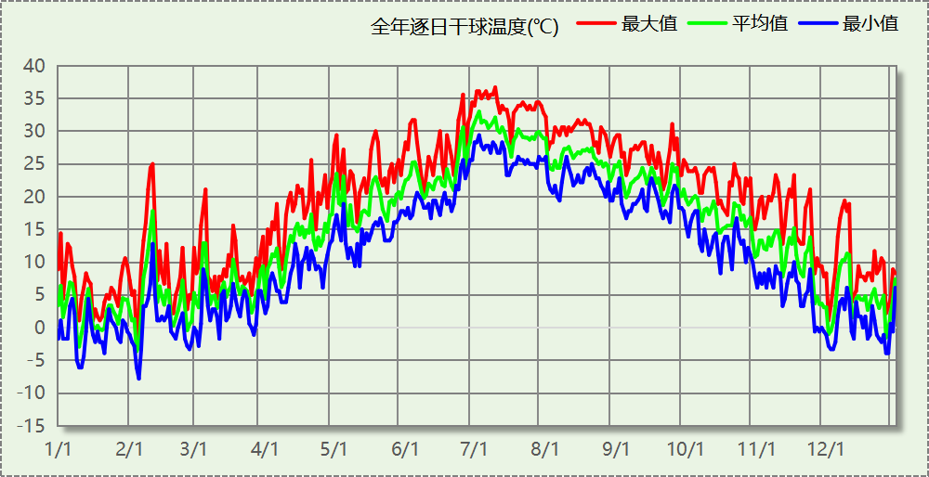

## 逐月辐照量表

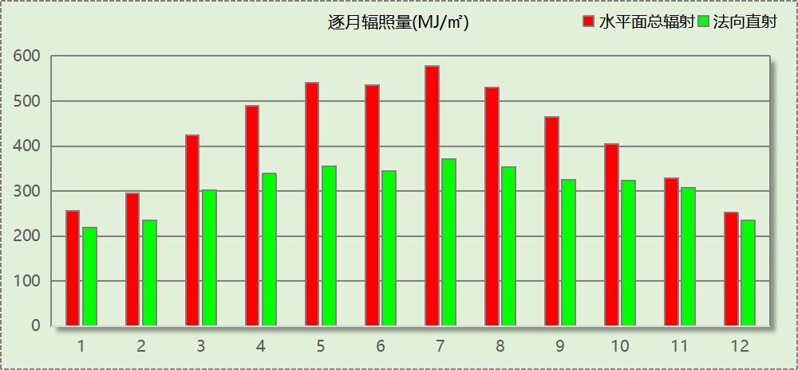

## 峰值工况

|  |  |  |  |  |  |
| --- | --- | --- | --- | --- | --- |
| 气象数据 | 时刻 | 干球温度(℃) | 湿球温度(℃) | 含湿量(g/kg) | 焓值(kj/kg) |
| 最热 | 07月09日14时 | 36.7 | 27.8 | 20.3 | 89.0 |
| 最冷 | 02月04日06时 | -7.8 | -8.3 | 1.6 | -3.8 |

# 软件介绍

本报告采用的软件为绿建暖通负荷BECH2024，该软件紧密结合暖通和节能设计规范、可根据项目实际情况建立建筑热工模型，并可对围护结构材料、房间内扰发热、作息时间表、热回收方式等参数进行设置。

软件包含全国各地典型气象年数据，内置DOE2.1E内核，对于建筑的逐时负荷进行动态模拟，既可以模拟8760小时理想负荷，也可以根据设定好的采暖期/空调期进行逐时模拟。

软件还支持分析全年建筑能耗的来源构成，依据日射得热、新风负荷、围护传热和内扰得热进行归类分项，生成设计建筑全年负荷计算报告书，提供详实的数据和多样的图表，为设计师在设备选型、制定运行策略等方面提供参考和帮助。

# 围护结构

## 屋顶构造

### 保温平屋面：挤塑聚苯板(XPS)+钢筋混凝土

|  |  |  |  |  |  |  |
| --- | --- | --- | --- | --- | --- | --- |
| 材料名称 （由上到下） | 厚度δ | 导热系数λ | 蓄热系数S | 修正 系数 | 热阻R | 热惰性 指标 |
| (mm) | W/(m.K) | W/(㎡.K) | α | (㎡K)/W | D=R*S |
| 细石混凝土 | 40 | 1.740 | 17.200 | 1.00 | 0.023 | 0.395 |
| 挤塑聚苯板(XPS) | 100 | 0.030 | 0.540 | 1.25 | 2.667 | 1.800 |
| 防水卷材 | 1 | － | － | － | － | － |
| 陶粒混凝土找坡 | 30 | 0.890 | 10.360 | 1.50 | 0.022 | 0.349 |
| 钢筋混凝土 | 120 | 1.740 | 17.200 | 1.00 | 0.069 | 1.186 |
| 各层之和∑ | 291 | － | － | － | 2.781 | 3.731 |
| 传热系数K=1/(0.15+∑R) | 0.34 | | | | | |

## 外墙构造

### 外墙（填充墙）构造一

|  |  |  |  |  |  |  |
| --- | --- | --- | --- | --- | --- | --- |
| 材料名称 （由外到内） | 厚度δ | 导热系数λ | 蓄热系数S | 修正 系数 | 热阻R | 热惰性 指标 |
| (mm) | W/(m.K) | W/(㎡.K) | α | (㎡K)/W | D=R*S |
| 干挂铝板 | 1 | － | － | － | － | － |
| 轻钢主龙骨+副龙骨 | 1 | － | － | － | － | － |
| 锚固件固定 | 1 | － | － | － | － | － |
| 高分子防水透气层 | 1 | － | － | － | － | － |
| 岩棉板（夏热冬冷地区） | 30 | 0.040 | 0.700 | 1.20 | 0.625 | 0.525 |
| 防水砂浆 | 10 | 0.930 | 11.370 | 1.00 | 0.011 | 0.122 |
| ALC外墙板 | 200 | 0.170 | 2.180 | 1.10 | 1.070 | 2.565 |
| 各层之和∑ | 244 | － | － | － | 1.705 | 3.212 |
| 传热系数K=1/(0.15+∑R) | 0.54 | | | | | |

## 挑空楼板构造

### 挑空楼板构造：TD3-90钢筋桁架楼承板+岩棉板

|  |  |  |  |  |  |  |
| --- | --- | --- | --- | --- | --- | --- |
| 材料名称 （由上到下） | 厚度δ | 导热系数λ | 蓄热系数S | 修正 系数 | 热阻R | 热惰性 指标 |
| (mm) | W/(m.K) | W/(㎡.K) | α | (㎡K)/W | D=R*S |
| TD3-90钢筋桁架楼承板 | 120 | 1.740 | 17.200 | 1.00 | 0.069 | 1.186 |
| 胶粘剂 | 1 | － | － | － | － | － |
| 岩棉板（夏热冬冷地区） | 60 | 0.040 | 0.700 | 1.20 | 1.250 | 1.050 |
| 抹面砂浆 | 10 | 0.930 | 11.306 | 1.00 | 0.011 | 0.122 |
| 各层之和∑ | 191 | － | － | － | 1.330 | 2.358 |
| 传热系数K=1/(0.15+∑R) | 0.68 | | | | | |

## 楼板构造

### 控温房间楼板构造一：挤塑聚苯板(XPS)+钢筋混凝土

|  |  |  |  |  |  |  |
| --- | --- | --- | --- | --- | --- | --- |
| 材料名称 | 厚度δ | 导热系数λ | 蓄热系数S | 修正 系数 | 热阻R | 热惰性 指标 |
| (mm) | W/(m.K) | W/(㎡.K) | α | (㎡K)/W | D=R*S |
| 饰面层 | 1 | － | － | － | － | － |
| 细石混凝土（内配筋） | 40 | 1.740 | 17.200 | 1.00 | 0.023 | 0.395 |
| 挤塑聚苯板(XPS) | 10 | 0.030 | 0.540 | 1.25 | 0.267 | 0.180 |
| 钢筋混凝土 | 120 | 1.740 | 17.200 | 1.00 | 0.069 | 1.186 |
| 各层之和∑ | 171 | － | － | － | 0.359 | 1.762 |
| 传热系数K=1/(0.22+∑R) | 1.73 | | | | | |

## 周边地面构造

### 地面构造一

|  |  |  |  |  |  |  |
| --- | --- | --- | --- | --- | --- | --- |
| 材料名称 | 厚度δ | 导热系数λ | 蓄热系数S | 修正 系数 | 热阻R | 热惰性 指标 |
| (mm) | W/(m.K) | W/(㎡.K) | α | (㎡K)/W | D=R*S |
| 水泥砂浆 | 20 | 0.930 | 11.370 | 1.00 | 0.022 | 0.245 |
| 挤塑聚苯板(XPS) | 45 | 0.030 | 0.540 | 1.25 | 1.200 | 0.810 |
| 钢筋混凝土 | 120 | 1.740 | 17.200 | 1.00 | 0.069 | 1.186 |
| 各层之和∑ | 185 | － | － | － | 1.290 | 2.241 |
| 传热系数K=1/(0.11+∑R) | 0.32 | | | | | |

## 非周边地面构造

### 地面构造一

|  |  |  |  |  |  |  |
| --- | --- | --- | --- | --- | --- | --- |
| 材料名称 | 厚度δ | 导热系数λ | 蓄热系数S | 修正 系数 | 热阻R | 热惰性 指标 |
| (mm) | W/(m.K) | W/(㎡.K) | α | (㎡K)/W | D=R*S |
| 水泥砂浆 | 20 | 0.930 | 11.370 | 1.00 | 0.022 | 0.245 |
| 挤塑聚苯板(XPS) | 45 | 0.030 | 0.540 | 1.25 | 1.200 | 0.810 |
| 钢筋混凝土 | 120 | 1.740 | 17.200 | 1.00 | 0.069 | 1.186 |
| 各层之和∑ | 185 | － | － | － | 1.290 | 2.241 |
| 传热系数K=1/(0.11+∑R) | 0.22 | | | | | |

## 地下墙构造

### 地下墙构造一

|  |  |  |  |  |  |  |
| --- | --- | --- | --- | --- | --- | --- |
| 材料名称 | 厚度δ | 导热系数λ | 蓄热系数S | 修正 系数 | 热阻R | 热惰性 指标 |
| (mm) | W/(m.K) | W/(㎡.K) | α | (㎡K)/W | D=R*S |
| 钢筋混凝土 | 200 | 1.740 | 17.200 | 1.00 | 0.115 | 1.977 |
| 石灰砂浆 | 20 | 0.810 | 10.070 | 1.00 | 0.025 | 0.249 |
| 各层之和∑ | 220 | － | － | － | 0.140 | 2.226 |
| 传热系数K=1/(0.11+∑R) | 4.01 | | | | | |

## 门构造

|  |  |  |  |
| --- | --- | --- | --- |
| 序号 | 构造名称 | 传热系数 | 备注 |
| 1 | 金属三防门(聚氨酯发泡) | 1.100 |  |

## 窗构造

|  |  |  |  |  |  |
| --- | --- | --- | --- | --- | --- |
| 序号 | 构造名称 | 传热系数 | 窗遮阳系数 | 可见光透射比 | 备注 |
| 1 | 60系列内外开下悬铝合金窗[5Low-E+9Ar+5Low-E+9A+5] | 1.600 | 0.320 | 0.620 |  |
| 2 | 65系列内平开塑料窗(5+12Ar+5Low-E+12Ar+5Low-E) | 1.200 | 0.316 | 0.620 |  |
| 3 | 65系列内平开塑料窗(5+12Ar+5Low-E+12Ar+5Low-E) | 1.200 | 0.316 | 0.620 |  |

# 房间类型

## 房间参数表

|  |  |  |  |  |  |  |
| --- | --- | --- | --- | --- | --- | --- |
| 房间类型 | 空调温度 ℃ | 供暖温度 ℃ | 新风量 | 人员密度 | 照明功率 密度 | 电器设备 功率 |
| 一般商店 | 26 | 20 | 19(m^3/h.人) | 4(m^2/人) | 9(W/m^2) | 13(W/m^2) |
| 书库 | 26 | 20 | 30(m^3/h.人) | 4(m^2/人) | 9(W/m^2) | 15(W/m^2) |
| 会议室 | 26 | 18 | 14(m^3/h.人) | 2.5(m^2/人) | 8(W/m^2) | 15(W/m^2) |
| 展示区 | 26 | 20 | 30(m^3/h.人) | 2.5(m^2/人) | 8(W/m^2) | 15(W/m^2) |
| 报告厅 | 26 | 18 | 14(m^3/h.人) | 2.5(m^2/人) | 8(W/m^2) | 15(W/m^2) |
| 普通办公室 | 26 | 20 | 30(m^3/h.人) | 8(m^2/人) | 8(W/m^2) | 15(W/m^2) |
| 空房间 | － | － | 20(m^3/h.人) | 0(人) | 0(W/m^2) | 0(W/m^2) |
| 空房间 | － | － | 20(m^3/h.人) | 0(人) | 0(W/m^2) | 0(W/m^2) |
| 阅览室 | 26 | 20 | 30(m^3/h.人) | 2(m^2/人) | 9(W/m^2) | 15(W/m^2) |
| 餐厅 | 26 | 18 | 30(m^3/h.人) | 2.5(m^2/人) | 8(W/m^2) | 15(W/m^2) |

## 作息时间表

详见附录

# 系统设置

## 系统划分

|  |  |  |  |  |  |  |
| --- | --- | --- | --- | --- | --- | --- |
| 系统编号 | 热回收 类型 | 启动 条件 | 回收 效率 | 排风 比例 | 面积(m2) | 包含的房间 |
| 默认 | 无 | -- | -- | -- | 6880.96 | 1004,1006,1005,1003,1002,X033,X032,X031,X030,X029,X028,X027,X026,X025,X024,X023,X022,X021,X020,X019,X018,X017,X016,X015,X014,X013,X012,X011,X010,X009,X008,X007,X006,X005,X004,X002,1004,1003,1002,X033,X032,X031,X030,X029,X028,X027,X026,X025,X024,X023,X022,X005,2001,2010,2002,X078,X075,X074,X070,X068,X067,X064,X062,X058,X056,X053,X051,X014,X008,X007,3002,3009,3003,3001,X077,X076,X073,X071,X069,X065,X063,X061,X059,X055,X054,X049,X017,X013,4007,X072,X066,X060,X057,X052,X050 |
| Sys | 全热回收 | 温差启动 冷:≥5.0(℃) 暖:≥5.0(℃) | 冷:0.50, 暖:0.55 | 0.80 | 3932.98 | 1006,1005,X021,X020,X019,X018,X017,X016,X015,X014,X013,X012,X011,X010,X009,X008,X007,X006,X004,X002,2008,2005,X048,X045,X044,X042,X039,X037,X034,X032,X028,X025,X022,X020,X015,X047,X043,X041,X040,X038,X036,X033,X031,X027,X026,X024,X023,X021,X018,X016,X010,X006,X046,X035,X030,X029,X019,X012 |

## 运行时间表

详见附录

# 计算结果

## 模拟周期

供冷季(6.14-8.31) 供暖季(11.30-2.28)

## 全年冷暖需求

|  |  |  |  |  |
| --- | --- | --- | --- | --- |
| 系统名称\负荷 | 供暖需求 (kWh) | 供暖指标 (kWh/㎡·a) | 供冷需求 (kWh) | 供冷指标 (kWh/㎡·a) |
| Sys | 32277 | 8.21 | 251614 | 63.98 |
| 默认系统 | 0 | 0.00 | 0 | 0.00 |
| 建筑总计 | 32277 | 3.36 | 251614 | 26.21 |

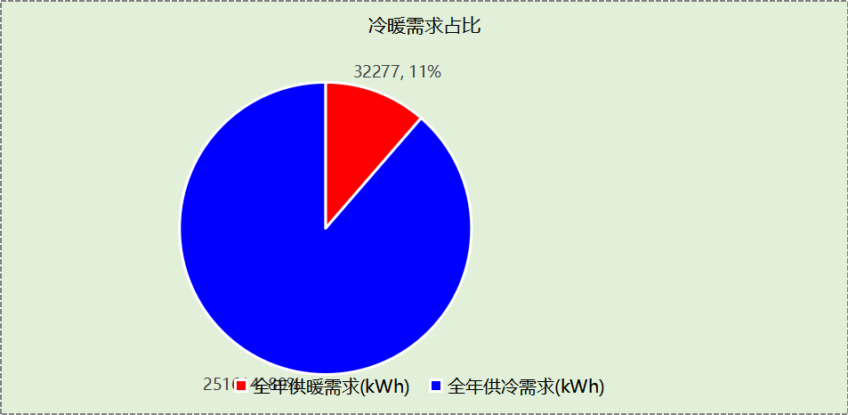

## 负荷分项统计

|  |  |  |  |  |  |  |
| --- | --- | --- | --- | --- | --- | --- |
| 分类 | 围护传热 | 室内得热 | 窗日射 | 新风/渗透 | 热回收 | 合计 |
| 供暖(kWh/㎡) | -1.80 | 5.60 | 0.59 | -13.58 | 5.83 | -3.36 |
| 供冷(kWh/㎡) | 4.23 | 7.62 | 0.74 | 16.94 | -3.32 | 26.21 |

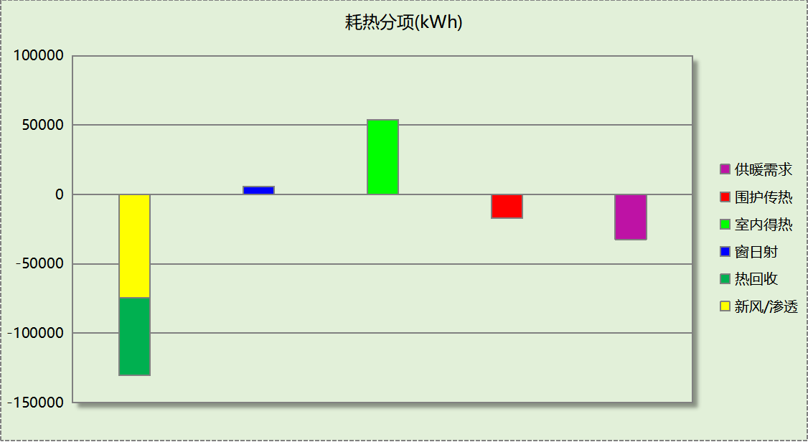

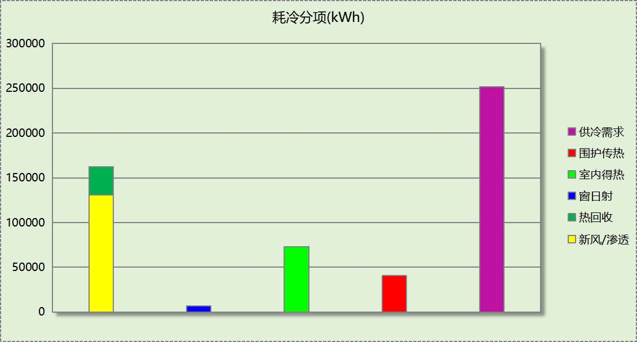

## 逐月负荷表

|  |  |  |  |  |  |  |
| --- | --- | --- | --- | --- | --- | --- |
| 月份 | 供暖(kWh) | 供冷(kWh) | 热负荷 峰值(kW) | 热负荷 峰值时刻 | 冷负荷 峰值(kW) | 冷负荷 峰值时刻 |
| 1月 | 15409 | 0 | 172.558 | 1月21日8时 | 0.000 | -- |
| 2月 | 12199 | 0 | 248.821 | 2月4日8时 | 0.000 | -- |
| 3月 | 0 | 0 | 0.000 | -- | 0.000 | -- |
| 4月 | 0 | 0 | 0.000 | -- | 0.000 | -- |
| 5月 | 0 | 0 | 0.000 | -- | 0.000 | -- |
| 6月 | 0 | 41194 | 0.000 | -- | 662.117 | 6月14日8时 |
| 7月 | 0 | 109197 | 0.000 | -- | 728.711 | 7月9日8时 |
| 8月 | 0 | 101223 | 0.000 | -- | 599.442 | 8月21日8时 |
| 9月 | 0 | 0 | 0.000 | -- | 0.000 | -- |
| 10月 | 0 | 0 | 0.000 | -- | 0.000 | -- |
| 11月 | 0 | 0 | 0.000 | -- | 0.000 | -- |
| 12月 | 4670 | 0 | 116.616 | 12月26日17时 | 0.000 | -- |

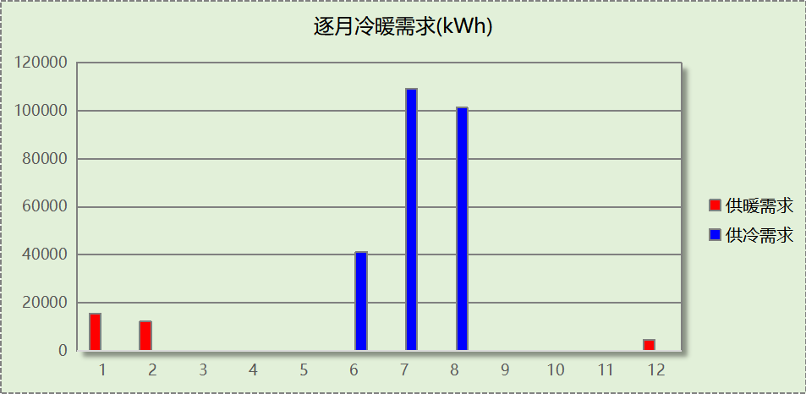

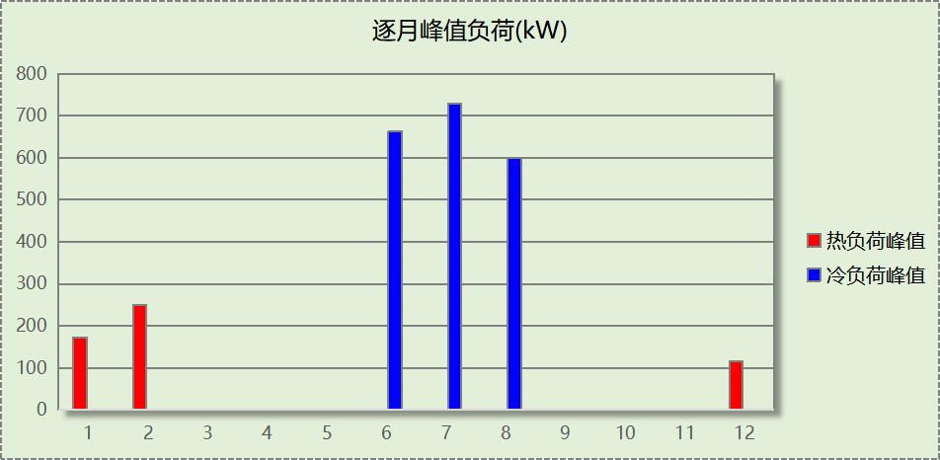

# 附录

**工作日/节假日人员逐时在室率(%)**

|  |  |  |  |  |  |  |  |  |  |  |  |  |  |  |  |  |  |  |  |  |  |  |  |  |
| --- | --- | --- | --- | --- | --- | --- | --- | --- | --- | --- | --- | --- | --- | --- | --- | --- | --- | --- | --- | --- | --- | --- | --- | --- |
| 房间类型 | 1 | 2 | 3 | 4 | 5 | 6 | 7 | 8 | 9 | 10 | 11 | 12 | 13 | 14 | 15 | 16 | 17 | 18 | 19 | 20 | 21 | 22 | 23 | 24 |
| 一般商店 | 0 | 0 | 0 | 0 | 0 | 0 | 0 | 20 | 50 | 80 | 80 | 80 | 80 | 80 | 80 | 80 | 80 | 80 | 80 | 70 | 50 | 0 | 0 | 0 |
| 0 | 0 | 0 | 0 | 0 | 0 | 0 | 20 | 50 | 80 | 80 | 80 | 80 | 80 | 80 | 80 | 80 | 80 | 80 | 70 | 50 | 0 | 0 | 0 |
| 书库 | 0 | 0 | 0 | 0 | 0 | 0 | 10 | 50 | 100 | 100 | 100 | 30 | 100 | 100 | 100 | 100 | 50 | 20 | 10 | 0 | 0 | 0 | 0 | 0 |
| 0 | 0 | 0 | 0 | 0 | 0 | 0 | 20 | 45 | 0 | 0 | 0 | 0 | 0 | 0 | 0 | 0 | 0 | 0 | 0 | 0 | 0 | 0 | 0 |
| 会议室 | 0 | 0 | 0 | 0 | 0 | 0 | 10 | 50 | 100 | 100 | 100 | 30 | 100 | 100 | 100 | 100 | 50 | 20 | 10 | 0 | 0 | 0 | 0 | 0 |
| 0 | 0 | 0 | 0 | 0 | 0 | 0 | 20 | 45 | 0 | 0 | 0 | 0 | 0 | 0 | 0 | 0 | 0 | 0 | 0 | 0 | 0 | 0 | 0 |
| 展示区 | 0 | 0 | 0 | 0 | 0 | 0 | 10 | 50 | 100 | 100 | 100 | 30 | 100 | 100 | 100 | 100 | 50 | 20 | 10 | 0 | 0 | 0 | 0 | 0 |
| 0 | 0 | 0 | 0 | 0 | 0 | 0 | 20 | 45 | 0 | 0 | 0 | 0 | 0 | 0 | 0 | 0 | 0 | 0 | 0 | 0 | 0 | 0 | 0 |
| 报告厅 | 0 | 0 | 0 | 0 | 0 | 0 | 10 | 50 | 100 | 100 | 100 | 30 | 100 | 100 | 100 | 100 | 50 | 20 | 10 | 0 | 0 | 0 | 0 | 0 |
| 0 | 0 | 0 | 0 | 0 | 0 | 0 | 20 | 45 | 0 | 0 | 0 | 0 | 0 | 0 | 0 | 0 | 0 | 0 | 0 | 0 | 0 | 0 | 0 |
| 普通办公室 | 0 | 0 | 0 | 0 | 0 | 0 | 10 | 50 | 100 | 100 | 100 | 30 | 100 | 100 | 100 | 100 | 50 | 20 | 10 | 0 | 0 | 0 | 0 | 0 |
| 0 | 0 | 0 | 0 | 0 | 0 | 0 | 20 | 45 | 0 | 0 | 0 | 0 | 0 | 0 | 0 | 0 | 0 | 0 | 0 | 0 | 0 | 0 | 0 |
| 空房间 | 0 | 0 | 0 | 0 | 0 | 0 | 0 | 20 | 50 | 80 | 80 | 80 | 80 | 80 | 80 | 80 | 80 | 80 | 80 | 70 | 50 | 0 | 0 | 0 |
| 0 | 0 | 0 | 0 | 0 | 0 | 0 | 20 | 50 | 80 | 80 | 80 | 80 | 80 | 80 | 80 | 80 | 80 | 80 | 70 | 50 | 0 | 0 | 0 |
| 空房间 | 0 | 0 | 0 | 0 | 0 | 0 | 0 | 20 | 50 | 80 | 80 | 80 | 80 | 80 | 80 | 80 | 80 | 80 | 80 | 70 | 50 | 0 | 0 | 0 |
| 0 | 0 | 0 | 0 | 0 | 0 | 0 | 0 | 0 | 0 | 0 | 0 | 0 | 0 | 0 | 0 | 0 | 0 | 0 | 0 | 0 | 0 | 0 | 0 |
| 阅览室 | 0 | 0 | 0 | 0 | 0 | 0 | 10 | 50 | 100 | 100 | 100 | 30 | 100 | 100 | 100 | 100 | 50 | 20 | 10 | 0 | 0 | 0 | 0 | 0 |
| 0 | 0 | 0 | 0 | 0 | 0 | 0 | 20 | 45 | 0 | 0 | 0 | 0 | 0 | 0 | 0 | 0 | 0 | 0 | 0 | 0 | 0 | 0 | 0 |
| 餐厅 | 0 | 0 | 0 | 0 | 0 | 0 | 10 | 50 | 100 | 100 | 100 | 30 | 100 | 100 | 100 | 100 | 50 | 20 | 10 | 0 | 0 | 0 | 0 | 0 |
| 0 | 0 | 0 | 0 | 0 | 0 | 0 | 20 | 45 | 0 | 0 | 0 | 0 | 0 | 0 | 0 | 0 | 0 | 0 | 0 | 0 | 0 | 0 | 0 |

注：上行：工作日；下行：节假日

**工作日/节假日照明开关时间表(%)**

|  |  |  |  |  |  |  |  |  |  |  |  |  |  |  |  |  |  |  |  |  |  |  |  |  |
| --- | --- | --- | --- | --- | --- | --- | --- | --- | --- | --- | --- | --- | --- | --- | --- | --- | --- | --- | --- | --- | --- | --- | --- | --- |
| 房间类型 | 1 | 2 | 3 | 4 | 5 | 6 | 7 | 8 | 9 | 10 | 11 | 12 | 13 | 14 | 15 | 16 | 17 | 18 | 19 | 20 | 21 | 22 | 23 | 24 |
| 一般商店 | 10 | 10 | 10 | 10 | 10 | 10 | 10 | 50 | 60 | 60 | 60 | 60 | 60 | 60 | 60 | 60 | 80 | 90 | 100 | 100 | 100 | 10 | 10 | 10 |
| 10 | 10 | 10 | 10 | 10 | 10 | 10 | 50 | 60 | 60 | 60 | 60 | 60 | 60 | 60 | 60 | 80 | 90 | 100 | 100 | 100 | 10 | 10 | 10 |
| 书库 | 10 | 10 | 10 | 10 | 10 | 10 | 10 | 36 | 62 | 56 | 54 | 43 | 53 | 55 | 58 | 67 | 40 | 18 | 10 | 10 | 10 | 10 | 10 | 10 |
| 0 | 0 | 0 | 0 | 0 | 0 | 0 | 0 | 0 | 0 | 0 | 0 | 0 | 0 | 0 | 0 | 0 | 0 | 0 | 0 | 0 | 0 | 0 | 0 |
| 会议室 | 10 | 10 | 10 | 10 | 10 | 10 | 10 | 36 | 62 | 56 | 54 | 43 | 53 | 55 | 58 | 67 | 40 | 18 | 10 | 10 | 10 | 10 | 10 | 10 |
| 0 | 0 | 0 | 0 | 0 | 0 | 0 | 0 | 0 | 0 | 0 | 0 | 0 | 0 | 0 | 0 | 0 | 0 | 0 | 0 | 0 | 0 | 0 | 0 |
| 展示区 | 10 | 10 | 10 | 10 | 10 | 10 | 10 | 36 | 62 | 56 | 54 | 43 | 53 | 55 | 58 | 67 | 40 | 18 | 10 | 10 | 10 | 10 | 10 | 10 |
| 0 | 0 | 0 | 0 | 0 | 0 | 0 | 0 | 0 | 0 | 0 | 0 | 0 | 0 | 0 | 0 | 0 | 0 | 0 | 0 | 0 | 0 | 0 | 0 |
| 报告厅 | 10 | 10 | 10 | 10 | 10 | 10 | 10 | 36 | 62 | 56 | 54 | 43 | 53 | 55 | 58 | 67 | 40 | 18 | 10 | 10 | 10 | 10 | 10 | 10 |
| 0 | 0 | 0 | 0 | 0 | 0 | 0 | 0 | 0 | 0 | 0 | 0 | 0 | 0 | 0 | 0 | 0 | 0 | 0 | 0 | 0 | 0 | 0 | 0 |
| 普通办公室 | 10 | 10 | 10 | 10 | 10 | 10 | 10 | 36 | 62 | 56 | 54 | 43 | 53 | 55 | 58 | 67 | 40 | 18 | 10 | 10 | 10 | 10 | 10 | 10 |
| 0 | 0 | 0 | 0 | 0 | 0 | 0 | 0 | 0 | 0 | 0 | 0 | 0 | 0 | 0 | 0 | 0 | 0 | 0 | 0 | 0 | 0 | 0 | 0 |
| 空房间 | 10 | 10 | 10 | 10 | 10 | 10 | 10 | 50 | 60 | 60 | 60 | 60 | 60 | 60 | 60 | 60 | 80 | 90 | 100 | 100 | 100 | 10 | 10 | 10 |
| 10 | 10 | 10 | 10 | 10 | 10 | 10 | 50 | 60 | 60 | 60 | 60 | 60 | 60 | 60 | 60 | 80 | 90 | 100 | 100 | 100 | 10 | 10 | 10 |
| 空房间 | 10 | 10 | 10 | 10 | 10 | 10 | 10 | 50 | 60 | 60 | 60 | 60 | 60 | 60 | 60 | 60 | 80 | 90 | 100 | 100 | 100 | 10 | 10 | 10 |
| 0 | 0 | 0 | 0 | 0 | 0 | 0 | 0 | 0 | 0 | 0 | 0 | 0 | 0 | 0 | 0 | 0 | 0 | 0 | 0 | 0 | 0 | 0 | 0 |
| 阅览室 | 10 | 10 | 10 | 10 | 10 | 10 | 10 | 36 | 62 | 56 | 54 | 43 | 53 | 55 | 58 | 67 | 40 | 18 | 10 | 10 | 10 | 10 | 10 | 10 |
| 0 | 0 | 0 | 0 | 0 | 0 | 0 | 0 | 0 | 0 | 0 | 0 | 0 | 0 | 0 | 0 | 0 | 0 | 0 | 0 | 0 | 0 | 0 | 0 |
| 餐厅 | 10 | 10 | 10 | 10 | 10 | 10 | 10 | 36 | 62 | 56 | 54 | 43 | 53 | 55 | 58 | 67 | 40 | 18 | 10 | 10 | 10 | 10 | 10 | 10 |
| 0 | 0 | 0 | 0 | 0 | 0 | 0 | 0 | 0 | 0 | 0 | 0 | 0 | 0 | 0 | 0 | 0 | 0 | 0 | 0 | 0 | 0 | 0 | 0 |

注：上行：工作日；下行：节假日

**工作日/节假日设备逐时使用率(%)**

|  |  |  |  |  |  |  |  |  |  |  |  |  |  |  |  |  |  |  |  |  |  |  |  |  |
| --- | --- | --- | --- | --- | --- | --- | --- | --- | --- | --- | --- | --- | --- | --- | --- | --- | --- | --- | --- | --- | --- | --- | --- | --- |
| 房间类型 | 1 | 2 | 3 | 4 | 5 | 6 | 7 | 8 | 9 | 10 | 11 | 12 | 13 | 14 | 15 | 16 | 17 | 18 | 19 | 20 | 21 | 22 | 23 | 24 |
| 一般商店 | 0 | 0 | 0 | 0 | 0 | 0 | 0 | 30 | 50 | 80 | 80 | 80 | 80 | 80 | 80 | 80 | 80 | 80 | 80 | 70 | 50 | 0 | 0 | 0 |
| 0 | 0 | 0 | 0 | 0 | 0 | 0 | 30 | 50 | 80 | 80 | 80 | 80 | 80 | 80 | 80 | 80 | 80 | 80 | 70 | 50 | 0 | 0 | 0 |
| 书库 | 0 | 0 | 0 | 0 | 0 | 0 | 10 | 50 | 100 | 100 | 100 | 100 | 100 | 100 | 100 | 100 | 50 | 20 | 10 | 0 | 0 | 0 | 0 | 0 |
| 0 | 0 | 0 | 0 | 0 | 0 | 0 | 0 | 0 | 0 | 0 | 0 | 0 | 0 | 0 | 0 | 0 | 0 | 0 | 0 | 0 | 0 | 0 | 0 |
| 会议室 | 0 | 0 | 0 | 0 | 0 | 0 | 10 | 50 | 100 | 100 | 100 | 100 | 100 | 100 | 100 | 100 | 50 | 20 | 10 | 0 | 0 | 0 | 0 | 0 |
| 0 | 0 | 0 | 0 | 0 | 0 | 0 | 0 | 0 | 0 | 0 | 0 | 0 | 0 | 0 | 0 | 0 | 0 | 0 | 0 | 0 | 0 | 0 | 0 |
| 展示区 | 0 | 0 | 0 | 0 | 0 | 0 | 10 | 50 | 100 | 100 | 100 | 100 | 100 | 100 | 100 | 100 | 50 | 20 | 10 | 0 | 0 | 0 | 0 | 0 |
| 0 | 0 | 0 | 0 | 0 | 0 | 0 | 0 | 0 | 0 | 0 | 0 | 0 | 0 | 0 | 0 | 0 | 0 | 0 | 0 | 0 | 0 | 0 | 0 |
| 报告厅 | 0 | 0 | 0 | 0 | 0 | 0 | 10 | 50 | 100 | 100 | 100 | 100 | 100 | 100 | 100 | 100 | 50 | 20 | 10 | 0 | 0 | 0 | 0 | 0 |
| 0 | 0 | 0 | 0 | 0 | 0 | 0 | 0 | 0 | 0 | 0 | 0 | 0 | 0 | 0 | 0 | 0 | 0 | 0 | 0 | 0 | 0 | 0 | 0 |
| 普通办公室 | 0 | 0 | 0 | 0 | 0 | 0 | 10 | 50 | 100 | 100 | 100 | 100 | 100 | 100 | 100 | 100 | 50 | 20 | 10 | 0 | 0 | 0 | 0 | 0 |
| 0 | 0 | 0 | 0 | 0 | 0 | 0 | 0 | 0 | 0 | 0 | 0 | 0 | 0 | 0 | 0 | 0 | 0 | 0 | 0 | 0 | 0 | 0 | 0 |
| 空房间 | 0 | 0 | 0 | 0 | 0 | 0 | 0 | 30 | 50 | 80 | 80 | 80 | 80 | 80 | 80 | 80 | 80 | 80 | 80 | 70 | 50 | 0 | 0 | 0 |
| 0 | 0 | 0 | 0 | 0 | 0 | 0 | 30 | 50 | 80 | 80 | 80 | 80 | 80 | 80 | 80 | 80 | 80 | 80 | 70 | 50 | 0 | 0 | 0 |
| 空房间 | 0 | 0 | 0 | 0 | 0 | 0 | 0 | 30 | 50 | 80 | 80 | 80 | 80 | 80 | 80 | 80 | 80 | 80 | 80 | 70 | 50 | 0 | 0 | 0 |
| 0 | 0 | 0 | 0 | 0 | 0 | 0 | 0 | 0 | 0 | 0 | 0 | 0 | 0 | 0 | 0 | 0 | 0 | 0 | 0 | 0 | 0 | 0 | 0 |
| 阅览室 | 0 | 0 | 0 | 0 | 0 | 0 | 10 | 50 | 100 | 100 | 100 | 100 | 100 | 100 | 100 | 100 | 50 | 20 | 10 | 0 | 0 | 0 | 0 | 0 |
| 0 | 0 | 0 | 0 | 0 | 0 | 0 | 0 | 0 | 0 | 0 | 0 | 0 | 0 | 0 | 0 | 0 | 0 | 0 | 0 | 0 | 0 | 0 | 0 |
| 餐厅 | 0 | 0 | 0 | 0 | 0 | 0 | 10 | 50 | 100 | 100 | 100 | 100 | 100 | 100 | 100 | 100 | 50 | 20 | 10 | 0 | 0 | 0 | 0 | 0 |
| 0 | 0 | 0 | 0 | 0 | 0 | 0 | 0 | 0 | 0 | 0 | 0 | 0 | 0 | 0 | 0 | 0 | 0 | 0 | 0 | 0 | 0 | 0 | 0 |

注：上行：工作日；下行：节假日

**工作日/节假日空调系统开关时间表**

采暖期：

|  |  |  |  |  |  |  |  |  |  |  |  |  |  |  |  |  |  |  |  |  |  |  |  |  |
| --- | --- | --- | --- | --- | --- | --- | --- | --- | --- | --- | --- | --- | --- | --- | --- | --- | --- | --- | --- | --- | --- | --- | --- | --- |
| 系统编号 | 1 | 2 | 3 | 4 | 5 | 6 | 7 | 8 | 9 | 10 | 11 | 12 | 13 | 14 | 15 | 16 | 17 | 18 | 19 | 20 | 21 | 22 | 23 | 24 |
| 默认 | 0 | 0 | 0 | 0 | 0 | 0 | 0 | 1 | 1 | 1 | 1 | 1 | 1 | 1 | 1 | 1 | 1 | 1 | 1 | 1 | 1 | 0 | 0 | 0 |
| 0 | 0 | 0 | 0 | 0 | 0 | 0 | 1 | 1 | 1 | 1 | 1 | 1 | 1 | 1 | 1 | 1 | 1 | 1 | 1 | 1 | 0 | 0 | 0 |
| Sys | 0 | 0 | 0 | 0 | 0 | 0 | 0 | 0 | 1 | 1 | 1 | 1 | 1 | 1 | 1 | 1 | 1 | 1 | 1 | 1 | 0 | 0 | 0 | 0 |
| 0 | 0 | 0 | 0 | 0 | 0 | 0 | 0 | 0 | 0 | 0 | 0 | 0 | 0 | 0 | 0 | 0 | 0 | 0 | 0 | 0 | 0 | 0 | 0 |

供冷期：

|  |  |  |  |  |  |  |  |  |  |  |  |  |  |  |  |  |  |  |  |  |  |  |  |  |
| --- | --- | --- | --- | --- | --- | --- | --- | --- | --- | --- | --- | --- | --- | --- | --- | --- | --- | --- | --- | --- | --- | --- | --- | --- |
| 系统编号 | 1 | 2 | 3 | 4 | 5 | 6 | 7 | 8 | 9 | 10 | 11 | 12 | 13 | 14 | 15 | 16 | 17 | 18 | 19 | 20 | 21 | 22 | 23 | 24 |
| 默认 | 0 | 0 | 0 | 0 | 0 | 0 | 0 | 1 | 1 | 1 | 1 | 1 | 1 | 1 | 1 | 1 | 1 | 1 | 1 | 1 | 1 | 0 | 0 | 0 |
| 0 | 0 | 0 | 0 | 0 | 0 | 0 | 1 | 1 | 1 | 1 | 1 | 1 | 1 | 1 | 1 | 1 | 1 | 1 | 1 | 1 | 0 | 0 | 0 |
| Sys | 0 | 0 | 0 | 0 | 0 | 0 | 0 | 0 | 1 | 1 | 1 | 1 | 1 | 1 | 1 | 1 | 1 | 1 | 1 | 1 | 0 | 0 | 0 | 0 |
| 0 | 0 | 0 | 0 | 0 | 0 | 0 | 0 | 0 | 0 | 0 | 0 | 0 | 0 | 0 | 0 | 0 | 0 | 0 | 0 | 0 | 0 | 0 | 0 |

注：上行：工作日；下行：节假日