**建筑全能耗报告书**

公共建筑

|  |  |
| --- | --- |
| 工程名称 | 新建项目 |
| 工程地点 | 湖南-长沙 |
| 设计编号 |  |
| 建设单位 |  |
| 设计单位 |  |
| 设 计 人 |  |
| 审 核 人 |  |
| 审 定 人 |  |
| 设计日期 | 2024年12月28日 |



|  |  |
| --- | --- |
| 采用软件 | 能耗计算BESI2024 |
| 软件版本 | 20240430(SP1) |
| 研发单位 | 北京绿建软件股份有限公司 |
| 正版授权码 | T13337442789 |

**目 录**

1 建筑概况 3

2 计算依据 3

3 软件介绍 3

4 气象数据 4

4.1 气象地点 4

4.2 逐日干球温度表 4

4.3 逐月辐照量表 4

4.4 峰值工况 5

5 围护结构 5

5.1 工程材料 5

5.2 围护结构作法简要说明 6

6 围护结构概况 6

7 房间类型 6

7.1 房间参数表 6

7.2 作息时间表 7

8 暖通空调系统 7

8.1 系统类型 7

8.1.1 系统分区 7

8.1.2 热回收参数 7

8.2 制冷系统 7

8.2.1 默认冷源 7

8.3 空调风机 8

8.3.1 独立新排风 8

8.3.2 风机盘管 8

9 照明 9

10 插座设备 9

11 电梯 9

11.1 直梯 9

12 光伏发电 10

13 计算结果 10

13.1 负荷分项统计 10

13.2 逐月负荷表 11

13.3 逐月电耗 12

13.4 全年能耗 13

14 附录 15

14.1 工作日/节假日人员逐时在室率(%) 15

14.2 工作日/节假日照明开关时间表(%) 16

14.3 工作日/节假日设备逐时使用率(%) 18

14.4 工作日/节假日空调系统运行时间表(1:开,0:关) 19

14.5 工作日/节假日新风运行时间表(%) 20

# 建筑概况

|  |  |  |
| --- | --- | --- |
| 工程名称 | 新建项目 | |
| 工程地点 | 湖南-长沙 | |
| 地理位置 | 北纬：28.00° | 东经：113.08° |
| 建筑面积(m2) | 地上8718 地下0 | |
| 建筑层数 | 地上6 地下0 | |
| 建筑高度（m） | 地上23.4 地下0.0 | |
| 建筑体积(m3) | 34817.59 | |
| 建筑外表面积(m2) | 9538.97 | |
| 北向角度 | 0 | |
| 结构类型 |  | |
| 外墙太阳辐射吸收系数 | 0.75 | |
| 屋顶太阳辐射吸收系数 | 0.75 | |
| 控温期 | 供冷期:5.15-9.15 | |

# 计算依据

1. 《绿色建筑评价标准》(GB/T50378-2019)

2. 《民用建筑绿色性能计算标准》(JGJ/T 449-2018)

3. 《建筑能效标识技术标准》(JGJ/T 288-2012)

4. 《建筑节能与可再生能源利用通用规范》GB55015-2021

5. 《公共建筑节能设计标准》GB50189-2015

6. 《民用建筑热工设计规范》GB50176-2016

7. 《建筑幕墙、门窗通用技术条件》GB/T31433-2015

# 软件介绍

本报告内容由能耗计算BESI2024计算并输出，能耗计算BESI以CAD为平台，内置DOE2内核，可与建筑节能模型无缝对接，精准快速得到动态理想负荷，完美支持从《建筑能效标识技术标准》到《绿色建筑评价标准》要求的节能率，以及建筑全能耗的计算；软件充分考虑工程实际需求，从冷热源、输配水泵到末端风机，覆盖了常见暖通设备的能耗计算；并支持灵活的采暖供冷期、系统划分、运行策略设置等功能以及强大的结果数据分析。

# 气象数据

## 气象地点

湖南-长沙, 《建筑节能气象参数标准》

## 逐日干球温度表

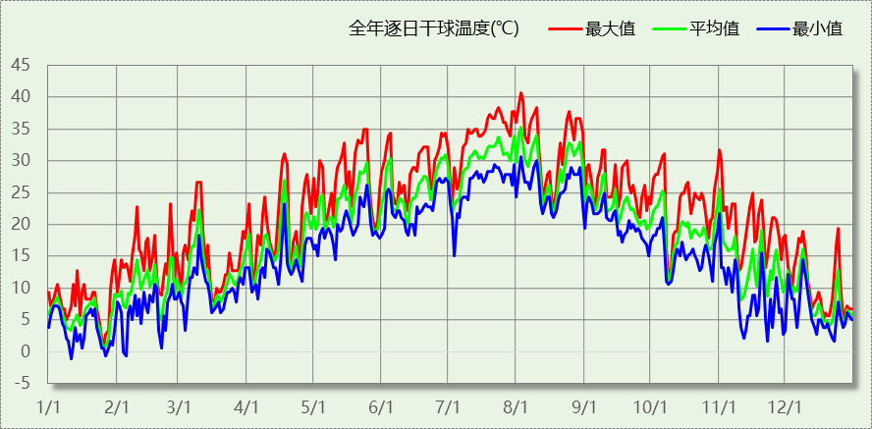

## 逐月辐照量表

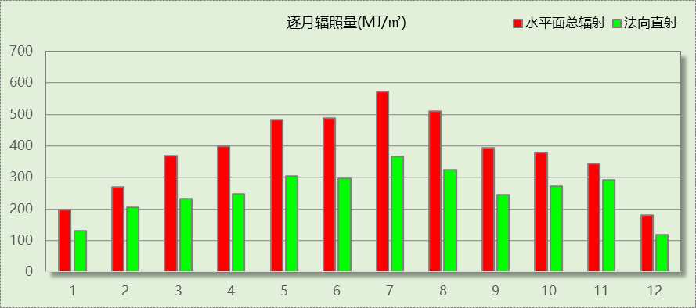

## 峰值工况

|  |  |  |  |  |  |
| --- | --- | --- | --- | --- | --- |
| 气象数据 | 时刻 | 干球温度(℃) | 湿球温度(℃) | 含湿量(g/kg) | 焓值(kj/kg) |
| 最热 | 08月02日15时 | 40.6 | 26.7 | 17.1 | 84.8 |
| 最冷 | 01月10日06时 | -1.1 | -1.1 | 3.4 | 7.4 |

# 围护结构

## 工程材料

|  |  |  |  |  |  |  |
| --- | --- | --- | --- | --- | --- | --- |
| 材料名称 | 导热系数λ | 蓄热系数S | 密度ρ | 比热容Cp | 蒸汽渗透 系数u | 数据来源 |
| W/(m.K) | W/(㎡.K) | kg/m3 | J/(kg.K) | g/(m.h.kPa) |
| 水泥砂浆 | 0.930 | 11.370 | 1800.0 | 1050.0 | 0.0210 | 民用建筑热工设计规范 GB50176-2016 |
| 聚苯乙烯泡沫塑料（灰板） | 0.033 | 0.280 | 20.0 | 1380.0 | 0.0162 | 民用建筑热工设计规范 GB50176-2016 |
| 混合砂浆 | 0.870 | 10.750 | 1700.0 | 1074.4 | 0.0975 | 民用建筑热工设计规范 GB50176-2016 |
| 钢筋混凝土 | 1.740 | 17.200 | 2500.0 | 920.0 | 0.0158 | 民用建筑热工设计规范 GB50176-2016 |
| 挤塑聚苯板(ρ=25-32) | 0.030 | 0.320 | 28.5 | 1647.0 | 0.0162 | 民用建筑热工设计规范 GB50176-2016 |
| 加气混凝土、泡沫混凝土(ρ=700) | 0.180 | 3.100 | 700.0 | 1050.0 | 0.0998 | 民用建筑热工设计规范 GB50176-2016 |
| 混凝土多孔砖(190六孔砖） | 0.750 | 7.490 | 1450.0 | 709.4 | 0.0010 | 民用建筑热工设计规范 GB50176-2016 |
| 岩棉板(ρ=60-160) | 0.041 | 0.615 | 110.0 | 1220.0 | 0.4880 | 民用建筑热工设计规范 GB50176-2016 |
| c20细石混凝土(ρ=2300) | 1.510 | 15.243 | 2300.0 | 920.0 | 0.0173 | 民用建筑热工设计规范 GB50176-2016 |
| 轻骨料混凝土(找坡层) | 0.300 | 5.000 | 1050.0 | 1091.3 | 0.0140 | 民用建筑热工设计规范 GB50176-2016 |

## 围护结构作法简要说明

**1. 屋顶：**屋顶构造一 (K=0.204,D=4.182)：（由上到下）

水泥砂浆 20mm＋c20细石混凝土(ρ=2300) 40mm＋挤塑聚苯板(ρ=25-32) 150mm＋轻骨料混凝土(找坡层) 30mm＋钢筋混凝土 120mm＋混合砂浆 20mm

**2. 外墙：**填充墙构造一 (K=0.378,D=4.986)：（由外到内）

水泥砂浆 20mm＋岩棉板(ρ=60-160) 70mm＋加气混凝土、泡沫混凝土(ρ=700) 200mm＋混合砂浆 20mm

**3. 挑空楼板：**挑空楼板构造一 (K=0.246,D=3.011)：（由上到下）

水泥砂浆 20mm＋挤塑聚苯板(ρ=25-32) 125mm＋钢筋混凝土 120mm＋混合砂浆 20mm

**4. 外窗：**80系列铝合金平开窗：5单银Low-E+12（16）Ar+5+12（16）Ar+5单银Low-E (K=1.100)：

传热系数1.100W/㎡.K，窗太阳得热系数0.360

**5. 幕墙：**80系列铝合金平开窗：5单银Low-E+12（16）Ar+5+12（16）Ar+5单银Low-E (K=1.100)：

传热系数1.100W/㎡.K，窗太阳得热系数0.360

# 围护结构概况

|  |  |  |  |  |  |
| --- | --- | --- | --- | --- | --- |
|  | | | 设计建筑 | | |
| 屋顶传热系数K  和热情性指标 D | | | 0.20  4.18 | | |
| 外墙传热系数K  和热情性指标 D | | | 0.42  4.99 | | |
| 挑空(或架空)楼板传热系数K  和热惰性指标 D | | | 0.25  3.01 | | |
| 天窗传热系数K  和太阳得热系数 SHGC | | | －  － | | |
| 外窗（包括透明幕墙） | 朝向 | 立面 | 窗墙比 | 传热  系数 | 太阳得热系数 |
| 南向 | 南-默认立面 | 0.34 | 1.10 | 0.29 |
| 北向 | 北-默认立面 | 0.36 | 1.10 | 0.36 |
| 东向 | 东-默认立面 | 0.31 | 1.10 | 0.36 |
| 西向 | 西-默认立面 | 0.32 | 1.10 | 0.36 |

# 房间类型

## 房间参数表

|  |  |  |  |  |  |  |  |
| --- | --- | --- | --- | --- | --- | --- | --- |
| 房间类型 | 空调 温度℃ | 供暖 温度℃ | 新风量 | 渗透风 换气次数 | 人员密度 | 照明功率 密度 | 电器设备 功率 |
| 会议室 | 26 | 20 | 30(m3/h.人) | 0(次/h) | 3.3(㎡/人) | 8(W/㎡) | 5(W/㎡) |
| 办公-普通办公室 | 26 | 20 | 30(m3/h.人) | 0(次/h) | 8(㎡/人) | 8(W/㎡) | 15(W/㎡) |
| 卫生间 | 28 | 16 | 0(m3/h.人) | 0(次/h) | 0(人) | 5(W/㎡) | 5(W/㎡) |
| 大厅 | 26 | 20 | 30(m3/h.人) | 0(次/h) | 20(㎡/人) | 10(W/㎡) | 0(W/㎡) |
| 实验教室 | 26 | 18 | 20(m3/h.人) | 0(次/h) | 4(㎡/人) | 8(W/㎡) | 5(W/㎡) |
| 报告厅 | 26 | 18 | 14(m3/h.人) | 0(次/h) | 2.5(㎡/人) | 9(W/㎡) | 5(W/㎡) |
| 普通办公室 | 26 | 20 | 30(m3/h.人) | 0(次/h) | 6(㎡/人) | 8(W/㎡) | 5(W/㎡) |
| 普通办公室 | 26 | 20 | 30(m3/h.人) | 0(次/h) | 8(㎡/人) | 8(W/㎡) | 15(W/㎡) |
| 普通教室 | 26 | 18 | 24(m3/h.人) | 0(次/h) | 1.39(㎡/人) | 8(W/㎡) | 5(W/㎡) |
| 楼梯间 | － | － | 0(m3/h.人) | 0(次/h) | 0(人) | 5(W/㎡) | 5(W/㎡) |
| 空房间 | － | － | 0(m3/h.人) | 0(次/h) | 0(人) | 0(W/㎡) | 0(W/㎡) |
| 设备间 | － | － | 0(次/h) | 0(次/h) | 0(人) | 6(W/㎡) | 15(W/㎡) |

## 作息时间表

详见附录

# 暖通空调系统

## 系统类型

### 系统分区

|  |  |  |  |  |  |
| --- | --- | --- | --- | --- | --- |
| 系统编号 | 系统类型 | 制冷 SEER | 制热 HSPF | 面积(㎡) | 包含的房间 |
| 默认 | 双管制风机盘管 | － | － | 5941.02 | 所有房间 |

### 热回收参数

|  |  |  |  |  |  |
| --- | --- | --- | --- | --- | --- |
| 系统编号 | 热回收 | 供冷 | | 供暖 | |
| 回收效率 | 启动温(焓)差 | 回收效率 | 启动温(焓)差 |
| 默认 | 无 | － | － | － | － |

## 制冷系统

### 默认冷源

#### 供应的系统

|  |  |
| --- | --- |
| 系统编号 | 默认 |

#### 冷水机组

|  |  |  |  |  |  |
| --- | --- | --- | --- | --- | --- |
| 名称 | 类型 | 额定耗电量 (kW) | 额定制冷量 (kW) | 额定性能系数 (COP) | 台数 |
| 机组1 | 水冷-螺杆式冷水机组 | 100 | 500 | 5.00 | 1 |

#### 水泵系统

|  |  |  |  |  |  |  |  |
| --- | --- | --- | --- | --- | --- | --- | --- |
| 类型 | 调节 | 流量 (m3/h) | 扬程 (m) | 设计工作效率(%) | 输入功率 (kW) | 冷却塔耗电比 (kWh/m3) | 台数 |
| 冷却水泵 | 单速 | 320 | 25 | 80 | 31.3 | 0.03 | 1 |
| 冷冻水泵 | 单速 | 320 | 30 | 80 | 37.6 | － | 1 |

#### 运行工况

|  |  |  |  |  |  |  |
| --- | --- | --- | --- | --- | --- | --- |
| 负载率 (%) | 机组制冷量 (kW) | 机组功率 (kW) | 性能系数 (COP) | 冷却水泵功率 (kW) | 冷冻水泵功率 (kW) | 冷却塔功率 (kW) |
| 20 | 100 | 25 | 4.00 | 31.3 | 37.6 | 10 |
| 40 | 200 | 48 | 4.17 | 31.3 | 37.6 | 10 |
| 60 | 300 | 68 | 4.41 | 31.3 | 37.6 | 10 |
| 80 | 400 | 80 | 5.00 | 31.3 | 37.6 | 10 |
| 100 | 500 | 100 | 5.00 | 31.3 | 37.6 | 10 |

#### 制冷能耗

|  |  |  |  |  |  |  |  |
| --- | --- | --- | --- | --- | --- | --- | --- |
| 负荷区间 (%) | 区间负荷 (kWh) | 运行时长(h) | 制冷机组 (kWh) | 平均性能系数(COP) | 冷却水泵 (kWh) | 冷冻水泵 (kWh) | 冷却塔 (kWh) |
| 0~20 | 0 | 0 | 0 | 0.00 | 0 | 0 | 0 |
| 20~40 | 2797 | 19 | 678 | 4.13 | 595 | 714 | 190 |
| 40~60 | 5398 | 21 | 1252 | 4.31 | 657 | 790 | 210 |
| 60~80 | 13742 | 38 | 2875 | 4.78 | 1189 | 1429 | 380 |
| 80~100 | 47188 | 104 | 9438 | 5.00 | 3255 | 3910 | 1040 |
| >100 | 267205 | 408 | 40800 | － | 12770 | 15341 | 4080 |
| 合计 | 336331 | 590 | 55043 |  | 18467 | 22184 | 5900 |

## 空调风机

### 独立新排风

|  |  |  |  |  |  |
| --- | --- | --- | --- | --- | --- |
| 系统编号 | 新风量 (m3/h) | 单位风量耗功率 W/(m3/h) | 风机功率(W) | 运行时长(h) | 新风电耗(kWh) |
| 默认 | 27818 | 0.24 | 6676 | 1305 | 7880 |
| 合计 | | | | | 7880 |

|  |  |  |  |  |  |  |
| --- | --- | --- | --- | --- | --- | --- |
| 系统编号 | 排风量 (m3/h) | 排风比 | 单位风量耗功率W/(m3/h) | 风机功率(W) | 运行时长(h) | 排风电耗 (kWh) |
| 默认 | 22255 | 0.8 | 0.24 | 5341 | 1305 | 6304 |
| 合计 | | | | | | 6304 |

### 风机盘管

|  |  |  |  |  |
| --- | --- | --- | --- | --- |
| 系统编号 | 总功率(W) | 同时使用系数 | 运行时长(h) | 风机盘管电耗(kWh) |
| 默认 | 400 | 1 | 590 | 236 |
| 合计 | | | | 236 |

# 照明

|  |  |  |  |  |
| --- | --- | --- | --- | --- |
| 房间类型 | 单位面积电耗 (kWh/㎡) | 房间个数 | 房间合计面积 (㎡) | 合计电耗 (kWh) |
| 会议室 | 15.95 | 2 | 149 | 2377 |
| 卫生间 | 9.97 | 10 | 302 | 3015 |
| 大厅 | 19.94 | 7 | 2014 | 40164 |
| 实验教室 | 15.95 | 17 | 1406 | 22431 |
| 报告厅 | 17.95 | 3 | 540 | 9691 |
| 普通办公室 | 15.95 | 42 | 1658 | 26455 |
| 普通教室 | 15.95 | 5 | 278 | 4433 |
| 楼梯间 | 9.97 | 24 | 1919 | 19136 |
| 空房间 | 0.00 | 4 | 187 | 0 |
| 设备间 | 30.38 | 1 | 20 | 613 |
| 总计 | | | | 128314 |

# 插座设备

|  |  |  |  |  |
| --- | --- | --- | --- | --- |
| 房间类型 | 单位面积电耗 (kWh/㎡) | 房间个数 | 房间合计面积 (㎡) | 合计电耗 (kWh) |
| 会议室 | 9.34 | 2 | 149 | 1392 |
| 卫生间 | 9.34 | 10 | 302 | 2823 |
| 大厅 | 0.00 | 7 | 2014 | 0 |
| 实验教室 | 9.34 | 17 | 1406 | 13129 |
| 报告厅 | 9.34 | 3 | 540 | 5042 |
| 普通办公室 | 9.34 | 42 | 1658 | 15484 |
| 普通教室 | 9.34 | 5 | 278 | 2595 |
| 楼梯间 | 9.34 | 24 | 1919 | 17921 |
| 空房间 | 0.00 | 4 | 187 | 0 |
| 设备间 | 75.96 | 1 | 20 | 1531 |
| 总计 | | | | 59917 |

# 电梯

## 直梯

|  |  |  |  |  |  |  |  |  |
| --- | --- | --- | --- | --- | --- | --- | --- | --- |
| 名称 | 特定能量消耗(mWh/kgm) | 额定载重量(kg) | 速度(m/s) | 待机功率(W) | 运行时长(h/天) | 年运行天数 | 数量 | 全年电耗 (kWh) |
| 直梯1 | 1.26 | 1350 | 1.75 | 200 | 1.5 | 365 | 2 | 15019 |
| 总计 | | | | | | | | 15019 |

# 光伏发电

日照辐照量(kJ/㎡.天)：16340，年运行天数：365

|  |  |  |  |  |
| --- | --- | --- | --- | --- |
| 光伏板面积 (㎡) | 光电转换 效率(%) | 光伏系统效率 | 光伏电池性能衰减修正系数 | 全年供电 (kWh) |
| 663 | 20 | 0.75 | 0.85 | 140045 |
| 总计 | | | | 140045 |

# 计算结果

## 负荷分项统计

|  |  |  |  |  |  |  |
| --- | --- | --- | --- | --- | --- | --- |
| 分类 | 围护传热 | 室内得热 | 窗日射 | 新风/渗透 | 热回收 | 合计 |
| 供暖(kWh/㎡) | 0.00 | 0.00 | 0.00 | 0.00 | 0.00 | 0.00 |
| 供冷(kWh/㎡) | 8.54 | 15.68 | 2.48 | 11.88 | 0.00 | 38.58 |

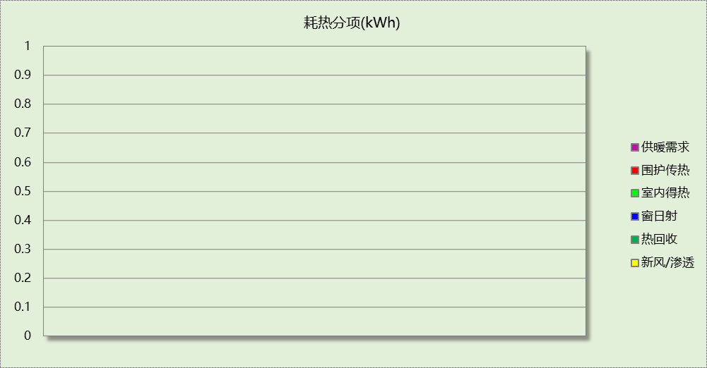

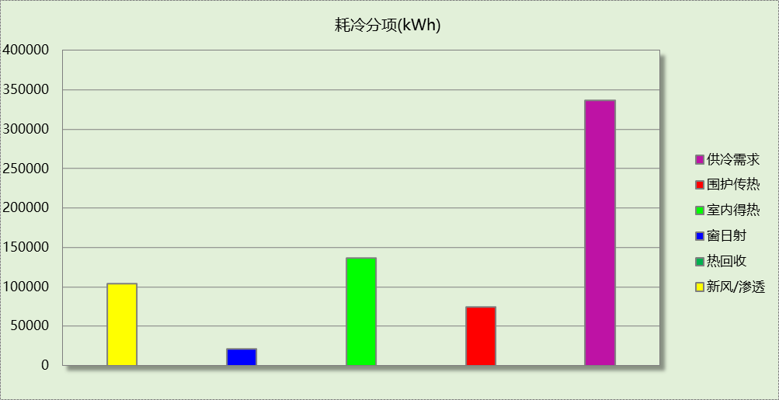

## 逐月负荷表

|  |  |  |  |  |  |  |
| --- | --- | --- | --- | --- | --- | --- |
| 月份 | 供暖(kWh) | 供冷(kWh) | 热负荷 峰值(kW) | 热负荷 峰值时刻 | 冷负荷 峰值(kW) | 冷负荷 峰值时刻 |
| 1月 | 0 | 0 | 0.000 | -- | 0.000 | -- |
| 2月 | 0 | 0 | 0.000 | -- | 0.000 | -- |
| 3月 | 0 | 0 | 0.000 | -- | 0.000 | -- |
| 4月 | 0 | 0 | 0.000 | -- | 0.000 | -- |
| 5月 | 0 | 54839 | 0.000 | -- | 651.302 | 5月24日9时 |
| 6月 | 0 | 108644 | 0.000 | -- | 731.706 | 6月3日9时 |
| 7月 | 0 | 66698 | 0.000 | -- | 808.331 | 7月1日9时 |
| 8月 | 0 | 46752 | 0.000 | -- | 1318.177 | 8月26日9时 |
| 9月 | 0 | 59397 | 0.000 | -- | 804.633 | 9月2日9时 |
| 10月 | 0 | 0 | 0.000 | -- | 0.000 | -- |
| 11月 | 0 | 0 | 0.000 | -- | 0.000 | -- |
| 12月 | 0 | 0 | 0.000 | -- | 0.000 | -- |

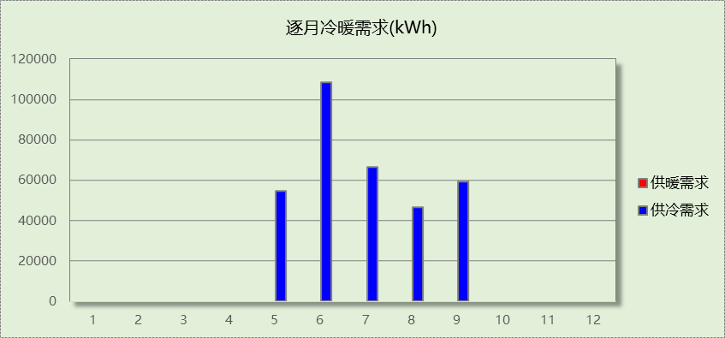

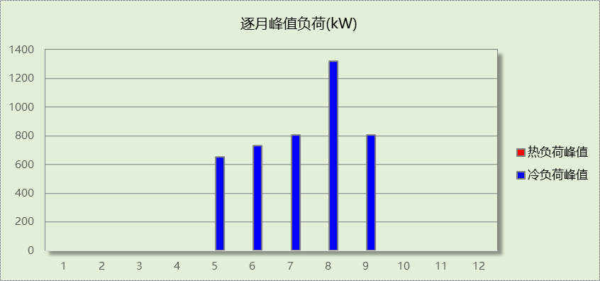

## 逐月电耗

注:供冷供暖为冷热源及输配水泵电耗，热水为扣减太阳能后电耗，所有数据单位kWh/㎡。

|  |  |  |  |  |  |  |  |  |
| --- | --- | --- | --- | --- | --- | --- | --- | --- |
| 月 | 供冷 | 供暖 | 空调风机 | 照明 | 插座设备 | 排风机 | 电梯 | 热水 |
| 1 | 0.00 | 0.00 | 0.00 | 0.00 | 0.00 | 0.00 | 1.72 | 0.00 |
| 2 | 0.00 | 0.00 | 0.00 | 0.00 | 0.00 |
| 3 | 0.00 | 0.00 | 0.00 | 1.46 | 0.68 |
| 4 | 0.00 | 0.00 | 0.00 | 1.46 | 0.68 |
| 5 | 2.29 | 0.00 | 0.25 | 1.53 | 0.72 |
| 6 | 3.86 | 0.00 | 0.36 | 1.33 | 0.62 |
| 7 | 2.19 | 0.00 | 0.44 | 1.60 | 0.75 |
| 8 | 1.13 | 0.00 | 0.41 | 1.53 | 0.72 |
| 9 | 2.18 | 0.00 | 0.19 | 1.40 | 0.65 |
| 10 | 0.00 | 0.00 | 0.00 | 1.40 | 0.65 |
| 11 | 0.00 | 0.00 | 0.00 | 1.46 | 0.68 |
| 12 | 0.00 | 0.00 | 0.00 | 1.53 | 0.72 |
| 合计 | 11.65 | 0.00 | 1.65 | 14.72 | 6.87 | 0.00 | 1.72 | 0.00 |

## 全年能耗

|  |  |  |  |
| --- | --- | --- | --- |
| 能耗分类 | 能耗子类 | 设计建筑  (kWh/㎡) | 备注 |
| 建筑负荷 | 耗冷量 | 38.58 |  |
| 耗热量 | 0.00 |  |
| 冷热合计 | 38.58 |  |
| 热回收 | 供冷 | 0.00 |  |
| 供暖 | 0.00 |  |
| 冷热合计 | 0.00 |  |
| 供冷电耗  (Ec) | 中央冷源 | 6.31 |  |
| 冷却水泵 | 2.12 |  |
| 冷冻水泵 | 2.54 |  |
| 冷却塔 | 0.68 |  |
| 多联机/单元式空调 | 0.00 |  |
| 供冷合计 | 11.65 |  |
| 供暖电耗  (Eh) | 中央热源 | 0.00 |  |
| 供暖水泵 | 0.00 |  |
| 热源侧水泵 | 0.00 |  |
| 多联机/单元式热泵 | 0.00 |  |
| 供暖合计 | 0.00 |  |
| 空调风机电耗  (Ef) | 新排风 | 1.63 |  |
| 风机盘管 | 0.03 |  |
| 全空气系统 | 0.00 |  |
| 风机合计 | 1.65 |  |
| 照明电耗(El) | | 14.72 |  |
| 插座设备电耗(Ej) | | 6.87 |  |
| 其他电耗(Eo) | 电梯 | 1.72 |  |
| 独立排风机 | 0.00 |  |
| 生活热水 | 0.00 | 扣减了太阳能热水 |
| 其他设备 | 0.00 |  |
| 其他合计 | 1.72 |  |
| 可再生发电  (Er) | 光伏发电(Ep) | 16.06 |  |
| 风力发电(Ew) | 0.00 |  |
| 合计 | 16.06 |  |
| 建筑总能耗(E1)：标煤(kgce/㎡) | | 20.55 | E1=Ec+Eh+Ef+El +Ej +Eo-Er |

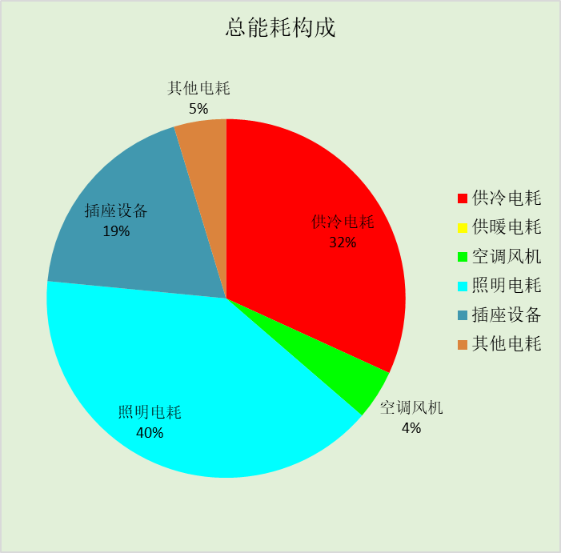

# 附录

暑假:7.15~8.25; 寒假：1.1~2.28

## 工作日/节假日人员逐时在室率(%)

|  |  |  |  |  |  |  |  |  |  |  |  |  |  |  |  |  |  |  |  |  |  |  |  |  |
| --- | --- | --- | --- | --- | --- | --- | --- | --- | --- | --- | --- | --- | --- | --- | --- | --- | --- | --- | --- | --- | --- | --- | --- | --- |
| 房间类型 | 1 | 2 | 3 | 4 | 5 | 6 | 7 | 8 | 9 | 10 | 11 | 12 | 13 | 14 | 15 | 16 | 17 | 18 | 19 | 20 | 21 | 22 | 23 | 24 |
| 会议室 | 0 | 0 | 0 | 0 | 0 | 0 | 10 | 50 | 95 | 95 | 95 | 80 | 80 | 95 | 95 | 95 | 95 | 30 | 30 | 0 | 0 | 0 | 0 | 0 |
| 0 | 0 | 0 | 0 | 0 | 0 | 0 | 0 | 0 | 0 | 0 | 0 | 0 | 0 | 0 | 0 | 0 | 0 | 0 | 0 | 0 | 0 | 0 | 0 |
| 0 | 0 | 0 | 0 | 0 | 0 | 0 | 0 | 0 | 0 | 0 | 0 | 0 | 0 | 0 | 0 | 0 | 0 | 0 | 0 | 0 | 0 | 0 | 0 |
| 0 | 0 | 0 | 0 | 0 | 0 | 0 | 0 | 0 | 0 | 0 | 0 | 0 | 0 | 0 | 0 | 0 | 0 | 0 | 0 | 0 | 0 | 0 | 0 |
| 办公-普通办公室 | 0 | 0 | 0 | 0 | 0 | 0 | 10 | 50 | 100 | 100 | 100 | 30 | 100 | 100 | 100 | 100 | 50 | 20 | 10 | 0 | 0 | 0 | 0 | 0 |
| 0 | 0 | 0 | 0 | 0 | 0 | 0 | 20 | 45 | 0 | 0 | 0 | 0 | 0 | 0 | 0 | 0 | 0 | 0 | 0 | 0 | 0 | 0 | 0 |
| 0 | 0 | 0 | 0 | 0 | 0 | 0 | 20 | 45 | 0 | 0 | 0 | 0 | 0 | 0 | 0 | 0 | 0 | 0 | 0 | 0 | 0 | 0 | 0 |
| 0 | 0 | 0 | 0 | 0 | 0 | 0 | 20 | 45 | 0 | 0 | 0 | 0 | 0 | 0 | 0 | 0 | 0 | 0 | 0 | 0 | 0 | 0 | 0 |
| 卫生间 | 0 | 0 | 0 | 0 | 0 | 0 | 10 | 50 | 95 | 95 | 95 | 80 | 80 | 95 | 95 | 95 | 95 | 30 | 30 | 0 | 0 | 0 | 0 | 0 |
| 0 | 0 | 0 | 0 | 0 | 0 | 0 | 0 | 0 | 0 | 0 | 0 | 0 | 0 | 0 | 0 | 0 | 0 | 0 | 0 | 0 | 0 | 0 | 0 |
| 0 | 0 | 0 | 0 | 0 | 0 | 0 | 0 | 0 | 0 | 0 | 0 | 0 | 0 | 0 | 0 | 0 | 0 | 0 | 0 | 0 | 0 | 0 | 0 |
| 0 | 0 | 0 | 0 | 0 | 0 | 0 | 0 | 0 | 0 | 0 | 0 | 0 | 0 | 0 | 0 | 0 | 0 | 0 | 0 | 0 | 0 | 0 | 0 |
| 大厅 | 0 | 0 | 0 | 0 | 0 | 0 | 10 | 50 | 95 | 95 | 95 | 80 | 80 | 95 | 95 | 95 | 95 | 30 | 30 | 0 | 0 | 0 | 0 | 0 |
| 0 | 0 | 0 | 0 | 0 | 0 | 0 | 0 | 0 | 0 | 0 | 0 | 0 | 0 | 0 | 0 | 0 | 0 | 0 | 0 | 0 | 0 | 0 | 0 |
| 0 | 0 | 0 | 0 | 0 | 0 | 0 | 0 | 0 | 0 | 0 | 0 | 0 | 0 | 0 | 0 | 0 | 0 | 0 | 0 | 0 | 0 | 0 | 0 |
| 0 | 0 | 0 | 0 | 0 | 0 | 0 | 0 | 0 | 0 | 0 | 0 | 0 | 0 | 0 | 0 | 0 | 0 | 0 | 0 | 0 | 0 | 0 | 0 |
| 实验教室 | 0 | 0 | 0 | 0 | 0 | 0 | 10 | 50 | 95 | 95 | 95 | 80 | 80 | 95 | 95 | 95 | 95 | 30 | 30 | 0 | 0 | 0 | 0 | 0 |
| 0 | 0 | 0 | 0 | 0 | 0 | 0 | 0 | 0 | 0 | 0 | 0 | 0 | 0 | 0 | 0 | 0 | 0 | 0 | 0 | 0 | 0 | 0 | 0 |
| 0 | 0 | 0 | 0 | 0 | 0 | 0 | 0 | 0 | 0 | 0 | 0 | 0 | 0 | 0 | 0 | 0 | 0 | 0 | 0 | 0 | 0 | 0 | 0 |
| 0 | 0 | 0 | 0 | 0 | 0 | 0 | 0 | 0 | 0 | 0 | 0 | 0 | 0 | 0 | 0 | 0 | 0 | 0 | 0 | 0 | 0 | 0 | 0 |
| 报告厅 | 0 | 0 | 0 | 0 | 0 | 0 | 10 | 50 | 95 | 95 | 95 | 80 | 80 | 95 | 95 | 95 | 95 | 30 | 30 | 0 | 0 | 0 | 0 | 0 |
| 0 | 0 | 0 | 0 | 0 | 0 | 0 | 0 | 0 | 0 | 0 | 0 | 0 | 0 | 0 | 0 | 0 | 0 | 0 | 0 | 0 | 0 | 0 | 0 |
| 0 | 0 | 0 | 0 | 0 | 0 | 0 | 0 | 0 | 0 | 0 | 0 | 0 | 0 | 0 | 0 | 0 | 0 | 0 | 0 | 0 | 0 | 0 | 0 |
| 0 | 0 | 0 | 0 | 0 | 0 | 0 | 0 | 0 | 0 | 0 | 0 | 0 | 0 | 0 | 0 | 0 | 0 | 0 | 0 | 0 | 0 | 0 | 0 |
| 普通办公室 | 0 | 0 | 0 | 0 | 0 | 0 | 10 | 50 | 95 | 95 | 95 | 80 | 80 | 95 | 95 | 95 | 95 | 30 | 30 | 0 | 0 | 0 | 0 | 0 |
| 0 | 0 | 0 | 0 | 0 | 0 | 0 | 0 | 0 | 0 | 0 | 0 | 0 | 0 | 0 | 0 | 0 | 0 | 0 | 0 | 0 | 0 | 0 | 0 |
| 0 | 0 | 0 | 0 | 0 | 0 | 0 | 0 | 0 | 0 | 0 | 0 | 0 | 0 | 0 | 0 | 0 | 0 | 0 | 0 | 0 | 0 | 0 | 0 |
| 0 | 0 | 0 | 0 | 0 | 0 | 0 | 0 | 0 | 0 | 0 | 0 | 0 | 0 | 0 | 0 | 0 | 0 | 0 | 0 | 0 | 0 | 0 | 0 |
| 普通办公室 | 0 | 0 | 0 | 0 | 0 | 0 | 10 | 50 | 100 | 100 | 100 | 30 | 100 | 100 | 100 | 100 | 50 | 20 | 10 | 0 | 0 | 0 | 0 | 0 |
| 0 | 0 | 0 | 0 | 0 | 0 | 0 | 20 | 45 | 0 | 0 | 0 | 0 | 0 | 0 | 0 | 0 | 0 | 0 | 0 | 0 | 0 | 0 | 0 |
| 0 | 0 | 0 | 0 | 0 | 0 | 0 | 20 | 45 | 0 | 0 | 0 | 0 | 0 | 0 | 0 | 0 | 0 | 0 | 0 | 0 | 0 | 0 | 0 |
| 0 | 0 | 0 | 0 | 0 | 0 | 0 | 20 | 45 | 0 | 0 | 0 | 0 | 0 | 0 | 0 | 0 | 0 | 0 | 0 | 0 | 0 | 0 | 0 |
| 普通教室 | 0 | 0 | 0 | 0 | 0 | 0 | 10 | 50 | 95 | 95 | 95 | 80 | 80 | 95 | 95 | 95 | 95 | 30 | 30 | 0 | 0 | 0 | 0 | 0 |
| 0 | 0 | 0 | 0 | 0 | 0 | 0 | 0 | 0 | 0 | 0 | 0 | 0 | 0 | 0 | 0 | 0 | 0 | 0 | 0 | 0 | 0 | 0 | 0 |
| 0 | 0 | 0 | 0 | 0 | 0 | 0 | 0 | 0 | 0 | 0 | 0 | 0 | 0 | 0 | 0 | 0 | 0 | 0 | 0 | 0 | 0 | 0 | 0 |
| 0 | 0 | 0 | 0 | 0 | 0 | 0 | 0 | 0 | 0 | 0 | 0 | 0 | 0 | 0 | 0 | 0 | 0 | 0 | 0 | 0 | 0 | 0 | 0 |
| 楼梯间 | 0 | 0 | 0 | 0 | 0 | 0 | 10 | 50 | 95 | 95 | 95 | 80 | 80 | 95 | 95 | 95 | 95 | 30 | 30 | 0 | 0 | 0 | 0 | 0 |
| 0 | 0 | 0 | 0 | 0 | 0 | 0 | 0 | 0 | 0 | 0 | 0 | 0 | 0 | 0 | 0 | 0 | 0 | 0 | 0 | 0 | 0 | 0 | 0 |
| 0 | 0 | 0 | 0 | 0 | 0 | 0 | 0 | 0 | 0 | 0 | 0 | 0 | 0 | 0 | 0 | 0 | 0 | 0 | 0 | 0 | 0 | 0 | 0 |
| 0 | 0 | 0 | 0 | 0 | 0 | 0 | 0 | 0 | 0 | 0 | 0 | 0 | 0 | 0 | 0 | 0 | 0 | 0 | 0 | 0 | 0 | 0 | 0 |
| 空房间 | 0 | 0 | 0 | 0 | 0 | 0 | 0 | 20 | 50 | 80 | 80 | 80 | 80 | 80 | 80 | 80 | 80 | 80 | 80 | 70 | 50 | 0 | 0 | 0 |
| 0 | 0 | 0 | 0 | 0 | 0 | 0 | 0 | 0 | 0 | 0 | 0 | 0 | 0 | 0 | 0 | 0 | 0 | 0 | 0 | 0 | 0 | 0 | 0 |
| 0 | 0 | 0 | 0 | 0 | 0 | 0 | 0 | 0 | 0 | 0 | 0 | 0 | 0 | 0 | 0 | 0 | 0 | 0 | 0 | 0 | 0 | 0 | 0 |
| 0 | 0 | 0 | 0 | 0 | 0 | 0 | 0 | 0 | 0 | 0 | 0 | 0 | 0 | 0 | 0 | 0 | 0 | 0 | 0 | 0 | 0 | 0 | 0 |
| 设备间 | 0 | 0 | 0 | 0 | 0 | 0 | 0 | 0 | 0 | 0 | 0 | 0 | 0 | 0 | 0 | 0 | 0 | 0 | 0 | 0 | 0 | 0 | 0 | 0 |
| 0 | 0 | 0 | 0 | 0 | 0 | 0 | 0 | 0 | 0 | 0 | 0 | 0 | 0 | 0 | 0 | 0 | 0 | 0 | 0 | 0 | 0 | 0 | 0 |
| 0 | 0 | 0 | 0 | 0 | 0 | 0 | 0 | 0 | 0 | 0 | 0 | 0 | 0 | 0 | 0 | 0 | 0 | 0 | 0 | 0 | 0 | 0 | 0 |
| 0 | 0 | 0 | 0 | 0 | 0 | 0 | 0 | 0 | 0 | 0 | 0 | 0 | 0 | 0 | 0 | 0 | 0 | 0 | 0 | 0 | 0 | 0 | 0 |

注：第一行：工作日；第二行：节假日；第三行：寒假；第四行：暑假

## 工作日/节假日照明开关时间表(%)

|  |  |  |  |  |  |  |  |  |  |  |  |  |  |  |  |  |  |  |  |  |  |  |  |  |
| --- | --- | --- | --- | --- | --- | --- | --- | --- | --- | --- | --- | --- | --- | --- | --- | --- | --- | --- | --- | --- | --- | --- | --- | --- |
| 房间类型 | 1 | 2 | 3 | 4 | 5 | 6 | 7 | 8 | 9 | 10 | 11 | 12 | 13 | 14 | 15 | 16 | 17 | 18 | 19 | 20 | 21 | 22 | 23 | 24 |
| 会议室 | 0 | 0 | 0 | 0 | 0 | 0 | 10 | 50 | 95 | 95 | 95 | 80 | 80 | 95 | 95 | 95 | 95 | 30 | 30 | 0 | 0 | 0 | 0 | 0 |
| 0 | 0 | 0 | 0 | 0 | 0 | 0 | 0 | 0 | 0 | 0 | 0 | 0 | 0 | 0 | 0 | 0 | 0 | 0 | 0 | 0 | 0 | 0 | 0 |
| 0 | 0 | 0 | 0 | 0 | 0 | 0 | 0 | 0 | 0 | 0 | 0 | 0 | 0 | 0 | 0 | 0 | 0 | 0 | 0 | 0 | 0 | 0 | 0 |
| 0 | 0 | 0 | 0 | 0 | 0 | 0 | 0 | 0 | 0 | 0 | 0 | 0 | 0 | 0 | 0 | 0 | 0 | 0 | 0 | 0 | 0 | 0 | 0 |
| 办公-普通办公室 | 10 | 10 | 10 | 10 | 10 | 10 | 10 | 36 | 62 | 56 | 54 | 43 | 53 | 55 | 58 | 67 | 40 | 18 | 10 | 10 | 10 | 10 | 10 | 10 |
| 0 | 0 | 0 | 0 | 0 | 0 | 0 | 0 | 0 | 0 | 0 | 0 | 0 | 0 | 0 | 0 | 0 | 0 | 0 | 0 | 0 | 0 | 0 | 0 |
| 0 | 0 | 0 | 0 | 0 | 0 | 0 | 0 | 0 | 0 | 0 | 0 | 0 | 0 | 0 | 0 | 0 | 0 | 0 | 0 | 0 | 0 | 0 | 0 |
| 0 | 0 | 0 | 0 | 0 | 0 | 0 | 0 | 0 | 0 | 0 | 0 | 0 | 0 | 0 | 0 | 0 | 0 | 0 | 0 | 0 | 0 | 0 | 0 |
| 卫生间 | 0 | 0 | 0 | 0 | 0 | 0 | 10 | 50 | 95 | 95 | 95 | 80 | 80 | 95 | 95 | 95 | 95 | 30 | 30 | 0 | 0 | 0 | 0 | 0 |
| 0 | 0 | 0 | 0 | 0 | 0 | 0 | 0 | 0 | 0 | 0 | 0 | 0 | 0 | 0 | 0 | 0 | 0 | 0 | 0 | 0 | 0 | 0 | 0 |
| 0 | 0 | 0 | 0 | 0 | 0 | 0 | 0 | 0 | 0 | 0 | 0 | 0 | 0 | 0 | 0 | 0 | 0 | 0 | 0 | 0 | 0 | 0 | 0 |
| 0 | 0 | 0 | 0 | 0 | 0 | 0 | 0 | 0 | 0 | 0 | 0 | 0 | 0 | 0 | 0 | 0 | 0 | 0 | 0 | 0 | 0 | 0 | 0 |
| 大厅 | 0 | 0 | 0 | 0 | 0 | 0 | 10 | 50 | 95 | 95 | 95 | 80 | 80 | 95 | 95 | 95 | 95 | 30 | 30 | 0 | 0 | 0 | 0 | 0 |
| 0 | 0 | 0 | 0 | 0 | 0 | 0 | 0 | 0 | 0 | 0 | 0 | 0 | 0 | 0 | 0 | 0 | 0 | 0 | 0 | 0 | 0 | 0 | 0 |
| 0 | 0 | 0 | 0 | 0 | 0 | 0 | 0 | 0 | 0 | 0 | 0 | 0 | 0 | 0 | 0 | 0 | 0 | 0 | 0 | 0 | 0 | 0 | 0 |
| 0 | 0 | 0 | 0 | 0 | 0 | 0 | 0 | 0 | 0 | 0 | 0 | 0 | 0 | 0 | 0 | 0 | 0 | 0 | 0 | 0 | 0 | 0 | 0 |
| 实验教室 | 0 | 0 | 0 | 0 | 0 | 0 | 10 | 50 | 95 | 95 | 95 | 80 | 80 | 95 | 95 | 95 | 95 | 30 | 30 | 0 | 0 | 0 | 0 | 0 |
| 0 | 0 | 0 | 0 | 0 | 0 | 0 | 0 | 0 | 0 | 0 | 0 | 0 | 0 | 0 | 0 | 0 | 0 | 0 | 0 | 0 | 0 | 0 | 0 |
| 0 | 0 | 0 | 0 | 0 | 0 | 0 | 0 | 0 | 0 | 0 | 0 | 0 | 0 | 0 | 0 | 0 | 0 | 0 | 0 | 0 | 0 | 0 | 0 |
| 0 | 0 | 0 | 0 | 0 | 0 | 0 | 0 | 0 | 0 | 0 | 0 | 0 | 0 | 0 | 0 | 0 | 0 | 0 | 0 | 0 | 0 | 0 | 0 |
| 报告厅 | 0 | 0 | 0 | 0 | 0 | 0 | 10 | 50 | 95 | 95 | 95 | 80 | 80 | 95 | 95 | 95 | 95 | 30 | 30 | 0 | 0 | 0 | 0 | 0 |
| 0 | 0 | 0 | 0 | 0 | 0 | 0 | 0 | 0 | 0 | 0 | 0 | 0 | 0 | 0 | 0 | 0 | 0 | 0 | 0 | 0 | 0 | 0 | 0 |
| 0 | 0 | 0 | 0 | 0 | 0 | 0 | 0 | 0 | 0 | 0 | 0 | 0 | 0 | 0 | 0 | 0 | 0 | 0 | 0 | 0 | 0 | 0 | 0 |
| 0 | 0 | 0 | 0 | 0 | 0 | 0 | 0 | 0 | 0 | 0 | 0 | 0 | 0 | 0 | 0 | 0 | 0 | 0 | 0 | 0 | 0 | 0 | 0 |
| 普通办公室 | 0 | 0 | 0 | 0 | 0 | 0 | 10 | 50 | 95 | 95 | 95 | 80 | 80 | 95 | 95 | 95 | 95 | 30 | 30 | 0 | 0 | 0 | 0 | 0 |
| 0 | 0 | 0 | 0 | 0 | 0 | 0 | 0 | 0 | 0 | 0 | 0 | 0 | 0 | 0 | 0 | 0 | 0 | 0 | 0 | 0 | 0 | 0 | 0 |
| 0 | 0 | 0 | 0 | 0 | 0 | 0 | 0 | 0 | 0 | 0 | 0 | 0 | 0 | 0 | 0 | 0 | 0 | 0 | 0 | 0 | 0 | 0 | 0 |
| 0 | 0 | 0 | 0 | 0 | 0 | 0 | 0 | 0 | 0 | 0 | 0 | 0 | 0 | 0 | 0 | 0 | 0 | 0 | 0 | 0 | 0 | 0 | 0 |
| 普通办公室 | 10 | 10 | 10 | 10 | 10 | 10 | 10 | 36 | 62 | 56 | 54 | 43 | 53 | 55 | 58 | 67 | 40 | 18 | 10 | 10 | 10 | 10 | 10 | 10 |
| 0 | 0 | 0 | 0 | 0 | 0 | 0 | 0 | 0 | 0 | 0 | 0 | 0 | 0 | 0 | 0 | 0 | 0 | 0 | 0 | 0 | 0 | 0 | 0 |
| 0 | 0 | 0 | 0 | 0 | 0 | 0 | 0 | 0 | 0 | 0 | 0 | 0 | 0 | 0 | 0 | 0 | 0 | 0 | 0 | 0 | 0 | 0 | 0 |
| 0 | 0 | 0 | 0 | 0 | 0 | 0 | 0 | 0 | 0 | 0 | 0 | 0 | 0 | 0 | 0 | 0 | 0 | 0 | 0 | 0 | 0 | 0 | 0 |
| 普通教室 | 0 | 0 | 0 | 0 | 0 | 0 | 10 | 50 | 95 | 95 | 95 | 80 | 80 | 95 | 95 | 95 | 95 | 30 | 30 | 0 | 0 | 0 | 0 | 0 |
| 0 | 0 | 0 | 0 | 0 | 0 | 0 | 0 | 0 | 0 | 0 | 0 | 0 | 0 | 0 | 0 | 0 | 0 | 0 | 0 | 0 | 0 | 0 | 0 |
| 0 | 0 | 0 | 0 | 0 | 0 | 0 | 0 | 0 | 0 | 0 | 0 | 0 | 0 | 0 | 0 | 0 | 0 | 0 | 0 | 0 | 0 | 0 | 0 |
| 0 | 0 | 0 | 0 | 0 | 0 | 0 | 0 | 0 | 0 | 0 | 0 | 0 | 0 | 0 | 0 | 0 | 0 | 0 | 0 | 0 | 0 | 0 | 0 |
| 楼梯间 | 0 | 0 | 0 | 0 | 0 | 0 | 10 | 50 | 95 | 95 | 95 | 80 | 80 | 95 | 95 | 95 | 95 | 30 | 30 | 0 | 0 | 0 | 0 | 0 |
| 0 | 0 | 0 | 0 | 0 | 0 | 0 | 0 | 0 | 0 | 0 | 0 | 0 | 0 | 0 | 0 | 0 | 0 | 0 | 0 | 0 | 0 | 0 | 0 |
| 0 | 0 | 0 | 0 | 0 | 0 | 0 | 0 | 0 | 0 | 0 | 0 | 0 | 0 | 0 | 0 | 0 | 0 | 0 | 0 | 0 | 0 | 0 | 0 |
| 0 | 0 | 0 | 0 | 0 | 0 | 0 | 0 | 0 | 0 | 0 | 0 | 0 | 0 | 0 | 0 | 0 | 0 | 0 | 0 | 0 | 0 | 0 | 0 |
| 空房间 | 10 | 10 | 10 | 10 | 10 | 10 | 10 | 50 | 60 | 60 | 60 | 60 | 60 | 60 | 60 | 60 | 80 | 90 | 100 | 100 | 100 | 10 | 10 | 10 |
| 0 | 0 | 0 | 0 | 0 | 0 | 0 | 0 | 0 | 0 | 0 | 0 | 0 | 0 | 0 | 0 | 0 | 0 | 0 | 0 | 0 | 0 | 0 | 0 |
| 0 | 0 | 0 | 0 | 0 | 0 | 0 | 0 | 0 | 0 | 0 | 0 | 0 | 0 | 0 | 0 | 0 | 0 | 0 | 0 | 0 | 0 | 0 | 0 |
| 0 | 0 | 0 | 0 | 0 | 0 | 0 | 0 | 0 | 0 | 0 | 0 | 0 | 0 | 0 | 0 | 0 | 0 | 0 | 0 | 0 | 0 | 0 | 0 |
| 设备间 | 100 | 100 | 100 | 100 | 100 | 100 | 100 | 100 | 100 | 100 | 100 | 100 | 100 | 100 | 100 | 100 | 100 | 100 | 100 | 100 | 100 | 100 | 100 | 100 |
| 0 | 0 | 0 | 0 | 0 | 0 | 0 | 0 | 0 | 0 | 0 | 0 | 0 | 0 | 0 | 0 | 0 | 0 | 0 | 0 | 0 | 0 | 0 | 0 |
| 0 | 0 | 0 | 0 | 0 | 0 | 0 | 0 | 0 | 0 | 0 | 0 | 0 | 0 | 0 | 0 | 0 | 0 | 0 | 0 | 0 | 0 | 0 | 0 |
| 0 | 0 | 0 | 0 | 0 | 0 | 0 | 0 | 0 | 0 | 0 | 0 | 0 | 0 | 0 | 0 | 0 | 0 | 0 | 0 | 0 | 0 | 0 | 0 |

注：第一行：工作日；第二行：节假日；第三行：寒假；第四行：暑假

## 工作日/节假日设备逐时使用率(%)

|  |  |  |  |  |  |  |  |  |  |  |  |  |  |  |  |  |  |  |  |  |  |  |  |  |
| --- | --- | --- | --- | --- | --- | --- | --- | --- | --- | --- | --- | --- | --- | --- | --- | --- | --- | --- | --- | --- | --- | --- | --- | --- |
| 房间类型 | 1 | 2 | 3 | 4 | 5 | 6 | 7 | 8 | 9 | 10 | 11 | 12 | 13 | 14 | 15 | 16 | 17 | 18 | 19 | 20 | 21 | 22 | 23 | 24 |
| 会议室 | 0 | 0 | 0 | 0 | 0 | 0 | 10 | 50 | 95 | 95 | 95 | 50 | 50 | 95 | 95 | 95 | 95 | 30 | 30 | 0 | 0 | 0 | 0 | 0 |
| 0 | 0 | 0 | 0 | 0 | 0 | 0 | 0 | 0 | 0 | 0 | 0 | 0 | 0 | 0 | 0 | 0 | 0 | 0 | 0 | 0 | 0 | 0 | 0 |
| 0 | 0 | 0 | 0 | 0 | 0 | 0 | 0 | 0 | 0 | 0 | 0 | 0 | 0 | 0 | 0 | 0 | 0 | 0 | 0 | 0 | 0 | 0 | 0 |
| 0 | 0 | 0 | 0 | 0 | 0 | 0 | 0 | 0 | 0 | 0 | 0 | 0 | 0 | 0 | 0 | 0 | 0 | 0 | 0 | 0 | 0 | 0 | 0 |
| 办公-普通办公室 | 0 | 0 | 0 | 0 | 0 | 0 | 10 | 50 | 100 | 100 | 100 | 100 | 100 | 100 | 100 | 100 | 50 | 20 | 10 | 0 | 0 | 0 | 0 | 0 |
| 0 | 0 | 0 | 0 | 0 | 0 | 0 | 0 | 0 | 0 | 0 | 0 | 0 | 0 | 0 | 0 | 0 | 0 | 0 | 0 | 0 | 0 | 0 | 0 |
| 0 | 0 | 0 | 0 | 0 | 0 | 0 | 0 | 0 | 0 | 0 | 0 | 0 | 0 | 0 | 0 | 0 | 0 | 0 | 0 | 0 | 0 | 0 | 0 |
| 0 | 0 | 0 | 0 | 0 | 0 | 0 | 0 | 0 | 0 | 0 | 0 | 0 | 0 | 0 | 0 | 0 | 0 | 0 | 0 | 0 | 0 | 0 | 0 |
| 卫生间 | 0 | 0 | 0 | 0 | 0 | 0 | 10 | 50 | 95 | 95 | 95 | 50 | 50 | 95 | 95 | 95 | 95 | 30 | 30 | 0 | 0 | 0 | 0 | 0 |
| 0 | 0 | 0 | 0 | 0 | 0 | 0 | 0 | 0 | 0 | 0 | 0 | 0 | 0 | 0 | 0 | 0 | 0 | 0 | 0 | 0 | 0 | 0 | 0 |
| 0 | 0 | 0 | 0 | 0 | 0 | 0 | 0 | 0 | 0 | 0 | 0 | 0 | 0 | 0 | 0 | 0 | 0 | 0 | 0 | 0 | 0 | 0 | 0 |
| 0 | 0 | 0 | 0 | 0 | 0 | 0 | 0 | 0 | 0 | 0 | 0 | 0 | 0 | 0 | 0 | 0 | 0 | 0 | 0 | 0 | 0 | 0 | 0 |
| 大厅 | 0 | 0 | 0 | 0 | 0 | 0 | 10 | 50 | 95 | 95 | 95 | 50 | 50 | 95 | 95 | 95 | 95 | 30 | 30 | 0 | 0 | 0 | 0 | 0 |
| 0 | 0 | 0 | 0 | 0 | 0 | 0 | 0 | 0 | 0 | 0 | 0 | 0 | 0 | 0 | 0 | 0 | 0 | 0 | 0 | 0 | 0 | 0 | 0 |
| 0 | 0 | 0 | 0 | 0 | 0 | 0 | 0 | 0 | 0 | 0 | 0 | 0 | 0 | 0 | 0 | 0 | 0 | 0 | 0 | 0 | 0 | 0 | 0 |
| 0 | 0 | 0 | 0 | 0 | 0 | 0 | 0 | 0 | 0 | 0 | 0 | 0 | 0 | 0 | 0 | 0 | 0 | 0 | 0 | 0 | 0 | 0 | 0 |
| 实验教室 | 0 | 0 | 0 | 0 | 0 | 0 | 10 | 50 | 95 | 95 | 95 | 50 | 50 | 95 | 95 | 95 | 95 | 30 | 30 | 0 | 0 | 0 | 0 | 0 |
| 0 | 0 | 0 | 0 | 0 | 0 | 0 | 0 | 0 | 0 | 0 | 0 | 0 | 0 | 0 | 0 | 0 | 0 | 0 | 0 | 0 | 0 | 0 | 0 |
| 0 | 0 | 0 | 0 | 0 | 0 | 0 | 0 | 0 | 0 | 0 | 0 | 0 | 0 | 0 | 0 | 0 | 0 | 0 | 0 | 0 | 0 | 0 | 0 |
| 0 | 0 | 0 | 0 | 0 | 0 | 0 | 0 | 0 | 0 | 0 | 0 | 0 | 0 | 0 | 0 | 0 | 0 | 0 | 0 | 0 | 0 | 0 | 0 |
| 报告厅 | 0 | 0 | 0 | 0 | 0 | 0 | 10 | 50 | 95 | 95 | 95 | 50 | 50 | 95 | 95 | 95 | 95 | 30 | 30 | 0 | 0 | 0 | 0 | 0 |
| 0 | 0 | 0 | 0 | 0 | 0 | 0 | 0 | 0 | 0 | 0 | 0 | 0 | 0 | 0 | 0 | 0 | 0 | 0 | 0 | 0 | 0 | 0 | 0 |
| 0 | 0 | 0 | 0 | 0 | 0 | 0 | 0 | 0 | 0 | 0 | 0 | 0 | 0 | 0 | 0 | 0 | 0 | 0 | 0 | 0 | 0 | 0 | 0 |
| 0 | 0 | 0 | 0 | 0 | 0 | 0 | 0 | 0 | 0 | 0 | 0 | 0 | 0 | 0 | 0 | 0 | 0 | 0 | 0 | 0 | 0 | 0 | 0 |
| 普通办公室 | 0 | 0 | 0 | 0 | 0 | 0 | 10 | 50 | 95 | 95 | 95 | 50 | 50 | 95 | 95 | 95 | 95 | 30 | 30 | 0 | 0 | 0 | 0 | 0 |
| 0 | 0 | 0 | 0 | 0 | 0 | 0 | 0 | 0 | 0 | 0 | 0 | 0 | 0 | 0 | 0 | 0 | 0 | 0 | 0 | 0 | 0 | 0 | 0 |
| 0 | 0 | 0 | 0 | 0 | 0 | 0 | 0 | 0 | 0 | 0 | 0 | 0 | 0 | 0 | 0 | 0 | 0 | 0 | 0 | 0 | 0 | 0 | 0 |
| 0 | 0 | 0 | 0 | 0 | 0 | 0 | 0 | 0 | 0 | 0 | 0 | 0 | 0 | 0 | 0 | 0 | 0 | 0 | 0 | 0 | 0 | 0 | 0 |
| 普通办公室 | 0 | 0 | 0 | 0 | 0 | 0 | 10 | 50 | 100 | 100 | 100 | 100 | 100 | 100 | 100 | 100 | 50 | 20 | 10 | 0 | 0 | 0 | 0 | 0 |
| 0 | 0 | 0 | 0 | 0 | 0 | 0 | 0 | 0 | 0 | 0 | 0 | 0 | 0 | 0 | 0 | 0 | 0 | 0 | 0 | 0 | 0 | 0 | 0 |
| 0 | 0 | 0 | 0 | 0 | 0 | 0 | 0 | 0 | 0 | 0 | 0 | 0 | 0 | 0 | 0 | 0 | 0 | 0 | 0 | 0 | 0 | 0 | 0 |
| 0 | 0 | 0 | 0 | 0 | 0 | 0 | 0 | 0 | 0 | 0 | 0 | 0 | 0 | 0 | 0 | 0 | 0 | 0 | 0 | 0 | 0 | 0 | 0 |
| 普通教室 | 0 | 0 | 0 | 0 | 0 | 0 | 10 | 50 | 95 | 95 | 95 | 50 | 50 | 95 | 95 | 95 | 95 | 30 | 30 | 0 | 0 | 0 | 0 | 0 |
| 0 | 0 | 0 | 0 | 0 | 0 | 0 | 0 | 0 | 0 | 0 | 0 | 0 | 0 | 0 | 0 | 0 | 0 | 0 | 0 | 0 | 0 | 0 | 0 |
| 0 | 0 | 0 | 0 | 0 | 0 | 0 | 0 | 0 | 0 | 0 | 0 | 0 | 0 | 0 | 0 | 0 | 0 | 0 | 0 | 0 | 0 | 0 | 0 |
| 0 | 0 | 0 | 0 | 0 | 0 | 0 | 0 | 0 | 0 | 0 | 0 | 0 | 0 | 0 | 0 | 0 | 0 | 0 | 0 | 0 | 0 | 0 | 0 |
| 楼梯间 | 0 | 0 | 0 | 0 | 0 | 0 | 10 | 50 | 95 | 95 | 95 | 50 | 50 | 95 | 95 | 95 | 95 | 30 | 30 | 0 | 0 | 0 | 0 | 0 |
| 0 | 0 | 0 | 0 | 0 | 0 | 0 | 0 | 0 | 0 | 0 | 0 | 0 | 0 | 0 | 0 | 0 | 0 | 0 | 0 | 0 | 0 | 0 | 0 |
| 0 | 0 | 0 | 0 | 0 | 0 | 0 | 0 | 0 | 0 | 0 | 0 | 0 | 0 | 0 | 0 | 0 | 0 | 0 | 0 | 0 | 0 | 0 | 0 |
| 0 | 0 | 0 | 0 | 0 | 0 | 0 | 0 | 0 | 0 | 0 | 0 | 0 | 0 | 0 | 0 | 0 | 0 | 0 | 0 | 0 | 0 | 0 | 0 |
| 空房间 | 0 | 0 | 0 | 0 | 0 | 0 | 0 | 30 | 50 | 80 | 80 | 80 | 80 | 80 | 80 | 80 | 80 | 80 | 80 | 70 | 50 | 0 | 0 | 0 |
| 0 | 0 | 0 | 0 | 0 | 0 | 0 | 0 | 0 | 0 | 0 | 0 | 0 | 0 | 0 | 0 | 0 | 0 | 0 | 0 | 0 | 0 | 0 | 0 |
| 0 | 0 | 0 | 0 | 0 | 0 | 0 | 0 | 0 | 0 | 0 | 0 | 0 | 0 | 0 | 0 | 0 | 0 | 0 | 0 | 0 | 0 | 0 | 0 |
| 0 | 0 | 0 | 0 | 0 | 0 | 0 | 0 | 0 | 0 | 0 | 0 | 0 | 0 | 0 | 0 | 0 | 0 | 0 | 0 | 0 | 0 | 0 | 0 |
| 设备间 | 100 | 100 | 100 | 100 | 100 | 100 | 100 | 100 | 100 | 100 | 100 | 100 | 100 | 100 | 100 | 100 | 100 | 100 | 100 | 100 | 100 | 100 | 100 | 100 |
| 0 | 0 | 0 | 0 | 0 | 0 | 0 | 0 | 0 | 0 | 0 | 0 | 0 | 0 | 0 | 0 | 0 | 0 | 0 | 0 | 0 | 0 | 0 | 0 |
| 0 | 0 | 0 | 0 | 0 | 0 | 0 | 0 | 0 | 0 | 0 | 0 | 0 | 0 | 0 | 0 | 0 | 0 | 0 | 0 | 0 | 0 | 0 | 0 |
| 0 | 0 | 0 | 0 | 0 | 0 | 0 | 0 | 0 | 0 | 0 | 0 | 0 | 0 | 0 | 0 | 0 | 0 | 0 | 0 | 0 | 0 | 0 | 0 |

注：第一行：工作日；第二行：节假日；第三行：寒假；第四行：暑假

## 工作日/节假日空调系统运行时间表(1:开,0:关)

采暖期：

|  |  |  |  |  |  |  |  |  |  |  |  |  |  |  |  |  |  |  |  |  |  |  |  |  |
| --- | --- | --- | --- | --- | --- | --- | --- | --- | --- | --- | --- | --- | --- | --- | --- | --- | --- | --- | --- | --- | --- | --- | --- | --- |
| 系统编号 | 1 | 2 | 3 | 4 | 5 | 6 | 7 | 8 | 9 | 10 | 11 | 12 | 13 | 14 | 15 | 16 | 17 | 18 | 19 | 20 | 21 | 22 | 23 | 24 |
| 默认 | 0 | 0 | 0 | 0 | 0 | 0 | 0 | 1 | 1 | 1 | 1 | 1 | 1 | 1 | 1 | 1 | 1 | 1 | 0 | 0 | 0 | 0 | 0 | 0 |
| 0 | 0 | 0 | 0 | 0 | 0 | 0 | 0 | 0 | 0 | 0 | 0 | 0 | 0 | 0 | 0 | 0 | 0 | 0 | 0 | 0 | 0 | 0 | 0 |
| 0 | 0 | 0 | 0 | 0 | 0 | 0 | 0 | 0 | 0 | 0 | 0 | 0 | 0 | 0 | 0 | 0 | 0 | 0 | 0 | 0 | 0 | 0 | 0 |
| 0 | 0 | 0 | 0 | 0 | 0 | 0 | 0 | 0 | 0 | 0 | 0 | 0 | 0 | 0 | 0 | 0 | 0 | 0 | 0 | 0 | 0 | 0 | 0 |

供冷期：

|  |  |  |  |  |  |  |  |  |  |  |  |  |  |  |  |  |  |  |  |  |  |  |  |  |
| --- | --- | --- | --- | --- | --- | --- | --- | --- | --- | --- | --- | --- | --- | --- | --- | --- | --- | --- | --- | --- | --- | --- | --- | --- |
| 系统编号 | 1 | 2 | 3 | 4 | 5 | 6 | 7 | 8 | 9 | 10 | 11 | 12 | 13 | 14 | 15 | 16 | 17 | 18 | 19 | 20 | 21 | 22 | 23 | 24 |
| 默认 | 0 | 0 | 0 | 0 | 0 | 0 | 0 | 1 | 1 | 1 | 1 | 1 | 1 | 1 | 1 | 1 | 1 | 1 | 0 | 0 | 0 | 0 | 0 | 0 |
| 0 | 0 | 0 | 0 | 0 | 0 | 0 | 0 | 0 | 0 | 0 | 0 | 0 | 0 | 0 | 0 | 0 | 0 | 0 | 0 | 0 | 0 | 0 | 0 |
| 0 | 0 | 0 | 0 | 0 | 0 | 0 | 0 | 0 | 0 | 0 | 0 | 0 | 0 | 0 | 0 | 0 | 0 | 0 | 0 | 0 | 0 | 0 | 0 |
| 0 | 0 | 0 | 0 | 0 | 0 | 0 | 0 | 0 | 0 | 0 | 0 | 0 | 0 | 0 | 0 | 0 | 0 | 0 | 0 | 0 | 0 | 0 | 0 |

注：第一行：工作日；第二行：节假日；第三行：寒假；第四行：暑假

## 工作日/节假日新风运行时间表(%)

|  |  |  |  |  |  |  |  |  |  |  |  |  |  |  |  |  |  |  |  |  |  |  |  |  |
| --- | --- | --- | --- | --- | --- | --- | --- | --- | --- | --- | --- | --- | --- | --- | --- | --- | --- | --- | --- | --- | --- | --- | --- | --- |
| 房间类型 | 1 | 2 | 3 | 4 | 5 | 6 | 7 | 8 | 9 | 10 | 11 | 12 | 13 | 14 | 15 | 16 | 17 | 18 | 19 | 20 | 21 | 22 | 23 | 24 |
| 会议室 | 0 | 0 | 0 | 0 | 0 | 0 | 0 | 100 | 100 | 100 | 100 | 100 | 100 | 100 | 100 | 100 | 100 | 100 | 100 | 100 | 100 | 0 | 0 | 0 |
| 0 | 0 | 0 | 0 | 0 | 0 | 0 | 0 | 0 | 0 | 0 | 0 | 0 | 0 | 0 | 0 | 0 | 0 | 0 | 0 | 0 | 0 | 0 | 0 |
| 0 | 0 | 0 | 0 | 0 | 0 | 0 | 0 | 0 | 0 | 0 | 0 | 0 | 0 | 0 | 0 | 0 | 0 | 0 | 0 | 0 | 0 | 0 | 0 |
| 0 | 0 | 0 | 0 | 0 | 0 | 0 | 0 | 0 | 0 | 0 | 0 | 0 | 0 | 0 | 0 | 0 | 0 | 0 | 0 | 0 | 0 | 0 | 0 |
| 办公-普通办公室 | 0 | 0 | 0 | 0 | 0 | 0 | 100 | 100 | 100 | 100 | 100 | 100 | 100 | 100 | 100 | 100 | 100 | 100 | 0 | 0 | 0 | 0 | 0 | 0 |
| 0 | 0 | 0 | 0 | 0 | 0 | 0 | 0 | 0 | 0 | 0 | 0 | 0 | 0 | 0 | 0 | 0 | 0 | 0 | 0 | 0 | 0 | 0 | 0 |
| 0 | 0 | 0 | 0 | 0 | 0 | 0 | 0 | 0 | 0 | 0 | 0 | 0 | 0 | 0 | 0 | 0 | 0 | 0 | 0 | 0 | 0 | 0 | 0 |
| 0 | 0 | 0 | 0 | 0 | 0 | 0 | 0 | 0 | 0 | 0 | 0 | 0 | 0 | 0 | 0 | 0 | 0 | 0 | 0 | 0 | 0 | 0 | 0 |
| 卫生间 | 0 | 0 | 0 | 0 | 0 | 0 | 0 | 100 | 100 | 100 | 100 | 100 | 100 | 100 | 100 | 100 | 100 | 100 | 100 | 100 | 100 | 0 | 0 | 0 |
| 0 | 0 | 0 | 0 | 0 | 0 | 0 | 0 | 0 | 0 | 0 | 0 | 0 | 0 | 0 | 0 | 0 | 0 | 0 | 0 | 0 | 0 | 0 | 0 |
| 0 | 0 | 0 | 0 | 0 | 0 | 0 | 0 | 0 | 0 | 0 | 0 | 0 | 0 | 0 | 0 | 0 | 0 | 0 | 0 | 0 | 0 | 0 | 0 |
| 0 | 0 | 0 | 0 | 0 | 0 | 0 | 0 | 0 | 0 | 0 | 0 | 0 | 0 | 0 | 0 | 0 | 0 | 0 | 0 | 0 | 0 | 0 | 0 |
| 大厅 | 0 | 0 | 0 | 0 | 0 | 0 | 0 | 100 | 100 | 100 | 100 | 100 | 100 | 100 | 100 | 100 | 100 | 100 | 100 | 100 | 100 | 0 | 0 | 0 |
| 0 | 0 | 0 | 0 | 0 | 0 | 0 | 0 | 0 | 0 | 0 | 0 | 0 | 0 | 0 | 0 | 0 | 0 | 0 | 0 | 0 | 0 | 0 | 0 |
| 0 | 0 | 0 | 0 | 0 | 0 | 0 | 0 | 0 | 0 | 0 | 0 | 0 | 0 | 0 | 0 | 0 | 0 | 0 | 0 | 0 | 0 | 0 | 0 |
| 0 | 0 | 0 | 0 | 0 | 0 | 0 | 0 | 0 | 0 | 0 | 0 | 0 | 0 | 0 | 0 | 0 | 0 | 0 | 0 | 0 | 0 | 0 | 0 |
| 实验教室 | 0 | 0 | 0 | 0 | 0 | 0 | 0 | 100 | 100 | 100 | 100 | 100 | 100 | 100 | 100 | 100 | 100 | 100 | 100 | 100 | 100 | 0 | 0 | 0 |
| 0 | 0 | 0 | 0 | 0 | 0 | 0 | 0 | 0 | 0 | 0 | 0 | 0 | 0 | 0 | 0 | 0 | 0 | 0 | 0 | 0 | 0 | 0 | 0 |
| 0 | 0 | 0 | 0 | 0 | 0 | 0 | 0 | 0 | 0 | 0 | 0 | 0 | 0 | 0 | 0 | 0 | 0 | 0 | 0 | 0 | 0 | 0 | 0 |
| 0 | 0 | 0 | 0 | 0 | 0 | 0 | 0 | 0 | 0 | 0 | 0 | 0 | 0 | 0 | 0 | 0 | 0 | 0 | 0 | 0 | 0 | 0 | 0 |
| 报告厅 | 0 | 0 | 0 | 0 | 0 | 0 | 0 | 100 | 100 | 100 | 100 | 100 | 100 | 100 | 100 | 100 | 100 | 100 | 100 | 100 | 100 | 0 | 0 | 0 |
| 0 | 0 | 0 | 0 | 0 | 0 | 0 | 0 | 0 | 0 | 0 | 0 | 0 | 0 | 0 | 0 | 0 | 0 | 0 | 0 | 0 | 0 | 0 | 0 |
| 0 | 0 | 0 | 0 | 0 | 0 | 0 | 0 | 0 | 0 | 0 | 0 | 0 | 0 | 0 | 0 | 0 | 0 | 0 | 0 | 0 | 0 | 0 | 0 |
| 0 | 0 | 0 | 0 | 0 | 0 | 0 | 0 | 0 | 0 | 0 | 0 | 0 | 0 | 0 | 0 | 0 | 0 | 0 | 0 | 0 | 0 | 0 | 0 |
| 普通办公室 | 0 | 0 | 0 | 0 | 0 | 0 | 0 | 100 | 100 | 100 | 100 | 100 | 100 | 100 | 100 | 100 | 100 | 100 | 100 | 100 | 100 | 0 | 0 | 0 |
| 0 | 0 | 0 | 0 | 0 | 0 | 0 | 0 | 0 | 0 | 0 | 0 | 0 | 0 | 0 | 0 | 0 | 0 | 0 | 0 | 0 | 0 | 0 | 0 |
| 0 | 0 | 0 | 0 | 0 | 0 | 0 | 0 | 0 | 0 | 0 | 0 | 0 | 0 | 0 | 0 | 0 | 0 | 0 | 0 | 0 | 0 | 0 | 0 |
| 0 | 0 | 0 | 0 | 0 | 0 | 0 | 0 | 0 | 0 | 0 | 0 | 0 | 0 | 0 | 0 | 0 | 0 | 0 | 0 | 0 | 0 | 0 | 0 |
| 普通办公室 | 0 | 0 | 0 | 0 | 0 | 0 | 100 | 100 | 100 | 100 | 100 | 100 | 100 | 100 | 100 | 100 | 100 | 100 | 0 | 0 | 0 | 0 | 0 | 0 |
| 0 | 0 | 0 | 0 | 0 | 0 | 0 | 0 | 0 | 0 | 0 | 0 | 0 | 0 | 0 | 0 | 0 | 0 | 0 | 0 | 0 | 0 | 0 | 0 |
| 0 | 0 | 0 | 0 | 0 | 0 | 0 | 0 | 0 | 0 | 0 | 0 | 0 | 0 | 0 | 0 | 0 | 0 | 0 | 0 | 0 | 0 | 0 | 0 |
| 0 | 0 | 0 | 0 | 0 | 0 | 0 | 0 | 0 | 0 | 0 | 0 | 0 | 0 | 0 | 0 | 0 | 0 | 0 | 0 | 0 | 0 | 0 | 0 |
| 普通教室 | 0 | 0 | 0 | 0 | 0 | 0 | 0 | 100 | 100 | 100 | 100 | 100 | 100 | 100 | 100 | 100 | 100 | 100 | 100 | 100 | 100 | 0 | 0 | 0 |
| 0 | 0 | 0 | 0 | 0 | 0 | 0 | 0 | 0 | 0 | 0 | 0 | 0 | 0 | 0 | 0 | 0 | 0 | 0 | 0 | 0 | 0 | 0 | 0 |
| 0 | 0 | 0 | 0 | 0 | 0 | 0 | 0 | 0 | 0 | 0 | 0 | 0 | 0 | 0 | 0 | 0 | 0 | 0 | 0 | 0 | 0 | 0 | 0 |
| 0 | 0 | 0 | 0 | 0 | 0 | 0 | 0 | 0 | 0 | 0 | 0 | 0 | 0 | 0 | 0 | 0 | 0 | 0 | 0 | 0 | 0 | 0 | 0 |
| 楼梯间 | 0 | 0 | 0 | 0 | 0 | 0 | 0 | 100 | 100 | 100 | 100 | 100 | 100 | 100 | 100 | 100 | 100 | 100 | 100 | 100 | 100 | 0 | 0 | 0 |
| 0 | 0 | 0 | 0 | 0 | 0 | 0 | 0 | 0 | 0 | 0 | 0 | 0 | 0 | 0 | 0 | 0 | 0 | 0 | 0 | 0 | 0 | 0 | 0 |
| 0 | 0 | 0 | 0 | 0 | 0 | 0 | 0 | 0 | 0 | 0 | 0 | 0 | 0 | 0 | 0 | 0 | 0 | 0 | 0 | 0 | 0 | 0 | 0 |
| 0 | 0 | 0 | 0 | 0 | 0 | 0 | 0 | 0 | 0 | 0 | 0 | 0 | 0 | 0 | 0 | 0 | 0 | 0 | 0 | 0 | 0 | 0 | 0 |
| 空房间 | 0 | 0 | 0 | 0 | 0 | 0 | 0 | 100 | 100 | 100 | 100 | 100 | 100 | 100 | 100 | 100 | 100 | 100 | 100 | 100 | 100 | 0 | 0 | 0 |
| 0 | 0 | 0 | 0 | 0 | 0 | 0 | 0 | 0 | 0 | 0 | 0 | 0 | 0 | 0 | 0 | 0 | 0 | 0 | 0 | 0 | 0 | 0 | 0 |
| 0 | 0 | 0 | 0 | 0 | 0 | 0 | 0 | 0 | 0 | 0 | 0 | 0 | 0 | 0 | 0 | 0 | 0 | 0 | 0 | 0 | 0 | 0 | 0 |
| 0 | 0 | 0 | 0 | 0 | 0 | 0 | 0 | 0 | 0 | 0 | 0 | 0 | 0 | 0 | 0 | 0 | 0 | 0 | 0 | 0 | 0 | 0 | 0 |
| 设备间 | 100 | 100 | 100 | 100 | 100 | 100 | 100 | 100 | 100 | 100 | 100 | 100 | 100 | 100 | 100 | 100 | 100 | 100 | 100 | 100 | 100 | 100 | 100 | 100 |
| 0 | 0 | 0 | 0 | 0 | 0 | 0 | 0 | 0 | 0 | 0 | 0 | 0 | 0 | 0 | 0 | 0 | 0 | 0 | 0 | 0 | 0 | 0 | 0 |
| 0 | 0 | 0 | 0 | 0 | 0 | 0 | 0 | 0 | 0 | 0 | 0 | 0 | 0 | 0 | 0 | 0 | 0 | 0 | 0 | 0 | 0 | 0 | 0 |
| 0 | 0 | 0 | 0 | 0 | 0 | 0 | 0 | 0 | 0 | 0 | 0 | 0 | 0 | 0 | 0 | 0 | 0 | 0 | 0 | 0 | 0 | 0 | 0 |

注：第一行：工作日；第二行：节假日；第三行：寒假；第四行：暑假