**图书馆改造（十三组）**

**全年负荷计算书**

|  |  |
| --- | --- |
| 工程名称 | 图书馆改造（十三组） |
| 设计编号 |  |
| 建设单位 |  |
| 设计单位 |  |
| 计 算 人 |  |
| 校 对 人 |  |
| 审 核 人 |  |
| 计算日期 | 2025年3月13日 |



|  |  |
| --- | --- |
| 采用软件 | 暖通负荷BECH2024 |
| 软件版本 | 20240430(SP1) |
| 研发单位 | 北京绿建软件股份有限公司 |
| 正版授权码 | T17713132620 |

**目 录**

1 建筑概况 1

2 气象数据 1

2.1 气象地点 1

2.2 逐日干球温度表 1

2.3 逐月辐照量表 2

2.4 峰值工况 2

3 软件介绍 2

4 围护结构 2

4.1 屋顶构造 2

4.1.1 屋顶构造一 2

4.2 外墙构造 3

4.2.1 外墙构造一 3

4.3 挑空楼板构造 3

4.3.1 挑空楼板构造一 3

4.4 楼板构造 3

4.4.1 楼板构造一 3

4.5 周边地面构造 4

4.5.1 周边地面构造一 4

4.6 非周边地面构造 4

4.6.1 非周边地面构造一 4

4.7 门构造 4

4.8 窗构造 4

5 房间类型 5

5.1 房间参数表 5

5.2 作息时间表 5

6 系统设置 5

6.1 系统划分 5

6.2 运行时间表 6

7 计算结果 6

7.1 模拟周期 6

7.2 全年冷暖需求 6

7.3 负荷分项统计 6

7.4 逐月负荷表 7

8 附录 9

# 建筑概况

|  |  |  |
| --- | --- | --- |
| 地理位置 | 河南-郑州 | |
| 气候分区 | 寒冷B区 | |
| 北纬 | 35.00 | |
| 东经 | 113.65 | |
| 建筑名称 | 图书馆改造（十三组） | |
| 建筑类型 | 公共建筑 |  |
| 建筑面积 | 地上 5962.91 ㎡ | 地下 0.00 ㎡ |
| 建筑高度 | 地上 16.00 m | 地下0.00 |
| 建筑层数 | 地上 4 | 地下 0 |
| 北向角度 | 90° | |

# 气象数据

## 气象地点

河南-郑州, 《建筑节能气象参数标准》JGJ346-2014

## 逐日干球温度表

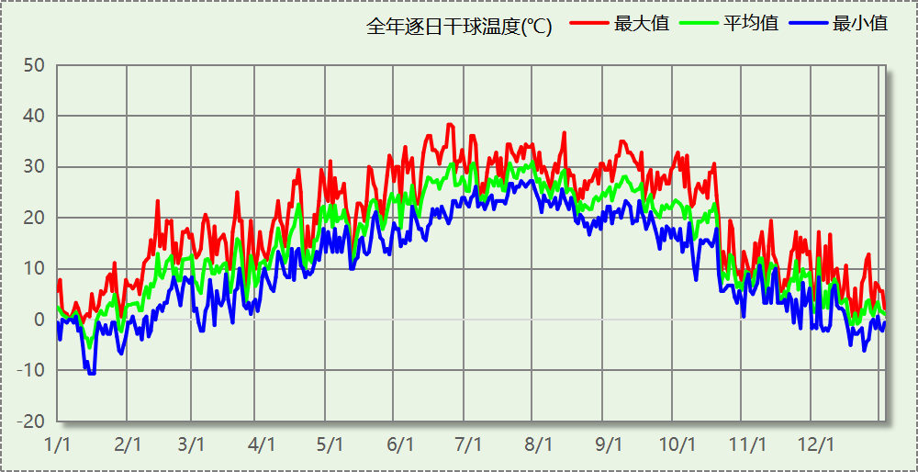

## 逐月辐照量表

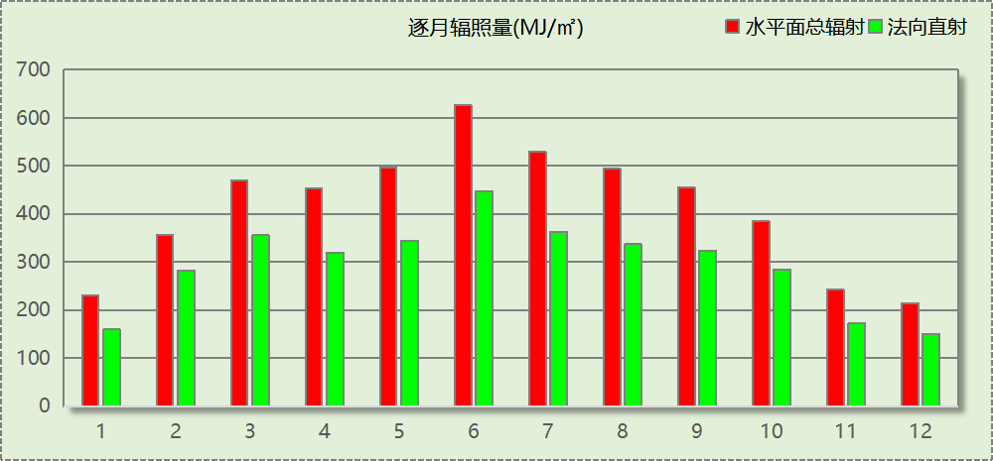

## 峰值工况

|  |  |  |  |  |  |
| --- | --- | --- | --- | --- | --- |
| 气象数据 | 时刻 | 干球温度(℃) | 湿球温度(℃) | 含湿量(g/kg) | 焓值(kj/kg) |
| 最热 | 06月21日15时 | 38.3 | 21.1 | 8.9 | 61.4 |
| 最冷 | 01月14日07时 | -10.6 | -10.6 | 1.4 | -7.1 |

# 软件介绍

本报告采用的软件为绿建暖通负荷BECH2024，该软件紧密结合暖通和节能设计规范、可根据项目实际情况建立建筑热工模型，并可对围护结构材料、房间内扰发热、作息时间表、热回收方式等参数进行设置。

软件包含全国各地典型气象年数据，内置DOE2.1E内核，对于建筑的逐时负荷进行动态模拟，既可以模拟8760小时理想负荷，也可以根据设定好的采暖期/空调期进行逐时模拟。

软件还支持分析全年建筑能耗的来源构成，依据日射得热、新风负荷、围护传热和内扰得热进行归类分项，生成设计建筑全年负荷计算报告书，提供详实的数据和多样的图表，为设计师在设备选型、制定运行策略等方面提供参考和帮助。

# 围护结构

## 屋顶构造

### 屋顶构造一

|  |  |  |  |  |  |  |
| --- | --- | --- | --- | --- | --- | --- |
| 材料名称 （由上到下） | 厚度δ | 导热系数λ | 蓄热系数S | 修正 系数 | 热阻R | 热惰性 指标 |
| (mm) | W/(m.K) | W/(㎡.K) | α | (㎡K)/W | D=R*S |
| 沥青混凝土 | 20 | 1.050 | 16.390 | 1.00 | 0.019 | 0.312 |
| 水泥砂浆找平层 | 20 | 0.930 | 11.306 | 1.00 | 0.022 | 0.243 |
| C20细石混凝土(ρ=2300) | 20 | 1.510 | 15.243 | 1.00 | 0.013 | 0.202 |
| 加气混凝土、泡沫混凝土(ρ=700) | 470.6 | 0.180 | 3.100 | 1.00 | 2.614 | 8.105 |
| 水泥砂浆找平层 | 120 | 0.930 | 11.306 | 1.00 | 0.129 | 1.459 |
| 专用抹面砂浆 | 20 | 0.930 | 11.306 | 1.00 | 0.022 | 0.243 |
| 各层之和∑ | 670.6 | － | － | － | 2.819 | 10.564 |
| 传热系数K=1/(0.15+∑R) | 0.34 | | | | | |

## 外墙构造

### 外墙构造一

|  |  |  |  |  |  |  |
| --- | --- | --- | --- | --- | --- | --- |
| 材料名称 （由外到内） | 厚度δ | 导热系数λ | 蓄热系数S | 修正 系数 | 热阻R | 热惰性 指标 |
| (mm) | W/(m.K) | W/(㎡.K) | α | (㎡K)/W | D=R*S |
| C20细石混凝土(ρ=2300) | 20 | 1.510 | 15.243 | 1.00 | 0.013 | 0.202 |
| 水泥砂浆找平层 | 372.1 | 0.930 | 11.306 | 1.00 | 0.400 | 4.524 |
| C20细石混凝土(ρ=2300) | 20 | 1.510 | 15.243 | 1.00 | 0.013 | 0.202 |
| 水泥砂浆找平层 | 200 | 0.930 | 11.306 | 1.00 | 0.215 | 2.431 |
| 专用抹面砂浆 | 1588.8 | 0.930 | 11.306 | 1.00 | 1.708 | 19.315 |
| 各层之和∑ | 2200.9 | － | － | － | 2.350 | 26.674 |
| 传热系数K=1/(0.15+∑R) | 0.40 | | | | | |

## 挑空楼板构造

### 挑空楼板构造一

|  |  |  |  |  |  |  |
| --- | --- | --- | --- | --- | --- | --- |
| 材料名称 （由上到下） | 厚度δ | 导热系数λ | 蓄热系数S | 修正 系数 | 热阻R | 热惰性 指标 |
| (mm) | W/(m.K) | W/(㎡.K) | α | (㎡K)/W | D=R*S |
| C20细石混凝土(ρ=2300) | 20 | 1.510 | 15.243 | 1.00 | 0.013 | 0.202 |
| 水泥砂浆找平层 | 1666.9 | 0.930 | 11.306 | 1.00 | 1.792 | 20.264 |
| C20细石混凝土(ρ=2300) | 20 | 1.510 | 15.243 | 1.00 | 0.013 | 0.202 |
| 水泥砂浆找平层 | 20 | 0.930 | 11.306 | 1.00 | 0.022 | 0.243 |
| C20细石混凝土(ρ=2300) | 20 | 1.510 | 15.243 | 1.00 | 0.013 | 0.202 |
| 各层之和∑ | 1746.9 | － | － | － | 1.854 | 21.113 |
| 传热系数K=1/(0.15+∑R) | 0.50 | | | | | |

## 楼板构造

### 楼板构造一

|  |  |  |  |  |  |  |
| --- | --- | --- | --- | --- | --- | --- |
| 材料名称 | 厚度δ | 导热系数λ | 蓄热系数S | 修正 系数 | 热阻R | 热惰性 指标 |
| (mm) | W/(m.K) | W/(㎡.K) | α | (㎡K)/W | D=R*S |
| C20细石混凝土(ρ=2300) | 20 | 1.510 | 15.243 | 1.00 | 0.013 | 0.202 |
| 1:3水泥砂浆找平层 | 120 | 0.930 | 11.370 | 1.00 | 0.129 | 1.467 |
| 抹面砂浆（敷设耐碱玻纤网格布一层） | 267.5 | 0.760 | 9.440 | 1.00 | 0.352 | 3.323 |
| 各层之和∑ | 407.5 | － | － | － | 0.494 | 4.992 |
| 传热系数K=1/(0.22+∑R) | 1.40 | | | | | |

## 周边地面构造

### 周边地面构造一

|  |  |  |  |  |  |  |
| --- | --- | --- | --- | --- | --- | --- |
| 材料名称 | 厚度δ | 导热系数λ | 蓄热系数S | 修正 系数 | 热阻R | 热惰性 指标 |
| (mm) | W/(m.K) | W/(㎡.K) | α | (㎡K)/W | D=R*S |
| C20细石混凝土(ρ=2300) | 20 | 1.510 | 15.243 | 1.00 | 0.013 | 0.202 |
| 1:3水泥砂浆找平层 | 120 | 0.930 | 11.370 | 1.00 | 0.129 | 1.467 |
| 加气混凝土、泡沫混凝土(ρ=700) | 20 | 0.180 | 3.100 | 1.00 | 0.111 | 0.344 |
| 难燃型挤塑聚苯板（1） | 20 | 0.030 | 0.540 | 1.00 | 0.667 | 0.360 |
| 各层之和∑ | 180 | － | － | － | 0.920 | 2.373 |
| 传热系数K=1/(0.11+∑R) | 0.37 | | | | | |

## 非周边地面构造

### 非周边地面构造一

|  |  |  |  |  |  |  |
| --- | --- | --- | --- | --- | --- | --- |
| 材料名称 | 厚度δ | 导热系数λ | 蓄热系数S | 修正 系数 | 热阻R | 热惰性 指标 |
| (mm) | W/(m.K) | W/(㎡.K) | α | (㎡K)/W | D=R*S |
| C20细石混凝土(ρ=2300) | 20 | 1.510 | 15.243 | 1.00 | 0.013 | 0.202 |
| 1:3水泥砂浆找平层 | 120 | 0.930 | 11.370 | 1.00 | 0.129 | 1.467 |
| 各层之和∑ | 140 | － | － | － | 0.142 | 1.669 |
| 传热系数K=1/(0.11+∑R) | 0.30 | | | | | |

## 门构造

|  |  |  |  |
| --- | --- | --- | --- |
| 序号 | 构造名称 | 传热系数 | 备注 |
| 1 | 保温门（多功能门） | 1.972 |  |

## 窗构造

|  |  |  |  |  |  |
| --- | --- | --- | --- | --- | --- |
| 序号 | 构造名称 | 传热系数 | 窗遮阳系数 | 可见光透射比 | 备注 |
| 1 | 12A钢铝单框双玻窗（平均） | 1.925 | 0.465 | 0.720 | 来源《民用建筑热工设计规范》 |
| 2 | 65系列内平开隔热铝合金窗(5+12Ar+5Low-E) | 2.200 | 0.425 | 0.620 |  |

# 房间类型

## 房间参数表

|  |  |  |  |  |  |  |
| --- | --- | --- | --- | --- | --- | --- |
| 房间类型 | 空调温度 ℃ | 供暖温度 ℃ | 新风量 | 人员密度 | 照明功率 密度 | 电器设备 功率 |
| 一般商店 | 26 | 20 | 19(m^3/h.人) | 4(m^2/人) | 9(W/m^2) | 13(W/m^2) |
| 书库 | 26 | 20 | 30(m^3/h.人) | 8(m^2/人) | 8(W/m^2) | 15(W/m^2) |
| 休息室 | 26 | 20 | 30(m^3/h.人) | 3.3(m^2/人) | 5(W/m^2) | 0(W/m^2) |
| 会议室 | 26 | 18 | 14(m^3/h.人) | 2.5(m^2/人) | 8(W/m^2) | 15(W/m^2) |
| 办公-普通办公室 | 26 | 20 | 30(m^3/h.人) | 8(m^2/人) | 8(W/m^2) | 15(W/m^2) |
| 卫生间 | 26 | 20 | 30(m^3/h.人) | 8(m^2/人) | 8(W/m^2) | 15(W/m^2) |
| 大厅 | 26 | 18 | 20(m^3/h.人) | 30(m^2/人) | 10(W/m^2) | 15(W/m^2) |
| 展示区 | 26 | 20 | 30(m^3/h.人) | 2.5(m^2/人) | 8(W/m^2) | 15(W/m^2) |
| 开架书库 | 26 | 20 | 30(m^3/h.人) | 8(m^2/人) | 8(W/m^2) | 15(W/m^2) |
| 普通办公室 | 26 | 20 | 30(m^3/h.人) | 8(m^2/人) | 8(W/m^2) | 15(W/m^2) |
| 楼梯间 | 26 | 20 | 30(m^3/h.人) | 8(m^2/人) | 8(W/m^2) | 15(W/m^2) |
| 目录室 | 26 | 20 | 30(m^3/h.人) | 8(m^2/人) | 8(W/m^2) | 15(W/m^2) |
| 走廊 | 26 | 20 | 30(m^3/h.人) | 8(m^2/人) | 8(W/m^2) | 15(W/m^2) |
| 酒吧、茶座 | 26 | 18 | 30(m^3/h.人) | 2(m^2/人) | 8(W/m^2) | 0(W/m^2) |
| 阅览室 | 26 | 20 | 30(m^3/h.人) | 32(m^2/人) | 8(W/m^2) | 15(W/m^2) |

## 作息时间表

详见附录

# 系统设置

## 系统划分

|  |  |  |  |  |  |  |
| --- | --- | --- | --- | --- | --- | --- |
| 系统编号 | 热回收 类型 | 启动 条件 | 回收 效率 | 排风 比例 | 面积(m2) | 包含的房间 |
| 默认 | 全热回收 | 温差启动 冷:≥5.0(℃) 暖:≥5.0(℃) | 冷:0.00, 暖:0.00 | 1.00 | 3053.33 | 1004,1003,2010,2008,2007,2003,2002,3006,3002,4001 |
| Sys | 全热回收 | 温差启动 冷:≥5.0(℃) 暖:≥5.0(℃) | 冷:0.50, 暖:0.55 | 1.00 | 3093.54 | 1045,1043,1044,1001,1042,1041,1039,1037,1033,1030,1029,1026,1019,1018,1017,1016,1015,1014,1013,1011,1010,2001,2044,2043,2040,2038,2034,2032,2031,2027,3009,3008,3004,4007,4006,4003 |

## 运行时间表

详见附录

# 计算结果

## 模拟周期

全年8760小时模拟

## 全年冷暖需求

|  |  |  |  |  |
| --- | --- | --- | --- | --- |
| 系统名称\负荷 | 供暖需求 (kWh) | 供暖指标 (kWh/㎡·a) | 供冷需求 (kWh) | 供冷指标 (kWh/㎡·a) |
| Sys | 22178 | 7.17 | 338537 | 109.43 |
| 默认系统 | 72698 | 23.81 | 143400 | 46.97 |
| 建筑总计 | 94877 | 15.91 | 481937 | 80.82 |

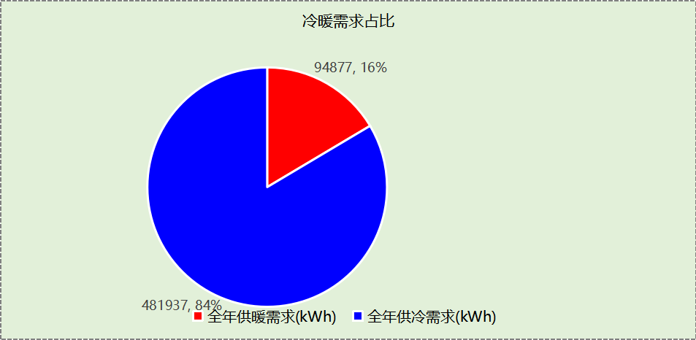

## 负荷分项统计

|  |  |  |  |  |  |  |
| --- | --- | --- | --- | --- | --- | --- |
| 分类 | 围护传热 | 室内得热 | 窗日射 | 新风/渗透 | 热回收 | 合计 |
| 供暖(kWh/㎡) | -22.31 | 17.57 | 7.11 | -30.07 | 11.79 | -15.91 |
| 供冷(kWh/㎡) | 13.55 | 39.02 | 6.39 | 26.22 | -4.35 | 80.82 |

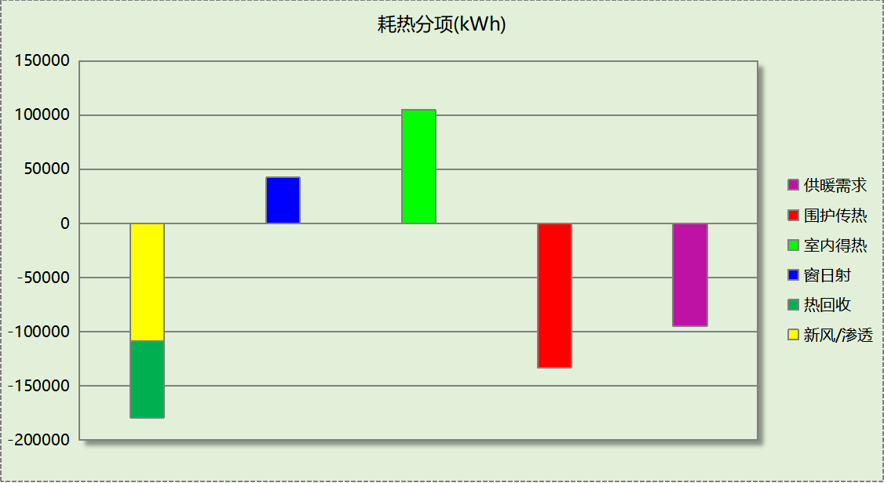

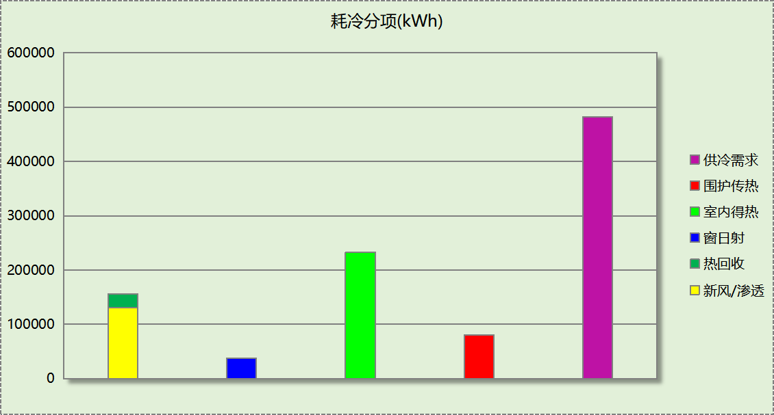

## 逐月负荷表

|  |  |  |  |  |  |  |
| --- | --- | --- | --- | --- | --- | --- |
| 月份 | 供暖(kWh) | 供冷(kWh) | 热负荷 峰值(kW) | 热负荷 峰值时刻 | 冷负荷 峰值(kW) | 冷负荷 峰值时刻 |
| 1月 | 42620 | 0 | 604.355 | 1月2日7时 | 0.000 | -- |
| 2月 | 9019 | 140 | 322.320 | 2月4日7时 | 15.118 | 2月28日15时 |
| 3月 | 5598 | 864 | 207.186 | 3月4日7时 | 35.493 | 3月22日14时 |
| 4月 | 2072 | 12189 | 98.817 | 4月5日7时 | 306.119 | 4月17日10时 |
| 5月 | 23 | 38582 | 6.890 | 5月10日7时 | 386.090 | 5月20日15时 |
| 6月 | 0 | 75783 | 0.000 | -- | 511.034 | 6月28日13时 |
| 7月 | 0 | 138987 | 0.000 | -- | 708.570 | 7月24日13时 |
| 8月 | 0 | 108955 | 0.000 | -- | 614.528 | 8月2日14时 |
| 9月 | 0 | 81519 | 0.000 | -- | 546.904 | 9月13日15时 |
| 10月 | 1303 | 24915 | 118.757 | 10月29日7时 | 368.444 | 10月17日14时 |
| 11月 | 7623 | 3 | 242.230 | 11月18日7时 | 0.620 | 11月6日13时 |
| 12月 | 26619 | 0 | 405.385 | 12月16日7时 | 0.000 | -- |

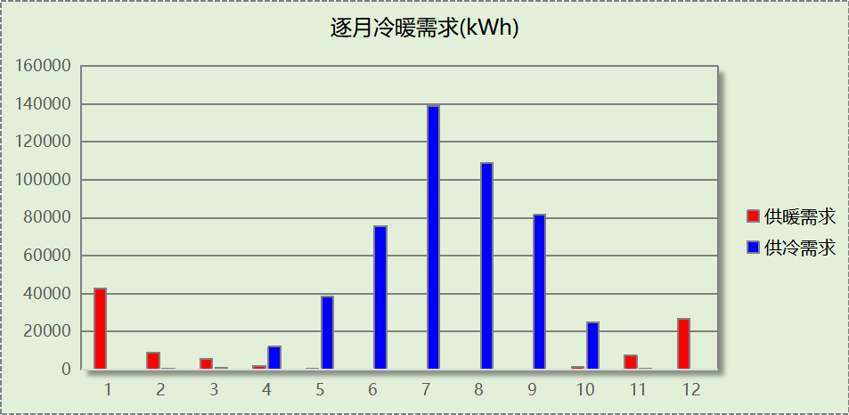

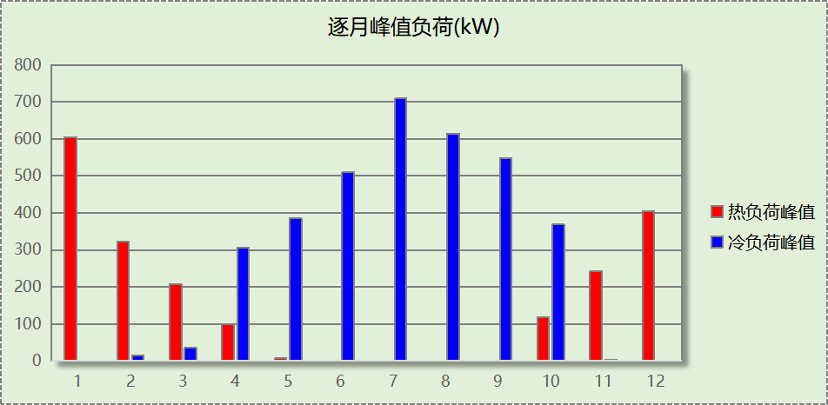

# 附录

**工作日/节假日人员逐时在室率(%)**

|  |  |  |  |  |  |  |  |  |  |  |  |  |  |  |  |  |  |  |  |  |  |  |  |  |
| --- | --- | --- | --- | --- | --- | --- | --- | --- | --- | --- | --- | --- | --- | --- | --- | --- | --- | --- | --- | --- | --- | --- | --- | --- |
| 房间类型 | 1 | 2 | 3 | 4 | 5 | 6 | 7 | 8 | 9 | 10 | 11 | 12 | 13 | 14 | 15 | 16 | 17 | 18 | 19 | 20 | 21 | 22 | 23 | 24 |
| 一般商店 | 0 | 0 | 0 | 0 | 0 | 0 | 0 | 20 | 50 | 80 | 80 | 80 | 80 | 80 | 80 | 80 | 80 | 80 | 80 | 70 | 50 | 0 | 0 | 0 |
| 0 | 0 | 0 | 0 | 0 | 0 | 0 | 20 | 50 | 80 | 80 | 80 | 80 | 80 | 80 | 80 | 80 | 80 | 80 | 70 | 50 | 0 | 0 | 0 |
| 书库 | 0 | 0 | 0 | 0 | 0 | 0 | 10 | 50 | 100 | 100 | 100 | 30 | 100 | 100 | 100 | 100 | 50 | 20 | 10 | 0 | 0 | 0 | 0 | 0 |
| 0 | 0 | 0 | 0 | 0 | 0 | 0 | 20 | 45 | 0 | 0 | 0 | 0 | 0 | 0 | 0 | 0 | 0 | 0 | 0 | 0 | 0 | 0 | 0 |
| 休息室 | 0 | 0 | 0 | 0 | 0 | 0 | 10 | 50 | 100 | 100 | 100 | 30 | 100 | 100 | 100 | 100 | 50 | 20 | 10 | 0 | 0 | 0 | 0 | 0 |
| 0 | 0 | 0 | 0 | 0 | 0 | 0 | 20 | 45 | 0 | 0 | 0 | 0 | 0 | 0 | 0 | 0 | 0 | 0 | 0 | 0 | 0 | 0 | 0 |
| 会议室 | 0 | 0 | 0 | 0 | 0 | 0 | 10 | 50 | 100 | 100 | 100 | 30 | 100 | 100 | 100 | 100 | 50 | 20 | 10 | 0 | 0 | 0 | 0 | 0 |
| 0 | 0 | 0 | 0 | 0 | 0 | 0 | 20 | 45 | 0 | 0 | 0 | 0 | 0 | 0 | 0 | 0 | 0 | 0 | 0 | 0 | 0 | 0 | 0 |
| 办公-普通办公室 | 0 | 0 | 0 | 0 | 0 | 0 | 10 | 50 | 100 | 100 | 100 | 30 | 100 | 100 | 100 | 100 | 50 | 20 | 10 | 0 | 0 | 0 | 0 | 0 |
| 0 | 0 | 0 | 0 | 0 | 0 | 0 | 20 | 45 | 0 | 0 | 0 | 0 | 0 | 0 | 0 | 0 | 0 | 0 | 0 | 0 | 0 | 0 | 0 |
| 卫生间 | 0 | 0 | 0 | 0 | 0 | 0 | 10 | 50 | 100 | 100 | 100 | 30 | 100 | 100 | 100 | 100 | 50 | 20 | 10 | 0 | 0 | 0 | 0 | 0 |
| 0 | 0 | 0 | 0 | 0 | 0 | 0 | 20 | 45 | 0 | 0 | 0 | 0 | 0 | 0 | 0 | 0 | 0 | 0 | 0 | 0 | 0 | 0 | 0 |
| 大厅 | 0 | 0 | 0 | 0 | 0 | 0 | 10 | 50 | 100 | 100 | 100 | 30 | 100 | 100 | 100 | 100 | 50 | 20 | 10 | 0 | 0 | 0 | 0 | 0 |
| 0 | 0 | 0 | 0 | 0 | 0 | 0 | 20 | 45 | 0 | 0 | 0 | 0 | 0 | 0 | 0 | 0 | 0 | 0 | 0 | 0 | 0 | 0 | 0 |
| 展示区 | 0 | 0 | 0 | 0 | 0 | 0 | 10 | 50 | 100 | 100 | 100 | 30 | 100 | 100 | 100 | 100 | 50 | 20 | 10 | 0 | 0 | 0 | 0 | 0 |
| 0 | 0 | 0 | 0 | 0 | 0 | 0 | 20 | 45 | 0 | 0 | 0 | 0 | 0 | 0 | 0 | 0 | 0 | 0 | 0 | 0 | 0 | 0 | 0 |
| 开架书库 | 0 | 0 | 0 | 0 | 0 | 0 | 10 | 50 | 100 | 100 | 100 | 30 | 100 | 100 | 100 | 100 | 50 | 20 | 10 | 0 | 0 | 0 | 0 | 0 |
| 0 | 0 | 0 | 0 | 0 | 0 | 0 | 20 | 45 | 0 | 0 | 0 | 0 | 0 | 0 | 0 | 0 | 0 | 0 | 0 | 0 | 0 | 0 | 0 |
| 普通办公室 | 0 | 0 | 0 | 0 | 0 | 0 | 10 | 50 | 100 | 100 | 100 | 30 | 100 | 100 | 100 | 100 | 50 | 20 | 10 | 0 | 0 | 0 | 0 | 0 |
| 0 | 0 | 0 | 0 | 0 | 0 | 0 | 20 | 45 | 0 | 0 | 0 | 0 | 0 | 0 | 0 | 0 | 0 | 0 | 0 | 0 | 0 | 0 | 0 |
| 楼梯间 | 0 | 0 | 0 | 0 | 0 | 0 | 10 | 50 | 100 | 100 | 100 | 30 | 100 | 100 | 100 | 100 | 50 | 20 | 10 | 0 | 0 | 0 | 0 | 0 |
| 0 | 0 | 0 | 0 | 0 | 0 | 0 | 20 | 45 | 0 | 0 | 0 | 0 | 0 | 0 | 0 | 0 | 0 | 0 | 0 | 0 | 0 | 0 | 0 |
| 目录室 | 0 | 0 | 0 | 0 | 0 | 0 | 10 | 50 | 100 | 100 | 100 | 30 | 100 | 100 | 100 | 100 | 50 | 20 | 10 | 0 | 0 | 0 | 0 | 0 |
| 0 | 0 | 0 | 0 | 0 | 0 | 0 | 20 | 45 | 0 | 0 | 0 | 0 | 0 | 0 | 0 | 0 | 0 | 0 | 0 | 0 | 0 | 0 | 0 |
| 走廊 | 0 | 0 | 0 | 0 | 0 | 0 | 10 | 50 | 100 | 100 | 100 | 30 | 100 | 100 | 100 | 100 | 50 | 20 | 10 | 0 | 0 | 0 | 0 | 0 |
| 0 | 0 | 0 | 0 | 0 | 0 | 0 | 20 | 45 | 0 | 0 | 0 | 0 | 0 | 0 | 0 | 0 | 0 | 0 | 0 | 0 | 0 | 0 | 0 |
| 酒吧、茶座 | 0 | 0 | 0 | 0 | 0 | 0 | 0 | 20 | 50 | 80 | 80 | 80 | 80 | 80 | 80 | 80 | 80 | 80 | 80 | 70 | 50 | 0 | 0 | 0 |
| 0 | 0 | 0 | 0 | 0 | 0 | 0 | 20 | 50 | 80 | 80 | 80 | 80 | 80 | 80 | 80 | 80 | 80 | 80 | 70 | 50 | 0 | 0 | 0 |
| 阅览室 | 0 | 0 | 0 | 0 | 0 | 0 | 10 | 50 | 100 | 100 | 100 | 30 | 100 | 100 | 100 | 100 | 50 | 20 | 10 | 0 | 0 | 0 | 0 | 0 |
| 0 | 0 | 0 | 0 | 0 | 0 | 0 | 20 | 45 | 0 | 0 | 0 | 0 | 0 | 0 | 0 | 0 | 0 | 0 | 0 | 0 | 0 | 0 | 0 |

注：上行：工作日；下行：节假日

**工作日/节假日照明开关时间表(%)**

|  |  |  |  |  |  |  |  |  |  |  |  |  |  |  |  |  |  |  |  |  |  |  |  |  |
| --- | --- | --- | --- | --- | --- | --- | --- | --- | --- | --- | --- | --- | --- | --- | --- | --- | --- | --- | --- | --- | --- | --- | --- | --- |
| 房间类型 | 1 | 2 | 3 | 4 | 5 | 6 | 7 | 8 | 9 | 10 | 11 | 12 | 13 | 14 | 15 | 16 | 17 | 18 | 19 | 20 | 21 | 22 | 23 | 24 |
| 一般商店 | 10 | 10 | 10 | 10 | 10 | 10 | 10 | 50 | 60 | 60 | 60 | 60 | 60 | 60 | 60 | 60 | 80 | 90 | 100 | 100 | 100 | 10 | 10 | 10 |
| 10 | 10 | 10 | 10 | 10 | 10 | 10 | 50 | 60 | 60 | 60 | 60 | 60 | 60 | 60 | 60 | 80 | 90 | 100 | 100 | 100 | 10 | 10 | 10 |
| 书库 | 10 | 10 | 10 | 10 | 10 | 10 | 10 | 36 | 62 | 56 | 54 | 43 | 53 | 55 | 58 | 67 | 40 | 18 | 10 | 10 | 10 | 10 | 10 | 10 |
| 0 | 0 | 0 | 0 | 0 | 0 | 0 | 0 | 0 | 0 | 0 | 0 | 0 | 0 | 0 | 0 | 0 | 0 | 0 | 0 | 0 | 0 | 0 | 0 |
| 休息室 | 10 | 10 | 10 | 10 | 10 | 10 | 10 | 36 | 62 | 56 | 54 | 43 | 53 | 55 | 58 | 67 | 40 | 18 | 10 | 10 | 10 | 10 | 10 | 10 |
| 0 | 0 | 0 | 0 | 0 | 0 | 0 | 0 | 0 | 0 | 0 | 0 | 0 | 0 | 0 | 0 | 0 | 0 | 0 | 0 | 0 | 0 | 0 | 0 |
| 会议室 | 10 | 10 | 10 | 10 | 10 | 10 | 10 | 36 | 62 | 56 | 54 | 43 | 53 | 55 | 58 | 67 | 40 | 18 | 10 | 10 | 10 | 10 | 10 | 10 |
| 0 | 0 | 0 | 0 | 0 | 0 | 0 | 0 | 0 | 0 | 0 | 0 | 0 | 0 | 0 | 0 | 0 | 0 | 0 | 0 | 0 | 0 | 0 | 0 |
| 办公-普通办公室 | 10 | 10 | 10 | 10 | 10 | 10 | 10 | 36 | 62 | 56 | 54 | 43 | 53 | 55 | 58 | 67 | 40 | 18 | 10 | 10 | 10 | 10 | 10 | 10 |
| 0 | 0 | 0 | 0 | 0 | 0 | 0 | 0 | 0 | 0 | 0 | 0 | 0 | 0 | 0 | 0 | 0 | 0 | 0 | 0 | 0 | 0 | 0 | 0 |
| 卫生间 | 10 | 10 | 10 | 10 | 10 | 10 | 10 | 36 | 62 | 56 | 54 | 43 | 53 | 55 | 58 | 67 | 40 | 18 | 10 | 10 | 10 | 10 | 10 | 10 |
| 0 | 0 | 0 | 0 | 0 | 0 | 0 | 0 | 0 | 0 | 0 | 0 | 0 | 0 | 0 | 0 | 0 | 0 | 0 | 0 | 0 | 0 | 0 | 0 |
| 大厅 | 10 | 10 | 10 | 10 | 10 | 10 | 10 | 36 | 62 | 56 | 54 | 43 | 53 | 55 | 58 | 67 | 40 | 18 | 10 | 10 | 10 | 10 | 10 | 10 |
| 0 | 0 | 0 | 0 | 0 | 0 | 0 | 0 | 0 | 0 | 0 | 0 | 0 | 0 | 0 | 0 | 0 | 0 | 0 | 0 | 0 | 0 | 0 | 0 |
| 展示区 | 10 | 10 | 10 | 10 | 10 | 10 | 10 | 36 | 62 | 56 | 54 | 43 | 53 | 55 | 58 | 67 | 40 | 18 | 10 | 10 | 10 | 10 | 10 | 10 |
| 0 | 0 | 0 | 0 | 0 | 0 | 0 | 0 | 0 | 0 | 0 | 0 | 0 | 0 | 0 | 0 | 0 | 0 | 0 | 0 | 0 | 0 | 0 | 0 |
| 开架书库 | 10 | 10 | 10 | 10 | 10 | 10 | 10 | 36 | 62 | 56 | 54 | 43 | 53 | 55 | 58 | 67 | 40 | 18 | 10 | 10 | 10 | 10 | 10 | 10 |
| 0 | 0 | 0 | 0 | 0 | 0 | 0 | 0 | 0 | 0 | 0 | 0 | 0 | 0 | 0 | 0 | 0 | 0 | 0 | 0 | 0 | 0 | 0 | 0 |
| 普通办公室 | 10 | 10 | 10 | 10 | 10 | 10 | 10 | 36 | 62 | 56 | 54 | 43 | 53 | 55 | 58 | 67 | 40 | 18 | 10 | 10 | 10 | 10 | 10 | 10 |
| 0 | 0 | 0 | 0 | 0 | 0 | 0 | 0 | 0 | 0 | 0 | 0 | 0 | 0 | 0 | 0 | 0 | 0 | 0 | 0 | 0 | 0 | 0 | 0 |
| 楼梯间 | 10 | 10 | 10 | 10 | 10 | 10 | 10 | 36 | 62 | 56 | 54 | 43 | 53 | 55 | 58 | 67 | 40 | 18 | 10 | 10 | 10 | 10 | 10 | 10 |
| 0 | 0 | 0 | 0 | 0 | 0 | 0 | 0 | 0 | 0 | 0 | 0 | 0 | 0 | 0 | 0 | 0 | 0 | 0 | 0 | 0 | 0 | 0 | 0 |
| 目录室 | 10 | 10 | 10 | 10 | 10 | 10 | 10 | 36 | 62 | 56 | 54 | 43 | 53 | 55 | 58 | 67 | 40 | 18 | 10 | 10 | 10 | 10 | 10 | 10 |
| 0 | 0 | 0 | 0 | 0 | 0 | 0 | 0 | 0 | 0 | 0 | 0 | 0 | 0 | 0 | 0 | 0 | 0 | 0 | 0 | 0 | 0 | 0 | 0 |
| 走廊 | 10 | 10 | 10 | 10 | 10 | 10 | 10 | 36 | 62 | 56 | 54 | 43 | 53 | 55 | 58 | 67 | 40 | 18 | 10 | 10 | 10 | 10 | 10 | 10 |
| 0 | 0 | 0 | 0 | 0 | 0 | 0 | 0 | 0 | 0 | 0 | 0 | 0 | 0 | 0 | 0 | 0 | 0 | 0 | 0 | 0 | 0 | 0 | 0 |
| 酒吧、茶座 | 10 | 10 | 10 | 10 | 10 | 10 | 10 | 50 | 60 | 60 | 60 | 60 | 60 | 60 | 60 | 60 | 80 | 90 | 100 | 100 | 100 | 10 | 10 | 10 |
| 10 | 10 | 10 | 10 | 10 | 10 | 10 | 50 | 60 | 60 | 60 | 60 | 60 | 60 | 60 | 60 | 80 | 90 | 100 | 100 | 100 | 10 | 10 | 10 |
| 阅览室 | 10 | 10 | 10 | 10 | 10 | 10 | 10 | 36 | 62 | 56 | 54 | 43 | 53 | 55 | 58 | 67 | 40 | 18 | 10 | 10 | 10 | 10 | 10 | 10 |
| 0 | 0 | 0 | 0 | 0 | 0 | 0 | 0 | 0 | 0 | 0 | 0 | 0 | 0 | 0 | 0 | 0 | 0 | 0 | 0 | 0 | 0 | 0 | 0 |

注：上行：工作日；下行：节假日

**工作日/节假日设备逐时使用率(%)**

|  |  |  |  |  |  |  |  |  |  |  |  |  |  |  |  |  |  |  |  |  |  |  |  |  |
| --- | --- | --- | --- | --- | --- | --- | --- | --- | --- | --- | --- | --- | --- | --- | --- | --- | --- | --- | --- | --- | --- | --- | --- | --- |
| 房间类型 | 1 | 2 | 3 | 4 | 5 | 6 | 7 | 8 | 9 | 10 | 11 | 12 | 13 | 14 | 15 | 16 | 17 | 18 | 19 | 20 | 21 | 22 | 23 | 24 |
| 一般商店 | 0 | 0 | 0 | 0 | 0 | 0 | 0 | 30 | 50 | 80 | 80 | 80 | 80 | 80 | 80 | 80 | 80 | 80 | 80 | 70 | 50 | 0 | 0 | 0 |
| 0 | 0 | 0 | 0 | 0 | 0 | 0 | 30 | 50 | 80 | 80 | 80 | 80 | 80 | 80 | 80 | 80 | 80 | 80 | 70 | 50 | 0 | 0 | 0 |
| 书库 | 0 | 0 | 0 | 0 | 0 | 0 | 10 | 50 | 100 | 100 | 100 | 100 | 100 | 100 | 100 | 100 | 50 | 20 | 10 | 0 | 0 | 0 | 0 | 0 |
| 0 | 0 | 0 | 0 | 0 | 0 | 0 | 0 | 0 | 0 | 0 | 0 | 0 | 0 | 0 | 0 | 0 | 0 | 0 | 0 | 0 | 0 | 0 | 0 |
| 休息室 | 0 | 0 | 0 | 0 | 0 | 0 | 10 | 50 | 100 | 100 | 100 | 100 | 100 | 100 | 100 | 100 | 50 | 20 | 10 | 0 | 0 | 0 | 0 | 0 |
| 0 | 0 | 0 | 0 | 0 | 0 | 0 | 0 | 0 | 0 | 0 | 0 | 0 | 0 | 0 | 0 | 0 | 0 | 0 | 0 | 0 | 0 | 0 | 0 |
| 会议室 | 0 | 0 | 0 | 0 | 0 | 0 | 10 | 50 | 100 | 100 | 100 | 100 | 100 | 100 | 100 | 100 | 50 | 20 | 10 | 0 | 0 | 0 | 0 | 0 |
| 0 | 0 | 0 | 0 | 0 | 0 | 0 | 0 | 0 | 0 | 0 | 0 | 0 | 0 | 0 | 0 | 0 | 0 | 0 | 0 | 0 | 0 | 0 | 0 |
| 办公-普通办公室 | 0 | 0 | 0 | 0 | 0 | 0 | 10 | 50 | 100 | 100 | 100 | 100 | 100 | 100 | 100 | 100 | 50 | 20 | 10 | 0 | 0 | 0 | 0 | 0 |
| 0 | 0 | 0 | 0 | 0 | 0 | 0 | 0 | 0 | 0 | 0 | 0 | 0 | 0 | 0 | 0 | 0 | 0 | 0 | 0 | 0 | 0 | 0 | 0 |
| 卫生间 | 0 | 0 | 0 | 0 | 0 | 0 | 10 | 50 | 100 | 100 | 100 | 100 | 100 | 100 | 100 | 100 | 50 | 20 | 10 | 0 | 0 | 0 | 0 | 0 |
| 0 | 0 | 0 | 0 | 0 | 0 | 0 | 0 | 0 | 0 | 0 | 0 | 0 | 0 | 0 | 0 | 0 | 0 | 0 | 0 | 0 | 0 | 0 | 0 |
| 大厅 | 0 | 0 | 0 | 0 | 0 | 0 | 10 | 50 | 100 | 100 | 100 | 100 | 100 | 100 | 100 | 100 | 50 | 20 | 10 | 0 | 0 | 0 | 0 | 0 |
| 0 | 0 | 0 | 0 | 0 | 0 | 0 | 0 | 0 | 0 | 0 | 0 | 0 | 0 | 0 | 0 | 0 | 0 | 0 | 0 | 0 | 0 | 0 | 0 |
| 展示区 | 0 | 0 | 0 | 0 | 0 | 0 | 10 | 50 | 100 | 100 | 100 | 100 | 100 | 100 | 100 | 100 | 50 | 20 | 10 | 0 | 0 | 0 | 0 | 0 |
| 0 | 0 | 0 | 0 | 0 | 0 | 0 | 0 | 0 | 0 | 0 | 0 | 0 | 0 | 0 | 0 | 0 | 0 | 0 | 0 | 0 | 0 | 0 | 0 |
| 开架书库 | 0 | 0 | 0 | 0 | 0 | 0 | 10 | 50 | 100 | 100 | 100 | 100 | 100 | 100 | 100 | 100 | 50 | 20 | 10 | 0 | 0 | 0 | 0 | 0 |
| 0 | 0 | 0 | 0 | 0 | 0 | 0 | 0 | 0 | 0 | 0 | 0 | 0 | 0 | 0 | 0 | 0 | 0 | 0 | 0 | 0 | 0 | 0 | 0 |
| 普通办公室 | 0 | 0 | 0 | 0 | 0 | 0 | 10 | 50 | 100 | 100 | 100 | 100 | 100 | 100 | 100 | 100 | 50 | 20 | 10 | 0 | 0 | 0 | 0 | 0 |
| 0 | 0 | 0 | 0 | 0 | 0 | 0 | 0 | 0 | 0 | 0 | 0 | 0 | 0 | 0 | 0 | 0 | 0 | 0 | 0 | 0 | 0 | 0 | 0 |
| 楼梯间 | 0 | 0 | 0 | 0 | 0 | 0 | 10 | 50 | 100 | 100 | 100 | 100 | 100 | 100 | 100 | 100 | 50 | 20 | 10 | 0 | 0 | 0 | 0 | 0 |
| 0 | 0 | 0 | 0 | 0 | 0 | 0 | 0 | 0 | 0 | 0 | 0 | 0 | 0 | 0 | 0 | 0 | 0 | 0 | 0 | 0 | 0 | 0 | 0 |
| 目录室 | 0 | 0 | 0 | 0 | 0 | 0 | 10 | 50 | 100 | 100 | 100 | 100 | 100 | 100 | 100 | 100 | 50 | 20 | 10 | 0 | 0 | 0 | 0 | 0 |
| 0 | 0 | 0 | 0 | 0 | 0 | 0 | 0 | 0 | 0 | 0 | 0 | 0 | 0 | 0 | 0 | 0 | 0 | 0 | 0 | 0 | 0 | 0 | 0 |
| 走廊 | 0 | 0 | 0 | 0 | 0 | 0 | 10 | 50 | 100 | 100 | 100 | 100 | 100 | 100 | 100 | 100 | 50 | 20 | 10 | 0 | 0 | 0 | 0 | 0 |
| 0 | 0 | 0 | 0 | 0 | 0 | 0 | 0 | 0 | 0 | 0 | 0 | 0 | 0 | 0 | 0 | 0 | 0 | 0 | 0 | 0 | 0 | 0 | 0 |
| 酒吧、茶座 | 0 | 0 | 0 | 0 | 0 | 0 | 0 | 30 | 50 | 80 | 80 | 80 | 80 | 80 | 80 | 80 | 80 | 80 | 80 | 70 | 50 | 0 | 0 | 0 |
| 0 | 0 | 0 | 0 | 0 | 0 | 0 | 30 | 50 | 80 | 80 | 80 | 80 | 80 | 80 | 80 | 80 | 80 | 80 | 70 | 50 | 0 | 0 | 0 |
| 阅览室 | 0 | 0 | 0 | 0 | 0 | 0 | 10 | 50 | 100 | 100 | 100 | 100 | 100 | 100 | 100 | 100 | 50 | 20 | 10 | 0 | 0 | 0 | 0 | 0 |
| 0 | 0 | 0 | 0 | 0 | 0 | 0 | 0 | 0 | 0 | 0 | 0 | 0 | 0 | 0 | 0 | 0 | 0 | 0 | 0 | 0 | 0 | 0 | 0 |

注：上行：工作日；下行：节假日

**工作日/节假日空调系统开关时间表**

|  |  |  |  |  |  |  |  |  |  |  |  |  |  |  |  |  |  |  |  |  |  |  |  |  |
| --- | --- | --- | --- | --- | --- | --- | --- | --- | --- | --- | --- | --- | --- | --- | --- | --- | --- | --- | --- | --- | --- | --- | --- | --- |
| 系统编号 | 1 | 2 | 3 | 4 | 5 | 6 | 7 | 8 | 9 | 10 | 11 | 12 | 13 | 14 | 15 | 16 | 17 | 18 | 19 | 20 | 21 | 22 | 23 | 24 |
| 默认 | 1 | 1 | 1 | 1 | 1 | 1 | 1 | 1 | 1 | 1 | 1 | 1 | 1 | 1 | 1 | 1 | 1 | 1 | 1 | 1 | 1 | 1 | 1 | 1 |
| 1 | 1 | 1 | 1 | 1 | 1 | 1 | 1 | 1 | 1 | 1 | 1 | 1 | 1 | 1 | 1 | 1 | 1 | 1 | 1 | 1 | 1 | 1 | 1 |
| Sys | 0 | 0 | 0 | 0 | 0 | 0 | 0 | 1 | 1 | 1 | 1 | 1 | 1 | 1 | 1 | 1 | 1 | 1 | 1 | 1 | 1 | 0 | 0 | 0 |
| 0 | 0 | 0 | 0 | 0 | 0 | 0 | 1 | 1 | 1 | 1 | 1 | 1 | 1 | 1 | 1 | 1 | 1 | 1 | 1 | 1 | 0 | 0 | 0 |

注：上行：工作日；下行：节假日