**启东滨海工业园滨海医院建设工程设计项目**

**全年负荷计算书**

|  |  |
| --- | --- |
| 工程名称 | 启东滨海工业园滨海医院建设工程设计项目 |
| 设计编号 | A232002895 |
| 建设单位 | 启东市新城建设投资发展有限公司 |
| 设计单位 | 江苏省建筑设计研究院股份有限公司 |
| 计 算 人 |  |
| 校 对 人 |  |
| 审 核 人 |  |
| 计算日期 | 2024年12月24日 |



|  |  |
| --- | --- |
| 采用软件 | 暖通负荷BECH2024 |
| 软件版本 | 20240430(SP1) |
| 研发单位 | 北京绿建软件股份有限公司 |
| 正版授权码 | T15696828582 |

**目 录**

1 建筑概况 1

2 气象数据 1

2.1 气象地点 1

2.2 逐日干球温度表 1

2.3 逐月辐照量表 2

2.4 峰值工况 2

3 软件介绍 2

4 围护结构 2

4.1 屋顶构造 2

4.1.1 屋顶构造一 2

4.2 挑空楼板构造 3

4.2.1 挑空楼板构造一 3

4.3 楼板构造 3

4.3.1 控温房间楼板构造一 3

4.4 门构造 3

4.5 窗构造 3

5 房间类型 4

5.1 房间参数表 4

5.2 作息时间表 4

6 系统设置 5

6.1 系统划分 5

6.2 运行时间表 5

7 计算结果 5

7.1 模拟周期 5

7.2 全年冷暖需求 5

7.3 负荷分项统计 5

7.4 逐月负荷表 6

8 附录 8

# 建筑概况

|  |  |  |
| --- | --- | --- |
| 地理位置 | 江苏-南通 | |
| 气候分区 | 夏热冬冷A区 | |
| 北纬 | 32.08 | |
| 东经 | 121.05 | |
| 建筑名称 | 启东滨海工业园滨海医院建设工程设计项目 | |
| 建筑类型 | 公共建筑 |  |
| 建筑面积 | 地上 17036.65 ㎡ | 地下 0.00 ㎡ |
| 建筑高度 | 地上 31.30 m | 地下0.00 |
| 建筑层数 | 地上 7 | 地下 0 |
| 北向角度 | 90° | |

# 气象数据

## 气象地点

江苏-南通, 《建筑节能气象参数标准》JGJ346-2014

## 逐日干球温度表

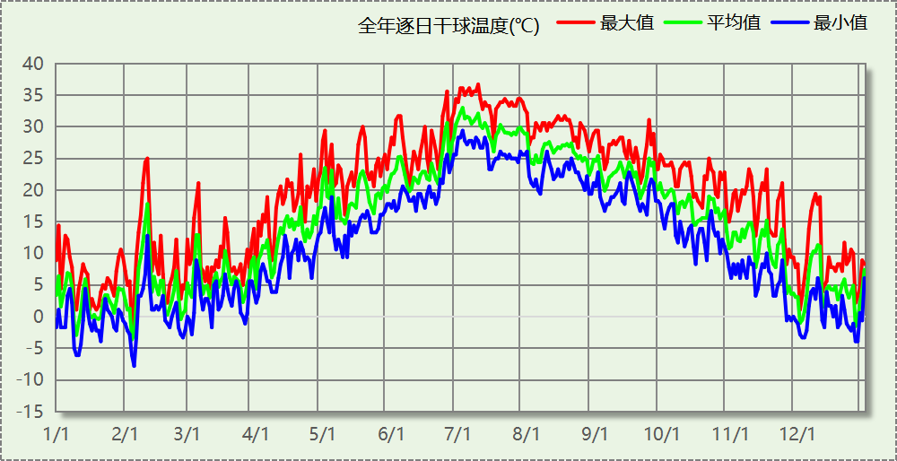

## 逐月辐照量表

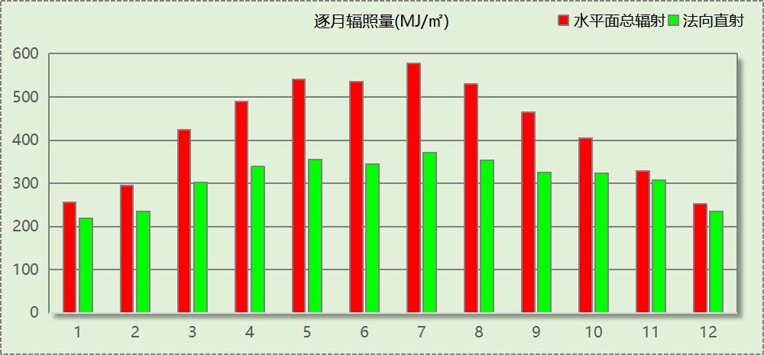

## 峰值工况

|  |  |  |  |  |  |
| --- | --- | --- | --- | --- | --- |
| 气象数据 | 时刻 | 干球温度(℃) | 湿球温度(℃) | 含湿量(g/kg) | 焓值(kj/kg) |
| 最热 | 07月09日14时 | 36.7 | 27.8 | 20.3 | 89.0 |
| 最冷 | 02月04日06时 | -7.8 | -8.3 | 1.6 | -3.8 |

# 软件介绍

本报告采用的软件为绿建暖通负荷BECH2024，该软件紧密结合暖通和节能设计规范、可根据项目实际情况建立建筑热工模型，并可对围护结构材料、房间内扰发热、作息时间表、热回收方式等参数进行设置。

软件包含全国各地典型气象年数据，内置DOE2.1E内核，对于建筑的逐时负荷进行动态模拟，既可以模拟8760小时理想负荷，也可以根据设定好的采暖期/空调期进行逐时模拟。

软件还支持分析全年建筑能耗的来源构成，依据日射得热、新风负荷、围护传热和内扰得热进行归类分项，生成设计建筑全年负荷计算报告书，提供详实的数据和多样的图表，为设计师在设备选型、制定运行策略等方面提供参考和帮助。

# 围护结构

## 屋顶构造

### 屋顶构造一

|  |  |  |  |  |  |  |
| --- | --- | --- | --- | --- | --- | --- |
| 材料名称 （由上到下） | 厚度δ | 导热系数λ | 蓄热系数S | 修正 系数 | 热阻R | 热惰性 指标 |
| (mm) | W/(m.K) | W/(㎡.K) | α | (㎡K)/W | D=R*S |
| 水泥砂浆 | 20 | 0.930 | 11.370 | 1.00 | 0.022 | 0.245 |
| c20细石混凝土(ρ=2300) | 40 | 1.510 | 15.243 | 1.00 | 0.026 | 0.404 |
| 挤塑聚苯板(ρ=25-32) | 90 | 0.030 | 0.320 | 1.10 | 2.727 | 0.960 |
| 轻骨料混凝土(找坡层) | 30 | 0.300 | 5.000 | 1.50 | 0.067 | 0.500 |
| 钢筋混凝土 | 120 | 1.740 | 17.200 | 1.00 | 0.069 | 1.186 |
| 混合砂浆 | 20 | 0.870 | 10.750 | 1.00 | 0.023 | 0.247 |
| 各层之和∑ | 320 | － | － | － | 2.934 | 3.542 |
| 传热系数K=1/(0.15+∑R) | 0.32 | | | | | |

## 挑空楼板构造

### 挑空楼板构造一

|  |  |  |  |  |  |  |
| --- | --- | --- | --- | --- | --- | --- |
| 材料名称 （由上到下） | 厚度δ | 导热系数λ | 蓄热系数S | 修正 系数 | 热阻R | 热惰性 指标 |
| (mm) | W/(m.K) | W/(㎡.K) | α | (㎡K)/W | D=R*S |
| 水泥砂浆 | 20 | 0.930 | 11.370 | 1.00 | 0.022 | 0.245 |
| 挤塑聚苯板(ρ=25-32) | 70 | 0.030 | 0.320 | 1.10 | 2.121 | 0.747 |
| 钢筋混凝土 | 120 | 1.740 | 17.200 | 1.00 | 0.069 | 1.186 |
| 混合砂浆 | 20 | 0.870 | 10.750 | 1.00 | 0.023 | 0.247 |
| 各层之和∑ | 230 | － | － | － | 2.235 | 2.425 |
| 传热系数K=1/(0.15+∑R) | 0.42 | | | | | |

## 楼板构造

### 控温房间楼板构造一

|  |  |  |  |  |  |  |
| --- | --- | --- | --- | --- | --- | --- |
| 材料名称 | 厚度δ | 导热系数λ | 蓄热系数S | 修正 系数 | 热阻R | 热惰性 指标 |
| (mm) | W/(m.K) | W/(㎡.K) | α | (㎡K)/W | D=R*S |
| 水泥砂浆 | 20 | 0.930 | 11.370 | 1.00 | 0.022 | 0.245 |
| 聚苯乙烯泡沫塑料（灰板） | 15 | 0.033 | 0.280 | 1.20 | 0.379 | 0.127 |
| 钢筋混凝土 | 120 | 1.740 | 17.200 | 1.00 | 0.069 | 1.186 |
| 混合砂浆 | 20 | 0.870 | 10.750 | 1.00 | 0.023 | 0.247 |
| 各层之和∑ | 175 | － | － | － | 0.492 | 1.805 |
| 传热系数K=1/(0.22+∑R) | 1.40 | | | | | |

## 门构造

|  |  |  |  |
| --- | --- | --- | --- |
| 序号 | 构造名称 | 传热系数 | 备注 |
| 1 | 金属三防门(硅酸铝板保温-普通型) | 1.500 |  |

## 窗构造

|  |  |  |  |  |  |
| --- | --- | --- | --- | --- | --- |
| 序号 | 构造名称 | 传热系数 | 窗遮阳系数 | 可见光透射比 | 备注 |
| 1 | 60系列内平开下悬铝合金窗[5Low-E+16A+5] | 2.500 | 0.425 | 0.620 |  |

# 房间类型

## 房间参数表

|  |  |  |  |  |  |  |
| --- | --- | --- | --- | --- | --- | --- |
| 房间类型 | 空调温度 ℃ | 供暖温度 ℃ | 新风量 | 人员密度 | 照明功率 密度 | 电器设备 功率 |
| 3星以下客房 | 25 | 22 | 30(m^3/h.人) | 14.3(m^2/人) | 6(W/m^2) | 13(W/m^2) |
| B超 | 26 | 22 | 30(m^3/h.人) | 10(m^2/人) | 8(W/m^2) | 20(W/m^2) |
| 休息室 | 26 | 20 | 30(m^3/h.人) | 8(m^2/人) | 3.5(W/m^2) | 20(W/m^2) |
| 会议室 | 26 | 20 | 14(m^3/h.人) | 2.5(m^2/人) | 8(W/m^2) | 20(W/m^2) |
| 候诊、挂号大厅 | 27 | 18 | 2(次/h) | 4(m^2/人) | 5.5(W/m^2) | 20(W/m^2) |
| 办公-普通办公室 | 26 | 20 | 30(m^3/h.人) | 8(m^2/人) | 8(W/m^2) | 15(W/m^2) |
| 办公室 | 26 | 20 | 30(m^3/h.人) | 6(m^2/人) | 8(W/m^2) | 20(W/m^2) |
| 化验室 | 26 | 20 | 2(次/h) | 10(m^2/人) | 13.5(W/m^2) | 20(W/m^2) |
| 卫生间 | 28 | 18 | 0(m^3/h.人) | 20(m^2/人) | 5(W/m^2) | 20(W/m^2) |
| 厨房 | 26 | 20 | 30(m^3/h.人) | 6(m^2/人) | 8(W/m^2) | 20(W/m^2) |
| 急诊室 | 26 | 20 | 2(次/h) | 4(m^2/人) | 8(W/m^2) | 20(W/m^2) |
| 抢救室 | 26 | 20 | 2(次/h) | 4(m^2/人) | 8(W/m^2) | 20(W/m^2) |
| 护士站 | 26 | 20 | 30(m^3/h.人) | 8(m^2/人) | 8(W/m^2) | 20(W/m^2) |
| 挂号室 | 26 | 20 | 30(m^3/h.人) | 6(m^2/人) | 8(W/m^2) | 20(W/m^2) |
| 文印间 | 27 | 18 | 0(m^3/h.人) | 20(m^2/人) | 8(W/m^2) | 15(W/m^2) |
|  |  |  |  |  |  |  |
| 更衣室 | 26 | 20 | 2(次/h) | 4(m^2/人) | 5(W/m^2) | 20(W/m^2) |
| 楼梯间 | 28 | 15 | 0(次/h) | 0(人) | 4(W/m^2) | 20(W/m^2) |
| 治疗室、诊室 | 26 | 22 | 2(次/h) | 6(m^2/人) | 8(W/m^2) | 20(W/m^2) |
| 灭菌室 | 20 | 18 | 6(次/h) | 10(m^2/人) | 8(W/m^2) | 20(W/m^2) |
| 病房 | 26 | 21 | 2(次/h) | 5(m^2/人) | 5.5(W/m^2) | 20(W/m^2) |
| 空房间 | － | － | 20(m^3/h.人) | 0(人) | 0(W/m^2) | 0(W/m^2) |
| 药房 | 26 | 20 | 2(次/h) | 10(m^2/人) | 13.5(W/m^2) | 20(W/m^2) |
| 设备间 | － | － | 0(次/h) | 0(人) | 6(W/m^2) | 15(W/m^2) |
| 走廊 | － | － | 30(m^3/h.人) | 50(m^2/人) | 3.5(W/m^2) | 20(W/m^2) |
| 输液室 | 26 | 20 | 2(次/h) | 2.5(m^2/人) | 8(W/m^2) | 20(W/m^2) |

## 作息时间表

详见附录

# 系统设置

## 系统划分

|  |  |  |  |  |  |  |
| --- | --- | --- | --- | --- | --- | --- |
| 系统编号 | 热回收 类型 | 启动 条件 | 回收 效率 | 排风 比例 | 面积(m2) | 包含的房间 |
| 默认 | 无 | -- | -- | -- | 14398.54 | 所有房间 |

## 运行时间表

详见附录

# 计算结果

## 模拟周期

全年8760小时模拟

## 全年冷暖需求

|  |  |  |  |  |
| --- | --- | --- | --- | --- |
| 系统名称\负荷 | 供暖需求 (kWh) | 供暖指标 (kWh/㎡·a) | 供冷需求 (kWh) | 供冷指标 (kWh/㎡·a) |
| 建筑总计 | 628852 | 36.91 | 1215629 | 71.35 |

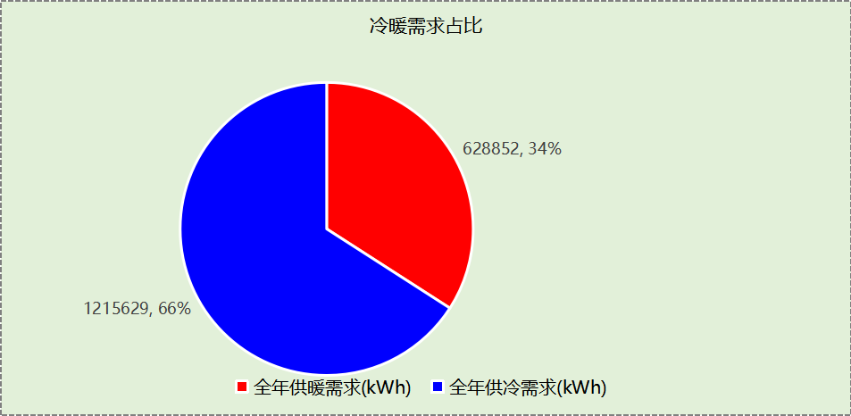

## 负荷分项统计

|  |  |  |  |  |  |  |
| --- | --- | --- | --- | --- | --- | --- |
| 分类 | 围护传热 | 室内得热 | 窗日射 | 新风/渗透 | 热回收 | 合计 |
| 供暖(kWh/㎡) | -35.96 | 12.29 | 10.92 | -24.16 | 0.00 | -36.91 |
| 供冷(kWh/㎡) | 6.36 | 21.20 | 19.58 | 24.21 | 0.00 | 71.35 |

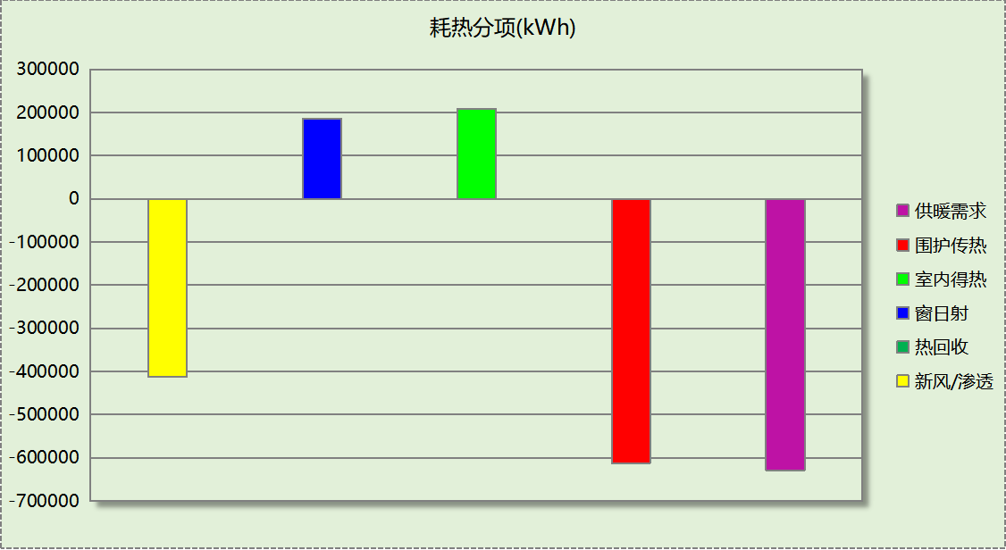

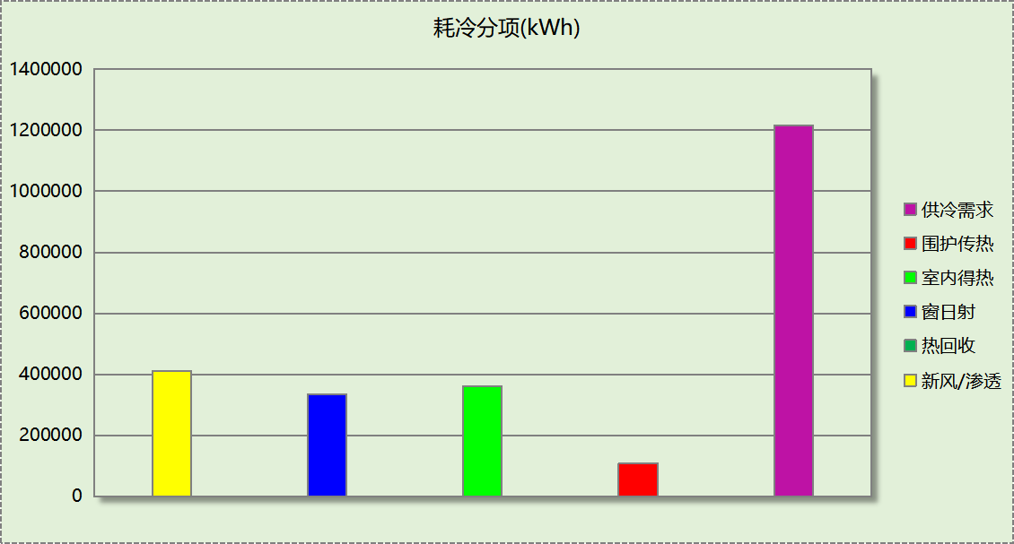

## 逐月负荷表

|  |  |  |  |  |  |  |
| --- | --- | --- | --- | --- | --- | --- |
| 月份 | 供暖(kWh) | 供冷(kWh) | 热负荷 峰值(kW) | 热负荷 峰值时刻 | 冷负荷 峰值(kW) | 冷负荷 峰值时刻 |
| 1月 | 186778 | 0 | 1591.416 | 1月21日7时 | 0.000 | -- |
| 2月 | 130398 | 420 | 1939.296 | 2月4日7时 | 64.205 | 2月8日14时 |
| 3月 | 95825 | 428 | 1393.031 | 3月11日7时 | 67.448 | 3月5日14时 |
| 4月 | 23593 | 8999 | 1046.992 | 4月1日7时 | 454.635 | 4月30日15时 |
| 5月 | 300 | 72761 | 46.403 | 5月9日7时 | 887.211 | 5月20日10时 |
| 6月 | 0 | 183526 | 0.000 | -- | 1556.984 | 6月25日14时 |
| 7月 | 0 | 423993 | 0.000 | -- | 1950.996 | 7月8日9时 |
| 8月 | 0 | 290779 | 0.000 | -- | 1543.330 | 8月19日9时 |
| 9月 | 0 | 178344 | 0.000 | -- | 1329.703 | 9月2日10时 |
| 10月 | 2120 | 47151 | 330.261 | 10月31日7时 | 630.242 | 10月4日14时 |
| 11月 | 44206 | 8822 | 1030.120 | 11月29日7时 | 205.028 | 11月8日14时 |
| 12月 | 145630 | 406 | 1679.970 | 12月2日7时 | 67.414 | 12月10日13时 |

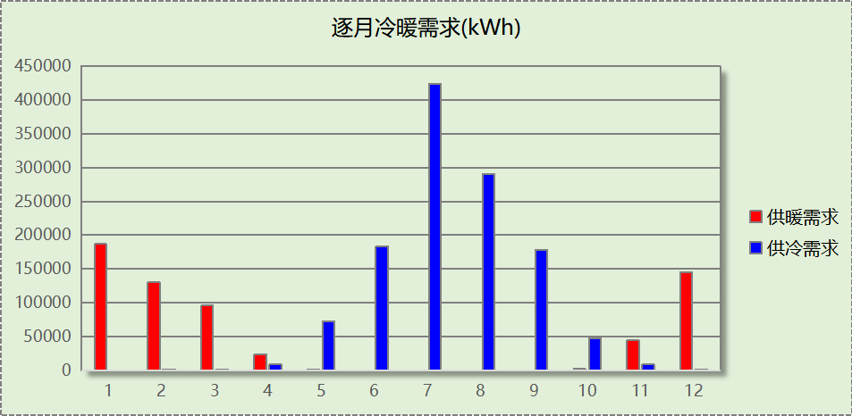

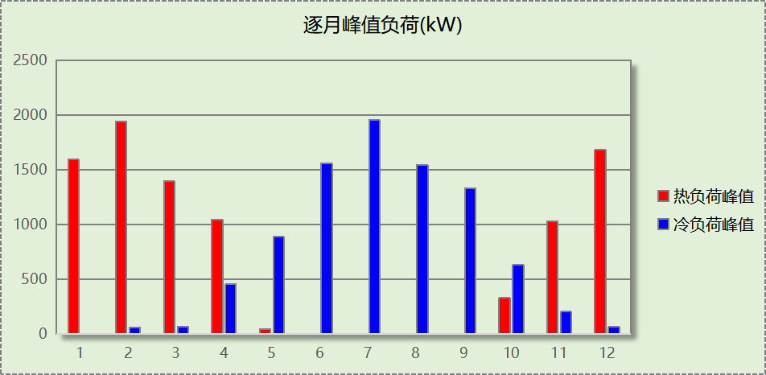

# 附录

**工作日/节假日人员逐时在室率(%)**

|  |  |  |  |  |  |  |  |  |  |  |  |  |  |  |  |  |  |  |  |  |  |  |  |  |
| --- | --- | --- | --- | --- | --- | --- | --- | --- | --- | --- | --- | --- | --- | --- | --- | --- | --- | --- | --- | --- | --- | --- | --- | --- |
| 房间类型 | 1 | 2 | 3 | 4 | 5 | 6 | 7 | 8 | 9 | 10 | 11 | 12 | 13 | 14 | 15 | 16 | 17 | 18 | 19 | 20 | 21 | 22 | 23 | 24 |
| 3星以下客房 | 70 | 70 | 70 | 70 | 70 | 70 | 70 | 70 | 50 | 50 | 50 | 50 | 50 | 50 | 50 | 50 | 50 | 50 | 70 | 70 | 70 | 70 | 70 | 70 |
| 70 | 70 | 70 | 70 | 70 | 70 | 70 | 70 | 50 | 50 | 50 | 50 | 50 | 50 | 50 | 50 | 50 | 50 | 70 | 70 | 70 | 70 | 70 | 70 |
| B超 | 0 | 0 | 0 | 0 | 0 | 0 | 0 | 20 | 50 | 95 | 80 | 40 | 20 | 50 | 60 | 60 | 20 | 20 | 0 | 0 | 0 | 0 | 0 | 0 |
| 0 | 0 | 0 | 0 | 0 | 0 | 0 | 20 | 50 | 95 | 80 | 40 | 20 | 50 | 60 | 60 | 20 | 20 | 0 | 0 | 0 | 0 | 0 | 0 |
| 休息室 | 0 | 0 | 0 | 0 | 0 | 0 | 0 | 20 | 50 | 95 | 80 | 40 | 20 | 50 | 60 | 60 | 20 | 20 | 0 | 0 | 0 | 0 | 0 | 0 |
| 0 | 0 | 0 | 0 | 0 | 0 | 0 | 20 | 50 | 95 | 80 | 40 | 20 | 50 | 60 | 60 | 20 | 20 | 0 | 0 | 0 | 0 | 0 | 0 |
| 会议室 | 0 | 0 | 0 | 0 | 0 | 0 | 0 | 20 | 50 | 95 | 80 | 40 | 20 | 50 | 60 | 60 | 20 | 20 | 0 | 0 | 0 | 0 | 0 | 0 |
| 0 | 0 | 0 | 0 | 0 | 0 | 0 | 20 | 50 | 95 | 80 | 40 | 20 | 50 | 60 | 60 | 20 | 20 | 0 | 0 | 0 | 0 | 0 | 0 |
| 候诊、挂号大厅 | 0 | 0 | 0 | 0 | 0 | 0 | 0 | 20 | 50 | 95 | 80 | 40 | 20 | 50 | 60 | 60 | 20 | 20 | 0 | 0 | 0 | 0 | 0 | 0 |
| 0 | 0 | 0 | 0 | 0 | 0 | 0 | 20 | 50 | 95 | 80 | 40 | 20 | 50 | 60 | 60 | 20 | 20 | 0 | 0 | 0 | 0 | 0 | 0 |
| 办公-普通办公室 | 0 | 0 | 0 | 0 | 0 | 0 | 10 | 50 | 100 | 100 | 100 | 30 | 100 | 100 | 100 | 100 | 50 | 20 | 10 | 0 | 0 | 0 | 0 | 0 |
| 0 | 0 | 0 | 0 | 0 | 0 | 0 | 20 | 45 | 0 | 0 | 0 | 0 | 0 | 0 | 0 | 0 | 0 | 0 | 0 | 0 | 0 | 0 | 0 |
| 办公室 | 0 | 0 | 0 | 0 | 0 | 0 | 0 | 20 | 50 | 95 | 80 | 40 | 20 | 50 | 60 | 60 | 20 | 20 | 0 | 0 | 0 | 0 | 0 | 0 |
| 0 | 0 | 0 | 0 | 0 | 0 | 0 | 20 | 50 | 95 | 80 | 40 | 20 | 50 | 60 | 60 | 20 | 20 | 0 | 0 | 0 | 0 | 0 | 0 |
| 化验室 | 0 | 0 | 0 | 0 | 0 | 0 | 0 | 20 | 50 | 95 | 80 | 40 | 20 | 50 | 60 | 60 | 20 | 20 | 0 | 0 | 0 | 0 | 0 | 0 |
| 0 | 0 | 0 | 0 | 0 | 0 | 0 | 20 | 50 | 95 | 80 | 40 | 20 | 50 | 60 | 60 | 20 | 20 | 0 | 0 | 0 | 0 | 0 | 0 |
| 卫生间 | 0 | 0 | 0 | 0 | 0 | 0 | 0 | 20 | 50 | 95 | 80 | 40 | 20 | 50 | 60 | 60 | 20 | 20 | 0 | 0 | 0 | 0 | 0 | 0 |
| 0 | 0 | 0 | 0 | 0 | 0 | 0 | 20 | 50 | 95 | 80 | 40 | 20 | 50 | 60 | 60 | 20 | 20 | 0 | 0 | 0 | 0 | 0 | 0 |
| 厨房 | 0 | 0 | 0 | 0 | 0 | 0 | 0 | 20 | 50 | 95 | 80 | 40 | 20 | 50 | 60 | 60 | 20 | 20 | 0 | 0 | 0 | 0 | 0 | 0 |
| 0 | 0 | 0 | 0 | 0 | 0 | 0 | 20 | 50 | 95 | 80 | 40 | 20 | 50 | 60 | 60 | 20 | 20 | 0 | 0 | 0 | 0 | 0 | 0 |
| 急诊室 | 0 | 0 | 0 | 0 | 0 | 0 | 0 | 20 | 50 | 95 | 80 | 40 | 20 | 50 | 60 | 60 | 20 | 20 | 0 | 0 | 0 | 0 | 0 | 0 |
| 0 | 0 | 0 | 0 | 0 | 0 | 0 | 20 | 50 | 95 | 80 | 40 | 20 | 50 | 60 | 60 | 20 | 20 | 0 | 0 | 0 | 0 | 0 | 0 |
| 抢救室 | 0 | 0 | 0 | 0 | 0 | 0 | 0 | 20 | 50 | 95 | 80 | 40 | 20 | 50 | 60 | 60 | 20 | 20 | 0 | 0 | 0 | 0 | 0 | 0 |
| 0 | 0 | 0 | 0 | 0 | 0 | 0 | 20 | 50 | 95 | 80 | 40 | 20 | 50 | 60 | 60 | 20 | 20 | 0 | 0 | 0 | 0 | 0 | 0 |
| 护士站 | 95 | 95 | 95 | 95 | 95 | 95 | 95 | 95 | 95 | 95 | 95 | 95 | 95 | 95 | 95 | 95 | 95 | 95 | 95 | 95 | 95 | 95 | 95 | 95 |
| 95 | 95 | 95 | 95 | 95 | 95 | 95 | 95 | 95 | 95 | 95 | 95 | 95 | 95 | 95 | 95 | 95 | 95 | 95 | 95 | 95 | 95 | 95 | 95 |
| 挂号室 | 0 | 0 | 0 | 0 | 0 | 0 | 0 | 20 | 50 | 95 | 80 | 40 | 20 | 50 | 60 | 60 | 20 | 20 | 0 | 0 | 0 | 0 | 0 | 0 |
| 0 | 0 | 0 | 0 | 0 | 0 | 0 | 20 | 50 | 95 | 80 | 40 | 20 | 50 | 60 | 60 | 20 | 20 | 0 | 0 | 0 | 0 | 0 | 0 |
| 文印间 | 0 | 0 | 0 | 0 | 0 | 0 | 10 | 50 | 100 | 100 | 100 | 30 | 100 | 100 | 100 | 100 | 50 | 20 | 10 | 0 | 0 | 0 | 0 | 0 |
| 0 | 0 | 0 | 0 | 0 | 0 | 0 | 20 | 45 | 0 | 0 | 0 | 0 | 0 | 0 | 0 | 0 | 0 | 0 | 0 | 0 | 0 | 0 | 0 |
|  |  |  |  |  |  |  |  |  |  |  |  |  |  |  |  |  |  |  |  |  |  |  |  |  |
|  |  |  |  |  |  |  |  |  |  |  |  |  |  |  |  |  |  |  |  |  |  |  |  |  |
| 更衣室 | 0 | 0 | 0 | 0 | 0 | 0 | 0 | 20 | 50 | 95 | 80 | 40 | 20 | 50 | 60 | 60 | 20 | 20 | 0 | 0 | 0 | 0 | 0 | 0 |
| 0 | 0 | 0 | 0 | 0 | 0 | 0 | 20 | 50 | 95 | 80 | 40 | 20 | 50 | 60 | 60 | 20 | 20 | 0 | 0 | 0 | 0 | 0 | 0 |
| 楼梯间 | 0 | 0 | 0 | 0 | 0 | 0 | 0 | 20 | 50 | 95 | 80 | 40 | 20 | 50 | 60 | 60 | 20 | 20 | 0 | 0 | 0 | 0 | 0 | 0 |
| 0 | 0 | 0 | 0 | 0 | 0 | 0 | 20 | 50 | 95 | 80 | 40 | 20 | 50 | 60 | 60 | 20 | 20 | 0 | 0 | 0 | 0 | 0 | 0 |
| 治疗室、诊室 | 0 | 0 | 0 | 0 | 0 | 0 | 0 | 20 | 50 | 95 | 80 | 40 | 20 | 50 | 60 | 60 | 20 | 20 | 0 | 0 | 0 | 0 | 0 | 0 |
| 0 | 0 | 0 | 0 | 0 | 0 | 0 | 20 | 50 | 95 | 80 | 40 | 20 | 50 | 60 | 60 | 20 | 20 | 0 | 0 | 0 | 0 | 0 | 0 |
| 灭菌室 | 0 | 0 | 0 | 0 | 0 | 0 | 0 | 20 | 50 | 95 | 80 | 40 | 20 | 50 | 60 | 60 | 20 | 20 | 0 | 0 | 0 | 0 | 0 | 0 |
| 0 | 0 | 0 | 0 | 0 | 0 | 0 | 20 | 50 | 95 | 80 | 40 | 20 | 50 | 60 | 60 | 20 | 20 | 0 | 0 | 0 | 0 | 0 | 0 |
| 病房 | 95 | 95 | 95 | 95 | 95 | 95 | 95 | 95 | 95 | 95 | 95 | 95 | 95 | 95 | 95 | 95 | 95 | 95 | 95 | 95 | 95 | 95 | 95 | 95 |
| 95 | 95 | 95 | 95 | 95 | 95 | 95 | 95 | 95 | 95 | 95 | 95 | 95 | 95 | 95 | 95 | 95 | 95 | 95 | 95 | 95 | 95 | 95 | 95 |
| 空房间 | 0 | 0 | 0 | 0 | 0 | 0 | 0 | 20 | 50 | 80 | 80 | 80 | 80 | 80 | 80 | 80 | 80 | 80 | 80 | 70 | 50 | 0 | 0 | 0 |
| 0 | 0 | 0 | 0 | 0 | 0 | 0 | 20 | 50 | 80 | 80 | 80 | 80 | 80 | 80 | 80 | 80 | 80 | 80 | 70 | 50 | 0 | 0 | 0 |
| 药房 | 0 | 0 | 0 | 0 | 0 | 0 | 0 | 20 | 50 | 95 | 80 | 40 | 20 | 50 | 60 | 60 | 20 | 20 | 0 | 0 | 0 | 0 | 0 | 0 |
| 0 | 0 | 0 | 0 | 0 | 0 | 0 | 20 | 50 | 95 | 80 | 40 | 20 | 50 | 60 | 60 | 20 | 20 | 0 | 0 | 0 | 0 | 0 | 0 |
| 设备间 | 0 | 0 | 0 | 0 | 0 | 0 | 0 | 0 | 0 | 0 | 0 | 0 | 0 | 0 | 0 | 0 | 0 | 0 | 0 | 0 | 0 | 0 | 0 | 0 |
| 0 | 0 | 0 | 0 | 0 | 0 | 0 | 0 | 0 | 0 | 0 | 0 | 0 | 0 | 0 | 0 | 0 | 0 | 0 | 0 | 0 | 0 | 0 | 0 |
| 走廊 | 0 | 0 | 0 | 0 | 0 | 0 | 0 | 20 | 50 | 95 | 80 | 40 | 20 | 50 | 60 | 60 | 20 | 20 | 0 | 0 | 0 | 0 | 0 | 0 |
| 0 | 0 | 0 | 0 | 0 | 0 | 0 | 20 | 50 | 95 | 80 | 40 | 20 | 50 | 60 | 60 | 20 | 20 | 0 | 0 | 0 | 0 | 0 | 0 |
| 输液室 | 0 | 0 | 0 | 0 | 0 | 0 | 0 | 20 | 50 | 95 | 80 | 40 | 20 | 50 | 60 | 60 | 20 | 20 | 0 | 0 | 0 | 0 | 0 | 0 |
| 0 | 0 | 0 | 0 | 0 | 0 | 0 | 20 | 50 | 95 | 80 | 40 | 20 | 50 | 60 | 60 | 20 | 20 | 0 | 0 | 0 | 0 | 0 | 0 |

注：上行：工作日；下行：节假日

**工作日/节假日照明开关时间表(%)**

|  |  |  |  |  |  |  |  |  |  |  |  |  |  |  |  |  |  |  |  |  |  |  |  |  |
| --- | --- | --- | --- | --- | --- | --- | --- | --- | --- | --- | --- | --- | --- | --- | --- | --- | --- | --- | --- | --- | --- | --- | --- | --- |
| 房间类型 | 1 | 2 | 3 | 4 | 5 | 6 | 7 | 8 | 9 | 10 | 11 | 12 | 13 | 14 | 15 | 16 | 17 | 18 | 19 | 20 | 21 | 22 | 23 | 24 |
| 3星以下客房 | 10 | 10 | 10 | 10 | 10 | 10 | 30 | 30 | 30 | 30 | 30 | 30 | 30 | 30 | 50 | 50 | 60 | 90 | 90 | 90 | 90 | 80 | 10 | 10 |
| 10 | 10 | 10 | 10 | 10 | 10 | 30 | 30 | 30 | 30 | 30 | 30 | 30 | 30 | 50 | 50 | 60 | 90 | 90 | 90 | 90 | 80 | 10 | 10 |
| B超 | 10 | 10 | 10 | 10 | 10 | 10 | 10 | 50 | 60 | 60 | 60 | 60 | 60 | 60 | 60 | 60 | 80 | 90 | 100 | 100 | 100 | 10 | 10 | 10 |
| 10 | 10 | 10 | 10 | 10 | 10 | 10 | 50 | 60 | 60 | 60 | 60 | 60 | 60 | 60 | 60 | 80 | 90 | 100 | 100 | 100 | 10 | 10 | 10 |
| 休息室 | 10 | 10 | 10 | 10 | 10 | 10 | 10 | 50 | 60 | 60 | 60 | 60 | 60 | 60 | 60 | 60 | 80 | 90 | 100 | 100 | 100 | 10 | 10 | 10 |
| 10 | 10 | 10 | 10 | 10 | 10 | 10 | 50 | 60 | 60 | 60 | 60 | 60 | 60 | 60 | 60 | 80 | 90 | 100 | 100 | 100 | 10 | 10 | 10 |
| 会议室 | 10 | 10 | 10 | 10 | 10 | 10 | 10 | 50 | 60 | 60 | 60 | 60 | 60 | 60 | 60 | 60 | 80 | 90 | 100 | 100 | 100 | 10 | 10 | 10 |
| 10 | 10 | 10 | 10 | 10 | 10 | 10 | 50 | 60 | 60 | 60 | 60 | 60 | 60 | 60 | 60 | 80 | 90 | 100 | 100 | 100 | 10 | 10 | 10 |
| 候诊、挂号大厅 | 10 | 10 | 10 | 10 | 10 | 10 | 10 | 50 | 60 | 60 | 60 | 60 | 60 | 60 | 60 | 60 | 80 | 90 | 100 | 100 | 100 | 10 | 10 | 10 |
| 10 | 10 | 10 | 10 | 10 | 10 | 10 | 50 | 60 | 60 | 60 | 60 | 60 | 60 | 60 | 60 | 80 | 90 | 100 | 100 | 100 | 10 | 10 | 10 |
| 办公-普通办公室 | 10 | 10 | 10 | 10 | 10 | 10 | 10 | 36 | 62 | 56 | 54 | 43 | 53 | 55 | 58 | 67 | 40 | 18 | 10 | 10 | 10 | 10 | 10 | 10 |
| 0 | 0 | 0 | 0 | 0 | 0 | 0 | 0 | 0 | 0 | 0 | 0 | 0 | 0 | 0 | 0 | 0 | 0 | 0 | 0 | 0 | 0 | 0 | 0 |
| 办公室 | 10 | 10 | 10 | 10 | 10 | 10 | 10 | 50 | 60 | 60 | 60 | 60 | 60 | 60 | 60 | 60 | 80 | 90 | 100 | 100 | 100 | 10 | 10 | 10 |
| 10 | 10 | 10 | 10 | 10 | 10 | 10 | 50 | 60 | 60 | 60 | 60 | 60 | 60 | 60 | 60 | 80 | 90 | 100 | 100 | 100 | 10 | 10 | 10 |
| 化验室 | 10 | 10 | 10 | 10 | 10 | 10 | 10 | 50 | 60 | 60 | 60 | 60 | 60 | 60 | 60 | 60 | 80 | 90 | 100 | 100 | 100 | 10 | 10 | 10 |
| 10 | 10 | 10 | 10 | 10 | 10 | 10 | 50 | 60 | 60 | 60 | 60 | 60 | 60 | 60 | 60 | 80 | 90 | 100 | 100 | 100 | 10 | 10 | 10 |
| 卫生间 | 10 | 10 | 10 | 10 | 10 | 10 | 10 | 50 | 60 | 60 | 60 | 60 | 60 | 60 | 60 | 60 | 80 | 90 | 100 | 100 | 100 | 10 | 10 | 10 |
| 10 | 10 | 10 | 10 | 10 | 10 | 10 | 50 | 60 | 60 | 60 | 60 | 60 | 60 | 60 | 60 | 80 | 90 | 100 | 100 | 100 | 10 | 10 | 10 |
| 厨房 | 10 | 10 | 10 | 10 | 10 | 10 | 10 | 50 | 60 | 60 | 60 | 60 | 60 | 60 | 60 | 60 | 80 | 90 | 100 | 100 | 100 | 10 | 10 | 10 |
| 10 | 10 | 10 | 10 | 10 | 10 | 10 | 50 | 60 | 60 | 60 | 60 | 60 | 60 | 60 | 60 | 80 | 90 | 100 | 100 | 100 | 10 | 10 | 10 |
| 急诊室 | 10 | 10 | 10 | 10 | 10 | 10 | 10 | 50 | 60 | 60 | 60 | 60 | 60 | 60 | 60 | 60 | 80 | 90 | 100 | 100 | 100 | 10 | 10 | 10 |
| 10 | 10 | 10 | 10 | 10 | 10 | 10 | 50 | 60 | 60 | 60 | 60 | 60 | 60 | 60 | 60 | 80 | 90 | 100 | 100 | 100 | 10 | 10 | 10 |
| 抢救室 | 10 | 10 | 10 | 10 | 10 | 10 | 10 | 50 | 60 | 60 | 60 | 60 | 60 | 60 | 60 | 60 | 80 | 90 | 100 | 100 | 100 | 10 | 10 | 10 |
| 10 | 10 | 10 | 10 | 10 | 10 | 10 | 50 | 60 | 60 | 60 | 60 | 60 | 60 | 60 | 60 | 80 | 90 | 100 | 100 | 100 | 10 | 10 | 10 |
| 护士站 | 10 | 10 | 10 | 10 | 10 | 10 | 30 | 30 | 30 | 30 | 30 | 30 | 30 | 30 | 50 | 50 | 60 | 90 | 90 | 90 | 90 | 80 | 10 | 10 |
| 10 | 10 | 10 | 10 | 10 | 10 | 30 | 30 | 30 | 30 | 30 | 30 | 30 | 30 | 50 | 50 | 60 | 90 | 90 | 90 | 90 | 80 | 10 | 10 |
| 挂号室 | 10 | 10 | 10 | 10 | 10 | 10 | 10 | 50 | 60 | 60 | 60 | 60 | 60 | 60 | 60 | 60 | 80 | 90 | 100 | 100 | 100 | 10 | 10 | 10 |
| 10 | 10 | 10 | 10 | 10 | 10 | 10 | 50 | 60 | 60 | 60 | 60 | 60 | 60 | 60 | 60 | 80 | 90 | 100 | 100 | 100 | 10 | 10 | 10 |
| 文印间 | 10 | 10 | 10 | 10 | 10 | 10 | 10 | 36 | 62 | 56 | 54 | 43 | 53 | 55 | 58 | 67 | 40 | 18 | 10 | 10 | 10 | 10 | 10 | 10 |
| 0 | 0 | 0 | 0 | 0 | 0 | 0 | 0 | 0 | 0 | 0 | 0 | 0 | 0 | 0 | 0 | 0 | 0 | 0 | 0 | 0 | 0 | 0 | 0 |
|  |  |  |  |  |  |  |  |  |  |  |  |  |  |  |  |  |  |  |  |  |  |  |  |  |
|  |  |  |  |  |  |  |  |  |  |  |  |  |  |  |  |  |  |  |  |  |  |  |  |  |
| 更衣室 | 10 | 10 | 10 | 10 | 10 | 10 | 10 | 50 | 60 | 60 | 60 | 60 | 60 | 60 | 60 | 60 | 80 | 90 | 100 | 100 | 100 | 10 | 10 | 10 |
| 10 | 10 | 10 | 10 | 10 | 10 | 10 | 50 | 60 | 60 | 60 | 60 | 60 | 60 | 60 | 60 | 80 | 90 | 100 | 100 | 100 | 10 | 10 | 10 |
| 楼梯间 | 10 | 10 | 10 | 10 | 10 | 10 | 10 | 50 | 60 | 60 | 60 | 60 | 60 | 60 | 60 | 60 | 80 | 90 | 100 | 100 | 100 | 10 | 10 | 10 |
| 10 | 10 | 10 | 10 | 10 | 10 | 10 | 50 | 60 | 60 | 60 | 60 | 60 | 60 | 60 | 60 | 80 | 90 | 100 | 100 | 100 | 10 | 10 | 10 |
| 治疗室、诊室 | 10 | 10 | 10 | 10 | 10 | 10 | 10 | 50 | 60 | 60 | 60 | 60 | 60 | 60 | 60 | 60 | 80 | 90 | 100 | 100 | 100 | 10 | 10 | 10 |
| 10 | 10 | 10 | 10 | 10 | 10 | 10 | 50 | 60 | 60 | 60 | 60 | 60 | 60 | 60 | 60 | 80 | 90 | 100 | 100 | 100 | 10 | 10 | 10 |
| 灭菌室 | 10 | 10 | 10 | 10 | 10 | 10 | 10 | 50 | 60 | 60 | 60 | 60 | 60 | 60 | 60 | 60 | 80 | 90 | 100 | 100 | 100 | 10 | 10 | 10 |
| 10 | 10 | 10 | 10 | 10 | 10 | 10 | 50 | 60 | 60 | 60 | 60 | 60 | 60 | 60 | 60 | 80 | 90 | 100 | 100 | 100 | 10 | 10 | 10 |
| 病房 | 10 | 10 | 10 | 10 | 10 | 10 | 30 | 30 | 30 | 30 | 30 | 30 | 30 | 30 | 50 | 50 | 60 | 90 | 90 | 90 | 90 | 80 | 10 | 10 |
| 10 | 10 | 10 | 10 | 10 | 10 | 30 | 30 | 30 | 30 | 30 | 30 | 30 | 30 | 50 | 50 | 60 | 90 | 90 | 90 | 90 | 80 | 10 | 10 |
| 空房间 | 10 | 10 | 10 | 10 | 10 | 10 | 10 | 50 | 60 | 60 | 60 | 60 | 60 | 60 | 60 | 60 | 80 | 90 | 100 | 100 | 100 | 10 | 10 | 10 |
| 10 | 10 | 10 | 10 | 10 | 10 | 10 | 50 | 60 | 60 | 60 | 60 | 60 | 60 | 60 | 60 | 80 | 90 | 100 | 100 | 100 | 10 | 10 | 10 |
| 药房 | 10 | 10 | 10 | 10 | 10 | 10 | 10 | 50 | 60 | 60 | 60 | 60 | 60 | 60 | 60 | 60 | 80 | 90 | 100 | 100 | 100 | 10 | 10 | 10 |
| 10 | 10 | 10 | 10 | 10 | 10 | 10 | 50 | 60 | 60 | 60 | 60 | 60 | 60 | 60 | 60 | 80 | 90 | 100 | 100 | 100 | 10 | 10 | 10 |
| 设备间 | 100 | 100 | 100 | 100 | 100 | 100 | 100 | 100 | 100 | 100 | 100 | 100 | 100 | 100 | 100 | 100 | 100 | 100 | 100 | 100 | 100 | 100 | 100 | 100 |
| 100 | 100 | 100 | 100 | 100 | 100 | 100 | 100 | 100 | 100 | 100 | 100 | 100 | 100 | 100 | 100 | 100 | 100 | 100 | 100 | 100 | 100 | 100 | 100 |
| 走廊 | 10 | 10 | 10 | 10 | 10 | 10 | 10 | 50 | 60 | 60 | 60 | 60 | 60 | 60 | 60 | 60 | 80 | 90 | 100 | 100 | 100 | 10 | 10 | 10 |
| 10 | 10 | 10 | 10 | 10 | 10 | 10 | 50 | 60 | 60 | 60 | 60 | 60 | 60 | 60 | 60 | 80 | 90 | 100 | 100 | 100 | 10 | 10 | 10 |
| 输液室 | 10 | 10 | 10 | 10 | 10 | 10 | 10 | 50 | 60 | 60 | 60 | 60 | 60 | 60 | 60 | 60 | 80 | 90 | 100 | 100 | 100 | 10 | 10 | 10 |
| 10 | 10 | 10 | 10 | 10 | 10 | 10 | 50 | 60 | 60 | 60 | 60 | 60 | 60 | 60 | 60 | 80 | 90 | 100 | 100 | 100 | 10 | 10 | 10 |

注：上行：工作日；下行：节假日

**工作日/节假日设备逐时使用率(%)**

|  |  |  |  |  |  |  |  |  |  |  |  |  |  |  |  |  |  |  |  |  |  |  |  |  |
| --- | --- | --- | --- | --- | --- | --- | --- | --- | --- | --- | --- | --- | --- | --- | --- | --- | --- | --- | --- | --- | --- | --- | --- | --- |
| 房间类型 | 1 | 2 | 3 | 4 | 5 | 6 | 7 | 8 | 9 | 10 | 11 | 12 | 13 | 14 | 15 | 16 | 17 | 18 | 19 | 20 | 21 | 22 | 23 | 24 |
| 3星以下客房 | 0 | 0 | 0 | 0 | 0 | 0 | 0 | 0 | 0 | 0 | 0 | 0 | 0 | 0 | 0 | 0 | 0 | 80 | 80 | 80 | 80 | 80 | 0 | 0 |
| 0 | 0 | 0 | 0 | 0 | 0 | 0 | 0 | 0 | 0 | 0 | 0 | 0 | 0 | 0 | 0 | 0 | 80 | 80 | 80 | 80 | 80 | 0 | 0 |
| B超 | 0 | 0 | 0 | 0 | 0 | 0 | 0 | 20 | 50 | 95 | 80 | 40 | 20 | 50 | 60 | 60 | 20 | 20 | 0 | 0 | 0 | 0 | 0 | 0 |
| 0 | 0 | 0 | 0 | 0 | 0 | 0 | 20 | 50 | 95 | 80 | 40 | 20 | 50 | 60 | 60 | 20 | 20 | 0 | 0 | 0 | 0 | 0 | 0 |
| 休息室 | 0 | 0 | 0 | 0 | 0 | 0 | 0 | 20 | 50 | 95 | 80 | 40 | 20 | 50 | 60 | 60 | 20 | 20 | 0 | 0 | 0 | 0 | 0 | 0 |
| 0 | 0 | 0 | 0 | 0 | 0 | 0 | 20 | 50 | 95 | 80 | 40 | 20 | 50 | 60 | 60 | 20 | 20 | 0 | 0 | 0 | 0 | 0 | 0 |
| 会议室 | 0 | 0 | 0 | 0 | 0 | 0 | 0 | 20 | 50 | 95 | 80 | 40 | 20 | 50 | 60 | 60 | 20 | 20 | 0 | 0 | 0 | 0 | 0 | 0 |
| 0 | 0 | 0 | 0 | 0 | 0 | 0 | 20 | 50 | 95 | 80 | 40 | 20 | 50 | 60 | 60 | 20 | 20 | 0 | 0 | 0 | 0 | 0 | 0 |
| 候诊、挂号大厅 | 0 | 0 | 0 | 0 | 0 | 0 | 0 | 20 | 50 | 95 | 80 | 40 | 20 | 50 | 60 | 60 | 20 | 20 | 0 | 0 | 0 | 0 | 0 | 0 |
| 0 | 0 | 0 | 0 | 0 | 0 | 0 | 20 | 50 | 95 | 80 | 40 | 20 | 50 | 60 | 60 | 20 | 20 | 0 | 0 | 0 | 0 | 0 | 0 |
| 办公-普通办公室 | 0 | 0 | 0 | 0 | 0 | 0 | 10 | 50 | 100 | 100 | 100 | 100 | 100 | 100 | 100 | 100 | 50 | 20 | 10 | 0 | 0 | 0 | 0 | 0 |
| 0 | 0 | 0 | 0 | 0 | 0 | 0 | 0 | 0 | 0 | 0 | 0 | 0 | 0 | 0 | 0 | 0 | 0 | 0 | 0 | 0 | 0 | 0 | 0 |
| 办公室 | 0 | 0 | 0 | 0 | 0 | 0 | 0 | 20 | 50 | 95 | 80 | 40 | 20 | 50 | 60 | 60 | 20 | 20 | 0 | 0 | 0 | 0 | 0 | 0 |
| 0 | 0 | 0 | 0 | 0 | 0 | 0 | 20 | 50 | 95 | 80 | 40 | 20 | 50 | 60 | 60 | 20 | 20 | 0 | 0 | 0 | 0 | 0 | 0 |
| 化验室 | 0 | 0 | 0 | 0 | 0 | 0 | 0 | 20 | 50 | 95 | 80 | 40 | 20 | 50 | 60 | 60 | 20 | 20 | 0 | 0 | 0 | 0 | 0 | 0 |
| 0 | 0 | 0 | 0 | 0 | 0 | 0 | 20 | 50 | 95 | 80 | 40 | 20 | 50 | 60 | 60 | 20 | 20 | 0 | 0 | 0 | 0 | 0 | 0 |
| 卫生间 | 0 | 0 | 0 | 0 | 0 | 0 | 0 | 20 | 50 | 95 | 80 | 40 | 20 | 50 | 60 | 60 | 20 | 20 | 0 | 0 | 0 | 0 | 0 | 0 |
| 0 | 0 | 0 | 0 | 0 | 0 | 0 | 20 | 50 | 95 | 80 | 40 | 20 | 50 | 60 | 60 | 20 | 20 | 0 | 0 | 0 | 0 | 0 | 0 |
| 厨房 | 0 | 0 | 0 | 0 | 0 | 0 | 0 | 20 | 50 | 95 | 80 | 40 | 20 | 50 | 60 | 60 | 20 | 20 | 0 | 0 | 0 | 0 | 0 | 0 |
| 0 | 0 | 0 | 0 | 0 | 0 | 0 | 20 | 50 | 95 | 80 | 40 | 20 | 50 | 60 | 60 | 20 | 20 | 0 | 0 | 0 | 0 | 0 | 0 |
| 急诊室 | 0 | 0 | 0 | 0 | 0 | 0 | 0 | 20 | 50 | 95 | 80 | 40 | 20 | 50 | 60 | 60 | 20 | 20 | 0 | 0 | 0 | 0 | 0 | 0 |
| 0 | 0 | 0 | 0 | 0 | 0 | 0 | 20 | 50 | 95 | 80 | 40 | 20 | 50 | 60 | 60 | 20 | 20 | 0 | 0 | 0 | 0 | 0 | 0 |
| 抢救室 | 0 | 0 | 0 | 0 | 0 | 0 | 0 | 20 | 50 | 95 | 80 | 40 | 20 | 50 | 60 | 60 | 20 | 20 | 0 | 0 | 0 | 0 | 0 | 0 |
| 0 | 0 | 0 | 0 | 0 | 0 | 0 | 20 | 50 | 95 | 80 | 40 | 20 | 50 | 60 | 60 | 20 | 20 | 0 | 0 | 0 | 0 | 0 | 0 |
| 护士站 | 95 | 95 | 95 | 95 | 95 | 95 | 95 | 95 | 95 | 95 | 95 | 95 | 95 | 95 | 95 | 95 | 95 | 95 | 95 | 95 | 95 | 95 | 95 | 95 |
| 95 | 95 | 95 | 95 | 95 | 95 | 95 | 95 | 95 | 95 | 95 | 95 | 95 | 95 | 95 | 95 | 95 | 95 | 95 | 95 | 95 | 95 | 95 | 95 |
| 挂号室 | 0 | 0 | 0 | 0 | 0 | 0 | 0 | 20 | 50 | 95 | 80 | 40 | 20 | 50 | 60 | 60 | 20 | 20 | 0 | 0 | 0 | 0 | 0 | 0 |
| 0 | 0 | 0 | 0 | 0 | 0 | 0 | 20 | 50 | 95 | 80 | 40 | 20 | 50 | 60 | 60 | 20 | 20 | 0 | 0 | 0 | 0 | 0 | 0 |
| 文印间 | 0 | 0 | 0 | 0 | 0 | 0 | 10 | 50 | 100 | 100 | 100 | 100 | 100 | 100 | 100 | 100 | 50 | 20 | 10 | 0 | 0 | 0 | 0 | 0 |
| 0 | 0 | 0 | 0 | 0 | 0 | 0 | 0 | 0 | 0 | 0 | 0 | 0 | 0 | 0 | 0 | 0 | 0 | 0 | 0 | 0 | 0 | 0 | 0 |
|  |  |  |  |  |  |  |  |  |  |  |  |  |  |  |  |  |  |  |  |  |  |  |  |  |
|  |  |  |  |  |  |  |  |  |  |  |  |  |  |  |  |  |  |  |  |  |  |  |  |  |
| 更衣室 | 0 | 0 | 0 | 0 | 0 | 0 | 0 | 20 | 50 | 95 | 80 | 40 | 20 | 50 | 60 | 60 | 20 | 20 | 0 | 0 | 0 | 0 | 0 | 0 |
| 0 | 0 | 0 | 0 | 0 | 0 | 0 | 20 | 50 | 95 | 80 | 40 | 20 | 50 | 60 | 60 | 20 | 20 | 0 | 0 | 0 | 0 | 0 | 0 |
| 楼梯间 | 0 | 0 | 0 | 0 | 0 | 0 | 0 | 20 | 50 | 95 | 80 | 40 | 20 | 50 | 60 | 60 | 20 | 20 | 0 | 0 | 0 | 0 | 0 | 0 |
| 0 | 0 | 0 | 0 | 0 | 0 | 0 | 20 | 50 | 95 | 80 | 40 | 20 | 50 | 60 | 60 | 20 | 20 | 0 | 0 | 0 | 0 | 0 | 0 |
| 治疗室、诊室 | 0 | 0 | 0 | 0 | 0 | 0 | 0 | 20 | 50 | 95 | 80 | 40 | 20 | 50 | 60 | 60 | 20 | 20 | 0 | 0 | 0 | 0 | 0 | 0 |
| 0 | 0 | 0 | 0 | 0 | 0 | 0 | 20 | 50 | 95 | 80 | 40 | 20 | 50 | 60 | 60 | 20 | 20 | 0 | 0 | 0 | 0 | 0 | 0 |
| 灭菌室 | 0 | 0 | 0 | 0 | 0 | 0 | 0 | 20 | 50 | 95 | 80 | 40 | 20 | 50 | 60 | 60 | 20 | 20 | 0 | 0 | 0 | 0 | 0 | 0 |
| 0 | 0 | 0 | 0 | 0 | 0 | 0 | 20 | 50 | 95 | 80 | 40 | 20 | 50 | 60 | 60 | 20 | 20 | 0 | 0 | 0 | 0 | 0 | 0 |
| 病房 | 95 | 95 | 95 | 95 | 95 | 95 | 95 | 95 | 95 | 95 | 95 | 95 | 95 | 95 | 95 | 95 | 95 | 95 | 95 | 95 | 95 | 95 | 95 | 95 |
| 95 | 95 | 95 | 95 | 95 | 95 | 95 | 95 | 95 | 95 | 95 | 95 | 95 | 95 | 95 | 95 | 95 | 95 | 95 | 95 | 95 | 95 | 95 | 95 |
| 空房间 | 0 | 0 | 0 | 0 | 0 | 0 | 0 | 30 | 50 | 80 | 80 | 80 | 80 | 80 | 80 | 80 | 80 | 80 | 80 | 70 | 50 | 0 | 0 | 0 |
| 0 | 0 | 0 | 0 | 0 | 0 | 0 | 30 | 50 | 80 | 80 | 80 | 80 | 80 | 80 | 80 | 80 | 80 | 80 | 70 | 50 | 0 | 0 | 0 |
| 药房 | 0 | 0 | 0 | 0 | 0 | 0 | 0 | 20 | 50 | 95 | 80 | 40 | 20 | 50 | 60 | 60 | 20 | 20 | 0 | 0 | 0 | 0 | 0 | 0 |
| 0 | 0 | 0 | 0 | 0 | 0 | 0 | 20 | 50 | 95 | 80 | 40 | 20 | 50 | 60 | 60 | 20 | 20 | 0 | 0 | 0 | 0 | 0 | 0 |
| 设备间 | 100 | 100 | 100 | 100 | 100 | 100 | 100 | 100 | 100 | 100 | 100 | 100 | 100 | 100 | 100 | 100 | 100 | 100 | 100 | 100 | 100 | 100 | 100 | 100 |
| 100 | 100 | 100 | 100 | 100 | 100 | 100 | 100 | 100 | 100 | 100 | 100 | 100 | 100 | 100 | 100 | 100 | 100 | 100 | 100 | 100 | 100 | 100 | 100 |
| 走廊 | 0 | 0 | 0 | 0 | 0 | 0 | 0 | 20 | 50 | 95 | 80 | 40 | 20 | 50 | 60 | 60 | 20 | 20 | 0 | 0 | 0 | 0 | 0 | 0 |
| 0 | 0 | 0 | 0 | 0 | 0 | 0 | 20 | 50 | 95 | 80 | 40 | 20 | 50 | 60 | 60 | 20 | 20 | 0 | 0 | 0 | 0 | 0 | 0 |
| 输液室 | 0 | 0 | 0 | 0 | 0 | 0 | 0 | 20 | 50 | 95 | 80 | 40 | 20 | 50 | 60 | 60 | 20 | 20 | 0 | 0 | 0 | 0 | 0 | 0 |
| 0 | 0 | 0 | 0 | 0 | 0 | 0 | 20 | 50 | 95 | 80 | 40 | 20 | 50 | 60 | 60 | 20 | 20 | 0 | 0 | 0 | 0 | 0 | 0 |

注：上行：工作日；下行：节假日

**工作日/节假日空调系统开关时间表**

|  |  |  |  |  |  |  |  |  |  |  |  |  |  |  |  |  |  |  |  |  |  |  |  |  |
| --- | --- | --- | --- | --- | --- | --- | --- | --- | --- | --- | --- | --- | --- | --- | --- | --- | --- | --- | --- | --- | --- | --- | --- | --- |
| 系统编号 | 1 | 2 | 3 | 4 | 5 | 6 | 7 | 8 | 9 | 10 | 11 | 12 | 13 | 14 | 15 | 16 | 17 | 18 | 19 | 20 | 21 | 22 | 23 | 24 |
| 默认 | 1 | 1 | 1 | 1 | 1 | 1 | 1 | 1 | 1 | 1 | 1 | 1 | 1 | 1 | 1 | 1 | 1 | 1 | 1 | 1 | 1 | 1 | 1 | 1 |
| 1 | 1 | 1 | 1 | 1 | 1 | 1 | 1 | 1 | 1 | 1 | 1 | 1 | 1 | 1 | 1 | 1 | 1 | 1 | 1 | 1 | 1 | 1 | 1 |

注：上行：工作日；下行：节假日