全年负荷计算报告书
高校教学楼


工程地点 | ： | 湘潭
建设单位 | ： | 湘潭市建筑施工研究院
设计单位 | ： | 湘潭市建筑设计研究院
设计人 | ： | 罗泳秋 王恺宇 王磊 陈婧怡 杨闵岚
校对人 | ： | 苏欢 李文菁 曹伟平
审定人 | ： | 苏欢 李文菁 曹伟平
报告日期 | : | 2026年1月1日

采用软件 | : 暖通负荷BECH2025 | 
软件版本 | : 20250505(PLUS)
正版授权码 | : T13077002569
研发单位 | : 北京绿建软件股份有限公司

目 录

1 建筑概况 1
2 气象数据 1
2.1 气象地点 1
2.2 逐日干球温度表 1
2.3 逐月辐照量表 2
2.4 峰值工况 2
3 软件介绍 2
4 围护结构 2
4.1 屋顶构造 2
4.2 外墙构造 3
4.3 挑空楼板构造 3
4.4 楼板构造 4
4.5 周边地面构造 4
4.6 非周边地面构造 4
4.7 门构造 4
4.8 窗构造 4
5 房间类型 5
5.1 房间参数表 5
5.2 作息时间表 5
6 系统设置 5
6.1 系统划分 5
6.2 运行时间表 6
7 计算结果 6
7.1 模拟周期 6
7.2 全年冷暖需求 6
7.3 负荷分项统计 6
7.4 逐月负荷表 7
8 附录 9

建筑概况
地理位置 | 北京-北京
气候分区 | 夏热冬冷A区
北纬 | 27.90
东经 | 112.90
建筑名称 | 高校教学楼
建筑类型 | 公共建筑
计算建筑面积 | 地上 14914.15 ㎡ | 地下 0.00 ㎡
建筑高度 | 地上 25.50 m | 地下0.00 m
建筑层数 | 地上 7 | 地下 0
北向角度 | 45°

气象数据

气象地点
湖南-长沙, 《建筑节能气象参数标准》JGJ346-2014

逐日干球温度表
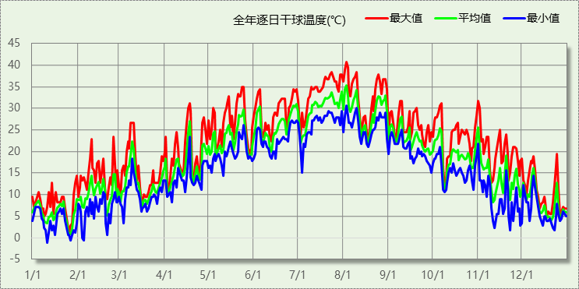

逐月辐照量表
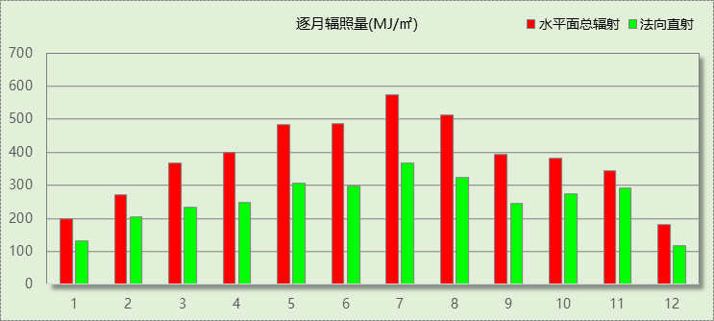

峰值工况
气象数据 | 时刻 | 干球温度(℃) | 湿球温度(℃) | 含湿量(g/kg) | 焓值(kj/kg)
最热 | 08月02日15时 | 40.6 | 26.7 | 17.1 | 84.8
最冷 | 01月10日06时 | -1.1 | -1.1 | 3.4 | 7.4

软件介绍
本报告采用的软件为绿建暖通负荷BECH2025通负荷BECH2018，该软件紧密结合暖通和节能设计规范、可根据项目实际情况建立建筑热工模型，并可对围护结构材料、房间内扰发热、作息时间表、热回收方式等参数进行设置。
软件包含全国各地典型气象年数据，内置DOE2.1E内核，对于建筑的逐时负荷进行动态模拟，既可以模拟8760小时理想负荷，也可以根据设定好的采暖期/空调期进行逐时模拟。
软件还支持分析全年建筑能耗的来源构成，依据日射得热、新风负荷、围护传热和内扰得热进行归类分项，生成设计建筑全年负荷计算报告书，提供详实的数据和多样的图表，为设计师在设备选型、制定运行策略等方面提供参考和帮助。

围护结构

屋顶构造

屋顶构造一（上人倒置式屋面）
材料名称  （由上到下） | 厚度δ | 导热系数λ | 蓄热系数S | 修正  系数 | 热阻R | 热惰性  指标
材料名称  （由上到下） | (mm) | W/(m.K) | W/(㎡.K) | α | (㎡K)/W | D=R*S
细石混凝土 | 50 | 1.280 | 13.570 | 1.00 | 0.039 | 0.530
干铺聚酯无纺布一层 | － | － | 11.033 | － | 0.000 | 0.000
难燃型挤塑聚苯板 | 85 | 0.030 | 0.540 | 1.20 | 2.361 | 1.530
SBS改性沥青防水卷材 | 3 | 0.230 | 9.370 | 1.20 | 0.011 | 0.122
现场喷涂硬泡聚氨酯防水保温材料(B1级) | 2 | 0.024 | 0.360 | 1.25 | 0.067 | 0.030
石灰水泥砂浆 | 20 | 0.870 | 10.750 | 1.00 | 0.023 | 0.247
粉煤灰陶粒混凝土(ρ=1100) | 30 | 0.440 | 6.300 | 1.00 | 0.068 | 0.430
钢筋混凝土 | 120 | 1.740 | 17.060 | 1.00 | 0.069 | 1.177
石灰水泥砂浆 | 10 | 0.870 | 10.750 | 1.00 | 0.011 | 0.124
各层之和∑ | 320 | － | － | － | 2.649 | 4.189
传热系数K=1/(0.15+∑R) | 0.36

外墙构造

外墙（填充墙）构造一
材料名称  （由外到内） | 厚度δ | 导热系数λ | 蓄热系数S | 修正  系数 | 热阻R | 热惰性  指标
材料名称  （由外到内） | (mm) | W/(m.K) | W/(㎡.K) | α | (㎡K)/W | D=R*S
岩棉保温装饰复合一体板 | 45 | 0.045 | 0.750 | 1.05 | 0.952 | 0.750
聚氨酯防水涂料 | 1.5 | 0.150 | 6.070 | 1.00 | 0.010 | 0.061
聚合物水泥防水砂浆 | 6 | 0.930 | 11.306 | 1.00 | 0.006 | 0.073
水泥砂浆 | 20 | 0.930 | 11.306 | 1.00 | 0.022 | 0.243
五排孔陶粒混凝土自保温砖墙（200mm厚) | 200 | 0.200 | 2.918 | 1.00 | 1.000 | 2.918
水泥砂浆 | 20 | 0.930 | 11.306 | 1.00 | 0.022 | 0.243
各层之和∑ | 292.5 | － | － | － | 2.012 | 4.288
传热系数K=1/(0.15+∑R) | 0.46

挑空楼板构造

挑空楼板构造一
材料名称  （由上到下） | 厚度δ | 导热系数λ | 蓄热系数S | 修正  系数 | 热阻R | 热惰性  指标
材料名称  （由上到下） | (mm) | W/(m.K) | W/(㎡.K) | α | (㎡K)/W | D=R*S
水泥砂浆 | 20 | 0.930 | 11.306 | 1.00 | 0.022 | 0.243
钢筋混凝土 | 120 | 1.740 | 17.060 | 1.00 | 0.069 | 1.177
水泥砂浆 | 20 | 0.930 | 11.306 | 1.00 | 0.022 | 0.243
岩棉保温装饰复合一体板 | 65 | 0.045 | 0.750 | 1.20 | 1.204 | 1.083
各层之和∑ | 225 | － | － | － | 1.316 | 2.746
传热系数K=1/(0.15+∑R) | 0.68

楼板构造

控温房间楼板构造一
材料名称 | 厚度δ | 导热系数λ | 蓄热系数S | 修正  系数 | 热阻R | 热惰性  指标
材料名称 | (mm) | W/(m.K) | W/(㎡.K) | α | (㎡K)/W | D=R*S
钢筋混凝土 | 130 | 1.740 | 17.060 | 1.00 | 0.075 | 1.275
水泥砂浆 | 20 | 0.930 | 11.306 | 1.00 | 0.022 | 0.243
各层之和∑ | 150 | － | － | － | 0.096 | 1.518
传热系数K=1/(0.22+∑R) | 3.16

周边地面构造

周边地面构造一
材料名称 | 厚度δ | 导热系数λ | 蓄热系数S | 修正  系数 | 热阻R | 热惰性  指标
材料名称 | (mm) | W/(m.K) | W/(㎡.K) | α | (㎡K)/W | D=R*S
水泥砂浆 | 20 | 0.930 | 11.306 | 1.00 | 0.022 | 0.243
钢筋混凝土 | 120 | 1.740 | 17.060 | 1.00 | 0.069 | 1.177
各层之和∑ | 140 | － | － | － | 0.090 | 1.420
传热系数K=1/(0.11+∑R) | 0.52

非周边地面构造

非周边地面构造一
材料名称 | 厚度δ | 导热系数λ | 蓄热系数S | 修正  系数 | 热阻R | 热惰性  指标
材料名称 | (mm) | W/(m.K) | W/(㎡.K) | α | (㎡K)/W | D=R*S
水泥砂浆 | 20 | 0.930 | 11.306 | 1.00 | 0.022 | 0.243
钢筋混凝土 | 120 | 1.740 | 17.060 | 1.00 | 0.069 | 1.177
各层之和∑ | 140 | － | － | － | 0.090 | 1.420
传热系数K=1/(0.11+∑R) | 0.30

门构造
序号 | 构造名称 | 传热系数 | 备注
1 | 木（塑料）框—单层玻璃门（玻璃比例30%—60%） | 3.800

窗构造
序号 | 构造名称 | 传热系数 | 窗遮阳系数 | 可见光透射比 | 备注
1 | 断桥铝合金型材窗断桥宽度 14.8mm6 中透光三银 Low-E+12air +6 透明(暖边间隔条） | 1.700 | 0.264 | 0.500
2 | 多腔塑钢型材窗 6 高透光单银 Low-E+12A+6 透明 | 1.850 | 0.517 | 0.720

房间类型

房间参数表
房间类型 | 空调温度  ℃ | 供暖温度  ℃ | 新风量 | 人员密度 | 照明功率  密度 | 电器设备  功率
会议室 | 26 | 20 | 30(m^3/h.人) | 3.3(m^2/人) | 8(W/m^2) | 5(W/m^2)
办公-普通办公室 | 26 | 20 | 30(m^3/h.人) | 8(m^2/人) | 8(W/m^2) | 15(W/m^2)
卫生间 | 28 | 16 | 0(m^3/h.人) | 0(人) | 5(W/m^2) | 5(W/m^2)
多媒体教室 | 26 | 18 | 20(m^3/h.人) | 4(m^2/人) | 8(W/m^2) | 5(W/m^2)
大厅 | 26 | 20 | 30(m^3/h.人) | 20(m^2/人) | 10(W/m^2) | 0(W/m^2)
库房 | 26 | 18 | 24(m^3/h.人) | 1.39(m^2/人) | 9(W/m^2) | 5(W/m^2)
库房 | 26 | 20 | 30(m^3/h.人) | 8(m^2/人) | 8(W/m^2) | 15(W/m^2)
报告厅 | 26 | 18 | 14(m^3/h.人) | 2.5(m^2/人) | 12(W/m^2) | 5(W/m^2)
普通办公室 | 26 | 20 | 30(m^3/h.人) | 6(m^2/人) | 8(W/m^2) | 5(W/m^2)
普通教室 | 26 | 18 | 24(m^3/h.人) | 1.39(m^2/人) | 8(W/m^2) | 5(W/m^2)
楼梯间 | － | － | 0(m^3/h.人) | 0(人) | 3.5(W/m^2) | 15(W/m^2)
楼梯间 | － | － | 0(m^3/h.人) | 0(人) | 5(W/m^2) | 5(W/m^2)
空房间 | － | － | 20(m^3/h.人) | 0(人) | 0(W/m^2) | 0(W/m^2)
绘图室 | 26 | 20 | 30(m^3/h.人) | 8(m^2/人) | 8(W/m^2) | 15(W/m^2)
美术教室 | 26 | 18 | 20(m^3/h.人) | 4(m^2/人) | 13.5(W/m^2) | 5(W/m^2)
计算机房 | 26 | 18 | 24(m^3/h.人) | 1.39(m^2/人) | 9(W/m^2) | 5(W/m^2)
设备间 | － | － | 0(次/h) | 0(人) | 6(W/m^2) | 15(W/m^2)
走廊 | － | － | 0(m^3/h.人) | 0(人) | 5(W/m^2) | 5(W/m^2)
阅览室 | 26 | 20 | 20(m^3/h.人) | 1.9(m^2/人) | 8(W/m^2) | 5(W/m^2)

作息时间表
详见附录

系统设置

系统划分
系统编号 | 热回收  类型 | 启动  条件 | 回收  效率 | 排风  比例 | 面积(m2) | 包含的房间
自动 | 全热回收 | 焓差启动  冷:≥5.0 kJ/kg  暖:≥5.0 kJ/kg | 冷:0.50, 暖:0.72 | 1.00 | 7315.92 | 所有房间

运行时间表
详见附录

计算结果

模拟周期
供冷季(6.1-10.15) 供暖季(12.1-3.25)

全年冷暖需求
系统名称\负荷 | 供暖需求  (kWh) | 供暖指标  kWh/(㎡·a) | 供冷需求  (kWh) | 供冷指标  kWh/(㎡·a)
建筑总计 | 8220 | 0.55 | 540881 | 36.27
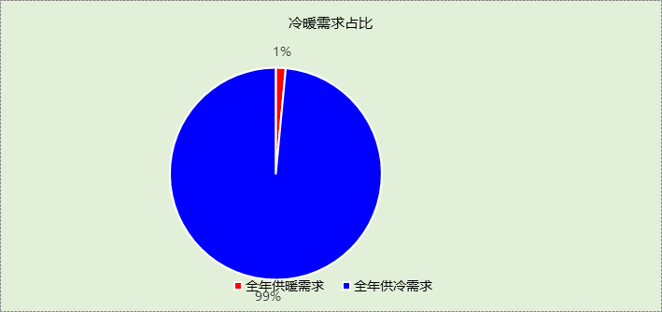

负荷分项统计
分类 | 围护传热 | 室内得热 | 窗日射 | 不利  新风/渗透 | 有利  新风/渗透 | 热回收 | 合计
供暖(kWh/㎡) | -3.01 | 3.49 | 0.51 | -4.07 | — | 2.53 | -0.55
供冷(kWh/㎡) | 7.80 | 16.26 | 2.69 | 19.59 | -0.33 | -9.75 | 36.27
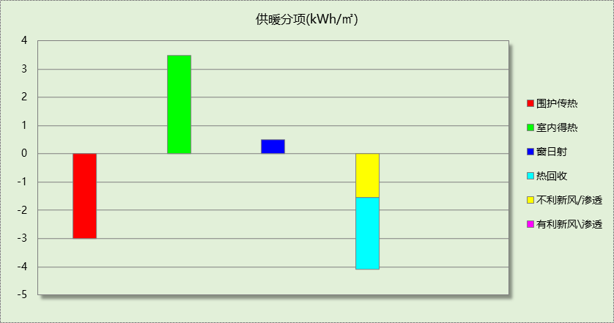
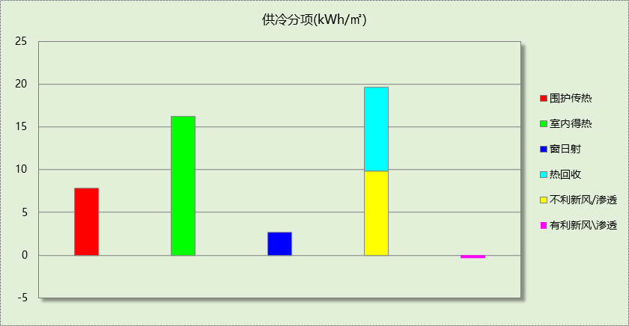

逐月负荷表
月份 | 供暖(kWh) | 供冷(kWh) | 热负荷  峰值(kW) | 热负荷  峰值时刻 | 冷负荷  峰值(kW) | 冷负荷  峰值时刻
1月 | 4034 | 0 | 276.466 | 1月2日8时 | 0.000 | --
2月 | 1567 | 0 | 112.199 | 2月4日8时 | 0.000 | --
3月 | 2283 | 0 | 81.824 | 3月4日8时 | 0.000 | --
4月 | 0 | 0 | 0.000 | -- | 0.000 | --
5月 | 0 | 0 | 0.000 | -- | 0.000 | --
6月 | 0 | 106078 | 0.000 | -- | 1200.836 | 6月3日8时
7月 | 0 | 153844 | 0.000 | -- | 893.691 | 7月22日8时
8月 | 0 | 156061 | 0.000 | -- | 1039.580 | 8月5日8时
9月 | 0 | 102452 | 0.000 | -- | 810.132 | 9月2日8时
10月 | 0 | 22446 | 0.000 | -- | 567.114 | 10月4日8时
11月 | 0 | 0 | 0.000 | -- | 0.000 | --
12月 | 337 | 0 | 61.964 | 12月23日8时 | 0.000 | --
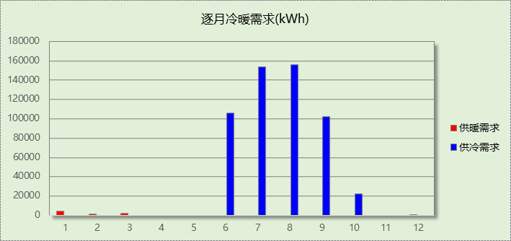
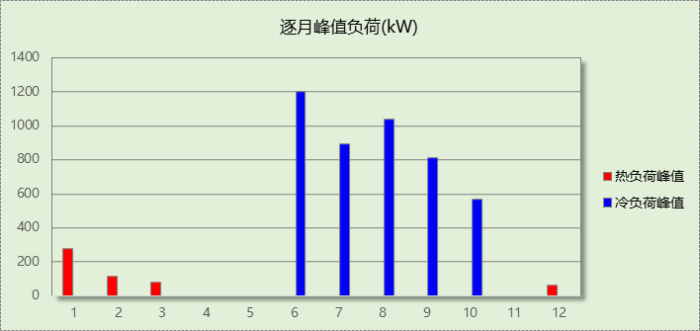

附录
工作日/节假日人员逐时在室率(%)

房间类型 | 1 | 2 | 3 | 4 | 5 | 6 | 7 | 8 | 9 | 10 | 11 | 12 | 13 | 14 | 15 | 16 | 17 | 18 | 19 | 20 | 21 | 22 | 23 | 24
会议室 | 0 | 0 | 0 | 0 | 0 | 0 | 10 | 50 | 95 | 95 | 95 | 80 | 80 | 95 | 95 | 95 | 95 | 30 | 30 | 0 | 0 | 0 | 0 | 0
会议室 | 0 | 0 | 0 | 0 | 0 | 0 | 0 | 0 | 0 | 0 | 0 | 0 | 0 | 0 | 0 | 0 | 0 | 0 | 0 | 0 | 0 | 0 | 0 | 0
办公-普通办公室 | 0 | 0 | 0 | 0 | 0 | 0 | 10 | 50 | 100 | 100 | 100 | 30 | 100 | 100 | 100 | 100 | 50 | 20 | 10 | 0 | 0 | 0 | 0 | 0
办公-普通办公室 | 0 | 0 | 0 | 0 | 0 | 0 | 0 | 20 | 45 | 0 | 0 | 0 | 0 | 0 | 0 | 0 | 0 | 0 | 0 | 0 | 0 | 0 | 0 | 0
卫生间 | 0 | 0 | 0 | 0 | 0 | 0 | 10 | 50 | 95 | 95 | 95 | 80 | 80 | 95 | 95 | 95 | 95 | 30 | 30 | 0 | 0 | 0 | 0 | 0
卫生间 | 0 | 0 | 0 | 0 | 0 | 0 | 0 | 0 | 0 | 0 | 0 | 0 | 0 | 0 | 0 | 0 | 0 | 0 | 0 | 0 | 0 | 0 | 0 | 0
多媒体教室 | 0 | 0 | 0 | 0 | 0 | 0 | 10 | 50 | 95 | 95 | 95 | 80 | 80 | 95 | 95 | 95 | 95 | 30 | 30 | 0 | 0 | 0 | 0 | 0
多媒体教室 | 0 | 0 | 0 | 0 | 0 | 0 | 0 | 0 | 0 | 0 | 0 | 0 | 0 | 0 | 0 | 0 | 0 | 0 | 0 | 0 | 0 | 0 | 0 | 0
大厅 | 0 | 0 | 0 | 0 | 0 | 0 | 10 | 50 | 95 | 95 | 95 | 80 | 80 | 95 | 95 | 95 | 95 | 30 | 30 | 0 | 0 | 0 | 0 | 0
大厅 | 0 | 0 | 0 | 0 | 0 | 0 | 0 | 0 | 0 | 0 | 0 | 0 | 0 | 0 | 0 | 0 | 0 | 0 | 0 | 0 | 0 | 0 | 0 | 0
库房 | 0 | 0 | 0 | 0 | 0 | 0 | 10 | 50 | 95 | 95 | 95 | 80 | 80 | 95 | 95 | 95 | 95 | 30 | 30 | 0 | 0 | 0 | 0 | 0
库房 | 0 | 0 | 0 | 0 | 0 | 0 | 0 | 0 | 0 | 0 | 0 | 0 | 0 | 0 | 0 | 0 | 0 | 0 | 0 | 0 | 0 | 0 | 0 | 0
库房 | 0 | 0 | 0 | 0 | 0 | 0 | 10 | 50 | 100 | 100 | 100 | 30 | 100 | 100 | 100 | 100 | 50 | 20 | 10 | 0 | 0 | 0 | 0 | 0
库房 | 0 | 0 | 0 | 0 | 0 | 0 | 0 | 20 | 45 | 0 | 0 | 0 | 0 | 0 | 0 | 0 | 0 | 0 | 0 | 0 | 0 | 0 | 0 | 0
报告厅 | 0 | 0 | 0 | 0 | 0 | 0 | 10 | 50 | 95 | 95 | 95 | 80 | 80 | 95 | 95 | 95 | 95 | 30 | 30 | 0 | 0 | 0 | 0 | 0
报告厅 | 0 | 0 | 0 | 0 | 0 | 0 | 0 | 0 | 0 | 0 | 0 | 0 | 0 | 0 | 0 | 0 | 0 | 0 | 0 | 0 | 0 | 0 | 0 | 0
普通办公室 | 0 | 0 | 0 | 0 | 0 | 0 | 10 | 50 | 95 | 95 | 95 | 80 | 80 | 95 | 95 | 95 | 95 | 30 | 30 | 0 | 0 | 0 | 0 | 0
普通办公室 | 0 | 0 | 0 | 0 | 0 | 0 | 0 | 0 | 0 | 0 | 0 | 0 | 0 | 0 | 0 | 0 | 0 | 0 | 0 | 0 | 0 | 0 | 0 | 0
普通教室 | 0 | 0 | 0 | 0 | 0 | 0 | 10 | 50 | 95 | 95 | 95 | 80 | 80 | 95 | 95 | 95 | 95 | 30 | 30 | 0 | 0 | 0 | 0 | 0
普通教室 | 0 | 0 | 0 | 0 | 0 | 0 | 0 | 0 | 0 | 0 | 0 | 0 | 0 | 0 | 0 | 0 | 0 | 0 | 0 | 0 | 0 | 0 | 0 | 0
楼梯间 | 0 | 0 | 0 | 0 | 0 | 0 | 0 | 20 | 50 | 80 | 80 | 80 | 80 | 80 | 80 | 80 | 80 | 80 | 80 | 70 | 50 | 0 | 0 | 0
楼梯间 | 0 | 0 | 0 | 0 | 0 | 0 | 0 | 0 | 0 | 0 | 0 | 0 | 0 | 0 | 0 | 0 | 0 | 0 | 0 | 0 | 0 | 0 | 0 | 0
楼梯间 | 0 | 0 | 0 | 0 | 0 | 0 | 10 | 50 | 95 | 95 | 95 | 80 | 80 | 95 | 95 | 95 | 95 | 30 | 30 | 0 | 0 | 0 | 0 | 0
楼梯间 | 0 | 0 | 0 | 0 | 0 | 0 | 0 | 0 | 0 | 0 | 0 | 0 | 0 | 0 | 0 | 0 | 0 | 0 | 0 | 0 | 0 | 0 | 0 | 0
空房间 | 0 | 0 | 0 | 0 | 0 | 0 | 0 | 20 | 50 | 80 | 80 | 80 | 80 | 80 | 80 | 80 | 80 | 80 | 80 | 70 | 50 | 0 | 0 | 0
空房间 | 0 | 0 | 0 | 0 | 0 | 0 | 0 | 0 | 0 | 0 | 0 | 0 | 0 | 0 | 0 | 0 | 0 | 0 | 0 | 0 | 0 | 0 | 0 | 0
绘图室 | 0 | 0 | 0 | 0 | 0 | 0 | 10 | 50 | 100 | 100 | 100 | 30 | 100 | 100 | 100 | 100 | 50 | 20 | 10 | 0 | 0 | 0 | 0 | 0
绘图室 | 0 | 0 | 0 | 0 | 0 | 0 | 0 | 20 | 45 | 0 | 0 | 0 | 0 | 0 | 0 | 0 | 0 | 0 | 0 | 0 | 0 | 0 | 0 | 0
美术教室 | 0 | 0 | 0 | 0 | 0 | 0 | 10 | 50 | 95 | 95 | 95 | 80 | 80 | 95 | 95 | 95 | 95 | 30 | 30 | 0 | 0 | 0 | 0 | 0
美术教室 | 0 | 0 | 0 | 0 | 0 | 0 | 0 | 0 | 0 | 0 | 0 | 0 | 0 | 0 | 0 | 0 | 0 | 0 | 0 | 0 | 0 | 0 | 0 | 0
计算机房 | 0 | 0 | 0 | 0 | 0 | 0 | 10 | 50 | 95 | 95 | 95 | 80 | 80 | 95 | 95 | 95 | 95 | 30 | 30 | 0 | 0 | 0 | 0 | 0
计算机房 | 0 | 0 | 0 | 0 | 0 | 0 | 0 | 0 | 0 | 0 | 0 | 0 | 0 | 0 | 0 | 0 | 0 | 0 | 0 | 0 | 0 | 0 | 0 | 0
设备间 | 0 | 0 | 0 | 0 | 0 | 0 | 0 | 0 | 0 | 0 | 0 | 0 | 0 | 0 | 0 | 0 | 0 | 0 | 0 | 0 | 0 | 0 | 0 | 0
设备间 | 0 | 0 | 0 | 0 | 0 | 0 | 0 | 0 | 0 | 0 | 0 | 0 | 0 | 0 | 0 | 0 | 0 | 0 | 0 | 0 | 0 | 0 | 0 | 0
走廊 | 0 | 0 | 0 | 0 | 0 | 0 | 10 | 50 | 95 | 95 | 95 | 80 | 80 | 95 | 95 | 95 | 95 | 30 | 30 | 0 | 0 | 0 | 0 | 0
走廊 | 0 | 0 | 0 | 0 | 0 | 0 | 0 | 0 | 0 | 0 | 0 | 0 | 0 | 0 | 0 | 0 | 0 | 0 | 0 | 0 | 0 | 0 | 0 | 0
阅览室 | 0 | 0 | 0 | 0 | 0 | 0 | 10 | 50 | 95 | 95 | 95 | 80 | 80 | 95 | 95 | 95 | 95 | 30 | 30 | 0 | 0 | 0 | 0 | 0
阅览室 | 0 | 0 | 0 | 0 | 0 | 0 | 0 | 0 | 0 | 0 | 0 | 0 | 0 | 0 | 0 | 0 | 0 | 0 | 0 | 0 | 0 | 0 | 0 | 0
注：上行：工作日；下行：节假日

工作日/节假日照明开关时间表(%)

房间类型 | 1 | 2 | 3 | 4 | 5 | 6 | 7 | 8 | 9 | 10 | 11 | 12 | 13 | 14 | 15 | 16 | 17 | 18 | 19 | 20 | 21 | 22 | 23 | 24
会议室 | 0 | 0 | 0 | 0 | 0 | 0 | 10 | 50 | 95 | 95 | 95 | 80 | 80 | 95 | 95 | 95 | 95 | 30 | 30 | 0 | 0 | 0 | 0 | 0
会议室 | 0 | 0 | 0 | 0 | 0 | 0 | 0 | 0 | 0 | 0 | 0 | 0 | 0 | 0 | 0 | 0 | 0 | 0 | 0 | 0 | 0 | 0 | 0 | 0
办公-普通办公室 | 10 | 10 | 10 | 10 | 10 | 10 | 10 | 36 | 62 | 56 | 54 | 43 | 53 | 55 | 58 | 67 | 40 | 18 | 10 | 10 | 10 | 10 | 10 | 10
办公-普通办公室 | 0 | 0 | 0 | 0 | 0 | 0 | 0 | 0 | 0 | 0 | 0 | 0 | 0 | 0 | 0 | 0 | 0 | 0 | 0 | 0 | 0 | 0 | 0 | 0
卫生间 | 0 | 0 | 0 | 0 | 0 | 0 | 10 | 50 | 95 | 95 | 95 | 80 | 80 | 95 | 95 | 95 | 95 | 30 | 30 | 0 | 0 | 0 | 0 | 0
卫生间 | 0 | 0 | 0 | 0 | 0 | 0 | 0 | 0 | 0 | 0 | 0 | 0 | 0 | 0 | 0 | 0 | 0 | 0 | 0 | 0 | 0 | 0 | 0 | 0
多媒体教室 | 0 | 0 | 0 | 0 | 0 | 0 | 10 | 50 | 95 | 95 | 95 | 80 | 80 | 95 | 95 | 95 | 95 | 30 | 30 | 0 | 0 | 0 | 0 | 0
多媒体教室 | 0 | 0 | 0 | 0 | 0 | 0 | 0 | 0 | 0 | 0 | 0 | 0 | 0 | 0 | 0 | 0 | 0 | 0 | 0 | 0 | 0 | 0 | 0 | 0
大厅 | 0 | 0 | 0 | 0 | 0 | 0 | 10 | 50 | 95 | 95 | 95 | 80 | 80 | 95 | 95 | 95 | 95 | 30 | 30 | 0 | 0 | 0 | 0 | 0
大厅 | 0 | 0 | 0 | 0 | 0 | 0 | 0 | 0 | 0 | 0 | 0 | 0 | 0 | 0 | 0 | 0 | 0 | 0 | 0 | 0 | 0 | 0 | 0 | 0
库房 | 0 | 0 | 0 | 0 | 0 | 0 | 10 | 50 | 95 | 95 | 95 | 80 | 80 | 95 | 95 | 95 | 95 | 30 | 30 | 0 | 0 | 0 | 0 | 0
库房 | 0 | 0 | 0 | 0 | 0 | 0 | 0 | 0 | 0 | 0 | 0 | 0 | 0 | 0 | 0 | 0 | 0 | 0 | 0 | 0 | 0 | 0 | 0 | 0
库房 | 10 | 10 | 10 | 10 | 10 | 10 | 10 | 36 | 62 | 56 | 54 | 43 | 53 | 55 | 58 | 67 | 40 | 18 | 10 | 10 | 10 | 10 | 10 | 10
库房 | 0 | 0 | 0 | 0 | 0 | 0 | 0 | 0 | 0 | 0 | 0 | 0 | 0 | 0 | 0 | 0 | 0 | 0 | 0 | 0 | 0 | 0 | 0 | 0
报告厅 | 0 | 0 | 0 | 0 | 0 | 0 | 10 | 50 | 95 | 95 | 95 | 80 | 80 | 95 | 95 | 95 | 95 | 30 | 30 | 0 | 0 | 0 | 0 | 0
报告厅 | 0 | 0 | 0 | 0 | 0 | 0 | 0 | 0 | 0 | 0 | 0 | 0 | 0 | 0 | 0 | 0 | 0 | 0 | 0 | 0 | 0 | 0 | 0 | 0
普通办公室 | 0 | 0 | 0 | 0 | 0 | 0 | 10 | 50 | 95 | 95 | 95 | 80 | 80 | 95 | 95 | 95 | 95 | 30 | 30 | 0 | 0 | 0 | 0 | 0
普通办公室 | 0 | 0 | 0 | 0 | 0 | 0 | 0 | 0 | 0 | 0 | 0 | 0 | 0 | 0 | 0 | 0 | 0 | 0 | 0 | 0 | 0 | 0 | 0 | 0
普通教室 | 0 | 0 | 0 | 0 | 0 | 0 | 10 | 50 | 95 | 95 | 95 | 80 | 80 | 95 | 95 | 95 | 95 | 30 | 30 | 0 | 0 | 0 | 0 | 0
普通教室 | 0 | 0 | 0 | 0 | 0 | 0 | 0 | 0 | 0 | 0 | 0 | 0 | 0 | 0 | 0 | 0 | 0 | 0 | 0 | 0 | 0 | 0 | 0 | 0
楼梯间 | 10 | 10 | 10 | 10 | 10 | 10 | 10 | 50 | 60 | 60 | 60 | 60 | 60 | 60 | 60 | 60 | 80 | 90 | 100 | 100 | 100 | 10 | 10 | 10
楼梯间 | 0 | 0 | 0 | 0 | 0 | 0 | 0 | 0 | 0 | 0 | 0 | 0 | 0 | 0 | 0 | 0 | 0 | 0 | 0 | 0 | 0 | 0 | 0 | 0
楼梯间 | 0 | 0 | 0 | 0 | 0 | 0 | 10 | 50 | 95 | 95 | 95 | 80 | 80 | 95 | 95 | 95 | 95 | 30 | 30 | 0 | 0 | 0 | 0 | 0
楼梯间 | 0 | 0 | 0 | 0 | 0 | 0 | 0 | 0 | 0 | 0 | 0 | 0 | 0 | 0 | 0 | 0 | 0 | 0 | 0 | 0 | 0 | 0 | 0 | 0
空房间 | 10 | 10 | 10 | 10 | 10 | 10 | 10 | 50 | 60 | 60 | 60 | 60 | 60 | 60 | 60 | 60 | 80 | 90 | 100 | 100 | 100 | 10 | 10 | 10
空房间 | 0 | 0 | 0 | 0 | 0 | 0 | 0 | 0 | 0 | 0 | 0 | 0 | 0 | 0 | 0 | 0 | 0 | 0 | 0 | 0 | 0 | 0 | 0 | 0
绘图室 | 10 | 10 | 10 | 10 | 10 | 10 | 10 | 36 | 62 | 56 | 54 | 43 | 53 | 55 | 58 | 67 | 40 | 18 | 10 | 10 | 10 | 10 | 10 | 10
绘图室 | 0 | 0 | 0 | 0 | 0 | 0 | 0 | 0 | 0 | 0 | 0 | 0 | 0 | 0 | 0 | 0 | 0 | 0 | 0 | 0 | 0 | 0 | 0 | 0
美术教室 | 0 | 0 | 0 | 0 | 0 | 0 | 10 | 50 | 95 | 95 | 95 | 80 | 80 | 95 | 95 | 95 | 95 | 30 | 30 | 0 | 0 | 0 | 0 | 0
美术教室 | 0 | 0 | 0 | 0 | 0 | 0 | 0 | 0 | 0 | 0 | 0 | 0 | 0 | 0 | 0 | 0 | 0 | 0 | 0 | 0 | 0 | 0 | 0 | 0
计算机房 | 0 | 0 | 0 | 0 | 0 | 0 | 10 | 50 | 95 | 95 | 95 | 80 | 80 | 95 | 95 | 95 | 95 | 30 | 30 | 0 | 0 | 0 | 0 | 0
计算机房 | 0 | 0 | 0 | 0 | 0 | 0 | 0 | 0 | 0 | 0 | 0 | 0 | 0 | 0 | 0 | 0 | 0 | 0 | 0 | 0 | 0 | 0 | 0 | 0
设备间 | 100 | 100 | 100 | 100 | 100 | 100 | 100 | 100 | 100 | 100 | 100 | 100 | 100 | 100 | 100 | 100 | 100 | 100 | 100 | 100 | 100 | 100 | 100 | 100
设备间 | 0 | 0 | 0 | 0 | 0 | 0 | 0 | 0 | 0 | 0 | 0 | 0 | 0 | 0 | 0 | 0 | 0 | 0 | 0 | 0 | 0 | 0 | 0 | 0
走廊 | 0 | 0 | 0 | 0 | 0 | 0 | 10 | 50 | 95 | 95 | 95 | 80 | 80 | 95 | 95 | 95 | 95 | 30 | 30 | 0 | 0 | 0 | 0 | 0
走廊 | 0 | 0 | 0 | 0 | 0 | 0 | 0 | 0 | 0 | 0 | 0 | 0 | 0 | 0 | 0 | 0 | 0 | 0 | 0 | 0 | 0 | 0 | 0 | 0
阅览室 | 0 | 0 | 0 | 0 | 0 | 0 | 10 | 50 | 95 | 95 | 95 | 80 | 80 | 95 | 95 | 95 | 95 | 30 | 30 | 0 | 0 | 0 | 0 | 0
阅览室 | 0 | 0 | 0 | 0 | 0 | 0 | 0 | 0 | 0 | 0 | 0 | 0 | 0 | 0 | 0 | 0 | 0 | 0 | 0 | 0 | 0 | 0 | 0 | 0
注：上行：工作日；下行：节假日

工作日/节假日设备逐时使用率(%)

房间类型 | 1 | 2 | 3 | 4 | 5 | 6 | 7 | 8 | 9 | 10 | 11 | 12 | 13 | 14 | 15 | 16 | 17 | 18 | 19 | 20 | 21 | 22 | 23 | 24
会议室 | 0 | 0 | 0 | 0 | 0 | 0 | 10 | 50 | 95 | 95 | 95 | 50 | 50 | 95 | 95 | 95 | 95 | 30 | 30 | 0 | 0 | 0 | 0 | 0
会议室 | 0 | 0 | 0 | 0 | 0 | 0 | 0 | 0 | 0 | 0 | 0 | 0 | 0 | 0 | 0 | 0 | 0 | 0 | 0 | 0 | 0 | 0 | 0 | 0
办公-普通办公室 | 0 | 0 | 0 | 0 | 0 | 0 | 10 | 50 | 100 | 100 | 100 | 100 | 100 | 100 | 100 | 100 | 50 | 20 | 10 | 0 | 0 | 0 | 0 | 0
办公-普通办公室 | 0 | 0 | 0 | 0 | 0 | 0 | 0 | 0 | 0 | 0 | 0 | 0 | 0 | 0 | 0 | 0 | 0 | 0 | 0 | 0 | 0 | 0 | 0 | 0
卫生间 | 0 | 0 | 0 | 0 | 0 | 0 | 10 | 50 | 95 | 95 | 95 | 50 | 50 | 95 | 95 | 95 | 95 | 30 | 30 | 0 | 0 | 0 | 0 | 0
卫生间 | 0 | 0 | 0 | 0 | 0 | 0 | 0 | 0 | 0 | 0 | 0 | 0 | 0 | 0 | 0 | 0 | 0 | 0 | 0 | 0 | 0 | 0 | 0 | 0
多媒体教室 | 0 | 0 | 0 | 0 | 0 | 0 | 10 | 50 | 95 | 95 | 95 | 50 | 50 | 95 | 95 | 95 | 95 | 30 | 30 | 0 | 0 | 0 | 0 | 0
多媒体教室 | 0 | 0 | 0 | 0 | 0 | 0 | 0 | 0 | 0 | 0 | 0 | 0 | 0 | 0 | 0 | 0 | 0 | 0 | 0 | 0 | 0 | 0 | 0 | 0
大厅 | 0 | 0 | 0 | 0 | 0 | 0 | 10 | 50 | 95 | 95 | 95 | 50 | 50 | 95 | 95 | 95 | 95 | 30 | 30 | 0 | 0 | 0 | 0 | 0
大厅 | 0 | 0 | 0 | 0 | 0 | 0 | 0 | 0 | 0 | 0 | 0 | 0 | 0 | 0 | 0 | 0 | 0 | 0 | 0 | 0 | 0 | 0 | 0 | 0
库房 | 0 | 0 | 0 | 0 | 0 | 0 | 10 | 50 | 95 | 95 | 95 | 50 | 50 | 95 | 95 | 95 | 95 | 30 | 30 | 0 | 0 | 0 | 0 | 0
库房 | 0 | 0 | 0 | 0 | 0 | 0 | 0 | 0 | 0 | 0 | 0 | 0 | 0 | 0 | 0 | 0 | 0 | 0 | 0 | 0 | 0 | 0 | 0 | 0
库房 | 0 | 0 | 0 | 0 | 0 | 0 | 10 | 50 | 100 | 100 | 100 | 100 | 100 | 100 | 100 | 100 | 50 | 20 | 10 | 0 | 0 | 0 | 0 | 0
库房 | 0 | 0 | 0 | 0 | 0 | 0 | 0 | 0 | 0 | 0 | 0 | 0 | 0 | 0 | 0 | 0 | 0 | 0 | 0 | 0 | 0 | 0 | 0 | 0
报告厅 | 0 | 0 | 0 | 0 | 0 | 0 | 10 | 50 | 95 | 95 | 95 | 50 | 50 | 95 | 95 | 95 | 95 | 30 | 30 | 0 | 0 | 0 | 0 | 0
报告厅 | 0 | 0 | 0 | 0 | 0 | 0 | 0 | 0 | 0 | 0 | 0 | 0 | 0 | 0 | 0 | 0 | 0 | 0 | 0 | 0 | 0 | 0 | 0 | 0
普通办公室 | 0 | 0 | 0 | 0 | 0 | 0 | 10 | 50 | 95 | 95 | 95 | 50 | 50 | 95 | 95 | 95 | 95 | 30 | 30 | 0 | 0 | 0 | 0 | 0
普通办公室 | 0 | 0 | 0 | 0 | 0 | 0 | 0 | 0 | 0 | 0 | 0 | 0 | 0 | 0 | 0 | 0 | 0 | 0 | 0 | 0 | 0 | 0 | 0 | 0
普通教室 | 0 | 0 | 0 | 0 | 0 | 0 | 10 | 50 | 95 | 95 | 95 | 50 | 50 | 95 | 95 | 95 | 95 | 30 | 30 | 0 | 0 | 0 | 0 | 0
普通教室 | 0 | 0 | 0 | 0 | 0 | 0 | 0 | 0 | 0 | 0 | 0 | 0 | 0 | 0 | 0 | 0 | 0 | 0 | 0 | 0 | 0 | 0 | 0 | 0
楼梯间 | 0 | 0 | 0 | 0 | 0 | 0 | 0 | 30 | 50 | 80 | 80 | 80 | 80 | 80 | 80 | 80 | 80 | 80 | 80 | 70 | 50 | 0 | 0 | 0
楼梯间 | 0 | 0 | 0 | 0 | 0 | 0 | 0 | 0 | 0 | 0 | 0 | 0 | 0 | 0 | 0 | 0 | 0 | 0 | 0 | 0 | 0 | 0 | 0 | 0
楼梯间 | 0 | 0 | 0 | 0 | 0 | 0 | 10 | 50 | 95 | 95 | 95 | 50 | 50 | 95 | 95 | 95 | 95 | 30 | 30 | 0 | 0 | 0 | 0 | 0
楼梯间 | 0 | 0 | 0 | 0 | 0 | 0 | 0 | 0 | 0 | 0 | 0 | 0 | 0 | 0 | 0 | 0 | 0 | 0 | 0 | 0 | 0 | 0 | 0 | 0
空房间 | 0 | 0 | 0 | 0 | 0 | 0 | 0 | 30 | 50 | 80 | 80 | 80 | 80 | 80 | 80 | 80 | 80 | 80 | 80 | 70 | 50 | 0 | 0 | 0
空房间 | 0 | 0 | 0 | 0 | 0 | 0 | 0 | 0 | 0 | 0 | 0 | 0 | 0 | 0 | 0 | 0 | 0 | 0 | 0 | 0 | 0 | 0 | 0 | 0
绘图室 | 0 | 0 | 0 | 0 | 0 | 0 | 10 | 50 | 100 | 100 | 100 | 100 | 100 | 100 | 100 | 100 | 50 | 20 | 10 | 0 | 0 | 0 | 0 | 0
绘图室 | 0 | 0 | 0 | 0 | 0 | 0 | 0 | 0 | 0 | 0 | 0 | 0 | 0 | 0 | 0 | 0 | 0 | 0 | 0 | 0 | 0 | 0 | 0 | 0
美术教室 | 0 | 0 | 0 | 0 | 0 | 0 | 10 | 50 | 95 | 95 | 95 | 50 | 50 | 95 | 95 | 95 | 95 | 30 | 30 | 0 | 0 | 0 | 0 | 0
美术教室 | 0 | 0 | 0 | 0 | 0 | 0 | 0 | 0 | 0 | 0 | 0 | 0 | 0 | 0 | 0 | 0 | 0 | 0 | 0 | 0 | 0 | 0 | 0 | 0
计算机房 | 0 | 0 | 0 | 0 | 0 | 0 | 10 | 50 | 95 | 95 | 95 | 50 | 50 | 95 | 95 | 95 | 95 | 30 | 30 | 0 | 0 | 0 | 0 | 0
计算机房 | 0 | 0 | 0 | 0 | 0 | 0 | 0 | 0 | 0 | 0 | 0 | 0 | 0 | 0 | 0 | 0 | 0 | 0 | 0 | 0 | 0 | 0 | 0 | 0
设备间 | 100 | 100 | 100 | 100 | 100 | 100 | 100 | 100 | 100 | 100 | 100 | 100 | 100 | 100 | 100 | 100 | 100 | 100 | 100 | 100 | 100 | 100 | 100 | 100
设备间 | 0 | 0 | 0 | 0 | 0 | 0 | 0 | 0 | 0 | 0 | 0 | 0 | 0 | 0 | 0 | 0 | 0 | 0 | 0 | 0 | 0 | 0 | 0 | 0
走廊 | 0 | 0 | 0 | 0 | 0 | 0 | 10 | 50 | 95 | 95 | 95 | 50 | 50 | 95 | 95 | 95 | 95 | 30 | 30 | 0 | 0 | 0 | 0 | 0
走廊 | 0 | 0 | 0 | 0 | 0 | 0 | 0 | 0 | 0 | 0 | 0 | 0 | 0 | 0 | 0 | 0 | 0 | 0 | 0 | 0 | 0 | 0 | 0 | 0
阅览室 | 0 | 0 | 0 | 0 | 0 | 0 | 10 | 50 | 95 | 95 | 95 | 50 | 50 | 95 | 95 | 95 | 95 | 30 | 30 | 0 | 0 | 0 | 0 | 0
阅览室 | 0 | 0 | 0 | 0 | 0 | 0 | 0 | 0 | 0 | 0 | 0 | 0 | 0 | 0 | 0 | 0 | 0 | 0 | 0 | 0 | 0 | 0 | 0 | 0
注：上行：工作日；下行：节假日

工作日/节假日空调系统开关时间表
采暖期：
系统编号 | 1 | 2 | 3 | 4 | 5 | 6 | 7 | 8 | 9 | 10 | 11 | 12 | 13 | 14 | 15 | 16 | 17 | 18 | 19 | 20 | 21 | 22 | 23 | 24
自动 | 0 | 0 | 0 | 0 | 0 | 0 | 0 | 1 | 1 | 1 | 1 | 1 | 1 | 1 | 1 | 1 | 1 | 1 | 0 | 0 | 0 | 0 | 0 | 0
自动 | 0 | 0 | 0 | 0 | 0 | 0 | 0 | 0 | 0 | 0 | 0 | 0 | 0 | 0 | 0 | 0 | 0 | 0 | 0 | 0 | 0 | 0 | 0 | 0
供冷期：

系统编号 | 1 | 2 | 3 | 4 | 5 | 6 | 7 | 8 | 9 | 10 | 11 | 12 | 13 | 14 | 15 | 16 | 17 | 18 | 19 | 20 | 21 | 22 | 23 | 24
自动 | 0 | 0 | 0 | 0 | 0 | 0 | 0 | 1 | 1 | 1 | 1 | 1 | 1 | 1 | 1 | 1 | 1 | 1 | 0 | 0 | 0 | 0 | 0 | 0
自动 | 0 | 0 | 0 | 0 | 0 | 0 | 0 | 0 | 0 | 0 | 0 | 0 | 0 | 0 | 0 | 0 | 0 | 0 | 0 | 0 | 0 | 0 | 0 | 0
注：上行：工作日；下行：节假日

