全年负荷计算报告书
成都市金牛区第十五幼儿园幸福桥分园改造设计
设计编号：2025-12-3

工程地点 | ： | 四川-成都
建设单位 | ：
设计单位 | ：
设计人 | ：
校对人 | ：
审定人 | ：
报告日期 | : | 2025年12月19日

采用软件 | : 暖通负荷BECH2025 | 
软件版本 | : 20250505(PLUS)
正版授权码 | : T13568179843
研发单位 | : 北京绿建软件股份有限公司

目 录

1 建筑概况 1
2 气象数据 1
2.1 气象地点 1
2.2 逐日干球温度表 1
2.3 逐月辐照量表 2
2.4 峰值工况 2
3 软件介绍 2
4 围护结构 2
4.1 屋顶构造 2
4.2 外墙构造 3
4.3 挑空楼板构造 3
4.4 楼板构造 3
4.5 周边地面构造 4
4.6 非周边地面构造 4
4.7 门构造 4
4.8 窗构造 4
5 房间类型 5
5.1 房间参数表 5
5.2 作息时间表 5
6 系统设置 5
6.1 系统划分 5
6.2 运行时间表 6
7 计算结果 6
7.1 模拟周期 6
7.2 全年冷暖需求 6
7.3 负荷分项统计 6
7.4 逐月负荷表 7
8 附录 9

建筑概况
地理位置 | 北京-北京
气候分区 | 夏热冬冷A区
北纬 | 30.66
东经 | 104.01
建筑名称 | 成都市金牛区第十五幼儿园幸福桥分园改造设计
建筑类型 | 公共建筑
计算建筑面积 | 地上 3715.28 ㎡ | 地下 0.00 ㎡
建筑高度 | 地上 15.60 m | 地下0.00 m
建筑层数 | 地上 4 | 地下 0
北向角度 | 90°

气象数据

气象地点
四川-成都, 《建筑节能气象参数标准》JGJ346-2014

逐日干球温度表
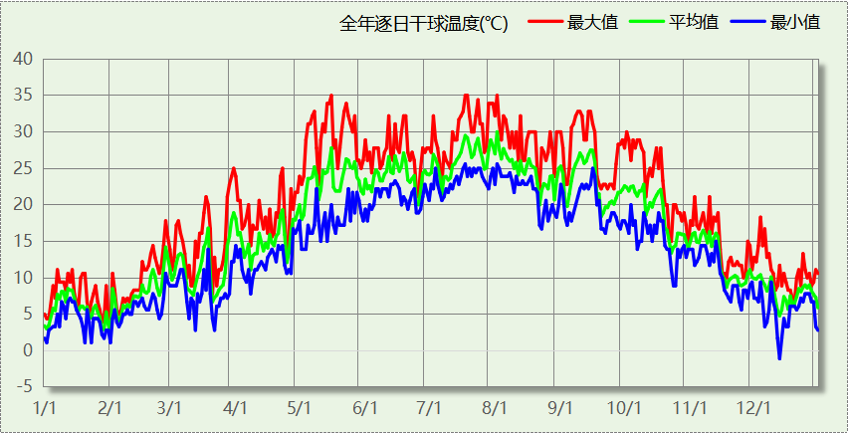

逐月辐照量表
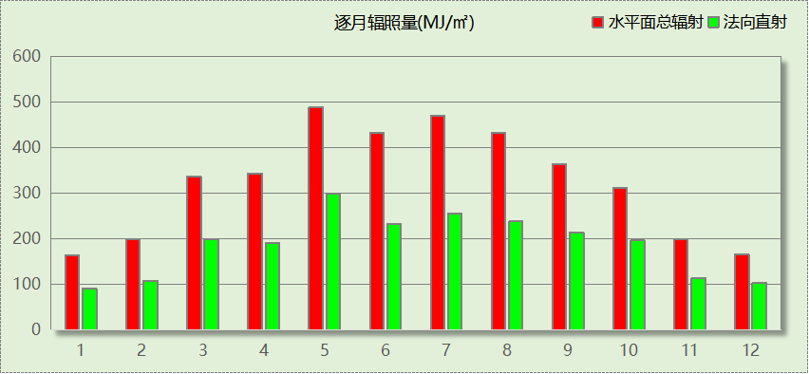

峰值工况
气象数据 | 时刻 | 干球温度(℃) | 湿球温度(℃) | 含湿量(g/kg) | 焓值(kj/kg)
最热 | 05月15日15时 | 35.0 | 22.2 | 13.0 | 68.5
最冷 | 12月12日07时 | -1.1 | -1.7 | 3.4 | 7.4

软件介绍
本报告采用的软件为绿建暖通负荷BECH2025通负荷BECH2018，该软件紧密结合暖通和节能设计规范、可根据项目实际情况建立建筑热工模型，并可对围护结构材料、房间内扰发热、作息时间表、热回收方式等参数进行设置。
软件包含全国各地典型气象年数据，内置DOE2.1E内核，对于建筑的逐时负荷进行动态模拟，既可以模拟8760小时理想负荷，也可以根据设定好的采暖期/空调期进行逐时模拟。
软件还支持分析全年建筑能耗的来源构成，依据日射得热、新风负荷、围护传热和内扰得热进行归类分项，生成设计建筑全年负荷计算报告书，提供详实的数据和多样的图表，为设计师在设备选型、制定运行策略等方面提供参考和帮助。

围护结构

屋顶构造

屋顶构造一
材料名称  （由上到下） | 厚度δ | 导热系数λ | 蓄热系数S | 修正  系数 | 热阻R | 热惰性  指标
材料名称  （由上到下） | (mm) | W/(m.K) | W/(㎡.K) | α | (㎡K)/W | D=R*S
发泡水泥 | 20 | 0.070 | 10.000 | 1.00 | 0.286 | 2.857
岩棉板(ρ=60-160) | 60 | 0.041 | 0.615 | 1.20 | 1.220 | 0.900
纤维板(ρ=1000) | 150 | 0.340 | 8.130 | 1.00 | 0.441 | 3.587
轻骨料混凝土(找坡层) | 30 | 0.300 | 5.000 | 1.50 | 0.067 | 0.500
加气混凝土、泡沫混凝土(ρ=700) | 120 | 0.180 | 3.100 | 1.25 | 0.533 | 2.067
混合砂浆 | 20 | 0.870 | 10.750 | 1.00 | 0.023 | 0.247
各层之和∑ | 400 | － | － | － | 2.569 | 10.158
传热系数K=1/(0.15+∑R) | 0.37

外墙构造

填充墙构造一
材料名称  （由外到内） | 厚度δ | 导热系数λ | 蓄热系数S | 修正  系数 | 热阻R | 热惰性  指标
材料名称  （由外到内） | (mm) | W/(m.K) | W/(㎡.K) | α | (㎡K)/W | D=R*S
发泡水泥 | 20 | 0.070 | 10.000 | 1.00 | 0.286 | 2.857
岩棉板(ρ=60-160) | 60 | 0.041 | 0.615 | 1.20 | 1.220 | 0.900
钢筋混凝土 | 140 | 1.740 | 17.200 | 1.00 | 0.080 | 1.384
纤维板(ρ=1000) | 60 | 0.340 | 8.130 | 1.00 | 0.176 | 1.435
混合砂浆 | 20 | 0.870 | 10.750 | 1.00 | 0.023 | 0.247
各层之和∑ | 300 | － | － | － | 1.785 | 6.823
传热系数K=1/(0.15+∑R) | 0.52

挑空楼板构造

挑空楼板构造一
材料名称  （由上到下） | 厚度δ | 导热系数λ | 蓄热系数S | 修正  系数 | 热阻R | 热惰性  指标
材料名称  （由上到下） | (mm) | W/(m.K) | W/(㎡.K) | α | (㎡K)/W | D=R*S
发泡水泥 | 40 | 0.070 | 10.000 | 1.00 | 0.571 | 5.714
纤维板(ρ=1000) | 100 | 0.340 | 8.130 | 1.00 | 0.294 | 2.391
岩棉板(ρ=60-160) | 120 | 0.041 | 0.615 | 1.20 | 2.439 | 1.800
混合砂浆 | 20 | 0.870 | 10.750 | 1.00 | 0.023 | 0.247
各层之和∑ | 280 | － | － | － | 3.328 | 10.153
传热系数K=1/(0.15+∑R) | 0.29

楼板构造

控温房间楼板构造一
材料名称 | 厚度δ | 导热系数λ | 蓄热系数S | 修正  系数 | 热阻R | 热惰性  指标
材料名称 | (mm) | W/(m.K) | W/(㎡.K) | α | (㎡K)/W | D=R*S
发泡水泥 | 20 | 0.070 | 10.000 | 1.00 | 0.286 | 2.857
石棉水泥板 | 60 | 0.520 | 8.520 | 1.00 | 0.115 | 0.983
钢筋混凝土 | 120 | 1.740 | 17.200 | 1.00 | 0.069 | 1.186
混合砂浆 | 20 | 0.870 | 10.750 | 1.00 | 0.023 | 0.247
各层之和∑ | 220 | － | － | － | 0.493 | 5.274
传热系数K=1/(0.22+∑R) | 1.40

周边地面构造

地面构造一
材料名称 | 厚度δ | 导热系数λ | 蓄热系数S | 修正  系数 | 热阻R | 热惰性  指标
材料名称 | (mm) | W/(m.K) | W/(㎡.K) | α | (㎡K)/W | D=R*S
发泡水泥 | 20 | 0.070 | 10.000 | 1.00 | 0.286 | 2.857
挤塑聚苯板(ρ=25-32) | 55 | 0.030 | 0.320 | 1.10 | 1.667 | 0.587
钢筋混凝土 | 120 | 1.740 | 17.200 | 1.00 | 0.069 | 1.186
混合砂浆 | 20 | 0.870 | 10.750 | 1.00 | 0.023 | 0.247
各层之和∑ | 215 | － | － | － | 2.044 | 4.877
传热系数K=1/(0.11+∑R) | 0.26

非周边地面构造

地面构造一
材料名称 | 厚度δ | 导热系数λ | 蓄热系数S | 修正  系数 | 热阻R | 热惰性  指标
材料名称 | (mm) | W/(m.K) | W/(㎡.K) | α | (㎡K)/W | D=R*S
发泡水泥 | 20 | 0.070 | 10.000 | 1.00 | 0.286 | 2.857
挤塑聚苯板(ρ=25-32) | 55 | 0.030 | 0.320 | 1.10 | 1.667 | 0.587
钢筋混凝土 | 120 | 1.740 | 17.200 | 1.00 | 0.069 | 1.186
混合砂浆 | 20 | 0.870 | 10.750 | 1.00 | 0.023 | 0.247
各层之和∑ | 215 | － | － | － | 2.044 | 4.877
传热系数K=1/(0.11+∑R) | 0.19

门构造
序号 | 构造名称 | 传热系数 | 备注
1 | 金属三防门(聚氨酯发泡) | 0.900

窗构造
序号 | 构造名称 | 传热系数 | 窗遮阳系数 | 可见光透射比 | 备注
1 | 75系列铝合金聚氨酯复合窗(5单银Low-E+12Ar+5单银Low-E+12Ar+5) | 1.100 | 0.448 | 0.700

房间类型

房间参数表
房间类型 | 空调温度  ℃ | 供暖温度  ℃ | 新风量 | 人员密度 | 照明功率  密度 | 电器设备  功率
休息室 | 26 | 18 | 24(m^3/h.人) | 1.39(m^2/人) | 5(W/m^2) | 5(W/m^2)
会议室 | 26 | 20 | 30(m^3/h.人) | 3.3(m^2/人) | 5(W/m^2) | 5(W/m^2)
健身活动室 | 24 | 19 | 40(m^3/h.人) | 4(m^2/人) | 5(W/m^2) | 5(W/m^2)
卫生间 | 28 | 16 | 0(m^3/h.人) | 0(人) | 3(W/m^2) | 5(W/m^2)
多媒体教室 | 26 | 18 | 20(m^3/h.人) | 4(m^2/人) | 5(W/m^2) | 5(W/m^2)
库房 | 26 | 18 | 24(m^3/h.人) | 1.39(m^2/人) | 9(W/m^2) | 5(W/m^2)
普通办公室 | 26 | 20 | 30(m^3/h.人) | 6(m^2/人) | 5(W/m^2) | 5(W/m^2)
普通办公室 | 26 | 20 | 30(m^3/h.人) | 8(m^2/人) | 8(W/m^2) | 15(W/m^2)
普通教室 | 26 | 18 | 24(m^3/h.人) | 1.39(m^2/人) | 5(W/m^2) | 5(W/m^2)
楼梯间 | － | － | 0(m^3/h.人) | 0(人) | 5(W/m^2) | 5(W/m^2)
空房间 | － | － | 20(m^3/h.人) | 0(人) | 0(W/m^2) | 0(W/m^2)
设备间 | － | － | 0(m^3/h.人) | 0(人) | 3.5(W/m^2) | 15(W/m^2)
走廊 | － | － | 0(m^3/h.人) | 0(人) | 5(W/m^2) | 5(W/m^2)
阅览室 | 26 | 20 | 20(m^3/h.人) | 1.9(m^2/人) | 5(W/m^2) | 5(W/m^2)
音乐教室 | 26 | 18 | 20(m^3/h.人) | 4(m^2/人) | 5(W/m^2) | 5(W/m^2)
餐厅 | 26 | 18 | 25(m^3/h.人) | 2(m^2/人) | 5(W/m^2) | 5(W/m^2)

作息时间表
详见附录

系统设置

系统划分
系统编号 | 热回收  类型 | 启动  条件 | 回收  效率 | 排风  比例 | 面积(m2) | 包含的房间
自动 | 全热回收 | 温差启动  冷:≥5.0(℃)  暖:≥5.0(℃) | 冷:0.70, 暖:0.70 | 0.80 | 441.10 | 1064,1083,1058,1055,1051,1047,1041,1040,1034,1073,1070,1067,1060,1050,2062,2045,2044,2027,2082,2079,2072,2078,2069,2066,2059,2052,2048,2024,3063,3046,3043,3081,3026,3080,3074,3077,3071,3068,3061,3056,3049,3025,4053,4088,4086,4076,4075,4065,4057,4054,4042,4038,4033
空调 | 全热回收 | 温差启动  冷:≥5.0(℃)  暖:≥5.0(℃) | 冷:0.80, 暖:0.80 | 0.80 | 2817.93 | 1039,1023,1022,1019,1017,1015,1013,1004,1002,2014,2029,2028,2020,2018,2006,2011,2010,2008,3003,3012,3009,3007,3005,3016,4001

运行时间表
详见附录

计算结果

模拟周期
供冷季(7.1-8.30) 供暖季(12.1-2.28)

全年冷暖需求
系统名称\负荷 | 供暖需求  (kWh) | 供暖指标  kWh/(㎡·a) | 供冷需求  (kWh) | 供冷指标  kWh/(㎡·a)
空调 | 3156 | 1.12 | 213193 | 75.66
自动 | 2236 | 5.07 | 23844 | 54.06
建筑总计 | 5392 | 1.45 | 237037 | 63.80
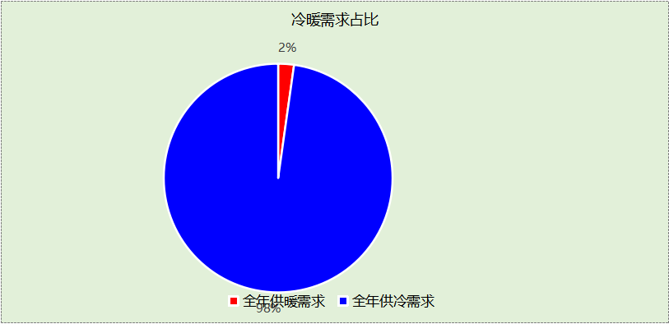

负荷分项统计
分类 | 围护传热 | 室内得热 | 窗日射 | 不利  新风/渗透 | 有利  新风/渗透 | 热回收 | 合计
供暖(kWh/㎡) | -5.80 | 12.79 | 1.72 | -19.89 | — | 9.73 | -1.45
供冷(kWh/㎡) | 7.95 | 19.16 | 3.05 | 39.01 | 0.00 | -5.38 | 63.80
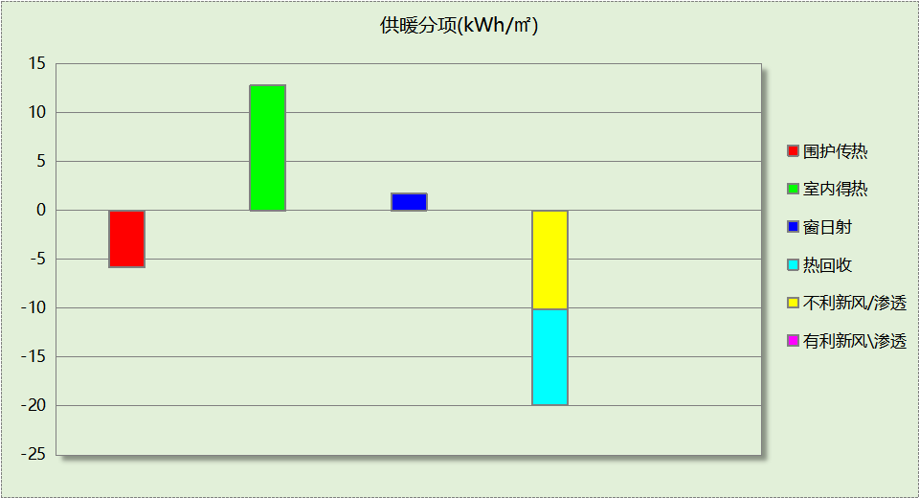
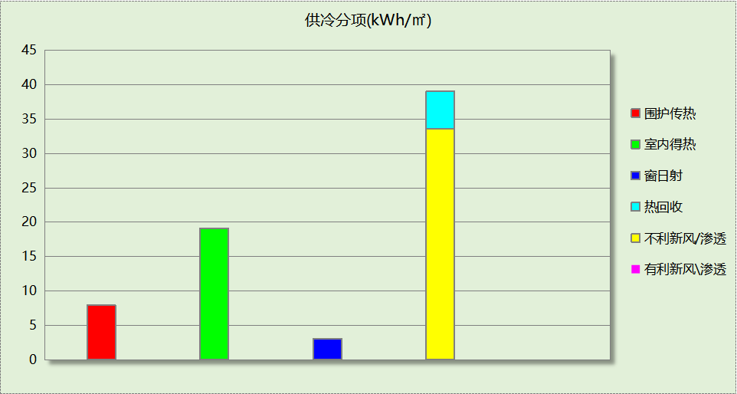

逐月负荷表
月份 | 供暖(kWh) | 供冷(kWh) | 热负荷  峰值(kW) | 热负荷  峰值时刻 | 冷负荷  峰值(kW) | 冷负荷  峰值时刻
1月 | 3577 | 0 | 237.285 | 1月2日8时 | 0.000 | --
2月 | 1139 | 0 | 108.148 | 2月14日8时 | 0.000 | --
3月 | 0 | 0 | 0.000 | -- | 0.000 | --
4月 | 0 | 0 | 0.000 | -- | 0.000 | --
5月 | 0 | 0 | 0.000 | -- | 0.000 | --
6月 | 0 | 0 | 0.000 | -- | 0.000 | --
7月 | 0 | 128416 | 0.000 | -- | 1026.642 | 7月1日8时
8月 | 0 | 108621 | 0.000 | -- | 777.150 | 8月2日13时
9月 | 0 | 0 | 0.000 | -- | 0.000 | --
10月 | 0 | 0 | 0.000 | -- | 0.000 | --
11月 | 0 | 0 | 0.000 | -- | 0.000 | --
12月 | 677 | 0 | 63.154 | 12月16日8时 | 0.000 | --
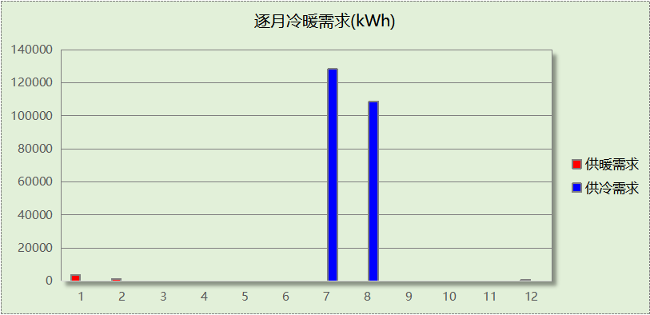
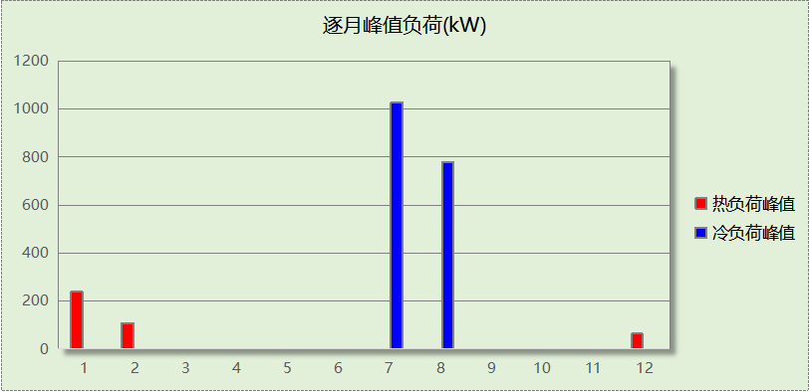

附录
工作日/节假日人员逐时在室率(%)

房间类型 | 1 | 2 | 3 | 4 | 5 | 6 | 7 | 8 | 9 | 10 | 11 | 12 | 13 | 14 | 15 | 16 | 17 | 18 | 19 | 20 | 21 | 22 | 23 | 24
休息室 | 0 | 0 | 0 | 0 | 0 | 0 | 10 | 50 | 95 | 95 | 95 | 80 | 80 | 95 | 95 | 95 | 95 | 30 | 30 | 0 | 0 | 0 | 0 | 0
休息室 | 0 | 0 | 0 | 0 | 0 | 0 | 0 | 0 | 0 | 0 | 0 | 0 | 0 | 0 | 0 | 0 | 0 | 0 | 0 | 0 | 0 | 0 | 0 | 0
会议室 | 0 | 0 | 0 | 0 | 0 | 0 | 10 | 50 | 95 | 95 | 95 | 80 | 80 | 95 | 95 | 95 | 95 | 30 | 30 | 0 | 0 | 0 | 0 | 0
会议室 | 0 | 0 | 0 | 0 | 0 | 0 | 0 | 0 | 0 | 0 | 0 | 0 | 0 | 0 | 0 | 0 | 0 | 0 | 0 | 0 | 0 | 0 | 0 | 0
健身活动室 | 0 | 0 | 0 | 0 | 0 | 0 | 10 | 50 | 95 | 95 | 95 | 80 | 80 | 95 | 95 | 95 | 95 | 30 | 30 | 0 | 0 | 0 | 0 | 0
健身活动室 | 0 | 0 | 0 | 0 | 0 | 0 | 0 | 0 | 0 | 0 | 0 | 0 | 0 | 0 | 0 | 0 | 0 | 0 | 0 | 0 | 0 | 0 | 0 | 0
卫生间 | 0 | 0 | 0 | 0 | 0 | 0 | 10 | 50 | 95 | 95 | 95 | 80 | 80 | 95 | 95 | 95 | 95 | 30 | 30 | 0 | 0 | 0 | 0 | 0
卫生间 | 0 | 0 | 0 | 0 | 0 | 0 | 0 | 0 | 0 | 0 | 0 | 0 | 0 | 0 | 0 | 0 | 0 | 0 | 0 | 0 | 0 | 0 | 0 | 0
多媒体教室 | 0 | 0 | 0 | 0 | 0 | 0 | 10 | 50 | 95 | 95 | 95 | 80 | 80 | 95 | 95 | 95 | 95 | 30 | 30 | 0 | 0 | 0 | 0 | 0
多媒体教室 | 0 | 0 | 0 | 0 | 0 | 0 | 0 | 0 | 0 | 0 | 0 | 0 | 0 | 0 | 0 | 0 | 0 | 0 | 0 | 0 | 0 | 0 | 0 | 0
库房 | 0 | 0 | 0 | 0 | 0 | 0 | 10 | 50 | 95 | 95 | 95 | 80 | 80 | 95 | 95 | 95 | 95 | 30 | 30 | 30 | 30 | 0 | 0 | 0
库房 | 0 | 0 | 0 | 0 | 0 | 0 | 0 | 0 | 0 | 0 | 0 | 0 | 0 | 0 | 0 | 0 | 0 | 0 | 0 | 0 | 0 | 0 | 0 | 0
普通办公室 | 0 | 0 | 0 | 0 | 0 | 0 | 10 | 50 | 95 | 95 | 95 | 80 | 80 | 95 | 95 | 95 | 95 | 30 | 30 | 0 | 0 | 0 | 0 | 0
普通办公室 | 0 | 0 | 0 | 0 | 0 | 0 | 0 | 0 | 0 | 0 | 0 | 0 | 0 | 0 | 0 | 0 | 0 | 0 | 0 | 0 | 0 | 0 | 0 | 0
普通办公室 | 0 | 0 | 0 | 0 | 0 | 0 | 10 | 50 | 100 | 100 | 100 | 30 | 100 | 100 | 100 | 100 | 50 | 20 | 10 | 0 | 0 | 0 | 0 | 0
普通办公室 | 0 | 0 | 0 | 0 | 0 | 0 | 0 | 20 | 45 | 0 | 0 | 0 | 0 | 0 | 0 | 0 | 0 | 0 | 0 | 0 | 0 | 0 | 0 | 0
普通教室 | 0 | 0 | 0 | 0 | 0 | 0 | 10 | 50 | 95 | 95 | 95 | 80 | 80 | 95 | 95 | 95 | 95 | 30 | 30 | 0 | 0 | 0 | 0 | 0
普通教室 | 0 | 0 | 0 | 0 | 0 | 0 | 0 | 0 | 0 | 0 | 0 | 0 | 0 | 0 | 0 | 0 | 0 | 0 | 0 | 0 | 0 | 0 | 0 | 0
楼梯间 | 0 | 0 | 0 | 0 | 0 | 0 | 10 | 50 | 95 | 95 | 95 | 80 | 80 | 95 | 95 | 95 | 95 | 30 | 30 | 30 | 30 | 0 | 0 | 0
楼梯间 | 0 | 0 | 0 | 0 | 0 | 0 | 0 | 0 | 0 | 0 | 0 | 0 | 0 | 0 | 0 | 0 | 0 | 0 | 0 | 0 | 0 | 0 | 0 | 0
空房间 | 0 | 0 | 0 | 0 | 0 | 0 | 0 | 20 | 50 | 80 | 80 | 80 | 80 | 80 | 80 | 80 | 80 | 80 | 80 | 70 | 50 | 0 | 0 | 0
空房间 | 0 | 0 | 0 | 0 | 0 | 0 | 0 | 0 | 0 | 0 | 0 | 0 | 0 | 0 | 0 | 0 | 0 | 0 | 0 | 0 | 0 | 0 | 0 | 0
设备间 | 0 | 0 | 0 | 0 | 0 | 0 | 0 | 20 | 50 | 80 | 80 | 80 | 80 | 80 | 80 | 80 | 80 | 80 | 80 | 70 | 50 | 0 | 0 | 0
设备间 | 0 | 0 | 0 | 0 | 0 | 0 | 0 | 0 | 0 | 0 | 0 | 0 | 0 | 0 | 0 | 0 | 0 | 0 | 0 | 0 | 0 | 0 | 0 | 0
走廊 | 0 | 0 | 0 | 0 | 0 | 0 | 10 | 50 | 95 | 95 | 95 | 80 | 80 | 95 | 95 | 95 | 95 | 30 | 30 | 0 | 0 | 0 | 0 | 0
走廊 | 0 | 0 | 0 | 0 | 0 | 0 | 0 | 0 | 0 | 0 | 0 | 0 | 0 | 0 | 0 | 0 | 0 | 0 | 0 | 0 | 0 | 0 | 0 | 0
阅览室 | 0 | 0 | 0 | 0 | 0 | 0 | 10 | 50 | 95 | 95 | 95 | 80 | 80 | 95 | 95 | 95 | 95 | 30 | 30 | 0 | 0 | 0 | 0 | 0
阅览室 | 0 | 0 | 0 | 0 | 0 | 0 | 0 | 0 | 0 | 0 | 0 | 0 | 0 | 0 | 0 | 0 | 0 | 0 | 0 | 0 | 0 | 0 | 0 | 0
音乐教室 | 0 | 0 | 0 | 0 | 0 | 0 | 10 | 50 | 95 | 95 | 95 | 80 | 80 | 95 | 95 | 95 | 95 | 30 | 30 | 0 | 0 | 0 | 0 | 0
音乐教室 | 0 | 0 | 0 | 0 | 0 | 0 | 0 | 0 | 0 | 0 | 0 | 0 | 0 | 0 | 0 | 0 | 0 | 0 | 0 | 0 | 0 | 0 | 0 | 0
餐厅 | 0 | 0 | 0 | 0 | 0 | 0 | 10 | 50 | 95 | 95 | 95 | 80 | 80 | 95 | 95 | 95 | 95 | 30 | 30 | 0 | 0 | 0 | 0 | 0
餐厅 | 0 | 0 | 0 | 0 | 0 | 0 | 0 | 0 | 0 | 0 | 0 | 0 | 0 | 0 | 0 | 0 | 0 | 0 | 0 | 0 | 0 | 0 | 0 | 0
注：上行：工作日；下行：节假日

工作日/节假日照明开关时间表(%)

房间类型 | 1 | 2 | 3 | 4 | 5 | 6 | 7 | 8 | 9 | 10 | 11 | 12 | 13 | 14 | 15 | 16 | 17 | 18 | 19 | 20 | 21 | 22 | 23 | 24
休息室 | 0 | 0 | 0 | 0 | 0 | 0 | 10 | 50 | 95 | 95 | 95 | 80 | 80 | 95 | 95 | 95 | 95 | 30 | 30 | 0 | 0 | 0 | 0 | 0
休息室 | 0 | 0 | 0 | 0 | 0 | 0 | 0 | 0 | 0 | 0 | 0 | 0 | 0 | 0 | 0 | 0 | 0 | 0 | 0 | 0 | 0 | 0 | 0 | 0
会议室 | 0 | 0 | 0 | 0 | 0 | 0 | 10 | 50 | 95 | 95 | 95 | 80 | 80 | 95 | 95 | 95 | 95 | 30 | 30 | 0 | 0 | 0 | 0 | 0
会议室 | 0 | 0 | 0 | 0 | 0 | 0 | 0 | 0 | 0 | 0 | 0 | 0 | 0 | 0 | 0 | 0 | 0 | 0 | 0 | 0 | 0 | 0 | 0 | 0
健身活动室 | 0 | 0 | 0 | 0 | 0 | 0 | 10 | 50 | 95 | 95 | 95 | 80 | 80 | 95 | 95 | 95 | 95 | 30 | 30 | 0 | 0 | 0 | 0 | 0
健身活动室 | 0 | 0 | 0 | 0 | 0 | 0 | 0 | 0 | 0 | 0 | 0 | 0 | 0 | 0 | 0 | 0 | 0 | 0 | 0 | 0 | 0 | 0 | 0 | 0
卫生间 | 0 | 0 | 0 | 0 | 0 | 0 | 10 | 50 | 95 | 95 | 95 | 80 | 80 | 95 | 95 | 95 | 95 | 30 | 30 | 0 | 0 | 0 | 0 | 0
卫生间 | 0 | 0 | 0 | 0 | 0 | 0 | 0 | 0 | 0 | 0 | 0 | 0 | 0 | 0 | 0 | 0 | 0 | 0 | 0 | 0 | 0 | 0 | 0 | 0
多媒体教室 | 0 | 0 | 0 | 0 | 0 | 0 | 10 | 50 | 95 | 95 | 95 | 80 | 80 | 95 | 95 | 95 | 95 | 30 | 30 | 0 | 0 | 0 | 0 | 0
多媒体教室 | 0 | 0 | 0 | 0 | 0 | 0 | 0 | 0 | 0 | 0 | 0 | 0 | 0 | 0 | 0 | 0 | 0 | 0 | 0 | 0 | 0 | 0 | 0 | 0
库房 | 0 | 0 | 0 | 0 | 0 | 0 | 10 | 50 | 95 | 95 | 95 | 80 | 80 | 95 | 95 | 95 | 95 | 30 | 30 | 30 | 30 | 0 | 0 | 0
库房 | 0 | 0 | 0 | 0 | 0 | 0 | 0 | 0 | 0 | 0 | 0 | 0 | 0 | 0 | 0 | 0 | 0 | 0 | 0 | 0 | 0 | 0 | 0 | 0
普通办公室 | 0 | 0 | 0 | 0 | 0 | 0 | 10 | 50 | 95 | 95 | 95 | 80 | 80 | 95 | 95 | 95 | 95 | 30 | 30 | 0 | 0 | 0 | 0 | 0
普通办公室 | 0 | 0 | 0 | 0 | 0 | 0 | 0 | 0 | 0 | 0 | 0 | 0 | 0 | 0 | 0 | 0 | 0 | 0 | 0 | 0 | 0 | 0 | 0 | 0
普通办公室 | 10 | 10 | 10 | 10 | 10 | 10 | 10 | 36 | 62 | 56 | 54 | 43 | 53 | 55 | 58 | 67 | 40 | 18 | 10 | 10 | 10 | 10 | 10 | 10
普通办公室 | 0 | 0 | 0 | 0 | 0 | 0 | 0 | 0 | 0 | 0 | 0 | 0 | 0 | 0 | 0 | 0 | 0 | 0 | 0 | 0 | 0 | 0 | 0 | 0
普通教室 | 0 | 0 | 0 | 0 | 0 | 0 | 10 | 50 | 95 | 95 | 95 | 80 | 80 | 95 | 95 | 95 | 95 | 30 | 30 | 0 | 0 | 0 | 0 | 0
普通教室 | 0 | 0 | 0 | 0 | 0 | 0 | 0 | 0 | 0 | 0 | 0 | 0 | 0 | 0 | 0 | 0 | 0 | 0 | 0 | 0 | 0 | 0 | 0 | 0
楼梯间 | 0 | 0 | 0 | 0 | 0 | 0 | 10 | 50 | 95 | 95 | 95 | 80 | 80 | 95 | 95 | 95 | 95 | 30 | 30 | 30 | 30 | 0 | 0 | 0
楼梯间 | 0 | 0 | 0 | 0 | 0 | 0 | 0 | 0 | 0 | 0 | 0 | 0 | 0 | 0 | 0 | 0 | 0 | 0 | 0 | 0 | 0 | 0 | 0 | 0
空房间 | 10 | 10 | 10 | 10 | 10 | 10 | 10 | 50 | 60 | 60 | 60 | 60 | 60 | 60 | 60 | 60 | 80 | 90 | 100 | 100 | 100 | 10 | 10 | 10
空房间 | 0 | 0 | 0 | 0 | 0 | 0 | 0 | 0 | 0 | 0 | 0 | 0 | 0 | 0 | 0 | 0 | 0 | 0 | 0 | 0 | 0 | 0 | 0 | 0
设备间 | 10 | 10 | 10 | 10 | 10 | 10 | 10 | 50 | 60 | 60 | 60 | 60 | 60 | 60 | 60 | 60 | 80 | 90 | 100 | 100 | 100 | 10 | 10 | 10
设备间 | 0 | 0 | 0 | 0 | 0 | 0 | 0 | 0 | 0 | 0 | 0 | 0 | 0 | 0 | 0 | 0 | 0 | 0 | 0 | 0 | 0 | 0 | 0 | 0
走廊 | 0 | 0 | 0 | 0 | 0 | 0 | 10 | 50 | 95 | 95 | 95 | 80 | 80 | 95 | 95 | 95 | 95 | 30 | 30 | 0 | 0 | 0 | 0 | 0
走廊 | 0 | 0 | 0 | 0 | 0 | 0 | 0 | 0 | 0 | 0 | 0 | 0 | 0 | 0 | 0 | 0 | 0 | 0 | 0 | 0 | 0 | 0 | 0 | 0
阅览室 | 0 | 0 | 0 | 0 | 0 | 0 | 10 | 50 | 95 | 95 | 95 | 80 | 80 | 95 | 95 | 95 | 95 | 30 | 30 | 0 | 0 | 0 | 0 | 0
阅览室 | 0 | 0 | 0 | 0 | 0 | 0 | 0 | 0 | 0 | 0 | 0 | 0 | 0 | 0 | 0 | 0 | 0 | 0 | 0 | 0 | 0 | 0 | 0 | 0
音乐教室 | 0 | 0 | 0 | 0 | 0 | 0 | 10 | 50 | 95 | 95 | 95 | 80 | 80 | 95 | 95 | 95 | 95 | 30 | 30 | 0 | 0 | 0 | 0 | 0
音乐教室 | 0 | 0 | 0 | 0 | 0 | 0 | 0 | 0 | 0 | 0 | 0 | 0 | 0 | 0 | 0 | 0 | 0 | 0 | 0 | 0 | 0 | 0 | 0 | 0
餐厅 | 0 | 0 | 0 | 0 | 0 | 0 | 10 | 50 | 95 | 95 | 95 | 80 | 80 | 95 | 95 | 95 | 95 | 30 | 30 | 0 | 0 | 0 | 0 | 0
餐厅 | 0 | 0 | 0 | 0 | 0 | 0 | 0 | 0 | 0 | 0 | 0 | 0 | 0 | 0 | 0 | 0 | 0 | 0 | 0 | 0 | 0 | 0 | 0 | 0
注：上行：工作日；下行：节假日

工作日/节假日设备逐时使用率(%)

房间类型 | 1 | 2 | 3 | 4 | 5 | 6 | 7 | 8 | 9 | 10 | 11 | 12 | 13 | 14 | 15 | 16 | 17 | 18 | 19 | 20 | 21 | 22 | 23 | 24
休息室 | 0 | 0 | 0 | 0 | 0 | 0 | 10 | 50 | 95 | 95 | 95 | 50 | 50 | 95 | 95 | 95 | 95 | 30 | 30 | 0 | 0 | 0 | 0 | 0
休息室 | 0 | 0 | 0 | 0 | 0 | 0 | 0 | 0 | 0 | 0 | 0 | 0 | 0 | 0 | 0 | 0 | 0 | 0 | 0 | 0 | 0 | 0 | 0 | 0
会议室 | 0 | 0 | 0 | 0 | 0 | 0 | 10 | 50 | 95 | 95 | 95 | 50 | 50 | 95 | 95 | 95 | 95 | 30 | 30 | 0 | 0 | 0 | 0 | 0
会议室 | 0 | 0 | 0 | 0 | 0 | 0 | 0 | 0 | 0 | 0 | 0 | 0 | 0 | 0 | 0 | 0 | 0 | 0 | 0 | 0 | 0 | 0 | 0 | 0
健身活动室 | 0 | 0 | 0 | 0 | 0 | 0 | 10 | 50 | 95 | 95 | 95 | 50 | 50 | 95 | 95 | 95 | 95 | 30 | 30 | 0 | 0 | 0 | 0 | 0
健身活动室 | 0 | 0 | 0 | 0 | 0 | 0 | 0 | 0 | 0 | 0 | 0 | 0 | 0 | 0 | 0 | 0 | 0 | 0 | 0 | 0 | 0 | 0 | 0 | 0
卫生间 | 0 | 0 | 0 | 0 | 0 | 0 | 10 | 50 | 95 | 95 | 95 | 50 | 50 | 95 | 95 | 95 | 95 | 30 | 30 | 0 | 0 | 0 | 0 | 0
卫生间 | 0 | 0 | 0 | 0 | 0 | 0 | 0 | 0 | 0 | 0 | 0 | 0 | 0 | 0 | 0 | 0 | 0 | 0 | 0 | 0 | 0 | 0 | 0 | 0
多媒体教室 | 0 | 0 | 0 | 0 | 0 | 0 | 10 | 50 | 95 | 95 | 95 | 50 | 50 | 95 | 95 | 95 | 95 | 30 | 30 | 0 | 0 | 0 | 0 | 0
多媒体教室 | 0 | 0 | 0 | 0 | 0 | 0 | 0 | 0 | 0 | 0 | 0 | 0 | 0 | 0 | 0 | 0 | 0 | 0 | 0 | 0 | 0 | 0 | 0 | 0
库房 | 0 | 0 | 0 | 0 | 0 | 0 | 10 | 50 | 95 | 95 | 95 | 50 | 50 | 95 | 95 | 95 | 95 | 30 | 30 | 30 | 30 | 0 | 0 | 0
库房 | 0 | 0 | 0 | 0 | 0 | 0 | 0 | 0 | 0 | 0 | 0 | 0 | 0 | 0 | 0 | 0 | 0 | 0 | 0 | 0 | 0 | 0 | 0 | 0
普通办公室 | 0 | 0 | 0 | 0 | 0 | 0 | 10 | 50 | 95 | 95 | 95 | 50 | 50 | 95 | 95 | 95 | 95 | 30 | 30 | 0 | 0 | 0 | 0 | 0
普通办公室 | 0 | 0 | 0 | 0 | 0 | 0 | 0 | 0 | 0 | 0 | 0 | 0 | 0 | 0 | 0 | 0 | 0 | 0 | 0 | 0 | 0 | 0 | 0 | 0
普通办公室 | 0 | 0 | 0 | 0 | 0 | 0 | 10 | 50 | 100 | 100 | 100 | 100 | 100 | 100 | 100 | 100 | 50 | 20 | 10 | 0 | 0 | 0 | 0 | 0
普通办公室 | 0 | 0 | 0 | 0 | 0 | 0 | 0 | 0 | 0 | 0 | 0 | 0 | 0 | 0 | 0 | 0 | 0 | 0 | 0 | 0 | 0 | 0 | 0 | 0
普通教室 | 0 | 0 | 0 | 0 | 0 | 0 | 10 | 50 | 95 | 95 | 95 | 50 | 50 | 95 | 95 | 95 | 95 | 30 | 30 | 0 | 0 | 0 | 0 | 0
普通教室 | 0 | 0 | 0 | 0 | 0 | 0 | 0 | 0 | 0 | 0 | 0 | 0 | 0 | 0 | 0 | 0 | 0 | 0 | 0 | 0 | 0 | 0 | 0 | 0
楼梯间 | 0 | 0 | 0 | 0 | 0 | 0 | 10 | 50 | 95 | 95 | 95 | 50 | 50 | 95 | 95 | 95 | 95 | 30 | 30 | 30 | 30 | 0 | 0 | 0
楼梯间 | 0 | 0 | 0 | 0 | 0 | 0 | 0 | 0 | 0 | 0 | 0 | 0 | 0 | 0 | 0 | 0 | 0 | 0 | 0 | 0 | 0 | 0 | 0 | 0
空房间 | 0 | 0 | 0 | 0 | 0 | 0 | 0 | 30 | 50 | 80 | 80 | 80 | 80 | 80 | 80 | 80 | 80 | 80 | 80 | 70 | 50 | 0 | 0 | 0
空房间 | 0 | 0 | 0 | 0 | 0 | 0 | 0 | 0 | 0 | 0 | 0 | 0 | 0 | 0 | 0 | 0 | 0 | 0 | 0 | 0 | 0 | 0 | 0 | 0
设备间 | 0 | 0 | 0 | 0 | 0 | 0 | 0 | 30 | 50 | 80 | 80 | 80 | 80 | 80 | 80 | 80 | 80 | 80 | 80 | 70 | 50 | 0 | 0 | 0
设备间 | 0 | 0 | 0 | 0 | 0 | 0 | 0 | 0 | 0 | 0 | 0 | 0 | 0 | 0 | 0 | 0 | 0 | 0 | 0 | 0 | 0 | 0 | 0 | 0
走廊 | 0 | 0 | 0 | 0 | 0 | 0 | 10 | 50 | 95 | 95 | 95 | 50 | 50 | 95 | 95 | 95 | 95 | 30 | 30 | 0 | 0 | 0 | 0 | 0
走廊 | 0 | 0 | 0 | 0 | 0 | 0 | 0 | 0 | 0 | 0 | 0 | 0 | 0 | 0 | 0 | 0 | 0 | 0 | 0 | 0 | 0 | 0 | 0 | 0
阅览室 | 0 | 0 | 0 | 0 | 0 | 0 | 10 | 50 | 95 | 95 | 95 | 50 | 50 | 95 | 95 | 95 | 95 | 30 | 30 | 0 | 0 | 0 | 0 | 0
阅览室 | 0 | 0 | 0 | 0 | 0 | 0 | 0 | 0 | 0 | 0 | 0 | 0 | 0 | 0 | 0 | 0 | 0 | 0 | 0 | 0 | 0 | 0 | 0 | 0
音乐教室 | 0 | 0 | 0 | 0 | 0 | 0 | 10 | 50 | 95 | 95 | 95 | 50 | 50 | 95 | 95 | 95 | 95 | 30 | 30 | 0 | 0 | 0 | 0 | 0
音乐教室 | 0 | 0 | 0 | 0 | 0 | 0 | 0 | 0 | 0 | 0 | 0 | 0 | 0 | 0 | 0 | 0 | 0 | 0 | 0 | 0 | 0 | 0 | 0 | 0
餐厅 | 0 | 0 | 0 | 0 | 0 | 0 | 10 | 50 | 95 | 95 | 95 | 50 | 50 | 95 | 95 | 95 | 95 | 30 | 30 | 0 | 0 | 0 | 0 | 0
餐厅 | 0 | 0 | 0 | 0 | 0 | 0 | 0 | 0 | 0 | 0 | 0 | 0 | 0 | 0 | 0 | 0 | 0 | 0 | 0 | 0 | 0 | 0 | 0 | 0
注：上行：工作日；下行：节假日

工作日/节假日空调系统开关时间表
采暖期：
系统编号 | 1 | 2 | 3 | 4 | 5 | 6 | 7 | 8 | 9 | 10 | 11 | 12 | 13 | 14 | 15 | 16 | 17 | 18 | 19 | 20 | 21 | 22 | 23 | 24
自动 | 0 | 0 | 0 | 0 | 0 | 0 | 1 | 1 | 1 | 1 | 1 | 1 | 1 | 1 | 1 | 1 | 1 | 1 | 0 | 0 | 0 | 0 | 0 | 0
自动 | 0 | 0 | 0 | 0 | 0 | 0 | 0 | 0 | 0 | 0 | 0 | 0 | 0 | 0 | 0 | 0 | 0 | 0 | 0 | 0 | 0 | 0 | 0 | 0
空调 | 0 | 0 | 0 | 0 | 0 | 0 | 1 | 1 | 1 | 1 | 1 | 1 | 1 | 1 | 1 | 1 | 1 | 1 | 0 | 0 | 0 | 0 | 0 | 0
空调 | 0 | 0 | 0 | 0 | 0 | 0 | 0 | 0 | 0 | 0 | 0 | 0 | 0 | 0 | 0 | 0 | 0 | 0 | 0 | 0 | 0 | 0 | 0 | 0
供冷期：

系统编号 | 1 | 2 | 3 | 4 | 5 | 6 | 7 | 8 | 9 | 10 | 11 | 12 | 13 | 14 | 15 | 16 | 17 | 18 | 19 | 20 | 21 | 22 | 23 | 24
自动 | 0 | 0 | 0 | 0 | 0 | 0 | 1 | 1 | 1 | 1 | 1 | 1 | 1 | 1 | 1 | 1 | 1 | 1 | 0 | 0 | 0 | 0 | 0 | 0
自动 | 0 | 0 | 0 | 0 | 0 | 0 | 0 | 0 | 0 | 0 | 0 | 0 | 0 | 0 | 0 | 0 | 0 | 0 | 0 | 0 | 0 | 0 | 0 | 0
空调 | 0 | 0 | 0 | 0 | 0 | 0 | 1 | 1 | 1 | 1 | 1 | 1 | 1 | 1 | 1 | 1 | 1 | 1 | 0 | 0 | 0 | 0 | 0 | 0
空调 | 0 | 0 | 0 | 0 | 0 | 0 | 0 | 0 | 0 | 0 | 0 | 0 | 0 | 0 | 0 | 0 | 0 | 0 | 0 | 0 | 0 | 0 | 0 | 0
注：上行：工作日；下行：节假日

